ELECTRONIC SUPPLETMENTARY DETAIL
Full search on OVID Medline
1. Intensive Care Units, Pediatric/
2. (Critical Illness/ or Critical Care/) and (exp Child/ or Pediatrics/)
3. (PICU or PICUs or pediatric ICU* or paediatric ICU* or pediatric intensive care or paediatric intensive care).ti,ab,kf,kw.
4. (critical* adj3 child*).ti,ab,kf.
5. 1 or 2 or 3 or 4
6. Hyperoxia/
7. (hyperoxi* or hyperoxemi* or hyperoxaemi* or PAO2 or PO2 or FIO2).ti,ab,kw,kf.
8. ((high or increased or elevated or supraphysiol*) adj3 oxygen adj3 (concentra* or tension* or pressure* or level*)).ti,ab,kw,kf.
9. (oxygen adj3 (supplement* or therap* or suppl* or administra* or inspir*)).ti,ab,kw,kf.
10. (arteria* adj3 oxygen adj3 (concentra* or tension* or pressure* or level*)).ti,ab,kw,kf.
11. 6 or 7 or 8 or 9 or 10
12. 5 and 11
Full search on OVID Embase
1. pediatric intensive care unit/
2. (critically ill patient/ or critical illness/ or intensive care/) and (exp child/ or pediatrics/)
3. (PICU or PICUs or pediatric ICU* or paediatric ICU* or pediatric intensive care or paediatric intensive care).ti,ab,kw.
4. (critical* adj3 child*).ti,ab,kw.
5. 1 or 2 or 3 or 4
6. hyperoxia/
7. (hyperoxi* or hyperoxemi* or hyperoxaemi* or PAO2 or PO2 or FIO2).ti,ab,kw.
8. ((high or increased or elevated or supraphysiol*) adj3 oxygen adj3 (concentra* or tension* or pressure* or level*)).ti,ab,kw.
9. (oxygen adj3 (supplement* or therap* or suppl* or administra* or inspir*)).ti,ab,kw.
10. (arteria* adj3 oxygen adj3 (concentra* or tension* or pressure* or level*)).ti,ab,kw.
11. 6 or 7 or 8 or 9 or 10
12. 5 and 11
Figure S1 Leave-one-out analysis sorted by effect size
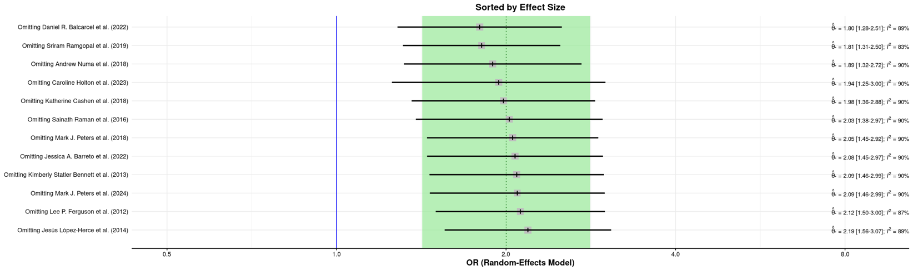
Figure S2 Leave-one-out analysis sorted by I²
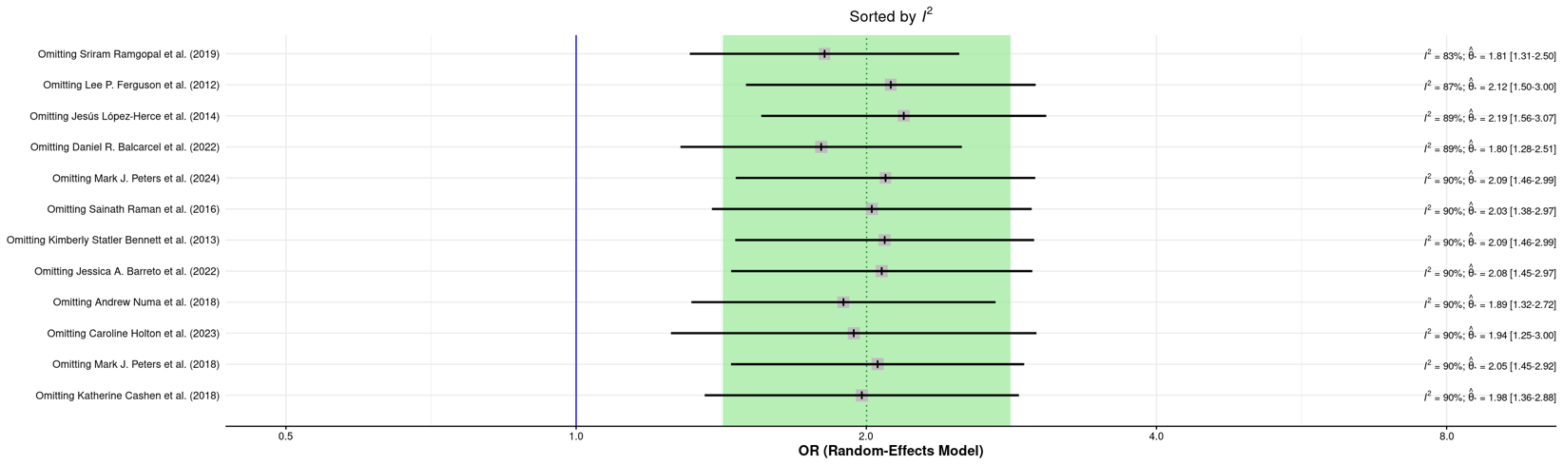
Figure S3 Baujat plot
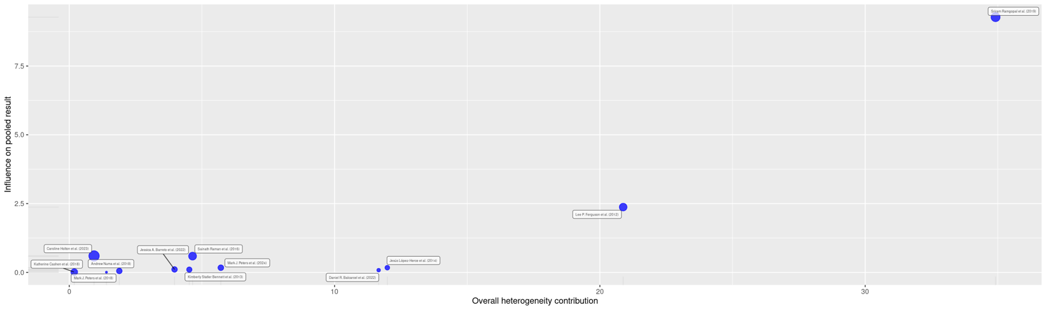
Figure S4 Funnel plot
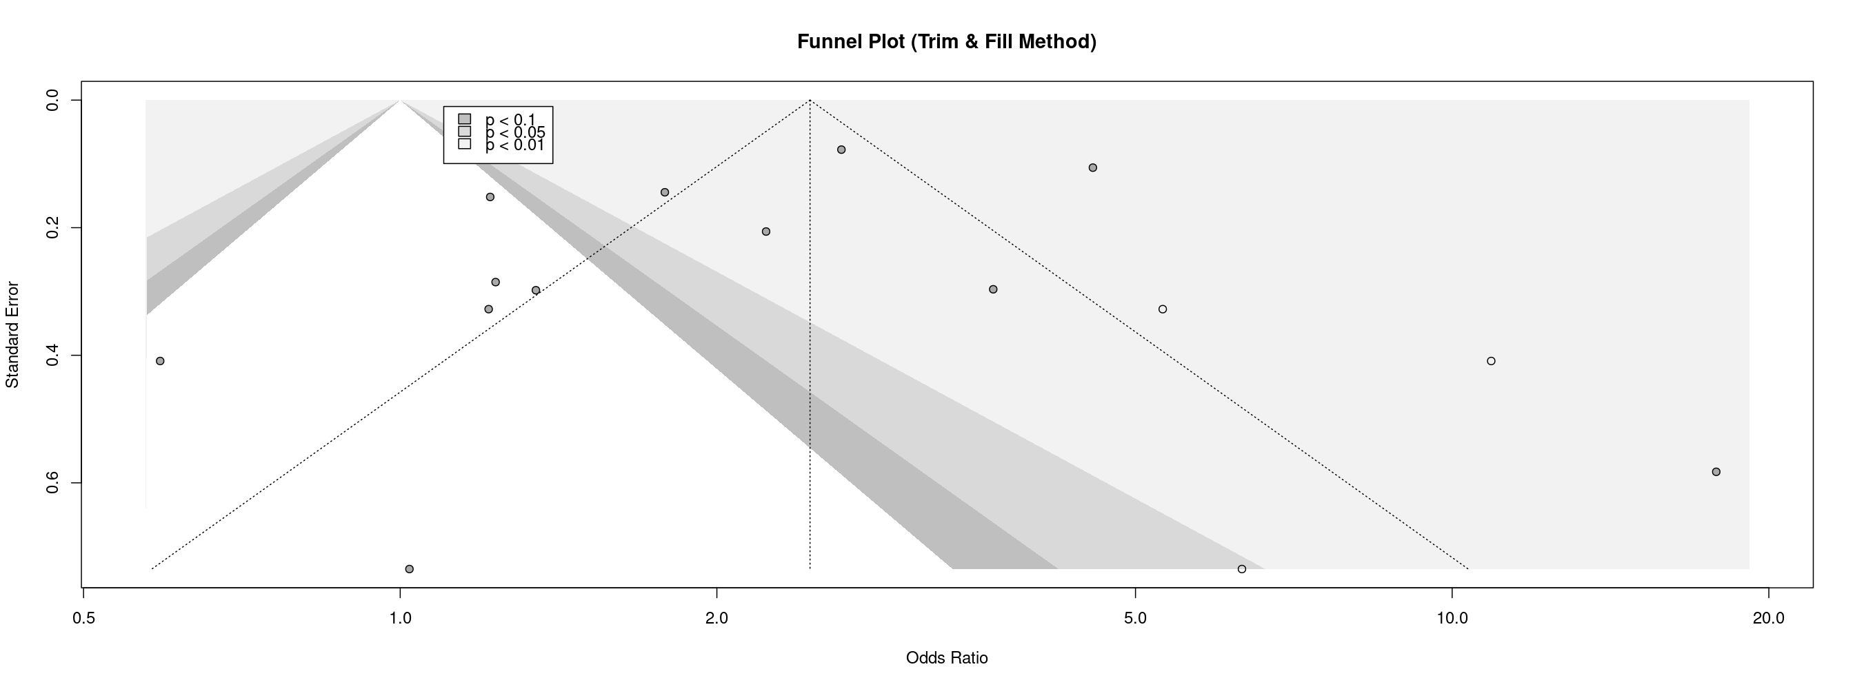
Figure S5 Cumulative meta-analysis
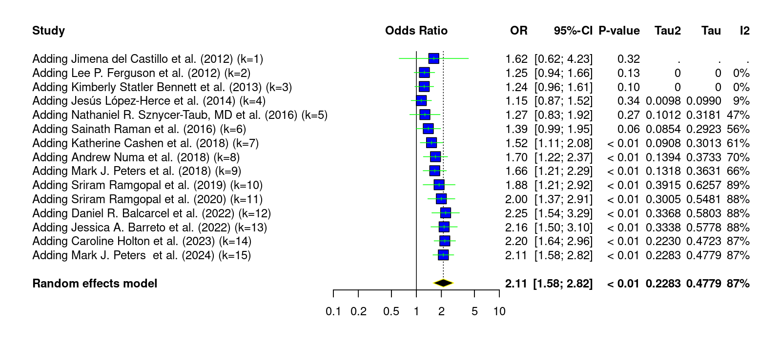
Figure S6 Forest plot demonstrating the impact of hyperoxia on the incidence of AKI at longest follow-up compared to normoxia/non-hyperoxia control groups
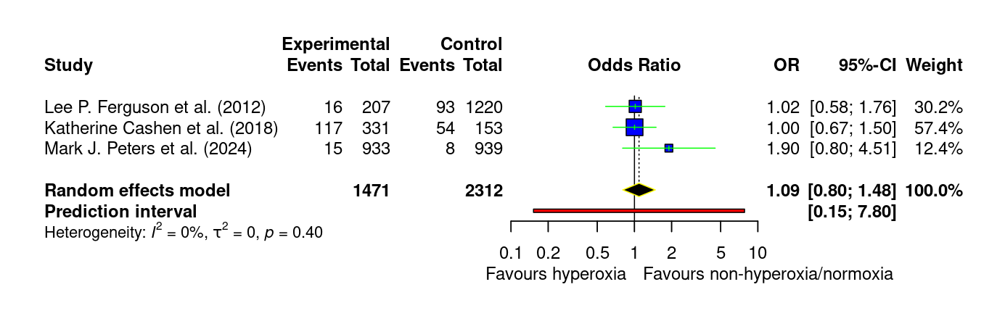
Figure S7 Forest plot demonstrating the impact of hyperoxia on the incidence of organ support at longest follow-up compared to normoxia/non-hyperoxia control groups
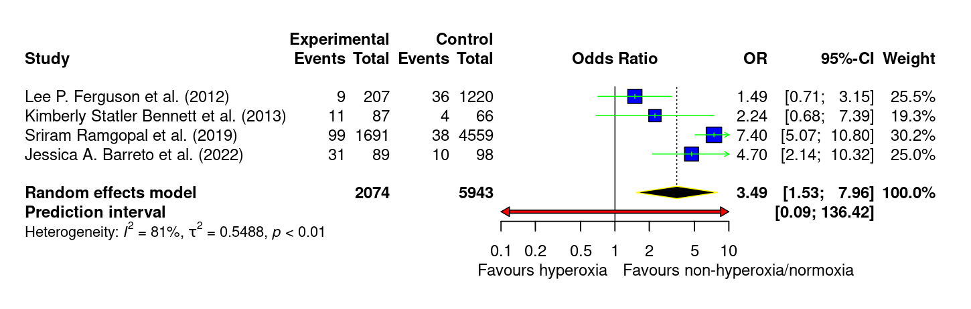
Figure S8 Forest plot demonstrating the impact of hyperoxia on the incidence of poor neurological outcomes at longest follow-up compared to normoxia/non-hyperoxia control groups
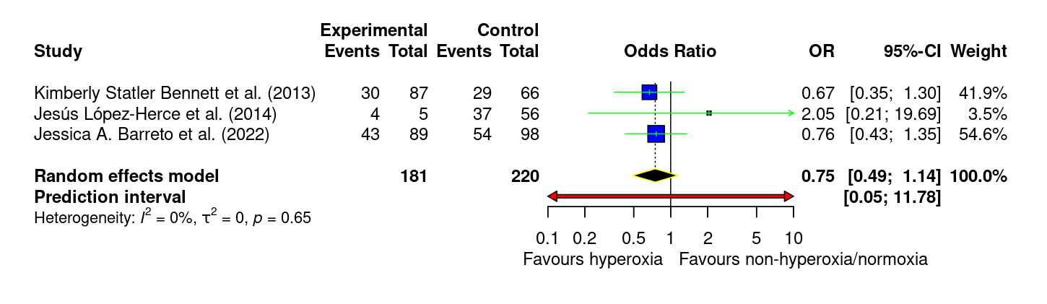
Figure S9 Forest plot demonstrating the impact of hyperoxia on the duration of organ support compared to normoxia/non-hyperoxia control groups
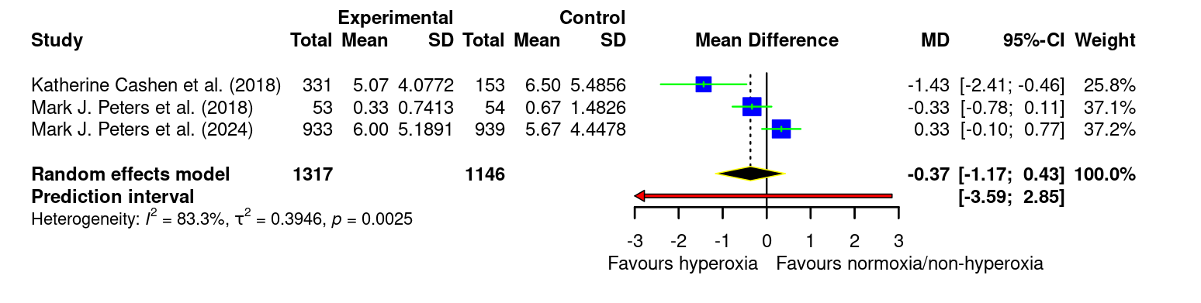
Figure S10 Forest plot demonstrating the impact of hyperoxia on PICU length of stay compared to normoxia/non-hyperoxia control groups 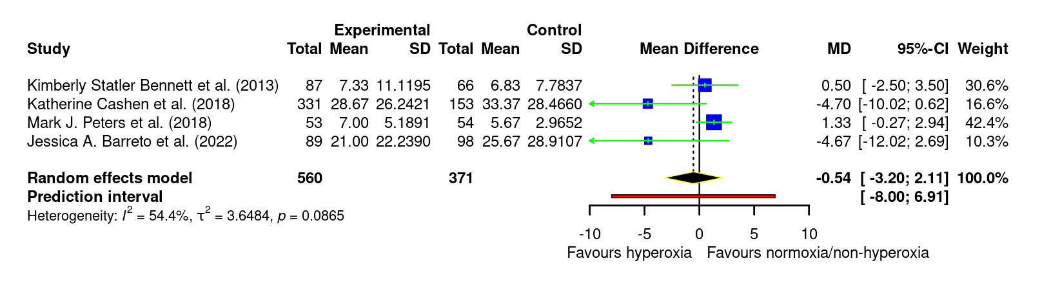 Figure S11 Forest plot demonstrating the impact of hyperoxia, defined as >200, on mortality at longest follow-up compared to normoxia/non-hyperoxia control groups
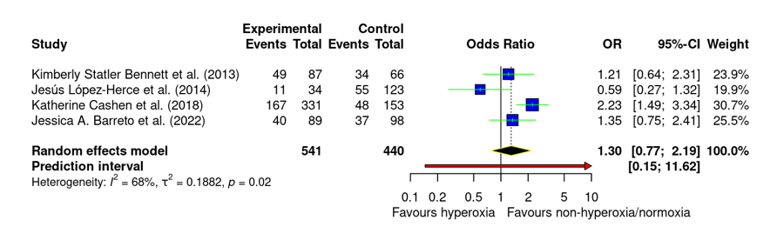
Figure S12 Forest plot demonstrating the impact of hyperoxia, defined as >250, on mortality at longest follow-up compared to normoxia/non-hyperoxia control groups
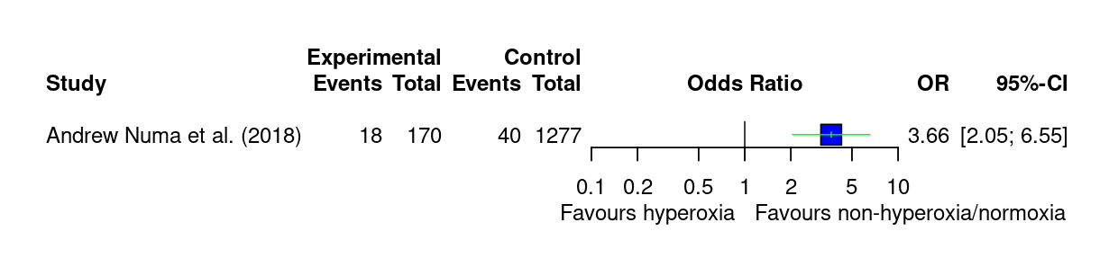
Figure S13 Forest plot demonstrating the impact of hyperoxia, defined as >300, on mortality at longest follow-up compared to normoxia/non-hyperoxia control groups
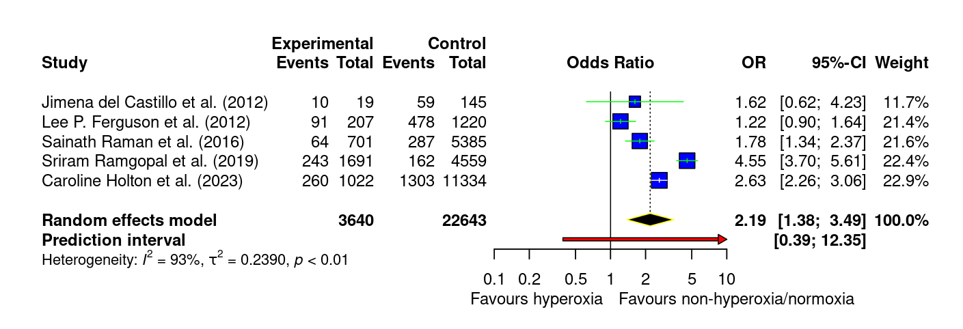
Figure S14 Forest plot demonstrating the impact of hyperoxia on mortality at longest follow-up compared to normoxia/non-hyperoxia control groups in patients with cardiac arrest
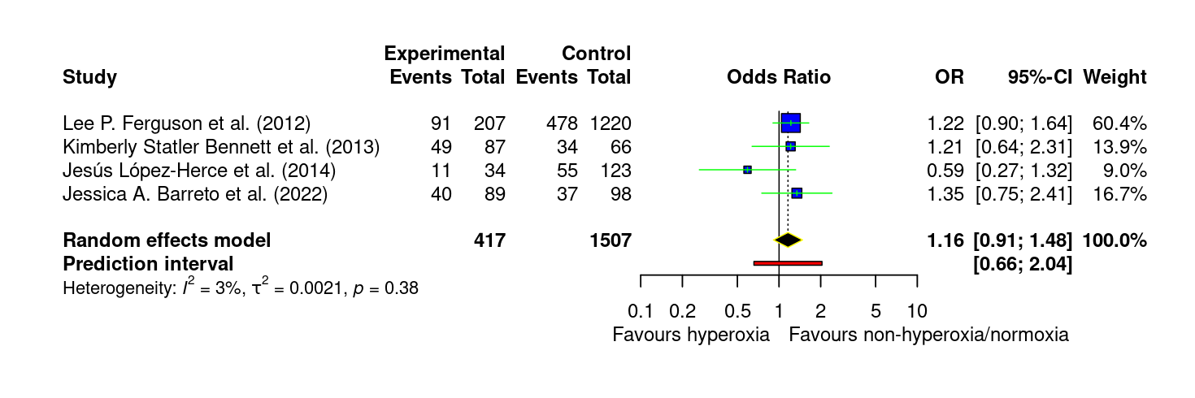
Figure S15 Forest plot demonstrating the impact of hyperoxia on mortality at longest follow-up compared to normoxia/non-hyperoxia control groups in patients with ECMO
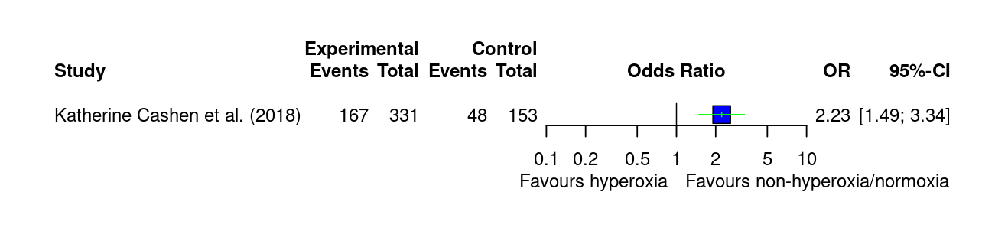
Figure S16 Forest plot demonstrating the impact of hyperoxia on mortality at longest follow-up compared to normoxia/non-hyperoxia control groups in general PICU patients
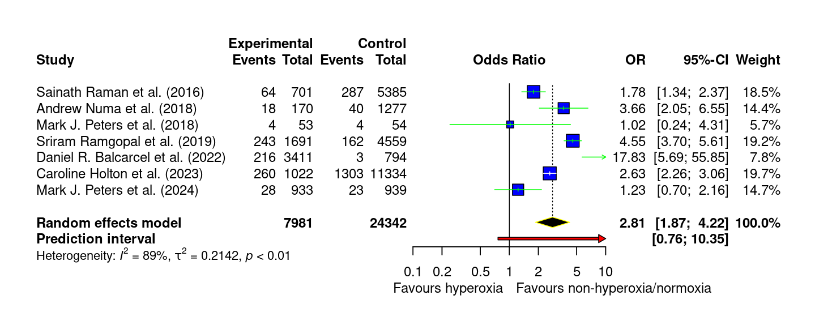
Table S1 The remaining secondary outcomes that had insufficient data (<3 studies) to be represented as forest plots
Outcome | Study | Hyperoxia | Non-hyperoxia/Normoxia | Odds ratio | P-value
Incidence of IMV | Peters et al. (2018) | 47/53 (88.7%) | 47/54 (87.0%) | N/A | N/A
Duration of IMV | Peters et al. (2018); median [IQR] | 3 days [2-6] | 3 days [2-6] | N/A | 1.0
 | Peters et al. (2024); median [IQR] | 73.2 hours [69.0-79.8] | 69.6 hours [66.1-75.2] | N/A | 0.03
Hospital length of stay (days) | Bennett et al. (2013); median [IQR] | 9 [1-29] | 7 [3-17] | N/A | 0.53
 | Cashen et al. (2018); median [IQR] | 33.2 [13.4-67.5] | 39.1 [19.7-64.8] | N/A | 0.130
 | Peters et al. (2024); median [IQR] | Survivors: 8 days [5-17]  Non-survivors: 13 days [6-49] | Survivors: 8 days [5-15]  Non-survivors: 17 days [5-33] | Survivors: 0.51 (0.49-0.54)  Non-survivors:  0.52 (0.38-0.66) | Survivors: 0.29  Non-survivors:  0.75
Long-term functional score | Cashen et al.ª (2018) | - Good: 44 (26.8%)  - Mildly abnormal: 71 (43.3%)  - Moderately abnormal: 43 (26.2%)  - Severely abnormal: 6 (3.7%)  - Very severely abnormal: 0 (0.0%) | - Good: 40 (38.1%)  - Mildly abnormal: 35 (33.3%)  - Moderately abnormal: 22 (21.0%)  - Severely abnormal: 7 (6.7%)  - Very severely abnormal: 1 (1.0%) | N/A | 0.296
 | SJ Tang et al. (2024) | 19/32 (59%)^{b} | 32/66 (48%)^{b} | N/A | 0.3898
 |  | 17/32 (53%)^{c} | 32/66 (48%)^{c} | N/A | 0.8297
ª The long-term functional score was calculated using the Functional Status Scale (FSS);
^{b} Unfavourable outcome (Modified Rankin Scale, mRS 3-6);
^{c} Unfavourable outcome (Glasgow Outcome Scale – Extended, GOS-E 1-4)
Table S2 Excluded studies and their reasons for exclusion
Author (Year) | Reason for exclusion
Michaud et al. (1992) [1] | Wrong intervention
Narotam et al. (2006) [2] | Wrong intervention
Ramaiah et al. (2013) [3] | Not population of interest (patients not admitted to PICU)
Guerra-Wallace et al. (2013) [4] | No comparator group
Saptharishi et al. (2014) [5] | No full-text available (Conference abstract)
Testa et al. (2014) [6] | No intervention group (no hyperoxia)
Van Zellem et al. (2015) [7] | No comparator group
Akyıldız et al. (2018) [8] | No comparator group (same oxygenation levels were used)
Kraft et al. (2018) [9] | Not population of interest (patients are not <18 years old)
Pelletier et al. (2020) [10] | Not population of interest (patients are 21 years and under)
Friedman et al. (2020) [11] | No comparator group
Lilien et al. (2023) [12] | No comparator group
Jones et al. (2024) [13] | Not study type of interest (post-hoc analysis)
Bachman et al. (2024) [14] | No comparator group + extractable data was unavailable

Table S3 GRADE summary of findings
Question: Hyperoxia compared to Non-hyperoxia/normoxia for PICU patients
Setting: PICU
Certainty assessment |  |  |  |  |  |  | № of patients |  | Effect |  | Certainty | Importance
№ of studies | Study design | Risk of bias | Inconsistency | Indirectness | Imprecision | Other considerations | Hyperoxia | Non-hyperoxia/normoxia | Relative  (95% CI) | Absolute  (95% CI) | Certainty | Importance
Mortality at the longest follow-up (assessed with: Death at longest reported follow-up)
12 | non-randomised studies | serious^{a,b} | serious^{c} | not serious | not serious | none | 8729/34.731 (25133.2%) | 26.002/34.731 (74.9%) | OR 2.00  (1.42 to 2.82) | 108 more per 1,000  (from 60 more to 145 more) | ⨁◯◯◯  Very low^{a,b,c} | CRITICAL
Incidence of AKI (assessed with: Acute kidney injury during PICU/hospital stay)
3 | non-randomised studies | serious^{d,e} | not serious | not serious | serious^{f} | none | 1471/3783 (38.9%) | 2312/3783 (61.1%) | OR 1.09  (0.80 to 1.48) | 20 more per 1,000  (from 54 fewer to 88 more) | ⨁◯◯◯  Very low^{d,e,f} | CRITICAL
Incidence of organ support (assessed with: New initiation of organ support during admission)
4 | non-randomised studies | serious^{g} | serious^{h} | not serious | serious^{i} | strong association | 2074/8017 (25.9%) | 5943/8017 (74.1%) | OR 3.49  (1.53 to 7.96) | 168 more per 1,000  (from 73 more to 217 more) | ⨁◯◯◯  Very low^{g,h,i} | CRITICAL
Incidence of poor neurological outcomes
3 | non-randomised studies | serious^{j} | not serious | not serious | serious^{k} | none | 181/401 (45.1%) | 220/401 (54.9%) | OR 0.75  (0.49 to 1.14) | 72 fewer per 1,000  (from 175 fewer to 32 more) | ⨁◯◯◯  Very low^{j,k} | CRITICAL
Duration of organ support (assessed with: Days of organ support during PICU/hospital stay)
3 | randomised trials | serious^{l} | serious^{m} | not serious | serious^{n} | none | 1317 | 1146 | - | MD 0.37 days lower  (1.17 lower to 0.43 higher) | ⨁◯◯◯  Very low^{l,m,n} | CRITICAL
PICU length of stay
4 | non-randomised studies | seriousº | serious^{p} | not serious | serious^{q} | none | 560 | 371 | - | MD 0.54 days lower  (3.2 lower to 2.11 higher) | ⨁◯◯◯  Very low^{o,p,q} | CRITICAL
CI: confidence interval; MD: mean difference; OR: odds ratio

Explanations
a. Downgraded due to most studies being observational with confounding
b. Majority of the studies (10 out of 12) contributed to the primary outcome on mortality are non-randomised, the other two studies were RCTs
c. I² = 89.3% = substantial heterogeneity
d. Downgraded one level for risk of bias: most studies are observational with potential confounding
e. 2 of the 3 studies were observational, the last one is an RCT
f. Downgraded one level for imprecision: CI includes appreciable harm and benefit; total events small (n=303), OIS not met
g. Downgraded for risk of bias: all four studies observational with potential confounding; several retrospective.
h. Downgraded for inconsistency: substantial heterogeneity (I² = 81.2%).
i. Downgraded for imprecision: total events small; CI wide though excludes no effect.
j. Downgraded for risk of bias: observational design, possible confounding, some retrospective data.
k. Downgraded for imprecision: relatively small number of total events, wide CI.
l. Downgraded one level for risk of bias: one included study was observational and the RCTs had unclear risk in allocation concealment and/or blinding of outcome assessment, which could influence results.
m. Downgraded one level for inconsistency: substantial heterogeneity (I² = 83.3%, τ² = 0.3946, p = 0.0025) with variation in effect size and direction across studies.
n. Downgraded one level for imprecision: the 95% CI (-1.17 to 0.43 days) crosses the line of no effect and the prediction interval (-3.59 to 2.85) is wide, indicating uncertainty in both magnitude and direction of effect.
o. Downgraded for risk of bias: three of four studies are observational (retrospective) with potential confounding; limited adjustment.
p. Downgraded for inconsistency: moderate heterogeneity (I² 54.4%, τ² 3.65) with differing directions of effect across studies.
q. Downgraded for imprecision: pooled CI (−3.20 to 2.11 days) includes meaningful benefit and harm; prediction interval wide.

REFERENCES
1. Michaud LJ, Rivara FP, Grady MS, Reay DT, (1992) Predictors of survival and severity of disability after severe brain injury in children. Neurosurgery 31: 254-264
2. Narotam PK, Burjonrappa SC, Raynor SC, Rao M, Taylon C, (2006) Cerebral oxygenation in major pediatric trauma: its relevance to trauma severity and outcome. J Pediatr Surg 41: 505-513
3. Ramaiah VK, Sharma D, Ma L, Prathep S, Hoffman NG, Vavilala MS, (2013) Admission oxygenation and ventilation parameters associated with discharge survival in severe pediatric traumatic brain injury. Childs Nerv Syst 29: 629-634
4. Guerra-Wallace MM, Casey FL, 3rd, Bell MJ, Fink EL, Hickey RW, (2013) Hyperoxia and hypoxia in children resuscitated from cardiac arrest. Pediatr Crit Care Med 14: e143-148
5. Saptharishi LG, Karthik N, Jayashree M, Singhi S, Bansal A, (2014) ABSTRACT 48: IDEAL ARTERIAL OXYGEN LEVELS IN MECHANICALLY VENTILATED CRITICALLY ILL CHILDREN DURING THE ACUTE PHASE OF ILLNESS. Pediatric Critical Care Medicine 15
6. Testa G, Iodice F, Ricci Z, Vitale V, De Razza F, Haiberger R, Iacoella C, Conti G, Cogo P, (2014) Comparative evaluation of high-flow nasal cannula and conventional oxygen therapy in paediatric cardiac surgical patients: a randomized controlled trial. Interact Cardiovasc Thorac Surg 19: 456-461
7. van Zellem L, de Jonge R, van Rosmalen J, Reiss I, Tibboel D, Buysse C, (2015) High cumulative oxygen levels are associated with improved survival of children treated with mild therapeutic hypothermia after cardiac arrest. Resuscitation 90: 150-157
8. Akyıldız B, Öztürk S, Ülgen-Tekerek N, Doğanay S, Görkem SB, (2018) Comparison between high-flow nasal oxygen cannula and conventional oxygen therapy after extubation in pediatric intensive care unit. Turk J Pediatr 60: 126-133
9. Kraft F, Andel H, Gamper J, Markstaller K, Ullrich R, Klein KU, (2018) Incidence of hyperoxia and related in-hospital mortality in critically ill patients: a retrospective data analysis. Acta Anaesthesiologica Scandinavica 62: 347-356
10. Pelletier JH, Ramgopal S, Au AK, Clark RS, Horvat CM, (2020) Maximum Pao2 in the first 72 hours of intensive care is associated with risk-adjusted mortality in pediatric patients undergoing mechanical ventilation. Critical Care Explorations 2: e0186
11. Friedman ML, Barbaro RP, Bembea MM, Bridges BC, Chima RS, Kilbaugh TJ, Pandiyan P, Potera RM, Rosner EA, Sandhu HS, Slaven JE, Tarquinio KM, Cheifetz IM, (2020) Mechanical Ventilation in Children on Venovenous ECMO. Respir Care 65: 271-280
12. Lilien TA, de Sonnaville ESV, van Woensel JBM, Bem RA, (2023) The Local and Systemic Exposure to Oxygen in Children With Severe Bronchiolitis on Invasive Mechanical Ventilation: A Retrospective Cohort Study. Pediatr Crit Care Med 24: e115-e120
13. Jones GAL, Wiegand M, Ray S, Gould DW, Agbeko R, Giallongo E, Charles WN, Orzol M, O'Neill L, Lampro L, Lillie J, Pappachan J, Ramnarayan P, Harrison DA, Mouncey PR, Peters MJ, (2024) Ethnicity and Observed Oxygen Saturations, Fraction of Inspired Oxygen, and Clinical Outcomes: A Post-Hoc Analysis of the Oxy-PICU Trial of Conservative Oxygenation. Pediatr Crit Care Med 25: 912-917
14. Bachman TE, Newth CJL, Ross PA, Patel N, Bhalla A, (2024) Association of extreme hyperoxemic events and mortality in pediatric critical care: an observational cohort study. Front Pediatr 12: 1429882

