Supplementary appendix

Title: A decision support tool reduces blood gas testing in a paediatric intensive care unit; a before and after study

Table of contents
Supplementary Figure 1. Absolute number of blood gas tests per bed day by week over the study period for the whole cohort 2
Supplementary Table 1. Multivariable regression analysis of blood gas tests per admission and the ratio between periods in subgroups 3
Supplementary Figure 2. Number of blood gas tests per bed day by week over the study period for general intensive care admissions 4
Supplementary Figure 3. Absolute number of blood gas tests by week over the study period for general intensive care admissions 5
Supplementary Figure 4. Number of blood gas tests per bed days by week over the study period for cardiac intensive care admissions 6
Supplementary Figure 5. Absolute number of blood gas tests by week over the study period for cardiac intensive care admissions 7
Supplementary appendix – R packages used for the analysis 7

Supplementary Figure 1. Absolute number of blood gas tests per bed day by week over the study period for the whole cohort
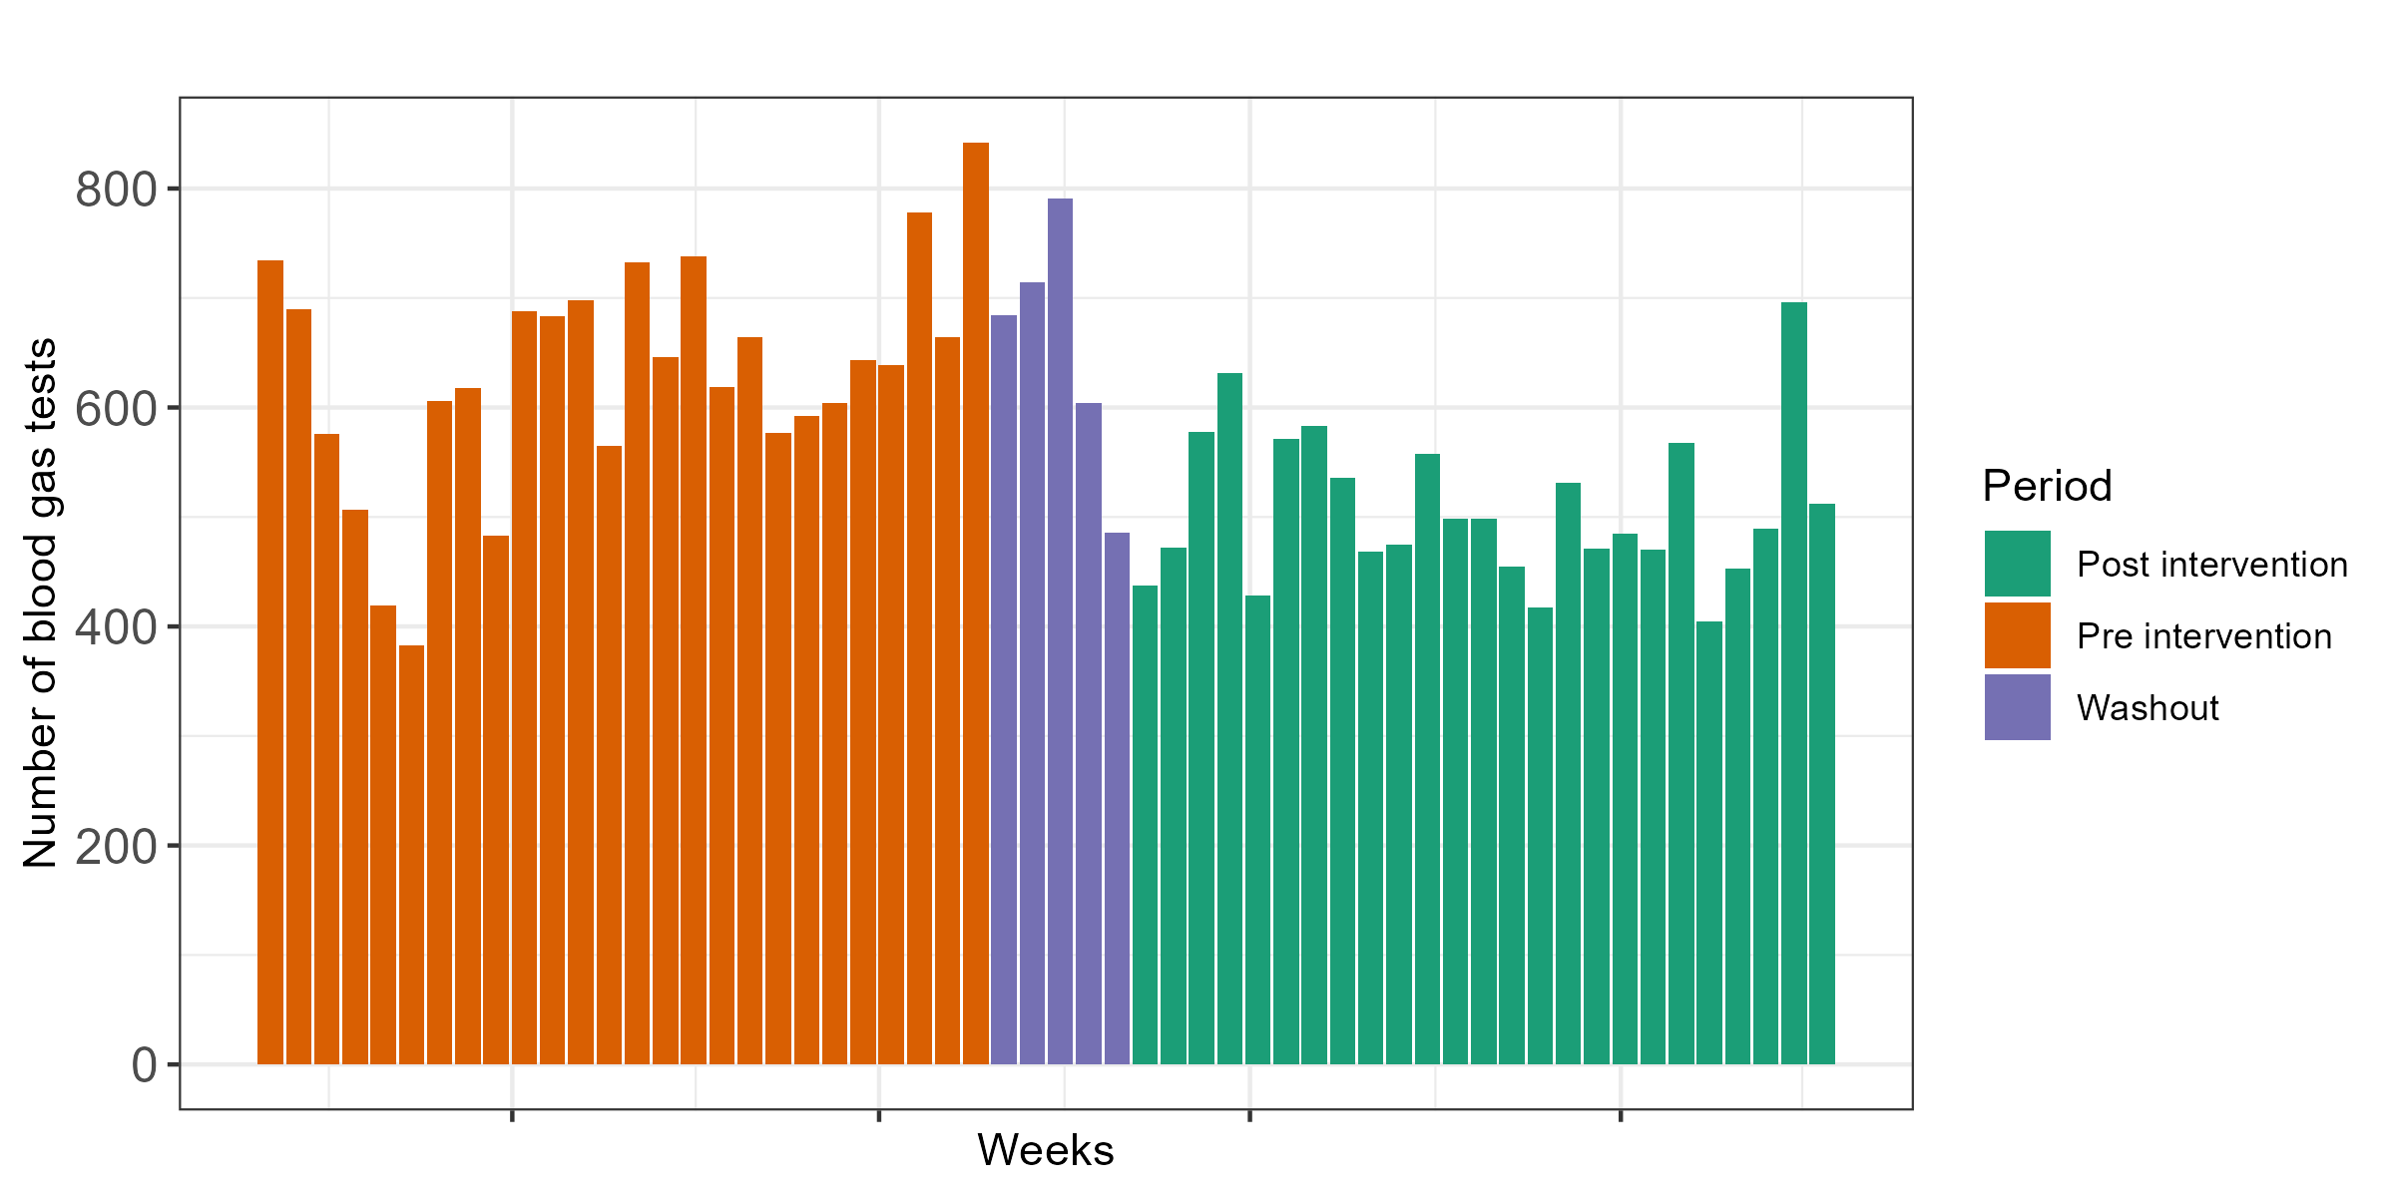

Supplementary Table 1. Multivariable regression analysis of blood gas tests per admission and the ratio between periods in subgroups
Variable | Number of admissions | Tests per admission  Pre intervention | Tests per admission  Post intervention | Ratio ª (95%CI) | P value
General intensive care | 860 | 10.9 | 7.8 | 1.4 (1.1 – 1.8) | <0.0001
Cardiac intensive care | 721 | 27.3 | 16.1 | 1.7 (1.5 – 2.0) | <0.0001
Liver transplant | 16 | 51.9 | 35.2 | 1.5 (1.1 – 2.0) | <0.0001
ECMO | 51 | 148.3 | 86.7 | 1.7 (1.3 – 2.3) | 0.0003
ª estimate is the ratio of the pre and post intervention rates using a quasi-Poisson regression accounting for bed days and study period;
ECMO Extracorporeal Membrane oxygenation; CI confidence interval

Supplementary Figure 2. Number of blood gas tests per bed day by week over the study period for general intensive care admissions
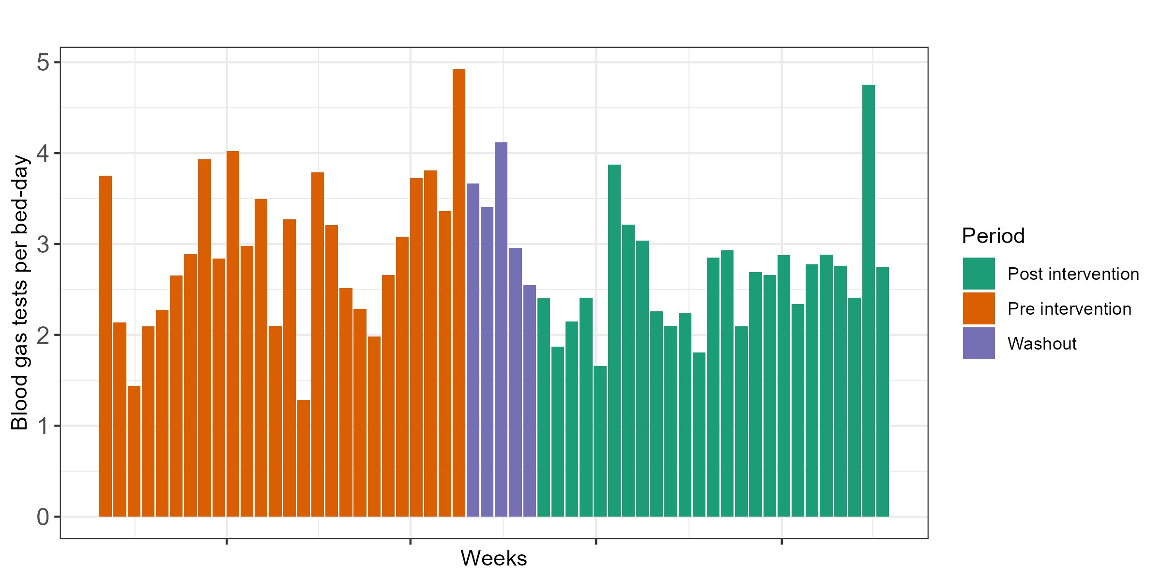
Blood gas tests per bed-day is the cumulative number of blood tests divided by the number of admission bed days

Supplementary Figure 3. Absolute number of blood gas tests by week over the study period for general intensive care admissions
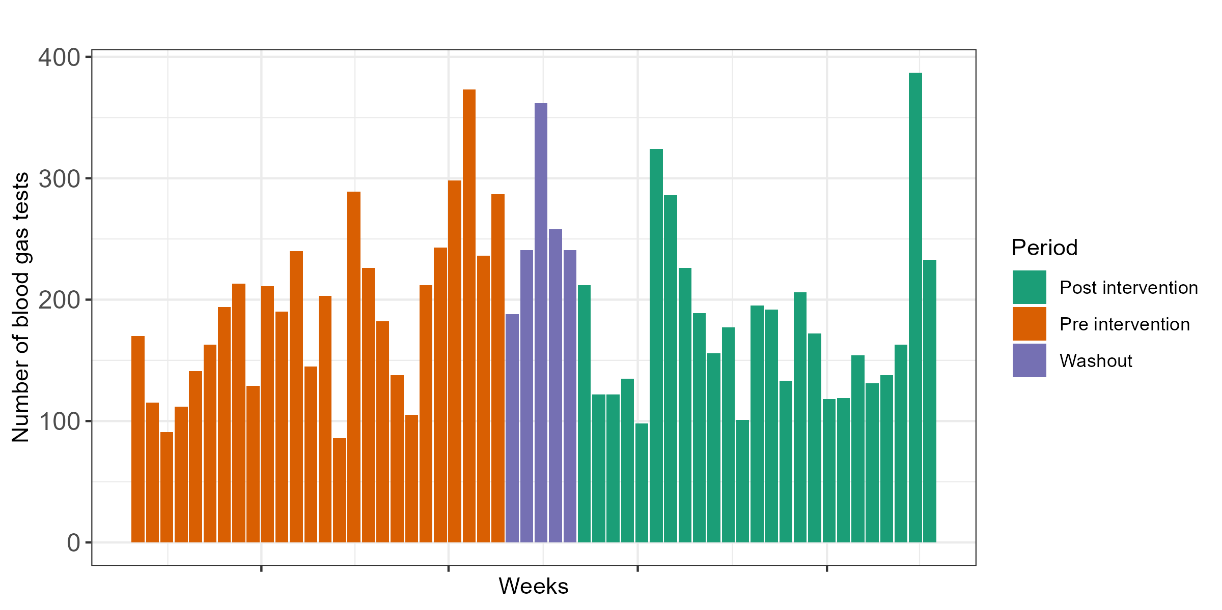

Supplementary Figure 4. Number of blood gas tests per bed days by week over the study period for cardiac intensive care admissions
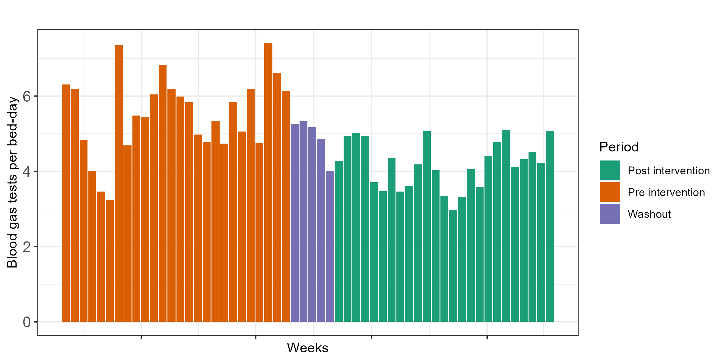
Blood gas tests per bed-day is the cumulative number of blood tests divided by the number of admission bed days

Supplementary Figure 5. Absolute number of blood gas tests by week over the study period for cardiac intensive care admissions
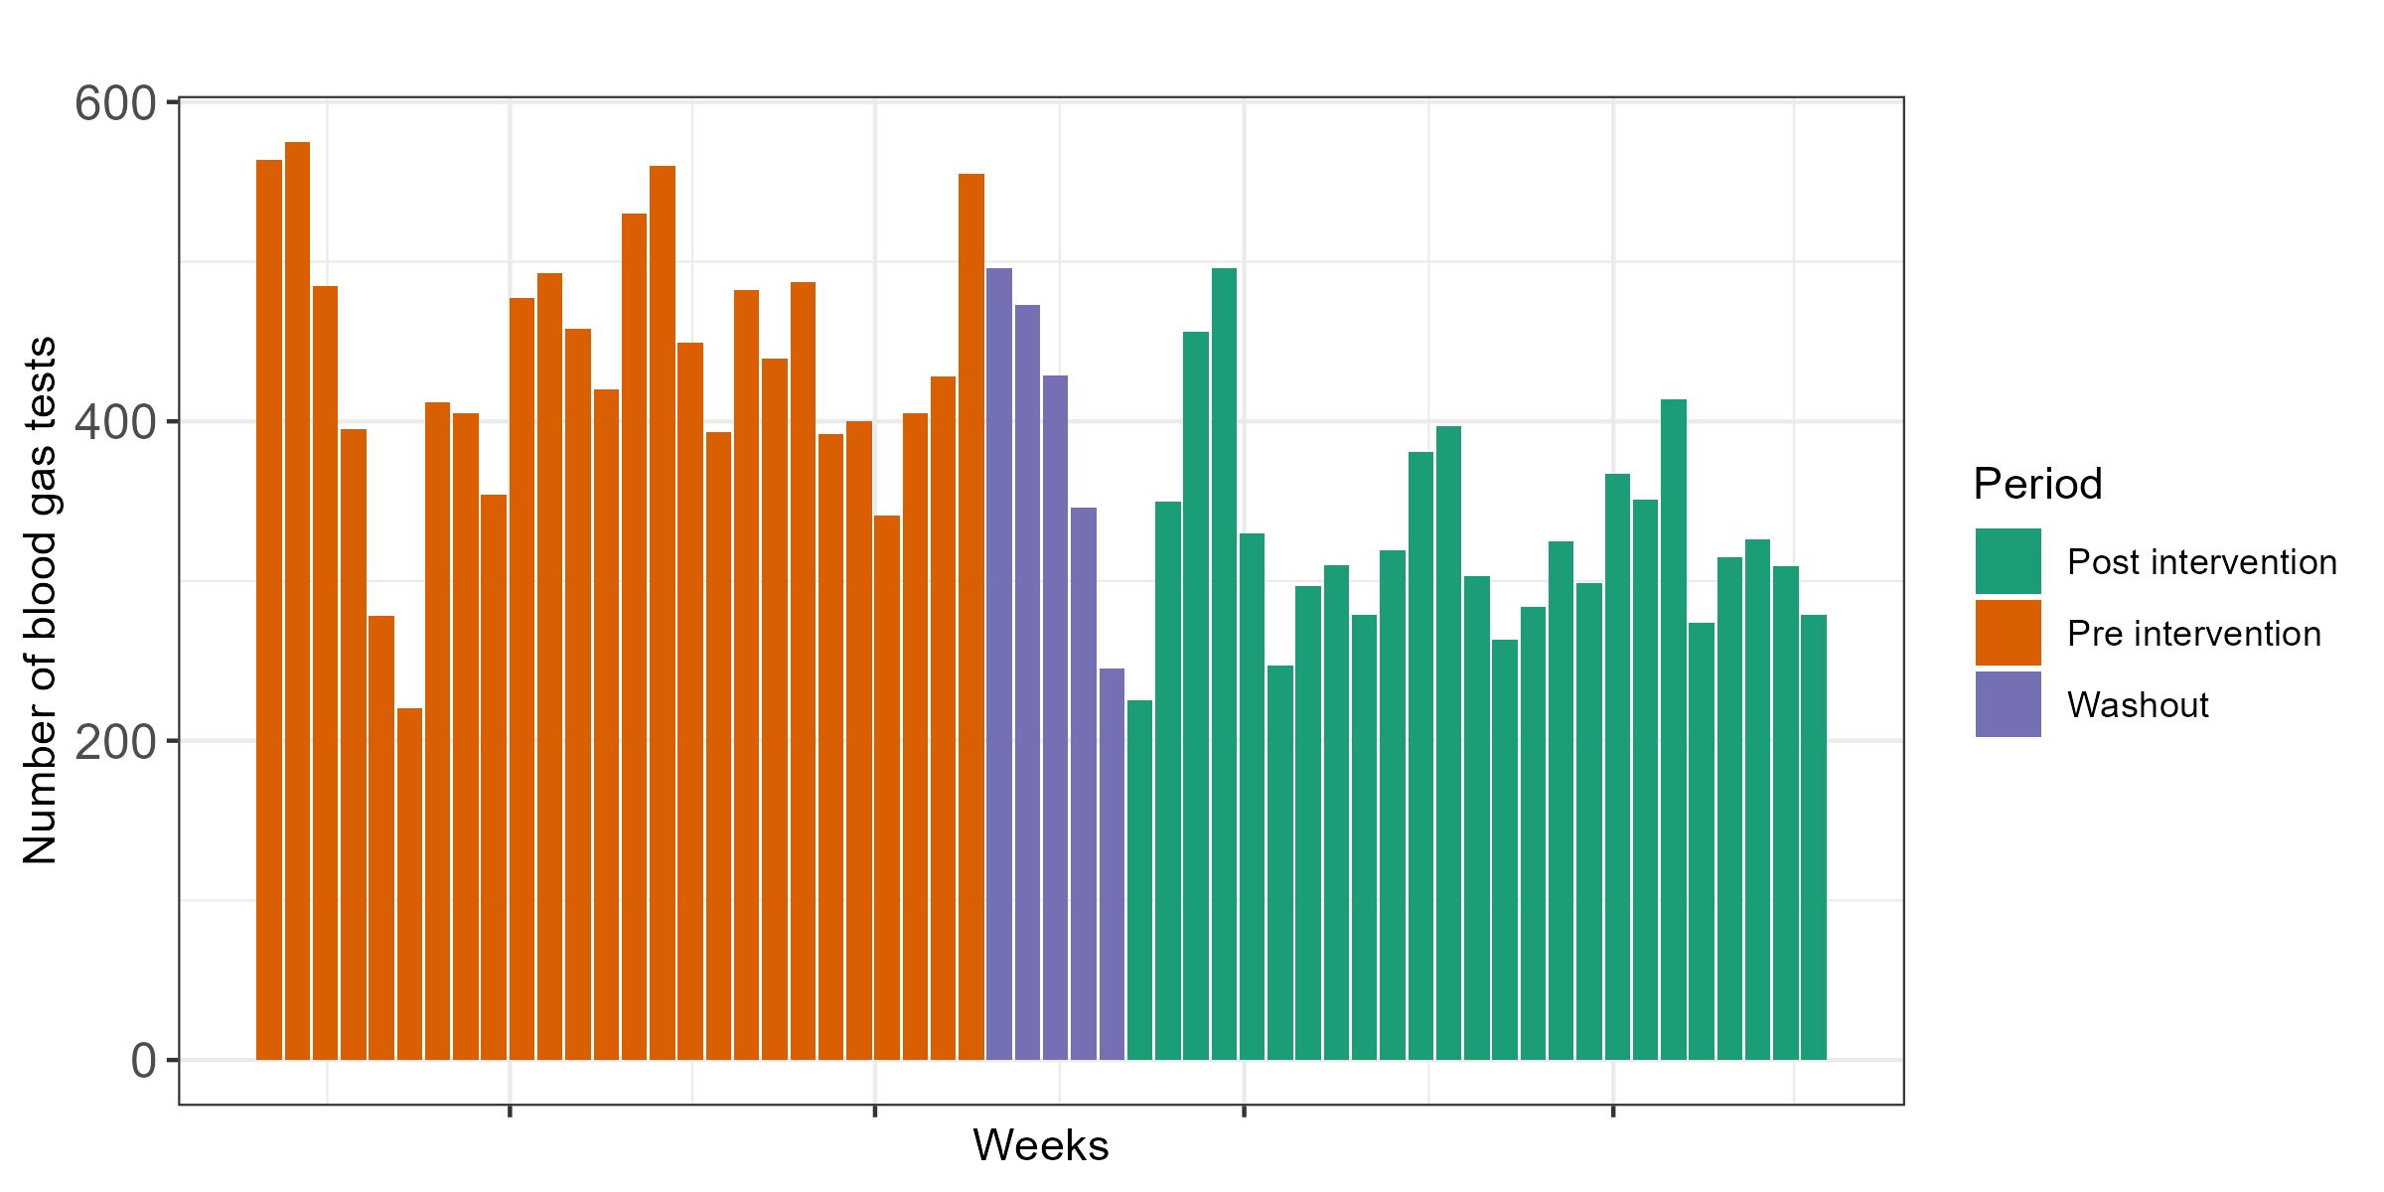

Supplementary appendix – R packages used for the analysis

Tidyverse
TableOne
Lubridate

