Supplementary Information

Effect of ultrasound-guided recruitment maneuver on atelectasis: a systematic review and meta-analysis of randomized controlled trial

This supplemental information has been provided by the authors to give readers additional information about their work.
Supplementary 1. PRISMA 2020 Checklist
Section and Topic | Item # | Checklist item | Location where item is reported
TITLE
Title | 1 | Identify the report as a systematic review. | 1
ABSTRACT
Abstract | 2 | See the PRISMA 2020 for Abstracts checklist. | 2
INTRODUCTION
Rationale | 3 | Describe the rationale for the review in the context of existing knowledge. | 3
Objectives | 4 | Provide an explicit statement of the objective(s) or question(s) the review addresses. | 3
METHODS
Eligibility criteria | 5 | Specify the inclusion and exclusion criteria for the review and how studies were grouped for the syntheses. | 4
Information sources | 6 | Specify all databases, registers, websites, organisations, reference lists and other sources searched or consulted to identify studies. Specify the date when each source was last searched or consulted. | 4
Search strategy | 7 | Present the full search strategies for all databases, registers and websites, including any filters and limits used. | 4, suppl.2
Selection process | 8 | Specify the methods used to decide whether a study met the inclusion criteria of the review, including how many reviewers screened each record and each report retrieved, whether they worked independently, and if applicable, details of automation tools used in the process. | 5, Fig. 1
Data collection process | 9 | Specify the methods used to collect data from reports, including how many reviewers collected data from each report, whether they worked independently, any processes for obtaining or confirming data from study investigators, and if applicable, details of automation tools used in the process. | 5
Data items | 10a | List and define all outcomes for which data were sought. Specify whether all results that were compatible with each outcome domain in each study were sought (e.g. for all measures, time points, analyses), and if not, the methods used to decide which results to collect. | 5
Data items | 10b | List and define all other variables for which data were sought (e.g. participant and intervention characteristics, funding sources). Describe any assumptions made about any missing or unclear information. | 5
Study risk of bias assessment | 11 | Specify the methods used to assess risk of bias in the included studies, including details of the tool(s) used, how many reviewers assessed each study and whether they worked independently, and if applicable, details of automation tools used in the process. | 5
Effect measures | 12 | Specify for each outcome the effect measure(s) (e.g. risk ratio, mean difference) used in the synthesis or presentation of results. | 6
Synthesis methods | 13a | Describe the processes used to decide which studies were eligible for each synthesis (e.g. tabulating the study intervention characteristics and comparing against the planned groups for each synthesis (item #5)). | 6
Synthesis methods | 13b | Describe any methods required to prepare the data for presentation or synthesis, such as handling of missing summary statistics, or data conversions. | 6
Synthesis methods | 13c | Describe any methods used to tabulate or visually display results of individual studies and syntheses. | 6
Synthesis methods | 13d | Describe any methods used to synthesize results and provide a rationale for the choice(s). If meta-analysis was performed, describe the model(s), method(s) to identify the presence and extent of statistical heterogeneity, and software package(s) used. | 6
Synthesis methods | 13e | Describe any methods used to explore possible causes of heterogeneity among study results (e.g. subgroup analysis, meta-regression). | 6
Synthesis methods | 13f | Describe any sensitivity analyses conducted to assess robustness of the synthesized results. | 6
Reporting bias assessment | 14 | Describe any methods used to assess risk of bias due to missing results in a synthesis (arising from reporting biases). | 5
Certainty assessment | 15 | Describe any methods used to assess certainty (or confidence) in the body of evidence for an outcome. | 5
RESULTS
Study selection | 16a | Describe the results of the search and selection process, from the number of records identified in the search to the number of studies included in the review, ideally using a flow diagram. | 7
Study selection | 16b | Cite studies that might appear to meet the inclusion criteria, but which were excluded, and explain why they were excluded. | 7
Study characteristics | 17 | Cite each included study and present its characteristics. | 7
Risk of bias in studies | 18 | Present assessments of risk of bias for each included study. | 7, suppl.3
Results of individual studies | 19 | For all outcomes, present, for each study: (a) summary statistics for each group (where appropriate) and (b) an effect estimate and its precision (e.g. confidence/credible interval), ideally using structured tables or plots. | 7-9, Table 1
Results of syntheses | 20a | For each synthesis, briefly summarise the characteristics and risk of bias among contributing studies. | 7
Results of syntheses | 20b | Present results of all statistical syntheses conducted. If meta-analysis was done, present for each the summary estimate and its precision (e.g. confidence/credible interval) and measures of statistical heterogeneity. If comparing groups, describe the direction of the effect. | 6, Figures. 2-5, suppl.5
Results of syntheses | 20c | Present results of all investigations of possible causes of heterogeneity among study results. | 8-9
Results of syntheses | 20d | Present results of all sensitivity analyses conducted to assess the robustness of the synthesized results. | 8-9
Reporting biases | 21 | Present assessments of risk of bias due to missing results (arising from reporting biases) for each synthesis assessed. | 7
Certainty of evidence | 22 | Present assessments of certainty (or confidence) in the body of evidence for each outcome assessed. | 7, suppl.4
DISCUSSION
Discussion | 23a | Provide a general interpretation of the results in the context of other evidence. | 10
Discussion | 23b | Discuss any limitations of the evidence included in the review. | 12
Discussion | 23c | Discuss any limitations of the review processes used. | 12
Discussion | 23d | Discuss implications of the results for practice, policy, and future research. | 10-12
OTHER INFORMATION
Registration and protocol | 24a | Provide registration information for the review, including register name and registration number, or state that the review was not registered. | 4
Registration and protocol | 24b | Indicate where the review protocol can be accessed, or state that a protocol was not prepared. | 4
Registration and protocol | 24c | Describe and explain any amendments to information provided at registration or in the protocol. | NA
Support | 25 | Describe sources of financial or non-financial support for the review, and the role of the funders or sponsors in the review. | Title page
Competing interests | 26 | Declare any competing interests of review authors. | Separate file
Availability of data, code and other materials | 27 | Report which of the following are publicly available and where they can be found: template data collection forms; data extracted from included studies; data used for all analyses; analytic code; any other materials used in the review. | NA

From: Page MJ, McKenzie JE, Bossuyt PM, Boutron I, Hoffmann TC, Mulrow CD, et al. The PRISMA 2020 statement: an updated guideline for reporting systematic reviews. BMJ 2021;372:n71. doi: 10.1136/bmj.n71
For more information, visit: http://www.prisma-statement.org/
Supplementary Material 2. Search strategy

Pubmed: 470
1 Pulmonary Atelectasis[MeSH Terms])
2 Lung Collapse[Title/Abstract]
3 Atelectasis[Title/Abstract]
4 Congestive Pulmonary Atelectasis[Title/Abstract]
5 Congestive Atelectasis[Title/Abstract]
6 Resorption Pulmonary Atelectasis[Title/Abstract]
7 Resorption Atelectasis[Title/Abstract]
8 Contraction Pulmonary Atelectasis[Title/Abstract]
9 Postoperative Pulmonary Atelectasis[Title/Abstract]
10 Compression Pulmonary Atelectasis[Title/Abstract]
11 Compression Atelectasis[Title/Abstract]
12 1 OR 2 OR 3 OR 4 OR 5 OR 6 OR 7 OR 8 OR 9 OR 10 OR 11
13 Lung Recruitment Manoeuvre[Title/Abstract]
14 Recruitment Manoeuvre[Title/Abstract]
15 Lung Recruitment[Title/Abstract]
16 Alveolar Recruitment[Title/Abstract]
17 Lung Recruitment Maneuver[Title/Abstract]
18 Recruitment Maneuver[Title/Abstract]
19 Pulmonary Rehabilitation[Title/Abstract]
20 Pulmonary Recruitment[Title/Abstract]
21 Lung Reexpansion[Title/Abstract]
22 Lung Recruitment Treatment[Title/Abstract]
23 Pulmonary Extension[Title/Abstract]
24 Pulmonary Recruitment Maneuver[Title/Abstract]
25 12 OR 13 OR 14 OR 15 OR 16 OR 17 OR 18 OR 19 OR 20 OR 21 OR 22 OR 23 OR 24
26 Ultrasonography[MeSH Terms]
27 Diagnostic Ultrasound[Title/Abstract]
28 Ultrasound Imaging[Title/Abstract]
29 Echotomography[Title/Abstract]
30 Ultrasonic Imaging[Title/Abstract]
31 Medical Sonography[Title/Abstract]
32 Ultrasonographic Imaging[Title/Abstract]
33 Echography[Title/Abstract]
34 Ultrasonic Diagnosis[Title/Abstract]
35 Computer Echotomography[Title/Abstract]
36 Ultrasonic Tomography[Title/Abstract]
37 26 OR 27 OR 28 OR 29 OR 30 OR 31 OR 32 OR 33 OR 34 OR 35 OR 36
38 25 AND 37

Embase: 203
#1 'pulmonary atelectasis'/exp OR 'lung collapse':ti,ab,kw OR 'atelectasis':ti,ab,kw OR 'congestive pulmonary atelectasis':ti,ab,kw OR 'congestive atelectasis':ti,ab,kw OR 'resorption pulmonary atelectasis':ti,ab,kw OR 'resorption atelectasis':ti,ab,kw OR 'contraction pulmonary atelectasis':ti,ab,kw OR 'contraction atelectasis':ti,ab,kw
#2 'lung recruitment manoeuvre':ti,ab,kw OR 'recruitment manoeuvre':ti,ab,kw OR 'lung recruitment':ti,ab,kw OR 'alveolar recruitment':ti,ab,kw OR 'lung recruitment maneuver':ti,ab,kw OR 'recruitment maneuver':ti,ab,kw OR 'pulmonary rehabilitation':ti,ab,kw OR 'pulmonary recruitment':ti,ab,kw OR 'lung reexpansion':ti,ab,kw OR 'lung recruitment treatment':ti,ab,kw OR 'pulmonary extension':ti,ab,kw OR 'pulmonary recruitment maneuver':ti,ab,kw
#3 #1 OR #2
#4 'ultrasonography'/exp OR 'diagnostic ultrasound':ti,ab,kw OR 'ultrasound imaging':ti,ab,kw OR 'echotomography':ti,ab,kw OR 'ultrasonic imaging':ti,ab,kw OR 'medical sonography':ti,ab,kw OR 'ultrasonographic imaging':ti,ab,kw OR 'echography':ti,ab,kw OR 'ultrasonic diagnosis':ti,ab,kw OR 'computer echotomography':ti,ab,kw OR 'ultrasonic tomography':ti,ab,kw
#5 'crossover procedure':de OR 'double-blind procedure':de OR 'randomized controlled trial':de OR 'single-blind procedure':de OR random*:de,ab,ti OR factorial*:de,ab,ti OR crossover*:de,ab,ti OR ((cross NEXT/1 over*):de,ab,ti) OR placebo*:de,ab,ti OR ((doubl* NEAR/1 blind*):de,ab,ti) OR ((singl* NEAR/1 blind*):de,ab,ti) OR assign*:de,ab,ti OR allocat*:de,ab,ti OR volunteer*:de,ab,ti
#6 #3 AND #4 AND #5

Web of Science 327
#1 TS=((Pulmonary Atelectasis) OR (Lung Collapse) OR (Atelectasis) OR (Congestive Pulmonary Atelectasis) OR (Congestive Atelectasis) OR (Resorption Pulmonary Atelectasis) OR (Resorption Atelectasis) OR (Contraction Pulmonary Atelectasis) OR (Postoperative Pulmonary Atelectasis) OR (Compression Pulmonary Atelectasis) OR (Compression Atelectasis))
#2 TS=((Lung Recruitment Manoeuvre) OR (Recruitment Manoeuvre) OR (Lung Recruitment) OR (Alveolar Recruitment) OR (Lung Recruitment Maneuver) OR (Recruitment Maneuver) OR (Pulmonary Rehabilitation) OR (Pulmonary Recruitment) OR (Lung Reexpansion) OR (Lung Reexpansion) OR (Lung Recruitment Treatment) OR (Pulmonary Extension) OR (Pulmonary Recruitment Maneuver))
#3 #1 OR #2
#4 TS=((Ultrasonography) OR (Diagnostic Ultrasound) OR (Ultrasound Imaging) OR (Echotomography) OR (Ultrasonic Imaging) OR (Medical Sonography) OR (Ultrasonographic Imaging) OR (Echography) OR (Ultrasonic Diagnosis) OR (Computer Echotomography) OR (Ultrasonic Tomography))
#5 #3 AND #4

Cochrane Central Register of Controlled Trials (CENTRAL): 239
#1 MeSH descriptor: [Pulmonary Atelectasis] explode all trees
#2 (lung collapse):ti,ab,kw OR (atelectasis):ti,ab,kw OR (congestive pulmonary atelectasis):ti,ab,kw OR (congestive atelectasis):ti,ab,kw OR (resorption pulmonary atelectasis):ti,ab,kw OR (resorption atelectasis):ti,ab,kw OR (contraction pulmonary atelectasis):ti,ab,kw OR (postoperative pulmonary atelectasis):ti,ab,kw OR (compression pulmonary atelectasis):ti,ab,kw OR (compression atelectasis):ti,ab,kw
(Word variations have been searched)
#3 (lung recruitment manoeuvre):ti,ab,kw OR (recruitment manoeuvre):ti,ab,kw OR (lung recruitment):ti,ab,kw OR (alveolar recruitment):ti,ab,kw OR (lung recruitment maneuver):ti,ab,kw OR (recruitment maneuver):ti,ab,kw OR (pulmonary rehabilitation):ti,ab,kw OR (pulmonary recruitment):ti,ab,kw OR (lung reexpansion):ti,ab,kw OR (lung recruitment treatment):ti,ab,kw OR (pulmonary extension):ti,ab,kw OR (pulmonary recruitment maneuver):ti,ab,kw
(Word variations have been searched)
#4 MeSH descriptor: [Ultrasonography] explode all trees
#5 (diagnostic ultrasound):ti,ab,kw OR (ultrasound imaging):ti,ab,kw OR (echotomography):ti,ab,kw OR (ultrasonic imaging):ti,ab,kw OR (medical sonography):ti,ab,kw OR (ultrasonographic imaging):ti,ab,kw OR (echography):ti,ab,kw OR (ultrasonic diagnosis):ti,ab,kw OR (computer echotomography):ti,ab,kw OR (ultrasonic tomography):ti,ab,kw
(Word variations have been searched)
#6 (#1 or #2 or #3) and (#4 or #5)

Supplementary 3. Grading of recommendations assessment, development, and evaluation (GRADE) assessment
(a) Summary of finding
Outcomes | № of participants  (studies) | Certainty of the evidence  (GRADE) | Relative effect  (95% CI) | Anticipated absolute effects
 |  |  |  | Risk with Control | Risk difference with Intervention
Incidence of early postoperative atelectasis | 723  (10 RCTs) | ⨁⨁⨁⨁  High | RR 0.44  (0.34 to 0.57) | 465 per 1,000 | 224 fewer per 1,000  (from 273 fewer to 165 fewer)
Early postoperative LUS score | 1454  (9 RCTs) | ⨁⨁◯◯  Low^{ab} | - | The mean LUS score was 7.51 | MD 3.02 lower  (3.98 lower to 2.06 lower)
Incidence of atelectasis at the end of surgery | 513  (8 RCTs) | ⨁⨁◯◯  Low^{bc} | RR 0.99  (0.86 to 1.14) | 652 per 1,000 | 4 fewer per 1,000  (from 55 fewer to 48 fewer)
Incidence of postoperative hypoxemia | 692  (8 RCTs) | ⨁⨁⨁◯  Moderate^{d} | RR 0.32  (0.18 to 0.56) | 137 per 1,000 | 91 fewer per 1,000  (from 111 fewer to 58 fewer)
Postoperative oxygenation index | 618  (7 RCTs) | ⨁⨁⨁◯  Moderate^{b} | - | The mean oxygenation index was 0 | MD 45.23 higher  (26.54 higher to 63.92 higher)
Length of PACU stay | 467  (7 RCTs) | ⨁⨁◯◯  Low^{edf} | - | The mean length of PACU stay was 49.5 hours | MD 1.89 lower  (3.14 lower to 0.63 lower)
Length of hospital stay | 723  (10 RCTs) | ⨁⨁◯◯  Low^{eg} | - | The mean length of hospital stay was 9.4 days | MD 0.17 lower  (0.3 lower to 0.03 lower)
*The risk in the intervention group (and its 95% confidence interval) is based on the assumed risk in the comparison group and the relative effect of the intervention (and its 95% CI).
RCT: randomized controlled trial; CI: confidence interval; LUS: lung ultrasound; MD: mean difference; RR: risk ratio; PACU: post-anesthesia care unit.
GRADE Working Group grades of evidence
High certainty: we are very confident that the true effect lies close to that of the estimate of the effect.
Moderate certainty: we are moderately confident in the effect estimate: the true effect is likely to be close to the estimate of the effect, but there is a possibility that it is substantially different.
Low certainty: our confidence in the effect estimate is limited: the true effect may be substantially different from the estimate of the effect.
Very low certainty: we have very little confidence in the effect estimate: the true effect is likely to be substantially different from the estimate of effect.

(b) Evidence profile
Certainty assessment |  |  |  |  |  |  | № of patients |  | Effect |  | Certainty | Importance
№ of studies | Study design | Risk of bias | Inconsistency | Indirectness | Imprecision | Other considerations | Intervention | Control | Relative  (95% CI) | Absolute  (95% CI) | Certainty | Importance
Incidence of early postoperative atelectasis
10 | randomized trials | not serious | not serious | not serious | not serious | none | 64/327 (19.6%) | 184/396 (46.5%) | RR 0.44  (0.34 to 0.57) | 224 fewer per 1,000  (from 273 fewer to 165 fewer) | ⨁⨁⨁⨁  High | CRITICAL
Early postoperative LUS score
9 | randomized trials | seriousª | serious^{b} | not serious | not serious | none | 260 | 317 | - | MD 3.02 lower  (3.98 lower to 2.06 lower) | ⨁⨁◯◯  Low | CRITICAL
Incidence of atelectasis at the end of surgery
8 | randomized trials | not serious | serious^{b} | not serious | serious^{c} | none | 149/237 (62.9%) | 370/659 (56.1%) | RR 0.99  (0.86 to 1.14) | 4 fewer per 1,000  (from 55 fewer to 48 fewer) | ⨁⨁◯◯  Low | CRITICAL
Incidence of postoperative hypoxemia
8 | randomized trials | not serious | not serious | not serious | serious^{d} | none | 12/197 (6.1%) | 54/395 (13.7%) | RR 0.32  (0.18 to 0.56) | 91 fewer per 1,000  (from 111 fewer to 58 fewer) | ⨁⨁⨁◯  Moderate | IMPORTANT
Postoperative oxygenation index
7 | randomized trials | not serious | serious^{b} | not serious | not serious | none | 258 | 369 | - | MD 45.23 higher  (26.54 higher to 63.92 higher) | ⨁⨁⨁◯  Moderate | IMPORTANT
Length of PACU stay
7 | randomized trials | not serious | not serious | serious^{e} | serious^{d,f} | none | 199 | 268 | - | MD 1.89 lower  (3.14 lower to 0.63 lower) | ⨁⨁◯◯  Low | IMPORTANT
Length of hospital stay
10 | randomized trials | not serious | not serious | serious^{e} | serious^{g} | none | 327 | 396 | - | MD 0.17 lower  (0.3 lower to 0.03 lower) | ⨁⨁◯◯  Low | IMPORTANT
CI: confidence interval; LUS: lung ultrasound; MD: mean difference; RR: risk ratio; PACU: post-anesthesia care unit.

Explanations
- The majority of studies being rated as high or some concerns of risk-of-bias.
b. Significant heterogeneity detected by I² statistic.
c. The confidence interval includes both possible of benefit and harm (i.e. cross 0)
d. Inadequate number of event.
e. Length of stay outcomes can be affected by many factors outside of patient and health conditions.
f. The upper bound of 0.63 fewer hours of PACU stay is not considered patient important.
g. The mean difference of 0.17 fewer days is of questionable patient importance.

Supplementary Table 1 Summary of subgroup analyses for the primary outcome
Outcomes or Subgroup | Studies | Participants | Statistical Methods | Effect Estimate | I² | Test of subgroup differences (p-value)
Incidence of early postoperative atelectasis | 10 | 723 | Risk Ratio (Random, 95% CI) | 0.44 (0.34 to 0.57) | 27% | NA
1. Patient population: |  |  |  |  |  | 0.41
1.1 elderly | 5 | 370 | Risk Ratio (Random, 95% CI) | 0.38 (0.24~0.61) | 55% | <0.001
1.2 non-elderly | 5 | 353 | Risk Ratio (Random, 95% CI) | 0.48 (0.35~0.67) | 4% | <0.001
2. Type of comparisons |  |  |  |  |  | 0.83
2.1 no RM | 7 | 439 | Risk Ratio (Random, 95% CI) | 0.44 (0.33~0.57) | 22% | <0.001
2.2 Conventional RM | 4 | 314 | Risk Ratio (Random, 95% CI) | 0.47 (0.23~0.96) | 39% | 0.04
3. Type of study interventions |  |  |  |  |  | 0.77
3.1 Stepwise RM | 6 | 476 | Risk Ratio (Random, 95% CI) | 0.44 (0.33～0.58) | 9% | <0.001
3.2 Sustained RM | 4 | 247 | Risk Ratio (Random, 95% CI) | 0.48 (0.27～0.86) | 57% | 0.01
4. Timing of study interventions |  |  |  |  |  | 0.85
4.1 Single RM | 7 | 503 | Risk Ratio (Random, 95% CI) | 0.44 (0.34~0.58) | 20% | <0.001
4.2 Repeated RM | 3 | 220 | Risk Ratio (Random, 95% CI) | 0.40 (0.17~0.97) | 59% | 0.04
- Level of FiO₂ |  |  |  |  |  | 0.68
5.1 <0.6 | 7 | 503 | Risk Ratio (Random, 95% CI) | 0.45 (0.33~0.62) | 32% | <0.001
5.2 ≥0.6 | 3 | 220 | Risk Ratio (Random, 95% CI) | 0.39 (0.20~0.75) | 47% | 0.005

RM Recruitment maneuver; FiO₂ fraction of inspiratory oxygen

Supplementary Fig. 1 Forest plot for early postoperative lung ultrasound score between the intervention group and the control group. CI confidence interval, M-H Mantel-Haenszel

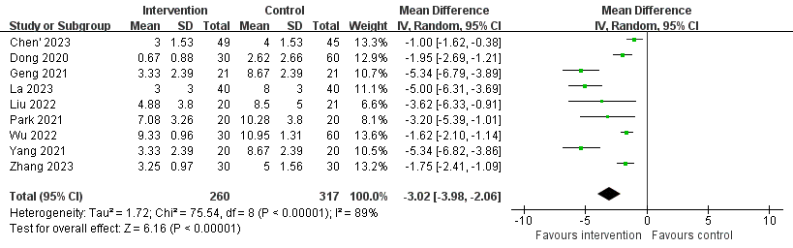

Supplementary Fig. 2 Forest plot for the incidence of atelectasis at the end of surgery between the ultrasound-guided recruitment maneuver and the control group. CI confidence interval, M-H Mantel-Haenszel

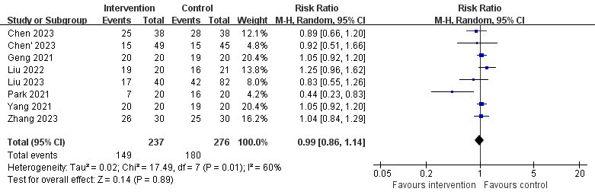

Supplementary Fig. 3 Forest plot for the incidence of postoperative hypoxemia between the ultrasound-guided recruitment maneuver and the control group. CI confidence interval, M-H Mantel-Haenszel

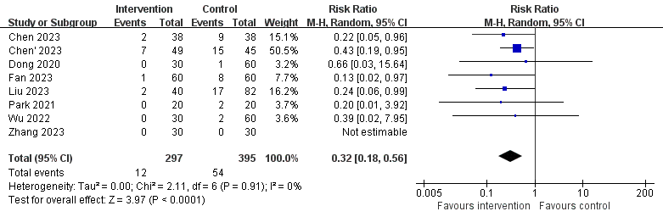

Supplementary Fig. 4 Forest plot for postoperative oxygenation index between the ultrasound-guided recruitment maneuver and the control group. CI confidence interval, M-H Mantel-Haenszel

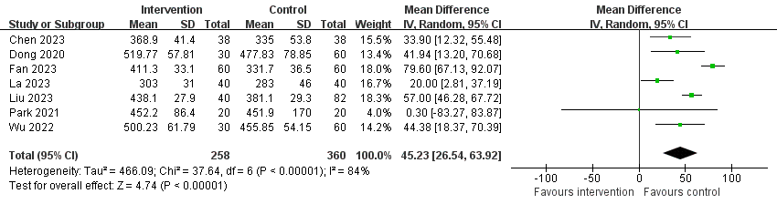

Supplementary Fig. 5 Forest plot for length of post-anesthesia care unit stay between the ultrasound-guided recruitment maneuver and the control group. CI confidence interval, M-H Mantel-Haenszel

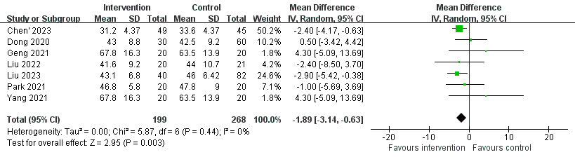

Supplementary Fig. 6 Forest plot for length of hospital stay between the ultrasound-guided recruitment maneuver and the control group. CI confidence interval, M-H Mantel-Haenszel

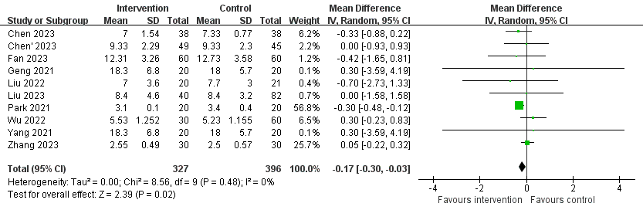

Supplementary Fig. 7 Funnel plots on the primary outcome

