Supplementary Materials
Supplementary Figure 1. Changes in Respiratory Rates Induced by Four Anesthetic Agents Across Different States
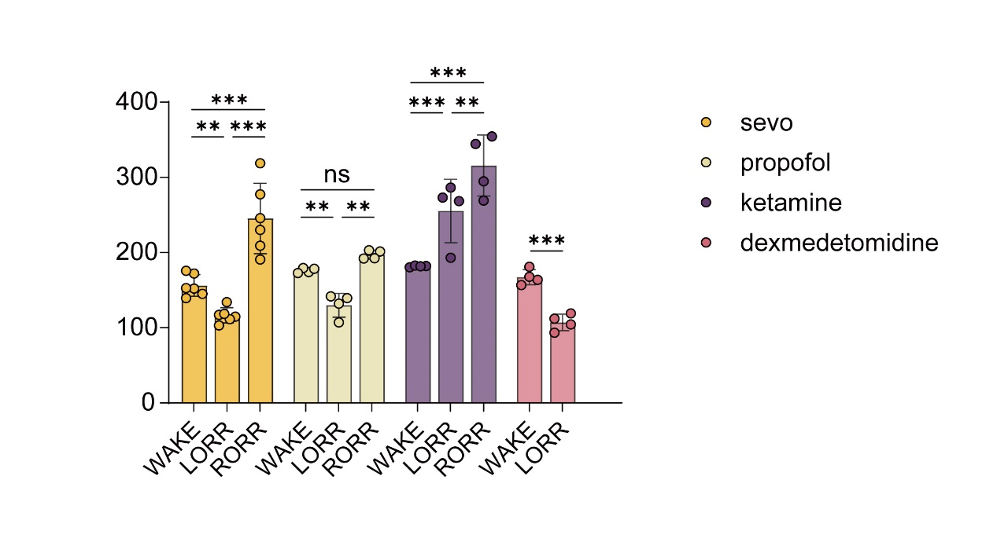
The bar graph illustrates the changes in respiratory rates under the influence of four anesthetic agents (sevoflurane, propofol, ketamine, and dexmedetomidine) across three states: wakefulness (WAKE), loss of the righting reflex (LORR), and recovery of the righting reflex (RORR). Each bar represents the mean ± SEM (standard error of the mean) for the measured respiratory rates. Statistical comparisons between states (WAKE, LORR, RORR) for each anesthetic agent are indicated: ***p < 0.001, **p < 0.01, *p < 0.05, ns = not significant. Notably, sevoflurane, propofol, and ketamine demonstrated significant respiratory suppression during LORR compared to WAKE, while dexmedetomidine exhibited a moderate effect. The ketamine group showed a pronounced increase in respiratory rate during RORR compared to LORR.
Methods for Respiratory Rate Measurement:
Respiratory rates were continuously recorded during the administration of four anesthetic agents across three experimental states: WAKE, LORR, and RORR. Data were collected using DSI Buxco FinePointe software and processed to calculate the mean respiratory rates ±SEM. Statistical significance was determined using two-way ANOVA, with post hoc comparisons for inter-state and inter-drug differences.
Results:
The results provide evidence of the differential effects of anesthetic agents on respiratory physiology. Sevoflurane, propofol, and dexmedetomidine induced marked suppression of respiratory rates during LORR, consistent with their effects on central respiratory control mechanisms. In contrast, ketamine exhibited an increase in respiratory rates, reflecting its distinct pharmacodynamic profile. The observed recovery in respiratory rates during RORR for ketamine highlights its excitatory properties during emergence from anesthesia.
Conclusion:
The measured respiratory rates correspond to the known pharmacological profiles of the anesthetic agents, demonstrating respiratory suppression during LORR for most anesthetics, except for the excitatory effects of ketamine during LORR. These findings confirm that the animals experienced a controlled and safe anesthesia process, with respiratory patterns consistent with expected pharmacodynamic responses.

