Supplemental Materials
Supplementary method
The co-immunoprecipitation (Co-IP) experiment was conducted using a commercial Co-IP kit (P0401, geneseed, China). Mouse liver tissue were immunoprecipitated with IP buffer containing IP antibody-coupled agarose beads, and protein-protein complexes were later subjected to Western blot. Here, IgG was used as a negative control. IP: Anti-SIRT1 (1:1000, 60303, proteintech, China), IB: Anti-LC3B (1:1000, 3868S, Cell Signaling Technology, USA).

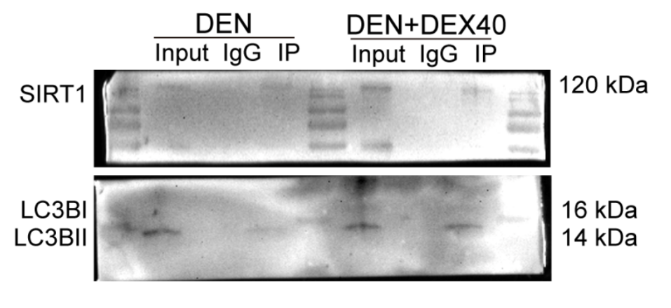

Supplementary Figure 1 Dexmedetomidine pretreatment increases the SIRT1-LC3B interaction in Co-IP assays. Western Blot after Co-IP was used to verify the binding of SIRT1 with LC3B.

