Supplementary information
Noninvasive and affordable type 2 diabetes screening by deep learning-based risk assessment and detection using ophthalmic images inspired by traditional Chinese medicine
Zhi Zhang^{1,2,20}, Han Wang^{3,20}, Lei Chen^{4,20}, Chensi Cao^{1,2}, Tengwen Liu⁵, Ruifang Ren^{1,2}, Ruixing Zhou^{1,2}, Rudan Huang^{1,2}, Dan Hu⁴, Chenxing Zhu⁴, Chong Lu⁶, Yunsheng Xu⁷, Zhaohui Fang⁸, Fuer Lu⁹, Huimin Pan¹⁰, Yanjin Su¹¹, Nanlin Fu¹², Huixia Zhan¹³, Qin Si¹⁴, Chenze Bai¹⁴, Ri Le Ge¹⁴, Hongmei Cao^{1,2}, Wei Dong^{1,2}, Guohui Yang^{1,2}, Lan Wu^{15,#}, Jiao Guo^{16,17,18,19,#}, Jing Cheng^{1,2,3,#}
¹National Engineering Research Center for Beijing Biochip Technology, Beijing, China. ²CapitalBio Corporation, Beijing, China. ³Department of Biomedical Engineering, School of Medicine, Tsinghua University, Beijing, China. ⁴Department of Neurology & Department of Clinical Research Management, West China Hospital, Sichuan University, Chengdu, China. ⁵School of Basic Medical Sciences, Chengdu University of Traditional Chinese Medicine. ⁶Department of Physical Examination, The First Affiliated Hospital/School of Clinical Medicine of Guangdong Pharmaceutical University, Guangzhou, China. ⁷Department of Endocrinology, The Second Affiliated Hospital of Shandong University of Traditional Chinese Medicine, Jinan, China. ⁸Department of Endocrinology, The First Affiliated Hospital of Anhui University of Chinese Medicine, Hefei, China. ⁹Department of Integrative Medicine, Tongji Hospital, Tongji Medical College, Huazhong University of Science and Technology, Wuhan, China. ¹⁰Health Management Center, Foshan Hospital Affiliated to Shunde Hospital of Guangzhou University of Chinese Medicine, Guangzhou, China. ¹¹Department of Endocrinology, Affiliated Hospital of Shaanxi University of Chinese Medicine, Xi’an, China. ¹²Famous Doctor Clinic, The Second Affiliated Hospital/School of Clinical Medicine of Guangdong Pharmaceutical University, Guangzhou, China. ¹³Famous Doctor Studio, The First Affiliated Hospital/School of Clinical Medicine of Guangdong Pharmaceutical University, Guangzhou, China. ¹⁴International Mongolia Hospital of Inner Mongolia, Hohhot, China. ¹⁵Mongolian Medicine School, Inner Mongolia Medical University, Hohhot, China. ¹⁶Guangdong Metabolic Diseases Research Center of Integrated Chinese and Western Medicine, Guangdong Pharmaceutical University. ¹⁷Key Laboratory of Glucolipid Metabolic Disorder, Ministry of Education of China. ¹⁸Institute of Chinese Medicine, Guangdong Pharmaceutical University. ¹⁹Guangdong TCM Key Laboratory for Metabolic Diseases, Guangzhou, China. ²⁰These authors contributed equally: Zhi Zhang, Han Wang, Lei Chen. #e-mail: wulan@immu.edu.cn, gyguoyz@163.com, jcheng@tsinghua.edu.cn.

Supplementary Methods
Institutions Participated in This Study
To develop AI systems for risk assessment and detection of T2DM, ophthalmic images of the ocular surface were collected from multiple cohorts, including CapitalBio Biological Community Health Screening Project (CCHSP, from Chongqing, Fuxin, Kunming, China); Guangdong Pharmaceutical University Metabolic Disease Screening Project (GDPUMDSP, from Yunfu, Guangzhou, Hefei, Jinan, Wuhan and Jun’an, China); Inner Mongolia International Mongolian Hospital Diabetes Screening Project (IMIMHDSP, from Huhhot, China); and West China Hospital of Sichuan University Health Benefit Project (WCHSCUHBP, from Mianzhu and Chengdu, China). Ophthalmic images of the ocular surface were collected by the following institutions: CapitalBio Corporation in Beijing; The First Affiliated Hospital of Clinical Medicine of Guangdong Pharmaceutical University and The Second Affiliated Hospital/School of Clinical Medicine of Guangdong Pharmaceutical University, both in Guangzhou, Guangdong Province; International Mongolia Hospital of Inner Mongolia in Hohhot, Inner Mongolia Autonomous Region; West China Hospital in Chengdu, Sichuan Province; The Second Affiliated Hospital of Shandong University of Traditional Chinese Medicine in Jinan, Shandong province; The First Affiliated Hospital of Anhui University of Chinese Medicine in Hefei, Anhui Province; Affiliated Hospital of Shaanxi University of Chinese Medicine in Xi’an, Shaanxi Province; Tongji Hospital in Wuhan, Hubei Province; and Foshan Hospital Affiliated to Shunde Hospital of Guangzhou University of Chinese Medicine in Foshan, Guangdong Province.
Participants
In this study, participant cohorts from multiple national and regional investigations have been obtained and divided randomly into the development, validation, internal testing, and external testing datasets, respectively. Demographic distribution of the cohorts (Supplementary Table 1) varied largely and covered multiple regions of the whole nation, facilitating accurate and unbiased evaluation of the proposed AI models. A total of 596256 images from 74532 participants were collected between May 2017 and December 2018 from Chongqing, and between March 2019 and May 2021 from Fuxin and Kunming, for system development and validation. A total of 91422 images from 12544 participants were collected for internal and external tests, consisting of data collected between June 2021 and December 2021 from CCHSP (internal test set), between August 2021 and December 2021 from GDPUMDSP (external test set 1), between March 2020 and July 2021 from IMIMHDSP (external test set 2), and between April 2021 and June 2021 from WCHSCUHBP (external test set 3).
Definition of T2DM and Prediabetes
In this study, registered T2DM patients, or subjects with fasting plasma glucose (FPG) ≥ 7.0 mmol/L (in the absence of impaired glucose tolerance (IGT)), or 2-hour oral post-load plasma glucose ≥11.1 mmol/L (defined as IGT), or haemoglobin A1c levels ≥6.5% were treated as T2DM. In the absence of T2DM, IGT or FPG of 6.1–6.9 mmol/L (in the absence of IGT), or haemoglobin A1c levels of 5.7-6.4% were defined as prediabetes in this study [1].
Data Collection and Pre-processing
In this study, demographic, medical history, and clinical testing information of the participants were collected at the examination site together with ophthalmic images. Especially, at least one of the following blood tests were carried out for each participant, including fasting plasma glucose, random blood glucose, impaired glucose tolerance, and haemoglobin A1c levels. Samples in the dataset were labelled as T2DM, high-risk cases of T2DM (HR), and other samples (NonHR) which include both healthy and unhealthy subjects that may carry diseases other than T2DM.
Ophthalmic Image Segmentation
We used PyPI package labelme (https://pypi.org/project/labelme/) to annotate ocular surface region of 2286 raw ophthalmic images. Then we trained 2 image segmentation network models, one for ocular surface segmentation based on the original images, and the other for iris segmentation based on ocular surface images (Supplementary Table 2). Finally, we acquired ocular surface images, iris images, and scleral images, respectively. All the models were trained in parallel on two NVIDIA Tesla P100 graphics processing units.
Classification Model Development
In the model development process, all hyperparameters (learning rate: 0.005 (for global model)/0.001 (for local models), weight decay: 0.001 (for global model)/0.05 (for local models)), and datasets partition (80% for training, 10% for tuning, and 10% for testing) maintained the same in different scenarios (Supplementary Table 2). All the models were trained in parallel on two NVIDIA Tesla P100 graphics processing units.
Elucidation of T2DM-Relevant Regions on Ocular Surface
We constructed ΔMCC maps together with the Grad-CAM maps for the illustration. The ΔMCC maps were generated based on occlusion test in three steps: First, we used ellipses to fit the edge of iris and detected iris center and diameters; Second, all ophthalmic images were aligned to a Cartesian coordinate system to make sure their iris were located in the same circle a²+b²=59², using zooming and panning; Third, given a patch with its size and coordinate, ocular surface images masked by the patch were inferred using OcularSurfaceNet-G2L models, and the decrease of MCC was computed. ΔMCC map was then obtained by repeating this process for sliding patches.
To test the association between T2DM and ocular features, we repeatedly sampled participants and used the chi-squared test to examine whether the ocular features were enriched in T2DM/high-risk participants. Specifically, we randomly sampled 80% T2DM/high-risk samples and 80% T2DM low-risk samples without replacement 1000 times and computed the frequency of enrichment in the T2DM/high-risk samples.
Portable Imaging Instrument
We have previously developed the portable eye imaging device that can perform automatic image acquisition and analysis on-site (Supplementary Fig. 1a and 1b) [2]. To obtain information on the ocular surface completely, we collected images of the eyeball rotating in different directions: up, down, left, and right, respectively (Supplementary Fig. 1c). Eight ocular surface images, including the right and left eyes, were collected for each subject. This process is non-invasive, fast, and low-cost.
This portable instrument has been approved as a second-class medical device of the People's Republic of China in 2018 (Registration Certificate No.: Sichuan Device Registration Approval No. 20182160164). On one hand, the instrument has been used in scientific research and auxiliary diagnosis of cardiovascular diseases, tumours, metabolic diseases, immune diseases, and TCM syndromes in more than 50 Level A Tertiary Hospitals such as Peking University Third Hospital, West China Hospital of Sichuan University, Shanghai Sixth People's Hospital Affiliated to Shanghai Jiao Tong University, First Affiliated Hospital of China Medical University, First Affiliated Hospital of Guangzhou Medical University, Second Affiliated Hospital of Harbin Medical University, Guang'anmen Hospital of China Academy of Chinese Medical Sciences, Dongzhimen Hospital of Beijing University of Traditional Chinese Medicine. On the other hand, the instrument has been widely used in diabetes screening and management projects in Liangjiang New Area of Chongqing, Fuxin of Liaoning province, and Kunming of Yunnan province. At present, the cumulative number of community residents screened by the portable instrument has exceeded 200,000. As demonstrated in the community screening studies, the portable instrument is compact, fully automated, user-friendly, and can report the ophthalmic image analysis result on-site, which well satisfied the need of large-scale screening. It has significantly improved the awareness rate of diabetes in local communities, providing an innovative approach for the prevention and control of diabetes in remote areas. Validated through multiple nationwide and regional cohort studies, the portable instrument is ready to be widely deployed not only in the hospitals, but also in the community and local medical centers.

Supplementary Table 1 | Demographic characteristics of the participants in the developmental dataset and in the external validation cohorts.

 | Developmental  datasetª | Internal test set  CCHSP-P | External test set 1  GDPU | External test set 2  IMIMH | External test set 3  WCHSCU | Total test set
Date | 2017.05–2021.05 | 2021.06–2021.12 | 2021.08–2022.01 | 2020.03–2021.07 | 2021.04–2021.06 | -
Number of images | 416580 | 62761 | 10170 | 1320 | 17171 | 90276
Number of participants | 67151 | 8876 | 1335 | 165 | 2168 | 12391
Male (%) | 27927 (41.59) | 3762 (42.38) | 826 (61.87) | 76 (46.06) | 671 (30.95) | 5275 (43.23)
Age (yr)^{b} | 55.02 ± 13.01 | 60.46 ± 13.38 | 46.58 ± 13.42 | 55.30 ± 15.11 | 54.39 ± 11.01 | -
Site (China) | Chongqing, Kunming,  Fuxin | Kunming, Fuxin | Jinan, Hefei, Guangzhou,  Xi'an, Yunfu, Wuhan, Junan | Huhhot | Mianzhu, Chengdu | -
High-risk T2DM-QS (%) | 39855 (59.35) | 5776 (65.07) | 459 (34.38) | NA | NA | 6204 (50.85)
Prediabetes (%) | 164 (0.24) | 38 (0.43) | 40 (3.0) | 0 (0) | 85 (3.92) | 163 (1.34)
T2DM (%) | 7224 (10.76) | 1046 (11.78) | 392 (29.36) | 99 (60) | 128 (5.90) | 1596 (13.08)
ª Training:Tuning:Testing=8:1:1.
^{b} Results are presented as mean ± SD.

Supplementary Fig. 1 | The eye imaging device for the collection of ocular surface images of the study. a, The specially designed eye imaging device. b, Real-world scenario of collecting ocular surface images in a medical institution. c, Examples of ocular surface images of the left and right eyes with eyeballs rotating in different directions: up, down, left, and right.

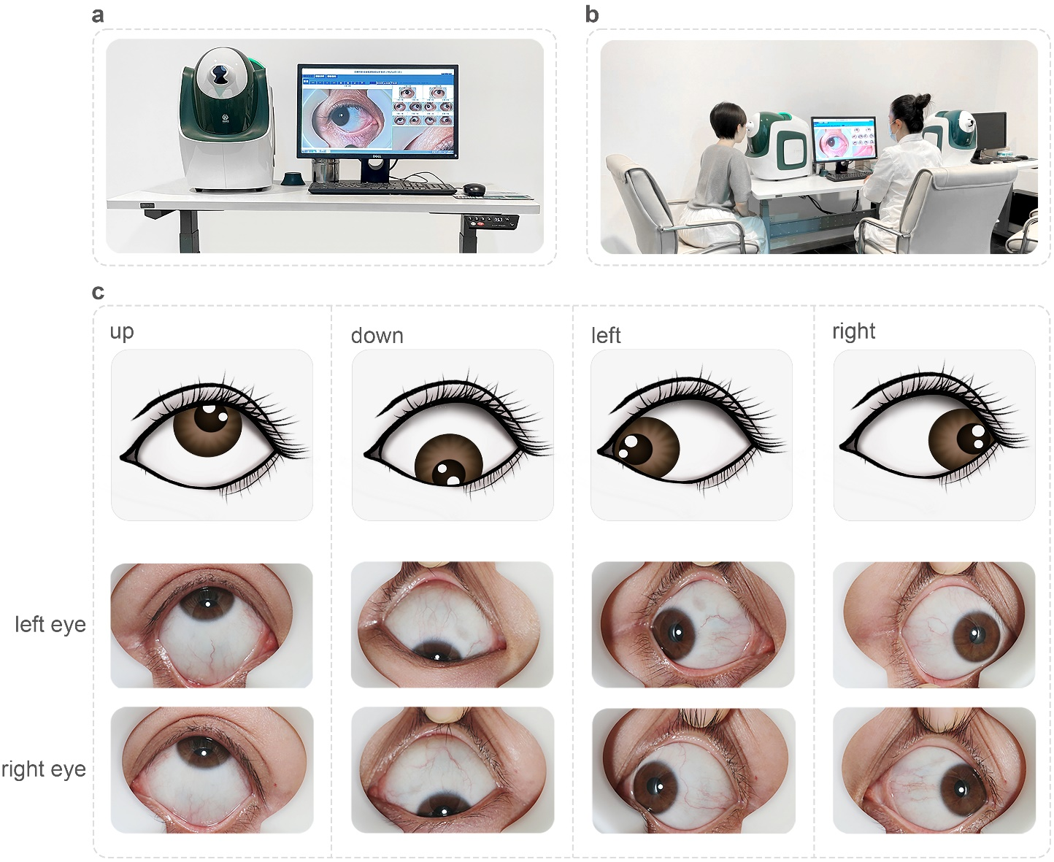

Supplementary Table 2 | Hyperparameters of the convolutional neural networks used in this study.

Hyperparameter | U-net  (ocular surface segmentation) | U-net  (iris segmentation) | ResNet-18  (global feature) | ResNet-18  (local feature)
batch size | 16 | 8 | 128 | 128
loss | BCELoss | BCEWithLogitsLoss | cross_entropy | cross_entropy
optimizer | SGD | Adam | Ranger | Ranger
learning rate | 0.1 | 0.001 | 0.005 | 0.001
momentum | 0.9 | 0.9 | 0.9 | 0.9
weight decay | 0.0005 | 0 | 0.001 | 0.05
epochs | 10 | 20 | 60 | 60

Supplementary Fig. 2 | Examples of coarse-grained morphological ocular features. a-f, The examples of coarse-grained morphological ocular features such as Ban, Dian, Qiu, Wuman, Xuemai and Yueyun, respectively.

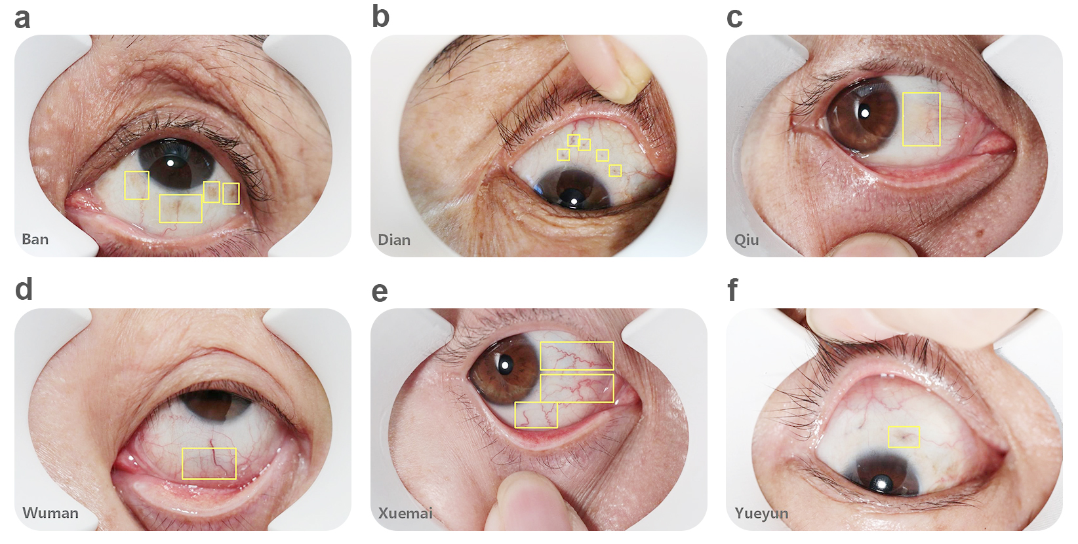

Supplementary Table 3 | The Performance of T2DM risk assessment models developed based on different regions of ocular surface (OS). images.

Test Set | Region | Accuracy | Sensitivity | Specificity | F1 | MCC | Kappa | AUROC
Validation | Iris | 0.8071  (0.7936-0.8199) | 0.8763  (0.8628-0.8905) | 0.6602  (0.63-0.687) | 0.8606  (0.8496-0.8708) | 0.5485  (0.5167-0.5781) | 0.5476  (0.516-0.5769) | 0.8587^{b}  (0.8452-0.8715)
Validation | Sclera | 0.8238  (0.8105-0.8378) | 0.8823  (0.868-0.8957) | 0.696  (0.6676-0.7255) | 0.873  (0.8625-0.8836) | 0.5859  (0.5545-0.6165) | 0.5856  (0.5542-0.6161) | 0.8728  (0.8599-0.885)
Validation | Iris+scleraª | 0.8156  (0.8016-0.8284) | 0.8488  (0.8342-0.8629) | 0.7429  (0.7171-0.7681) | 0.8634  (0.8514-0.8742) | 0.5809  (0.5515-0.6089) | 0.5801  (0.5506-0.6082) | 0.8823  (0.8697-0.8941)
Validation | Whole OS | 0.8226  (0.8101-0.8352) | 0.8684  (0.8545-0.8822) | 0.7225  (0.6964-0.75) | 0.8705  (0.8602-0.8805) | 0.5892  (0.5606-0.6171) | 0.5892  (0.5605-0.617) | 0.8869  (0.8751-0.8988)
Internal | Iris | 0.8418  (0.834-0.85) | 0.937  (0.9311-0.9429) | 0.5258  (0.5046-0.547) | 0.901  (0.8959-0.9066) | 0.5194  (0.4969-0.541) | 0.51  (0.4873-0.5322) | 0.8627  (0.8533-0.8717)
Internal | Sclera | 0.8447  (0.8365-0.8523) | 0.9208  (0.9138-0.9271) | 0.592  (0.5693-0.6121) | 0.9012  (0.8955-0.9063) | 0.5429  (0.5209-0.5644) | 0.5403  (0.518-0.5616) | 0.8766  (0.8682-0.8853)
Internal | Iris+scleraª | 0.8482  (0.8406-0.8551) | 0.9162  (0.9095-0.9226) | 0.6227  (0.6026-0.6433) | 0.9027  (0.8974-0.9075) | 0.5594  (0.5378-0.5794) | 0.5581  (0.5369-0.5783) | 0.8824  (0.8744-0.8905)
Internal | Whole OS | 0.8578  (0.8505-0.8646) | 0.9365  (0.9308-0.9422) | 0.5964  (0.5766-0.6182) | 0.9101  (0.905-0.9147) | 0.5767  (0.5571-0.5957) | 0.5714  (0.5516-0.5908) | 0.8874  (0.8794-0.8951)
External 1 | Iris | 0.8007  (0.7805-0.8225) | 0.7681  (0.7417-0.7975) | 0.8595  (0.8272-0.8911) | 0.8321  (0.8127-0.8514) | 0.6038  (0.5635-0.6473) | 0.5913  (0.55-0.6364) | 0.9011  (0.8847-0.9196)
External 1 | Sclera | 0.8052  (0.7835-0.827) | 0.7599  (0.7291-0.7877) | 0.8868  (0.8577-0.9149) | 0.8338  (0.8127-0.8531) | 0.6208  (0.5796-0.661) | 0.604  (0.5602-0.6469) | 0.9104  (0.8922-0.9269)
External 1 | Iris+scleraª | 0.794  (0.7723-0.815) | 0.7214  (0.6901-0.7517) | 0.9245  (0.9011-0.9479) | 0.8182  (0.7963-0.8394) | 0.6192  (0.5817-0.6555) | 0.5902  (0.5481-0.6299) | 0.9131  (0.8968-0.9287)
External 1 | Whole OS | 0.821  (0.7993-0.8412) | 0.7855  (0.7578-0.8116) | 0.8847  (0.856-0.9112) | 0.8494  (0.8302-0.8674) | 0.6451  (0.6053-0.6839) | 0.6323  (0.5899-0.6726) | 0.915  (0.8986-0.9299)
ª Ensemble of iris model and sclera model.
^{b} DeLong’s test on AUROC, P < 0.05 (Whole OS against Iris)
MCC, Matthews correlation coefficient; AUROC, areas under the receiver operating characteristic curve.

Supplementary Table 4 | Accuracy of models developed with different regions for detection of T2DM case and high-risk case of T2DM.

Test sets | Status | Iris | Sclera | Iris+scleraª | Whole Ocular Surface
Internal | T2DM | 0.9522 (0.9379-0.9637) | 0.9369 (0.9216-0.9512) | 0.9388 (0.9254-0.9532) | 0.9512 (0.9369-0.9637)
Internal | Prediabetes (FBS)^{b} | 0.8947 (0.8158-0.9605) | 0.9211 (0.8553-0.9737) | 0.8684 (0.7895-0.9342) | 0.9211 (0.8553-0.9737)
Internal | High-risk T2DM (QS) ^{b} | 0.934 (0.9276-0.94) | 0.918 (0.9107-0.925) | 0.9118 (0.9044-0.9192) | 0.9338 (0.9274-0.9401)
Internal | NonHR | 0.5258 (0.5044-0.5472) | 0.592 (0.5706-0.612) | 0.6227 (0.6027-0.6422) | 0.5964 (0.575-0.6173)
External 1 | T2DM | 0.8138 (0.7755-0.852) | 0.8138 (0.7755-0.852) | 0.7806 (0.7423-0.824) | 0.8316 (0.7908-0.8673)
External 1 | Prediabetes (FBS) ^{b} | 0.75 (0.6-0.875) | 0.65 (0.525-0.8) | 0.65 (0.5-0.8) | 0.7 (0.55-0.825)
External 1 | High-risk T2DM (QS) ^{b} | 0.7342 (0.695-0.7734) | 0.7233 (0.6797-0.7603) | 0.6797 (0.6362-0.7211) | 0.756 (0.719-0.793)
External 1 | NonHR | 0.8595 (0.8281-0.891) | 0.8868 (0.8574-0.9161) | 0.9245 (0.8994-0.9476) | 0.8847 (0.8553-0.914)
ª Ensemble of iris model and sclera model.
^{b} Containing samples in both prediabetes and High-risk T2DM.
NonHR: data excluded the union of T2DM, prediabetes, and high-risk T2DM. FBS: fast plasma glucose. QS: high-risk T2DM assessed by questionnaire score.

Supplementary Fig. 3 | Multi-stage multi-perspective (MSMP) transfer learning for type 2 diabetes detection. In each stage, we refined the previous model with binocular images from all perspectives (G) or each perspective (L={P_{k}}, k=1,2,⋯,8) to learn global or local features. The first stage networks were pretrained on ImageNet (I). The bottom panel shows the details of refining process for corresponding workflows denoted by arrows in the same color. M_{I} denotes the input model to be refined and M_{O} denotes the output model. Models with suffix -P_{k} and dark background consist of eight sub-models.

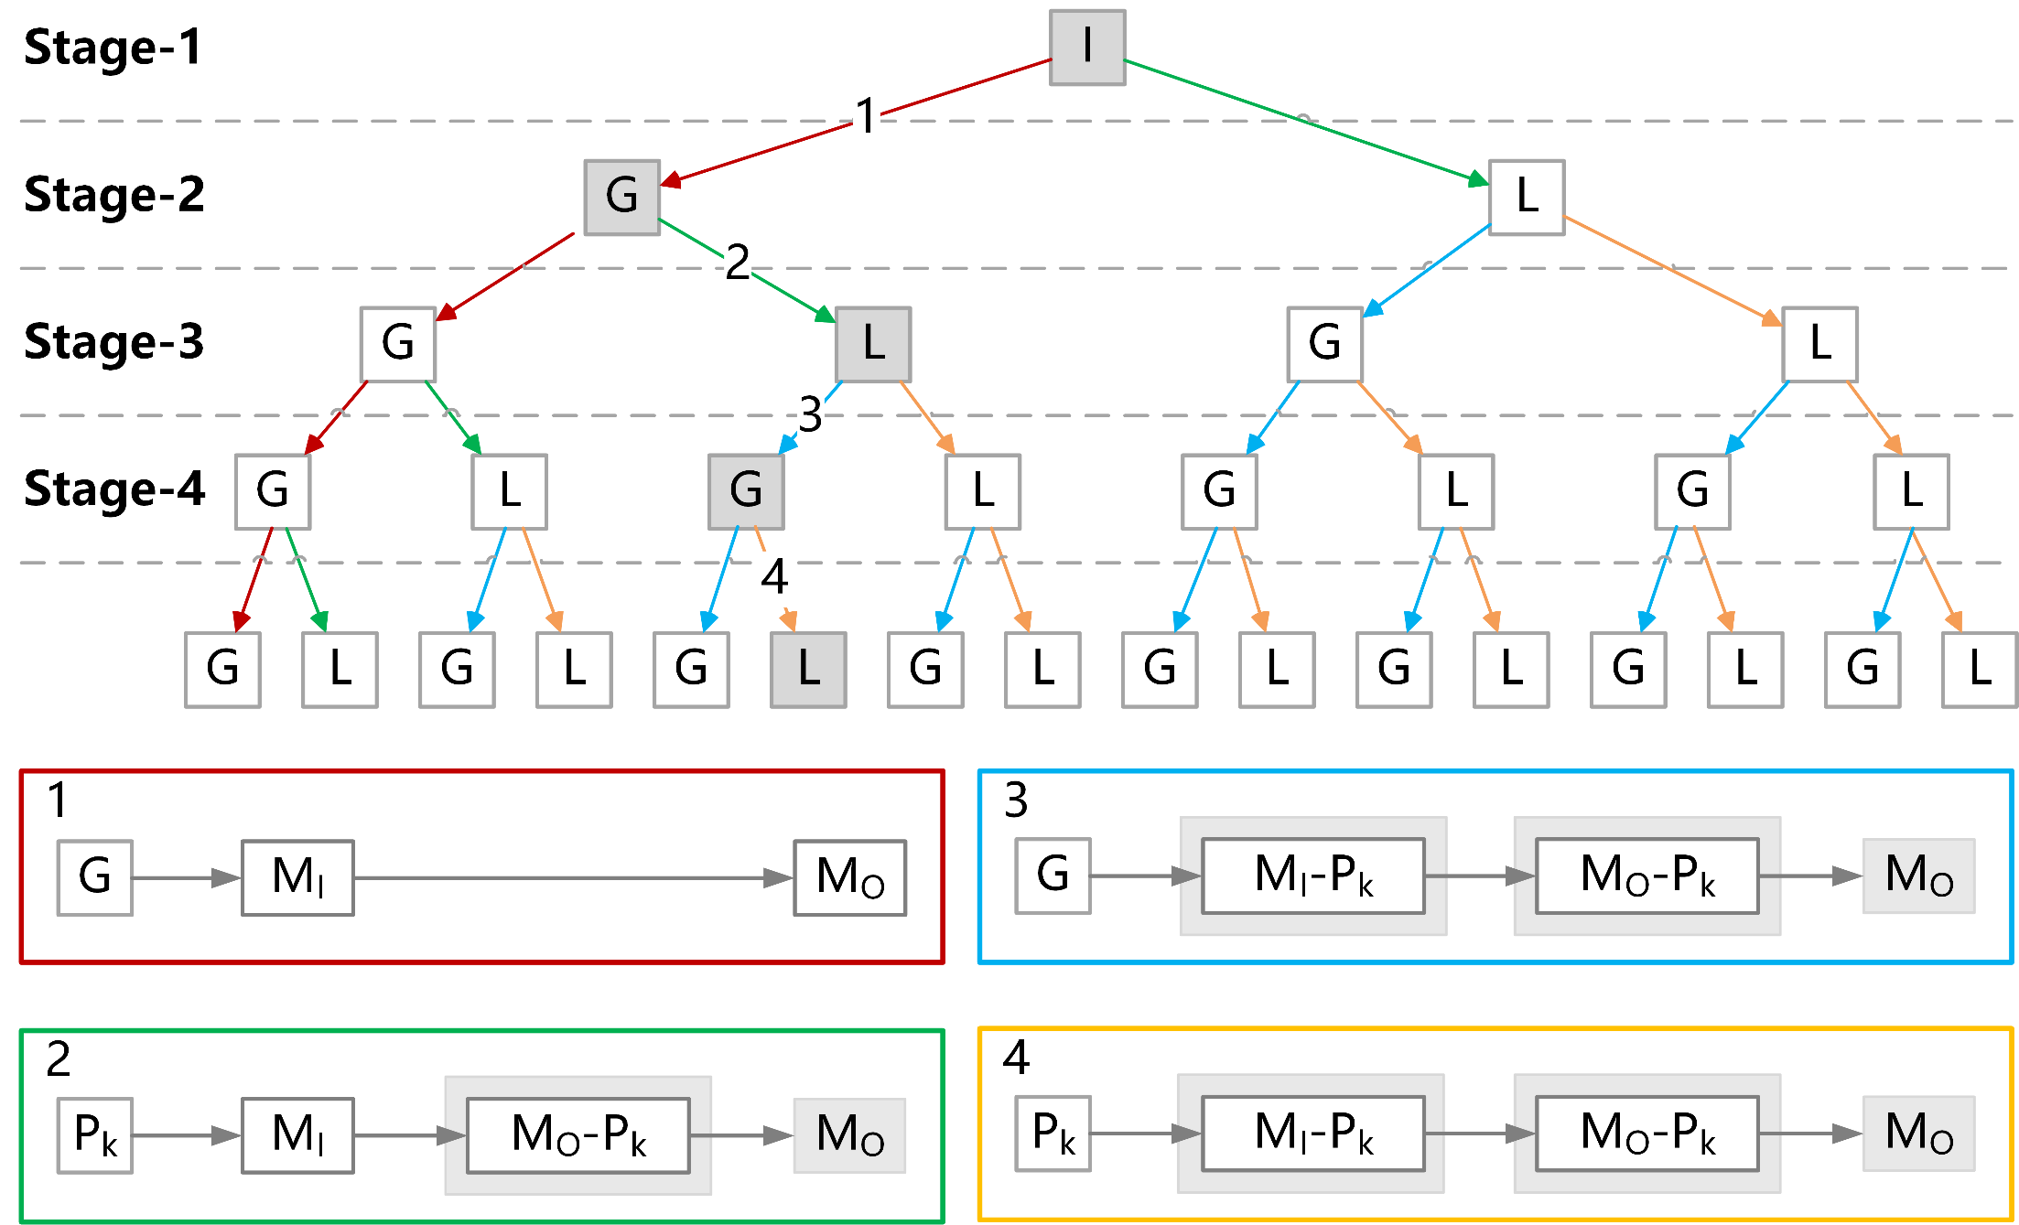

Supplementary Table 5 | Performance of high-risk cases of T2DM prediction models learned from global and local ophthalmic features.

Test Set | Model | Accuracy | Sensitivity | Specificity | F1 | MCC | Kappa | AUROC
Validation | G | 0.8226  (0.8101-0.8352) | 0.8684  (0.8545-0.8822) | 0.7225  (0.6964-0.75) | 0.8705  (0.8602-0.8805) | 0.5892  (0.5606-0.6171) | 0.5892  (0.5605-0.617) | 0.8869  (0.8751-0.8988)
Validation | L | 0.8224  (0.8089-0.8368) | 0.8698  (0.8561-0.8839) | 0.7217  (0.6932-0.7495) | 0.8694  (0.8585-0.8809) | 0.5918  (0.5598-0.6227) | 0.5918  (0.5596-0.6225) | 0.886ª  (0.8741-0.8983)
Validation | G2L | 0.8493  (0.8367-0.8608) | 0.8586  (0.8435-0.8722) | 0.8296  (0.8077-0.8506) | 0.8856  (0.8753-0.8949) | 0.6685  (0.6418-0.6936) | 0.6656  (0.6389-0.691) | 0.9169^{b}  (0.9072-0.9266)
Validation | L2G | 0.822  (0.8095-0.8346) | 0.8666  (0.8522-0.8799) | 0.7244  (0.6988-0.7531) | 0.8699  (0.8592-0.88) | 0.5884  (0.5594-0.6193) | 0.5884  (0.5594-0.6186) | 0.8867^{c}  (0.8749-0.8992)
Internal | G | 0.8578  (0.8505-0.8646) | 0.9365  (0.9308-0.9422) | 0.5964  (0.5766-0.6182) | 0.9101  (0.905-0.9147) | 0.5767  (0.5571-0.5957) | 0.5714  (0.5516-0.5908) | 0.8874  (0.8794-0.8951)
Internal | L | 0.8534  (0.8454-0.8604) | 0.9305  (0.9243-0.9362) | 0.5974  (0.5755-0.6197) | 0.9071  (0.9015-0.9118) | 0.5656  (0.5427-0.5869) | 0.5616  (0.5382-0.5827) | 0.8894  (0.8812-0.8967)
Internal | G2L | 0.8561  (0.8487-0.8636) | 0.909  (0.9019-0.9156) | 0.6806  (0.6617-0.7) | 0.9066  (0.9015-0.9118) | 0.5932  (0.573-0.6137) | 0.5931  (0.573-0.6136) | 0.8912  (0.8837-0.8991)
Internal | L2G | 0.8582  (0.8508-0.8656) | 0.9374  (0.9319-0.943) | 0.5949  (0.5744-0.6154) | 0.9104  (0.9054-0.9152) | 0.5772  (0.5566-0.598) | 0.5717  (0.551-0.5928) | 0.8893  (0.8818-0.8968)
External1 | G | 0.821  (0.7993-0.8412) | 0.7855  (0.7578-0.8116) | 0.8847  (0.856-0.9112) | 0.8494  (0.8302-0.8674) | 0.6451  (0.6053-0.6839) | 0.6323  (0.5899-0.6726) | 0.915  (0.8986-0.9299)
External1 | L | 0.8262  (0.8045-0.8457) | 0.7949  (0.7662-0.8197) | 0.8826  (0.8522-0.9112) | 0.8546  (0.8341-0.8725) | 0.6529  (0.6106-0.692) | 0.6416  (0.5977-0.6809) | 0.9182  (0.9025-0.9334)
External1 | G2L | 0.7993  (0.779-0.8195) | 0.7331  (0.7062-0.761) | 0.9182  (0.8947-0.9413) | 0.8244  (0.8047-0.8439) | 0.6243  (0.588-0.6619) | 0.5984  (0.5604-0.6371) | 0.9163  (0.9002-0.9313)
External1 | L2G | 0.8217  (0.8015-0.8427) | 0.7786  (0.7506-0.8072) | 0.8994  (0.8712-0.9242) | 0.8488  (0.8298-0.8681) | 0.6515  (0.6117-0.6924) | 0.6359  (0.5947-0.6782) | 0.9167  (0.9009-0.9325)
ª DeLong’s test on AUROC, P < 0.05 (G against L)
^{b} DeLong’s test on AUROC, P < 0.05 (G against G2L)
^{c} DeLong’s test on AUROC, P < 0.05 (G against L2G)
MCC, Matthews correlation coefficient; AUROC, areas under the receiver operating characteristic curve.

Supplementary Table 6 | Accuracy of the models developed with different stages for detection of T2DM case and high-risk cases of T2DM.

Test sets | Status | G | L | G2L | L2G
Internal | T2DM | 0.9512 (0.9369-0.9637) | 0.9474 (0.934-0.9608) | 0.935 (0.9207-0.9484) | 0.9484 (0.9359-0.9618)
Internal | Prediabetes (FBS)ª | 0.9211 (0.8553-0.9737) | 0.9211 (0.8553-0.9737) | 0.9474 (0.8816-0.9868) | 0.9211 (0.8553-0.9737)
Internal | High-risk T2DM (QS)ª | 0.9338 (0.9274-0.9401) | 0.9274 (0.9209-0.9338) | 0.9045 (0.8971-0.9123) | 0.9353 (0.9293-0.942)
Internal | NonHR | 0.5964 (0.575-0.6173) | 0.5974 (0.5759-0.6188) | 0.6806 (0.6597-0.6996) | 0.5949 (0.5735-0.6144)
External 1 | T2DM | 0.8316 (0.7908-0.8673) | 0.8367 (0.7959-0.875) | 0.7908 (0.75-0.8291) | 0.8214 (0.7806-0.8571)
External 1 | Prediabetes (FBS)ª | 0.7 (0.55-0.825) | 0.7 (0.55-0.85) | 0.65 (0.5-0.775) | 0.725 (0.6-0.85)
External 1 | High-risk T2DM (QS)ª | 0.756 (0.719-0.793) | 0.7669 (0.7255-0.8039) | 0.6928 (0.6536-0.7386) | 0.7495 (0.7081-0.7887)
External 1 | NonHR | 0.8847 (0.8553-0.914) | 0.8826 (0.8532-0.9099) | 0.9182 (0.8931-0.9413) | 0.8994 (0.8721-0.9266)
ª Containing sample in both prediabetes and High-risk T2DM.
NonHR: data excluded the union of T2DM, prediabetes, and high-risk T2DM. FBS: fast plasma glucose. QS: high-risk T2DM assessed by questionnaire score.

Supplementary Table 7 | Performance of the T2DM detection models.

Model | Accuracy | Sensitivity | Specificity | F1 | MCC | Kappa | AUROC
Validation | 0.9298  (0.9123-0.9463) | 0.8792  (0.835-0.9195) | 0.9447  (0.9274-0.9633) | 0.8505  (0.8131-0.8851) | 0.8054  (0.7592-0.8506) | 0.8047  (0.758-0.8501) | 0.971  (0.9595-0.9805)
Internal | 0.4997  (0.4898-0.51) | 0.8203  (0.7977-0.8422) | 0.4569  (0.4466-0.468) | 0.2785  (0.2641-0.2944) | 0.1807  (0.1639-0.1968) | 0.1032  (0.0926-0.1142) | 0.6957  (0.681-0.7117)
External 1 | 0.7493  (0.7246-0.771) | 0.6658  (0.616-0.7121) | 0.7839  (0.7565-0.8097) | 0.6091  (0.5683-0.6451) | 0.4299  (0.3755-0.4774) | 0.4265  (0.3721-0.4735) | 0.7961  (0.7696-0.8214)
External 2 | 0.7333  (0.6727-0.8061) | 0.7273  (0.6408-0.8148) | 0.7424  (0.6429-0.8471) | 0.766  (0.6971-0.8333) | 0.4616  (0.3379-0.6054) | 0.4581  (0.3328-0.5992) | 0.7922  (0.7256-0.864)
External 3 | 0.7117  (0.6923-0.7311) | 0.5781  (0.4887-0.6633) | 0.7201  (0.7002-0.7412) | 0.1915  (0.1551-0.2286) | 0.1538  (0.1044-0.1984) | 0.1031  (0.0696-0.1368) | 0.7122  (0.6655-0.7564)
MCC, Matthews correlation coefficient; AUROC, areas under the receiver operating characteristic curve.

Supplementary Table 8 | Performance of the T2DM prediction model on different age groups.

Age | Test Set | Accuracy | Sensitivity | Specificity | F1 | MCC | Kappa | AUROC
0-29 | Internal | 0.9797  (0.9594-0.9949) | 0.0  (0.0-0.0) | 0.9897  (0.9742-1.0) | 0.0  (0.0-0.0) | -0.0103  (-0.0201-0.0) | -0.0103  (-0.0194-0.0) | 0.5231  (0.3549-0.6306)
0-29 | External 1 | 0.9375  (0.9062-0.974) | 0.0  (0.0-0.0) | 1.0  (1.0-1.0) | 0.0  (0.0-0.0) | 0.0  (0.0-0.0) | 0.0  (0.0-0.0) | 0.5255  (0.3358-0.7307)
0-29 | External 2 | 0.8889  (0.6667-1) | 0.0  (0.0-1) | 1.0  (1-1.0) | 0.0  (0.0-1) | 0.0  (0.0-1) | 0.0  (0.0-1) | 1.0  (1-1.0)
0-29 | External 3 | 1  (1-1) | 1  (1-1) | 1  (1-1) | 1  (1-1) | 1  (1-1) | 1  (1-1) | 1  (1-1)
0-29 | Total | 0.9615  (0.9434-0.9796) | 0.0  (0.0-0.0) | 0.9953  (0.9883-1.0) | 0.0  (0.0-0.0) | -0.0126  (-0.0212-0.0) | -0.008  (-0.0173-0.0) | 0.5255  (0.3487-0.7011)
30-39 | Internal | 0.9245  (0.9-0.949) | 0.1667  (0.037-0.3235) | 0.9635  (0.9443-0.9803) | 0.1778  (0.0417-0.3404) | 0.1387  (-0.0076-0.3103) | 0.1384  (-0.0076-0.3076) | 0.6646  (0.5252-0.7829)
30-39 | External 1 | 0.87  (0.8206-0.9148) | 0.0  (0.0-0.0) | 0.9848  (0.966-1.0) | 0.0  (0.0-0.0) | -0.0424  (-0.0675-0.0) | -0.0247  (-0.0484-0.0) | 0.6749  (0.5589-0.7773)
30-39 | External 2 | 0.8462  (0.6923-0.9615) | 0.0  (0.0-0.0) | 1.0  (1.0-1.0) | 0.0  (0.0-0.0) | 0.0  (0.0-0.0) | 0.0  (0.0-0.0) | 0.7841  (0.5833-0.96)
30-39 | External 3 | 0.9896  (0.974-1) | 0.0  (0.0-1) | 1.0  (1.0-1) | 0.0  (0.0-1) | 0.0  (0.0-1) | 0.0  (0.0-1) | 0.5316  (0.199-1)
30-39 | Total | 0.9227  (0.9044-0.9398) | 0.0714  (0.0145-0.1458) | 0.9771  (0.966-0.9873) | 0.1  (0.022-0.1944) | 0.0729  (-0.0191-0.184) | 0.0663  (-0.0172-0.1639) | 0.6663  (0.5844-0.7376)
40-49 | Internal | 0.8826  (0.8638-0.9006) | 0.3774  (0.2576-0.5098) | 0.9066  (0.8895-0.9231) | 0.226  (0.1446-0.3068) | 0.1919  (0.1046-0.2804) | 0.1734  (0.0936-0.2548) | 0.7277  (0.6586-0.7926)
40-49 | External 1 | 0.7937  (0.7492-0.8349) | 0.3651  (0.2545-0.4821) | 0.9008  (0.8622-0.9388) | 0.4144  (0.2991-0.5243) | 0.2959  (0.1656-0.4303) | 0.2919  (0.1628-0.4207) | 0.7328  (0.6644-0.795)
40-49 | External 2 | 0.3889  (0.1667-0.6111) | 0.2308  (0.0-0.4615) | 0.8  (0.6-1.0) | 0.3529  (0.0-0.6) | 0.0331  (-0.4781-0.378) | 0.0198  (-0.299-0.2759) | 0.5846  (0.3231-0.8889)
40-49 | External 3 | 0.921  (0.8937-0.9482) | 0.1111  (0.0-0.2941) | 0.9628  (0.9425-0.9804) | 0.1212  (0.0-0.3) | 0.0806  (-0.0472-0.2717) | 0.0802  (-0.0467-0.2627) | 0.6735  (0.5126-0.8157)
40-49 | Total | 0.8704  (0.8548-0.8859) | 0.3265  (0.2534-0.4014) | 0.9169  (0.9043-0.9302) | 0.284  (0.225-0.3473) | 0.2163  (0.1523-0.2871) | 0.2141  (0.1495-0.2828) | 0.7246  (0.6817-0.765)
MCC, Matthews correlation coefficient; AUROC, areas under the receiver operating characteristic curve.

Supplementary Table 8 | Performance of the T2DM prediction model on different age groups (continued).

Age | Test Set | Accuracy | Sensitivity | Specificity | F1 | MCC | Kappa | AUROC
50-59 | Internal | 0.6466  (0.6249-0.6688) | 0.6588  (0.5921-0.7207) | 0.645  (0.6225-0.6679) | 0.2939  (0.2542-0.3306) | 0.1963  (0.1487-0.2418) | 0.1457  (0.1088-0.1817) | 0.7088  (0.6706-0.7464)
50-59 | External 1 | 0.5839  (0.5414-0.6327) | 0.7527  (0.6888-0.8098) | 0.4737  (0.4152-0.5382) | 0.5882  (0.5351-0.6395) | 0.2275  (0.1446-0.3176) | 0.2063  (0.1302-0.2937) | 0.6606  (0.6122-0.7118)
50-59 | External 2 | 0.6774  (0.5161-0.8387) | 0.6667  (0.4286-0.875) | 0.6923  (0.4118-0.9231) | 0.7059  (0.48-0.8571) | 0.3545  (-0.0092-0.6778) | 0.3515  (-0.0087-0.6723) | 0.7692  (0.5667-0.919)
50-59 | External 3 | 0.7833  (0.7548-0.8097) | 0.5417  (0.4-0.6889) | 0.7962  (0.77-0.8229) | 0.2023  (0.1338-0.2692) | 0.1787  (0.0956-0.2617) | 0.1306  (0.0647-0.1977) | 0.7227  (0.6469-0.8001)
50-59 | Total | 0.6768  (0.6612-0.6923) | 0.6847  (0.6403-0.73) | 0.6755  (0.6585-0.6927) | 0.3701  (0.34-0.3991) | 0.2572  (0.222-0.2921) | 0.2102  (0.18-0.2413) | 0.7383  (0.7139-0.763)
60-69 | Internal | 0.3565  (0.34-0.3751) | 0.8953  (0.8634-0.9247) | 0.2722  (0.2555-0.29) | 0.2736  (0.2513-0.296) | 0.1324  (0.104-0.1592) | 0.0574  (0.0446-0.0709) | 0.6626  (0.6352-0.6903)
60-69 | External 1 | 0.6949  (0.6102-0.7712) | 0.9143  (0.8507-0.973) | 0.375  (0.234-0.5098) | 0.7805  (0.702-0.8409) | 0.353  (0.1759-0.5089) | 0.314  (0.1515-0.4657) | 0.7307  (0.6324-0.8161)
60-69 | External 2 | 0.7636  (0.6545-0.8727) | 0.878  (0.7805-0.9737) | 0.4286  (0.1818-0.7) | 0.8471  (0.7619-0.9184) | 0.3339  (0.0463-0.5993) | 0.3299  (0.0462-0.59) | 0.5923  (0.4103-0.7944)
60-69 | External 3 | 0.4193  (0.3744-0.4641) | 0.7368  (0.6047-0.8718) | 0.3897  (0.3423-0.436) | 0.1778  (0.1234-0.2353) | 0.0728  (-0.014-0.1543) | 0.0329  (-0.0063-0.0715) | 0.5969  (0.5125-0.6846)
60-69 | Total | 0.3817  (0.3667-0.3965) | 0.8855  (0.86-0.912) | 0.2903  (0.275-0.3062) | 0.3055  (0.2849-0.326) | 0.1439  (0.119-0.1678) | 0.0688  (0.0562-0.0814) | 0.6532  (0.6299-0.6765)
70-79 | Internal | 0.2238  (0.2038-0.2438) | 0.9535  (0.9257-0.9775) | 0.0931  (0.0775-0.1079) | 0.2718  (0.2446-0.2979) | 0.0596  (0.0166-0.0957) | 0.0152  (0.0042-0.0254) | 0.6212  (0.5844-0.6543)
70-79 | External 1 | 0.7381  (0.5952-0.8571) | 0.9655  (0.8824-1.0) | 0.2308  (0.0-0.5) | 0.8358  (0.7241-0.9189) | 0.3091  (-0.0758-0.5812) | 0.2426  (-0.0442-0.5294) | 0.6711  (0.4642-0.8541)
70-79 | External 2 | 0.7826  (0.6087-0.913) | 0.9474  (0.8333-1.0) | 0.0  (0.0-nan) | 0.878  (0.7568-0.9545) | -0.0978  (-0.2041-0.0) | -0.0748  (-0.1752-0.0) | 0.5395  (0.3667-0.8095)
70-79 | External 3 | 0.2335  (0.1737-0.2994) | 0.7895  (0.5833-0.9524) | 0.1622  (0.1067-0.223) | 0.1899  (0.1103-0.2791) | -0.0411  (-0.2075-0.1154) | -0.0129  (-0.068-0.0362) | 0.5697  (0.4174-0.7128)
70-79 | Total | 0.2425  (0.2238-0.2611) | 0.9446  (0.9191-0.9688) | 0.1003  (0.0853-0.1146) | 0.2958  (0.2698-0.3213) | 0.058  (0.0214-0.0944) | 0.0163  (0.006-0.0268) | 0.6131  (0.5821-0.6471)
MCC, Matthews correlation coefficient; AUROC, areas under the receiver operating characteristic curve.

Supplementary Table 8 | Performance of the T2DM prediction model on different age groups (continued).

Age | Test Set | Accuracy | Sensitivity | Specificity | F1 | MCC | Kappa | AUROC
80-89 | Internal | 0.2236  (0.1876-0.2615) | 0.9247  (0.8713-0.9756) | 0.0637  (0.0405-0.09) | 0.3066  (0.256-0.3554) | -0.0181  (-0.111-0.0746) | -0.0045  (-0.0283-0.0189) | 0.5869  (0.5171-0.6547)
80-89 | External 1 | 0.6667  (0.3333-1) | 1.0  (1.0-1.0) | 0.0  (0.0-1) | 0.8  (0.5-1) | 0.0  (0.0-1) | 0.0  (0.0-1) | 0.3889  (0.0-1)
80-89 | External 2 | 1  (1-1) | 1  (1-1) | 1  (1-1) | 1  (1-1) | 1  (1-1) | 1  (1-1) | 1  (1-1)
80-89 | External 3 | 0.6667  (0.3333-1.0) | 1.0  (1.0-1.0) | 0.3333  (0.0-1.0) | 0.75  (0.2857-1.0) | 0.4472  (0.0-1.0) | 0.3333  (0.0-1.0) | 0.8889  (0.75-1.0)
80-89 | Total | 0.2408  (0.2042-0.2813) | 0.9333  (0.8842-0.9804) | 0.0652  (0.0406-0.0902) | 0.3322  (0.2832-0.3849) | -0.0024  (-0.0896-0.0854) | -0.0006  (-0.0235-0.0227) | 0.5815  (0.5177-0.6477)
90-99 | Internal | 0.36  (0.16-0.56) | 1.0  (1.0-1.0) | 0.2381  (0.087-0.4444) | 0.3333  (0.0909-0.5625) | 0.2182  (0.0754-0.3855) | 0.0909  (0.0113-0.2588) | 0.4286  (0.2544-0.66)
90-99 | Total | 0.36  (0.16-0.56) | 1.0  (1.0-1.0) | 0.2381  (0.087-0.4444) | 0.3333  (0.0909-0.5625) | 0.2182  (0.0754-0.3855) | 0.0909  (0.0113-0.2588) | 0.4286  (0.2544-0.66)
MCC, Matthews correlation coefficient; AUROC, areas under the receiver operating characteristic curve.

Supplementary Table 9 | Performance of the age-specific model in T2DM prediction.

Test Set | Age Group | Accuracy | Sensitivity | Specificity | F1 | MCC | Kappa | AUROC
Internal | [60, 100) | 0.4742  (0.4607-0.4877) | 0.7593  (0.727-0.7914) | 0.4255  (0.4101-0.4394) | 0.2963  (0.2775-0.3143) | 0.1332  (0.1079-0.158) | 0.0805  (0.0647-0.0954) | 0.6382  (0.6163-0.6596)
Internal | (0,100) | 0.5657  (0.5554-0.5759) | 0.739  (0.7117-0.766) | 0.5426  (0.5317-0.5534) | 0.2861  (0.2706-0.3011) | 0.1816  (0.1626-0.1997) | 0.1187  (0.106-0.1317) | 0.6855  (0.6698-0.7001)
External 1 | [60, 100) | 0.6213  (0.5503-0.6982) | 0.6762  (0.5825-0.7708) | 0.5312  (0.4062-0.6567) | 0.6893  (0.6139-0.757) | 0.2052  (0.0576-0.3678) | 0.2049  (0.0576-0.3657) | 0.6458  (0.5575-0.7305)
External 1 | (0,100) | 0.738  (0.7156-0.762) | 0.5969  (0.5465-0.6478) | 0.7966  (0.7712-0.8223) | 0.5721  (0.5319-0.6129) | 0.3845  (0.3328-0.4394) | 0.3838  (0.3324-0.4381) | 0.7768  (0.7511-0.8019)
External 2 | [60, 100) | 0.6296  (0.5309-0.7407) | 0.6667  (0.5484-0.7778) | 0.5  (0.2667-0.75) | 0.7368  (0.6465-0.8167) | 0.1435  (-0.0824-0.376) | 0.1346  (-0.073-0.355) | 0.5556  (0.3913-0.7228)
External 2 | (0,100) | 0.6606  (0.5879-0.7273) | 0.5758  (0.4767-0.6737) | 0.7879  (0.6825-0.8824) | 0.6706  (0.5823-0.7461) | 0.3598  (0.2241-0.4944) | 0.3396  (0.2051-0.4697) | 0.7732  (0.697-0.844)
External 3 | [60, 100) | 0.5493  (0.5121-0.5897) | 0.5333  (0.4-0.6604) | 0.551  (0.5099-0.5957) | 0.1866  (0.1284-0.2412) | 0.0501  (-0.0284-0.13) | 0.0317  (-0.0177-0.0835) | 0.5654  (0.487-0.6413)
External 3 | (0,100) | 0.7625  (0.744-0.7795) | 0.4688  (0.3821-0.5546) | 0.7809  (0.763-0.7973) | 0.189  (0.1453-0.2312) | 0.139  (0.0872-0.1894) | 0.1046  (0.0633-0.1456) | 0.6995  (0.6563-0.741)
MCC, Matthews correlation coefficient; AUROC, areas under the receiver operating characteristic curve.

Supplementary Table 10 | Performance of AI models based on healthy and mixed controls on test sets with only healthy controls.

Test set | Controls | Accuracy | Sensitivity | Specificity | F1 | MCC | Kappa | AUROC
External 1 | Mixed | 0.785  (0.7575-0.8125) | 0.6301  (0.5851-0.6798) | 0.9338  (0.9083-0.9567) | 0.7417  (0.7043-0.7796) | 0.5941  (0.5428-0.6433) | 0.5673  (0.5129-0.6219) | 0.9008  (0.8782-0.9223)
External 1 | Healthy | 0.5904  (0.5512-0.6265) | 0.8483  (0.8048-0.8831) | 0.346  (0.2973-0.3958) | 0.6683  (0.6255-0.702) | 0.2239  (0.1456-0.2933) | 0.1916  (0.1244-0.2528) | 0.6806  (0.6402-0.7198)
MCC, Matthews correlation coefficient; AUROC, areas under the receiver operating characteristic curve.

Supplementary Table 11 | Performance of AI models based on healthy and mixed controls.

Test set | Control  group | Accuracy | Sensitivity | Specificity | F1 | MCC | Kappa | AUROC
Internal | Mixed | 0.4693  (0.4582-0.4802) | 0.8356  (0.8125-0.8562) | 0.4204  (0.4092-0.4313) | 0.2705  (0.2557-0.2848) | 0.1691  (0.1519-0.186) | 0.0911  (0.0809-0.1014) | 0.6896  (0.6731-0.7059)
Internal | Healthy | 0.1274  (0.1208-0.1342) | 0.9971  (0.9933-1.0) | 0.0114  (0.009-0.0138) | 0.212  (0.2018-0.223) | 0.027  (0.0141-0.0369) | 0.002  (0.001-0.0029) | 0.5842  (0.5667-0.602)
External 1 | Mixed | 0.7358  (0.7126-0.7582) | 0.6301  (0.5815-0.6759) | 0.7797  (0.7525-0.804) | 0.5832  (0.5455-0.6202) | 0.3937  (0.3446-0.443) | 0.3914  (0.3425-0.4405) | 0.7842  (0.7575-0.8091)
External 1 | Healthy | 0.4192  (0.3937-0.4469) | 0.8546  (0.8187-0.8886) | 0.2383  (0.2131-0.2663) | 0.4633  (0.4303-0.4956) | 0.1037  (0.0541-0.1531) | 0.0622  (0.0328-0.0929) | 0.5835  (0.5529-0.6182)
External 2 | Mixed | 0.7333  (0.6727-0.8061) | 0.7273  (0.6408-0.8148) | 0.7424  (0.6429-0.8471) | 0.766  (0.6971-0.8333) | 0.4616  (0.3379-0.6054) | 0.4581  (0.3328-0.5992) | 0.7922  (0.7256-0.864)
External 2 | Healthy | 0.6545  (0.5818-0.7273) | 1.0  (1.0-1.0) | 0.1364  (0.058-0.2206) | 0.7765  (0.7171-0.8276) | 0.2942  (0.193-0.3825) | 0.1593  (0.0719-0.2553) | 0.6604  (0.561-0.7442)
External 3 | Mixed | 0.7117  (0.6923-0.7311) | 0.5781  (0.4887-0.6633) | 0.7201  (0.7002-0.7412) | 0.1915  (0.1551-0.2286) | 0.1538  (0.1044-0.1984) | 0.1031  (0.0696-0.1368) | 0.7122  (0.6655-0.7564)
External 3 | Healthy | 0.1508  (0.137-0.1651) | 0.9766  (0.9459-1.0) | 0.099  (0.0866-0.1124) | 0.1196  (0.1015-0.1385) | 0.0609  (0.0352-0.0811) | 0.0098  (0.0054-0.0139) | 0.6564  (0.6126-0.6961)
MCC, Matthews correlation coefficient; AUROC, areas under the receiver operating characteristic curve.

Supplementary Fig. 4 | The regions of ocular surface. The definition of ocular surface regions A to O comes from [3].

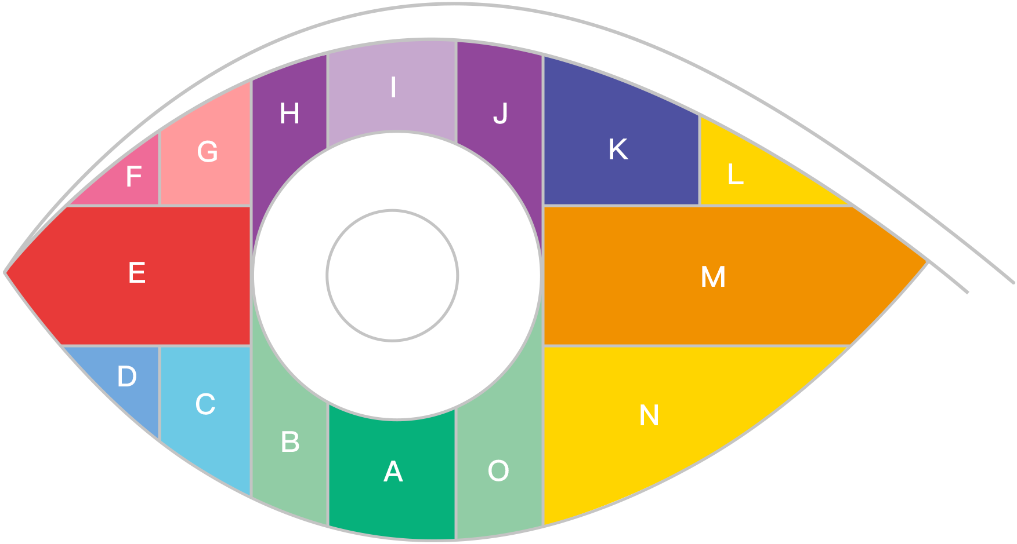

Supplementary Fig. 5 | Heatmap of frequency of enrichment in T2DM/high-risk samples.

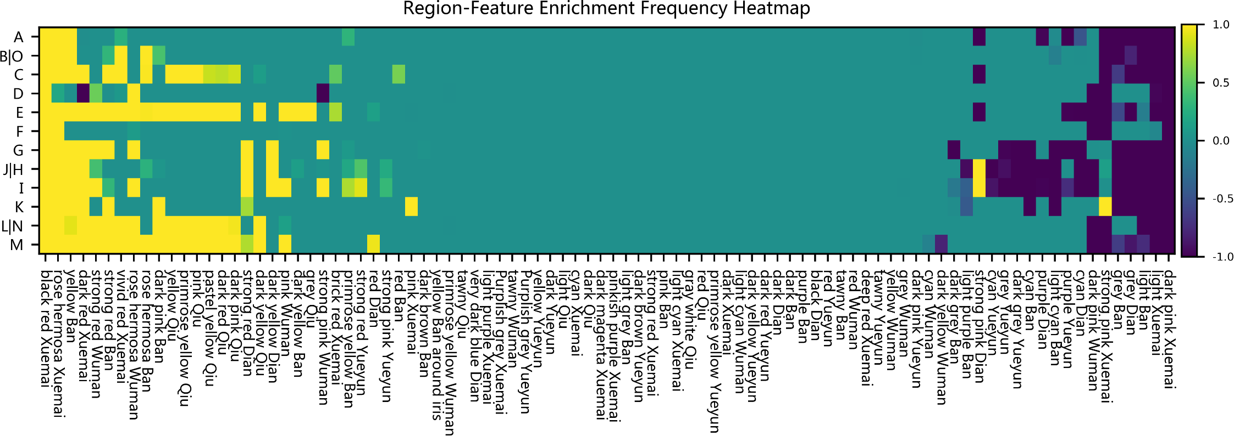
Supplementary Table 12 | Classification of ocular features based on TCM syndrome patterns of T2DM [3].

TCM syndrome patterns of T2DM | Ocular features correlated to T2DM
Yin deficiency, blood deficiency, blood stasis and heat | black red Xuemai
Yin deficiency, blood deficiency, blood stasis and heat | rose hermosa Xuemai
Yin deficiency, blood deficiency, blood stasis and heat | rose hermosa Wuman
Yin deficiency, blood deficiency, blood stasis and heat | dark red Xuemai
Yin deficiency, blood deficiency, blood stasis and heat | strong red Wuman
Yin deficiency, blood deficiency, blood stasis and heat | strong red Ban
Yin deficiency, blood deficiency, blood stasis and heat | vivid red Xuemai
Yin deficiency, blood deficiency, blood stasis and heat | rose hermosa Ban
Yin deficiency, blood deficiency, blood stasis and heat | dark pink Qiu
Yin deficiency, blood deficiency, blood stasis and heat | strong red Dian
Yin deficiency, blood deficiency, blood stasis and heat | dark pink Ban
Yin deficiency, blood deficiency, blood stasis and heat | dark yellow Dian
Yin deficiency, blood deficiency, blood stasis and heat | strong red Yueyun
Yin deficiency, blood deficiency, blood stasis and heat | brick red Xuemai
Yin deficiency, blood deficiency, blood stasis and heat | red Dian
Yin deficiency, blood deficiency, blood stasis and heat | red background
Damp heat, phlegm dampness, Qi stagnation and heat | yellow Ban
Damp heat, phlegm dampness, Qi stagnation and heat | primrose yellow Qiu
Damp heat, phlegm dampness, Qi stagnation and heat | yellow Qiu
Damp heat, phlegm dampness, Qi stagnation and heat | pink Qiu
Damp heat, phlegm dampness, Qi stagnation and heat | pastel yellow Qiu
Damp heat, phlegm dampness, Qi stagnation and heat | dark red Qiu
Damp heat, phlegm dampness, Qi stagnation and heat | dark yellow Qiu
Damp heat, phlegm dampness, Qi stagnation and heat | primrose yellow Ban
Damp heat, phlegm dampness, Qi stagnation and heat | dark yellow Ban
Damp heat, phlegm dampness, Qi stagnation and heat | grey Qiu
Damp heat, phlegm dampness, Qi stagnation and heat | yellow Ban around iris
Qi deficiency, blood deficiency, Yang deficiency | pink Wuman
Qi deficiency, blood deficiency, Yang deficiency | pink background
Qi deficiency, blood deficiency, Yang deficiency | strong pink background
Qi deficiency, blood deficiency, Yang deficiency | light pink background

References
1. Tabák AG, Herder C, Rathmann W, et al. Prediabetes: A high-risk state for diabetes development. Lancet. 2012; 379(9833): 2279–2290.
2. Xue N, Jiang K, Li Q, et al. Original askiatic imaging used in Chinese medicine eye-feature diagnosis of visceral diseases. Journal of Innovative Optical Health Sciences 2018, 11(04): 1850023.
3. Wang JJ, eds. Ophthalmology-based syndrome differentiation in diagnostics. Beijing: China Press of Traditional Chinese Medicine; 2013.

