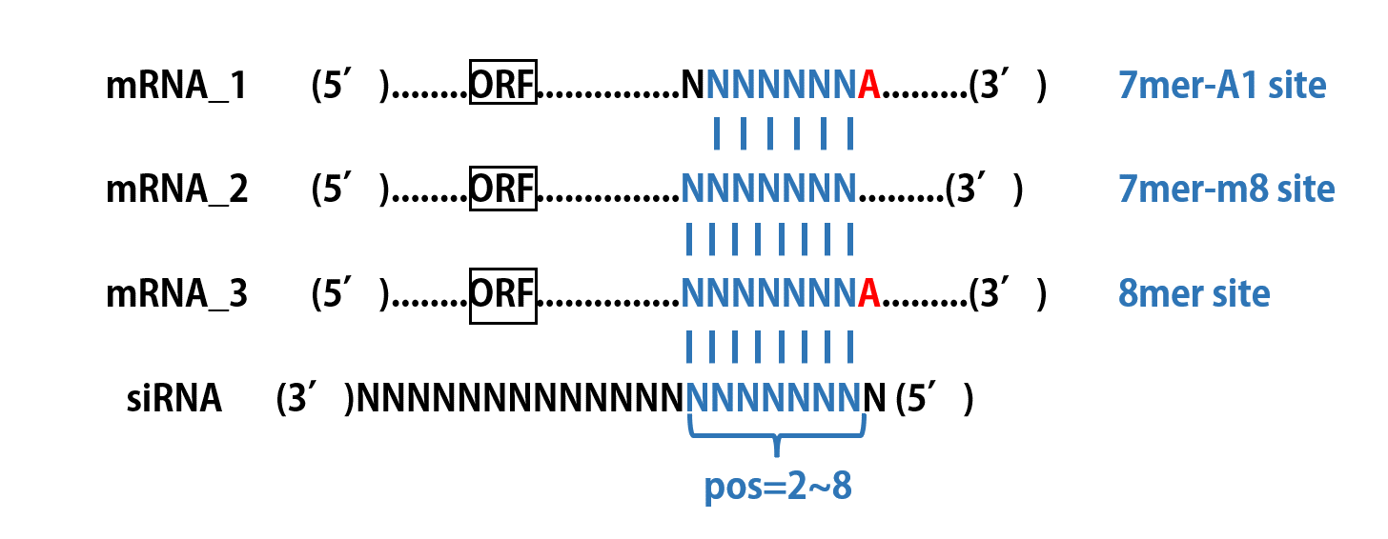
Fig. S1: The most possible binding sites for miRNA-like off-target effects, including 8mer site, 7mer-m8 site, and 7mer-A1 site.

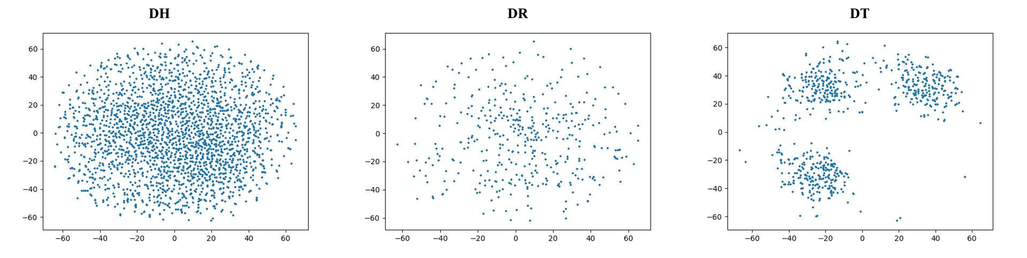

Fig. S2: Two-dimensional visualization of three datasets via t-SNE technology. Obviously, the samples in DT can be divided into three clusters, while those in DH and DR have rather chaotic distributions.

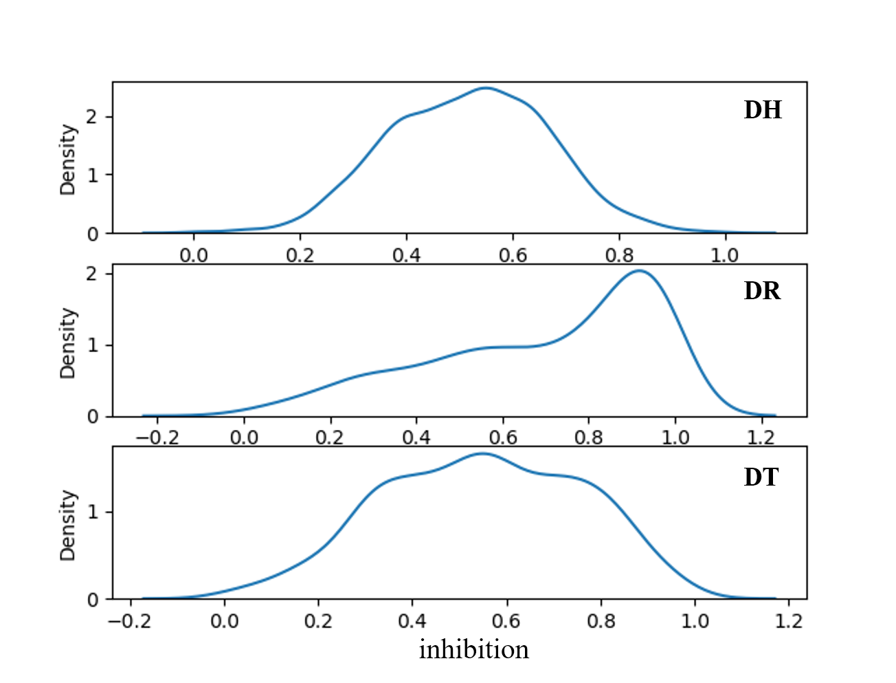
Fig. S3: KDE plots of inhibitions of three datasets. The inhibition distributions of DH and DT are quite similar, while showing significant difference with DR.

Table S1. Details of five chemically modified siRNA drugs from Alnylam Company. A=adenosine. C=cytidine. G=guanosine. U=uridine. T=thymidine. Af, Cf, Gf, Uf=2’- Fluoro ribonucleosides. Am, Cm, Gm, Um=2’-O-Methyl ribonucleosides. s=Phosphorothioate.
Drug | Target  mRNA | Antisense strand | Sense strand | Reported  inhibition
AMVUTTRA | TTR | UmsCfsUmUmGmGfUm  UmAfCmAmUmGmAfAm  AfUmCmCmCmAmsUmsCm | UmsGmsGmGmAmUmUf  UmCfAfUfGmUmAmAm  CmCmAmAmGmAm | 83%TTR
GIVLAARI | ALAS1 | UmsAfsAfGfAmUfGmAf  GmAfCmAfCmUfCmUf  UmUfCmUfGmsGmsUm | CmsAmsGmAmAmAmGf  AmGfUmGfUmCfUmCfAm  UmCmUmUmAm | 75.1% PBG  83.7% ALA
LEQVIO | PCSK9 | AmsCfsAmAfAfAfGm  CfAmAfAmAfCmAfGm  GfUmCfUmAmGmsAmsAm | CmsUmsAmGmAmCmCfUm  GfUmTUmUmGmCmUmUm  UmUmGmUm | 53% LDL-C
OXLUMO | HAO1 | UmsAfsUmAmUmUfUm  CfCfAmGmGmAmUfGm  AfAmAmGmUmCmsCmsAm | GmsAmsCmUmUmUmCf  AmUfCfCfUmGmGmAm  AmAmUmAmUmAm | /
ONPATTRO | TTR | AUGGAAUmACUCU  UGGUUmACTT | GUmAACmCmAAGAGUm  AUmUmCmCmAUmTT | 83%TTR

Table S2. Reference table of Gibbs energy between two adjacent base pairs (Kj/mol)
Base | A | C | G | U
A | -0.93 | -2.24 | -2.08 | -1.1
C | -2.11 | -3.26 | -2.36 | -2.08
G | -2.35 | -3.42 | -3.26 | -2.24
U | -1.33 | -2.35 | -2.11 | -0.93

Table S3. Comparison between the reported median inhibition, the predicted inhibition, and rankings among all candidates of five siRNA drugs. It also shows the number of possible off-target binding sites for each siRNA predicted by our pipeline, including on-target off-target (based on substring searching algorithm), miRNA-like off-target (8mer / 7mer-m8 / 7mer-A1), and autoimmune off-target. Bold means the best ranking.
Drug | Reported  inhibition | Num of  candidates | On-target  off-target | miRNA-like  off-target | Autoimmune  off-target | Method | Predicted  iinhibition | Ranking
AMVUTTRA | 83% (TTR) | 558 | 1 | 3429 | 0 | ours | 0.677 | 1.79%
 |  |  |  | (552/1432/1445) |  | CNN | 0.598 | 12.9%
 |  |  |  |  |  | Takasaki | -6.3 | 89.5%
 |  |  |  |  |  | sBiopredsi | 0.791 | 10.5%
 |  |  |  |  |  | i-score | 67.7 | 6.7%
 |  |  |  |  |  | Katoh | 70.9 | 21.2%
 |  |  |  |  |  | DSIR | 78.1 | 21.4%
GIVLAARI | 75.1% (PBG) | 9142 | 8 | 1680 | 0 | ours | 0.851 | 0.62%
 | 83.7% (ALA) |  |  | (312/871/497) |  | CNN | 0.673 | 4.62%
 |  |  |  |  |  | Takasaki | -4 | 80.7%
 |  |  |  |  |  | sBiopredsi | 0.793 | 10.2%
 |  |  |  |  |  | i-score | 62 | 15.4%
 |  |  |  |  |  | Katoh | 80.8 | 7.6%
 |  |  |  |  |  | DSIR | 87.6 | 5.9%
LEQVIO | 75% (LDL-C) | 34711 | 2 | 1079 | 0 | ours | 0.8 | 2.4%
 |  |  |  | (179/765/135 |  | CNN | 0.566 | 6.12%
 |  |  |  |  |  | Takasaki | 3.4 | 31.9%
 |  |  |  |  |  | sBiopredsi | 0.747 | 8.5%
 |  |  |  |  |  | i-score | 57.7 | 12.6%
 |  |  |  |  |  | Katoh | 65.1 | 7.6%
 |  |  |  |  |  | DSIR | 82.8 | 4%
OXLUMO | / | 1700 | 0 | 2910 | 0 | ours | 0.816 | 11.2%
 |  |  |  | (653/1737/520) |  | CNN | 0.657 | 14.1%
 |  |  |  |  |  | Takasaki | -0.3 | 51.2%
 |  |  |  |  |  | sBiopredsi | 0.574 | 59%
 |  |  |  |  |  | i-score | 56.6 | 37%
 |  |  |  |  |  | Katoh | 76.1 | 24.6%
 |  |  |  |  |  | DSIR | 63.2 | 71.1%
ONPATTRO | 80% (TTR) | 558 | 30 | 241 | 0 | ours | 0.822 | 3.58%
 |  |  |  | (50/115/76) |  | CNN | 0.576 | 10%
 |  |  |  |  |  | Takasaki | 10.8 | 6.4%
 |  |  |  |  |  | sBiopredsi | 0.654 | 33.9%
 |  |  |  |  |  | i-score | 56.9 | 27.6%
 |  |  |  |  |  | Katoh | 74.1 | 16.4%
 |  |  |  |  |  | DSIR | 75.3 | 26.3%

