Supplementary Information for
Variations of dissolved trace elements in precipitation and stream water in Japanese forest area:
additional evidence of changing air pollution in the region

Masayuki Morohashi^{1,2*}, Tatsuyoshi Saito^{3,4}, Masaaki Takahashi³, Yayoi Inomata⁵, Makoto Nakata⁴, Masaki Ohno², Tomohiro Kose², Tsuyoshi Ohizumi¹, Ki-Cheol Shin⁶, Ichiro Tayasu⁶, Hiroyuki Sase^{1,4}

¹Asia Center for Air Pollution Research, 1182 Sowa, Nishi-ku, Niigata-shi, Niigata, 950-2144, Japan
²Niigata University of Pharmacy and Medical and Life Sciences, 265-1 Higashijima, Akiha-ku, Niigata-shi, Niigata, 956-8603, Japan
³Niigata Prefecture, 4-1 Shinko-cho, Chuo-ku, Niigata-shi, Niigata, 950-8570, Japan
⁴Niigata University, 8050 Ikarashi 2-no-cho, Nishi-ku, Niigata-shi, Niigata, 950-2181, Japan
⁵Kanazawa University, Kakuma-machi, Kanazawa-shi, Ishikawa, 920-1192, Japan
⁶Research Institute for Humanity and Nature, 457-4 Motoyama, Kamigamo, Kita-ku, Kyoto-shi, Kyoto, 603-8047, Japan

* Corresponding author
Correspondence to Masayuki Morohashi,
E-mail: morohashi@acap.asia

Supplementary Information

Fig. S1 Monthly variations of inorganic ions fluxes in precipitation during the study period at the Kajikawa study site. Fig. S2 Monthly variations of TEs fluxes in precipitation during the study period at the Kajikawa study site. Fig. S3 Volume-weighted mean flux of TEs in precipitation divided into warm and cold seasons. The warm season was defined as April to September, and the cold season was defined as October to March of the following year, respectively. Fig. S4 Monthly variations of TEs concentrations in stream water during the study period at the Kajikawa study site. Fig. S5 Monthly variations of Pb isotope ratio (²⁰⁷Pb/²⁰⁴Pb) in precipitation and stream water. Dotted lines show 3-month moving average.

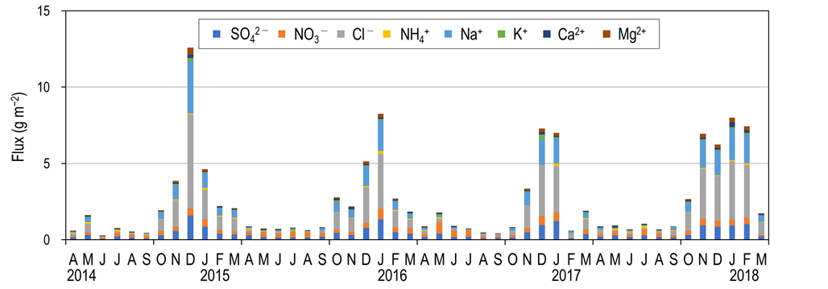
Fig. S1 Monthly variations of inorganic ions fluxes in precipitation during the study period at the Kajikawa study site.

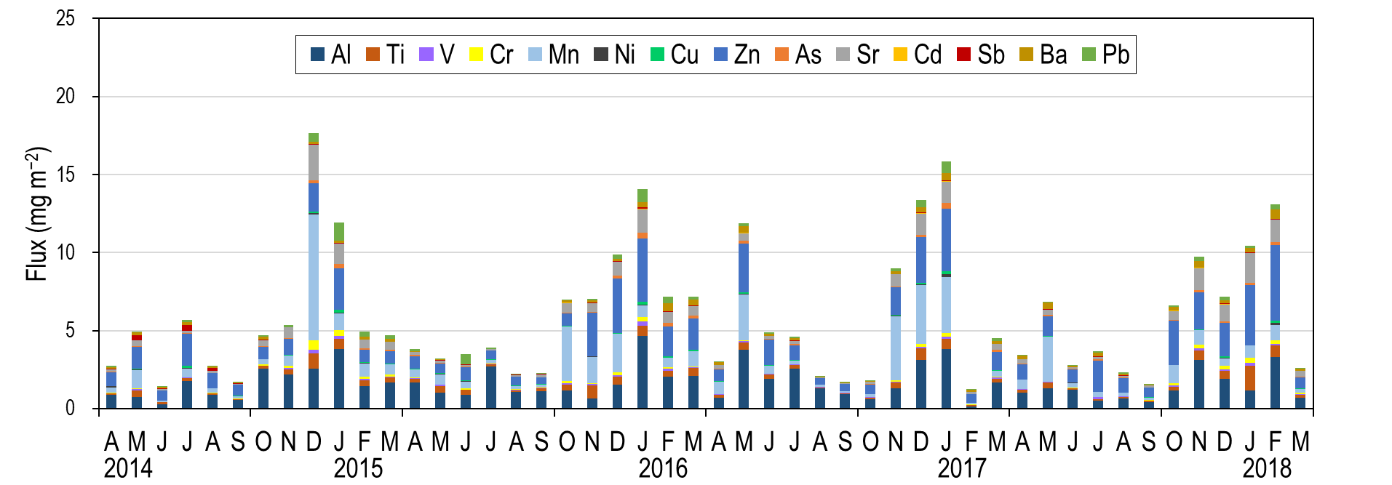
Fig. S2 Monthly variations of TEs fluxes in precipitation during the study period at the Kajikawa study site.

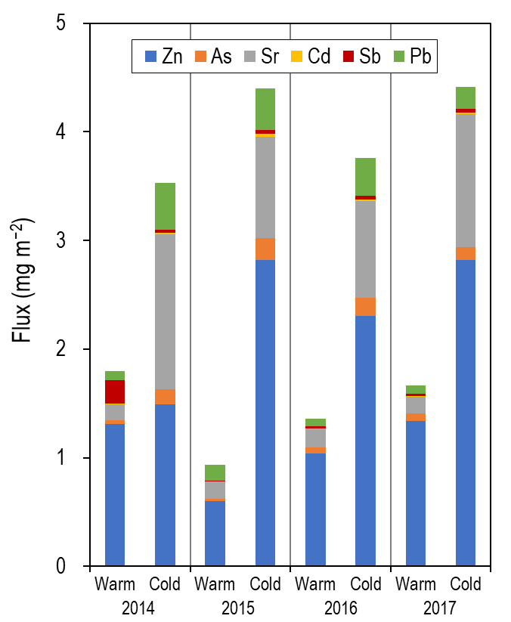
Fig. S3 Volume-weighted mean flux of TEs in precipitation divided into warm and cold seasons. The warm season was defined as April to September, and the cold season was defined as October to March of the following year, respectively.

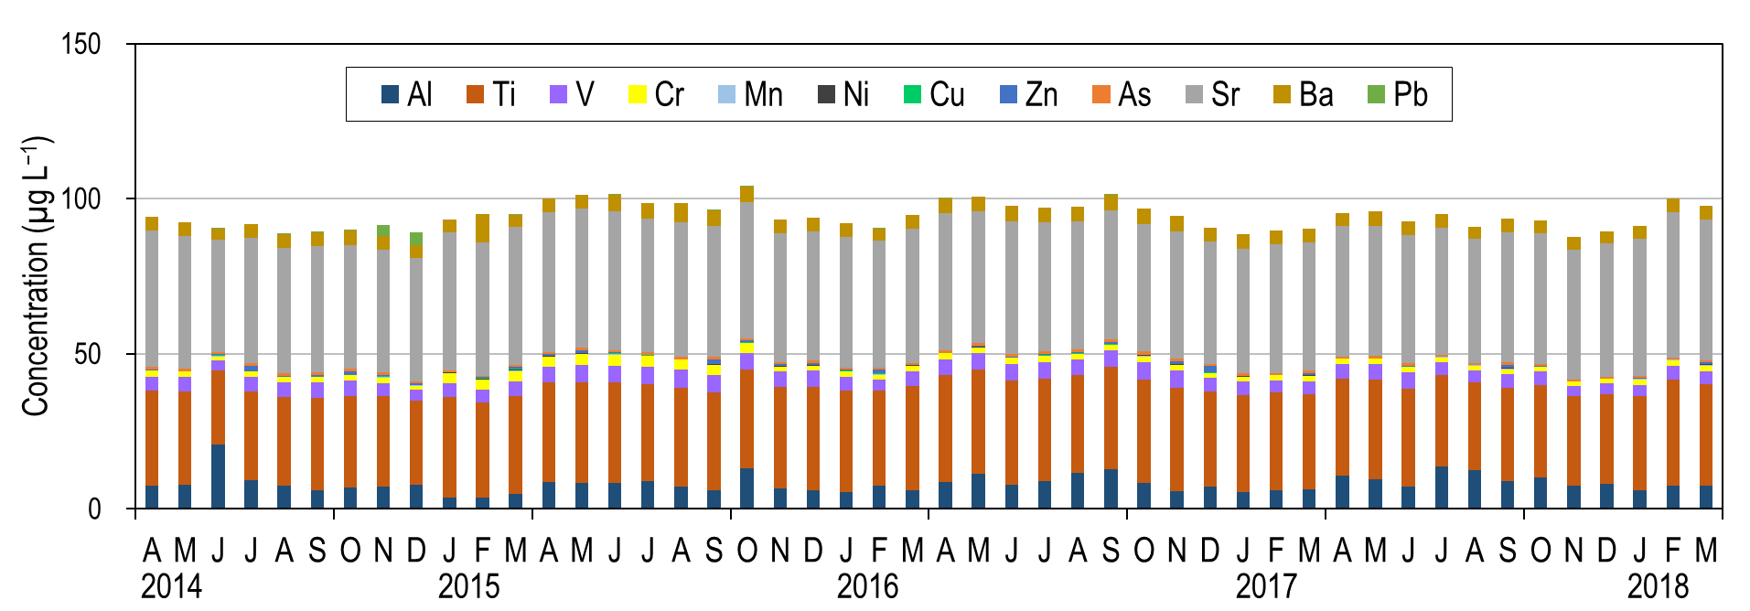
Fig. S4 Monthly variations of TEs concentrations in stream water during the study period at the Kajikawa study site.

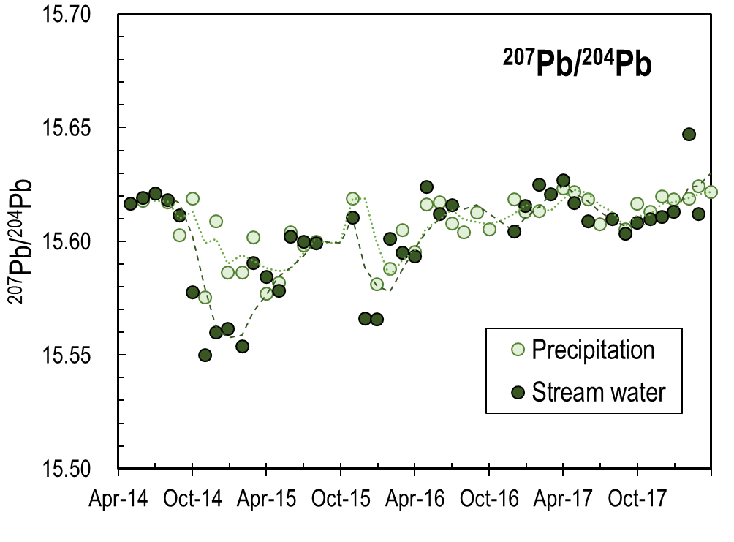
Fig. S5 Monthly variations of Pb isotope ratio (²⁰⁷Pb/²⁰⁴Pb) in precipitation and stream water. Dotted lines show 3-month moving average.

