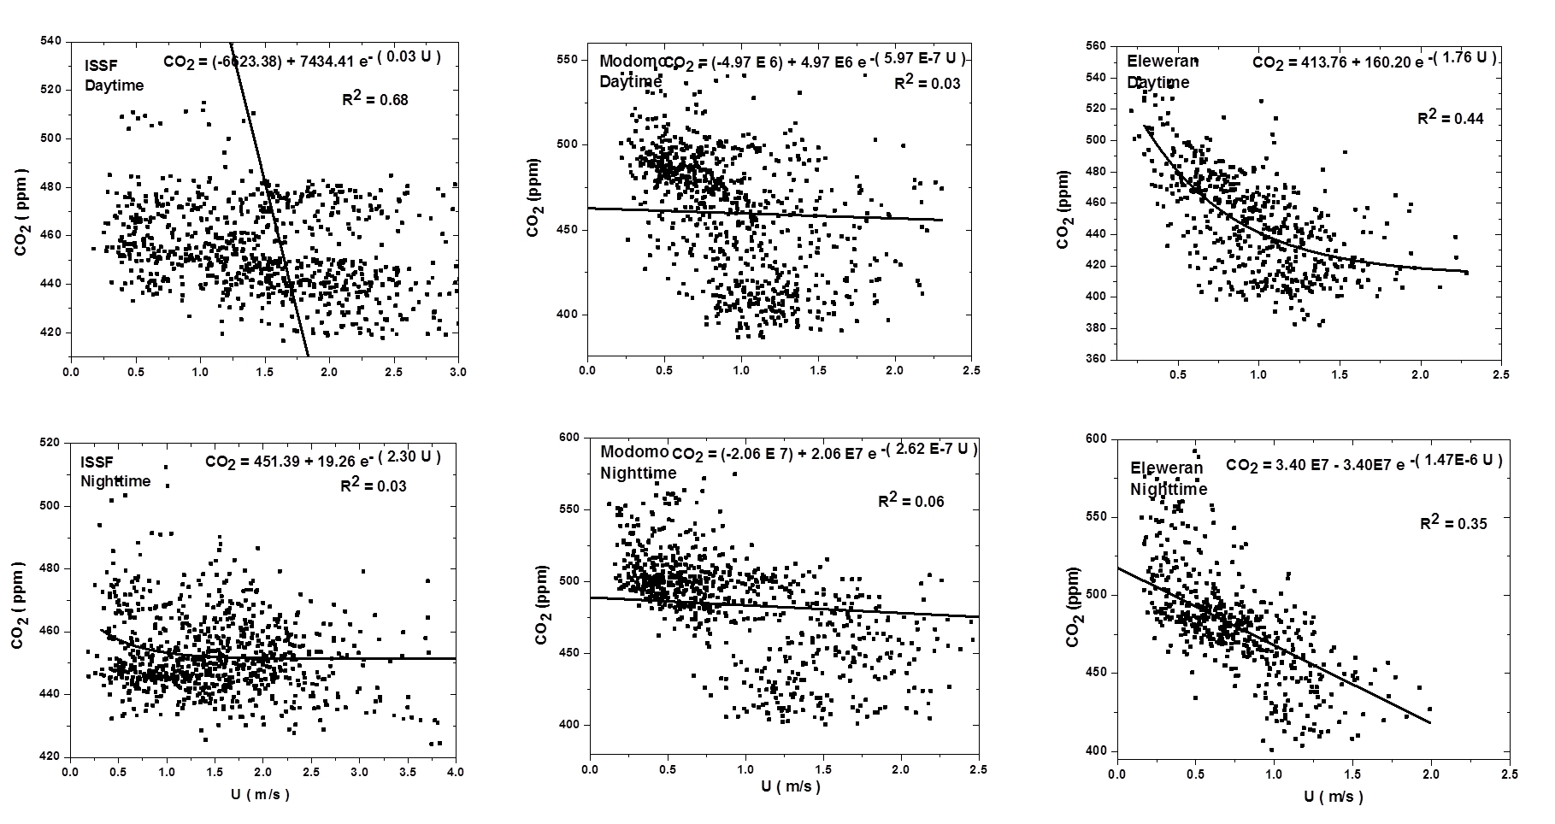
Supp.Fig 1 (a): Exponential fits of CO₂ (Day and Nighttime) to Wind Speed for ISSF, Modomo, and Eleweran sites
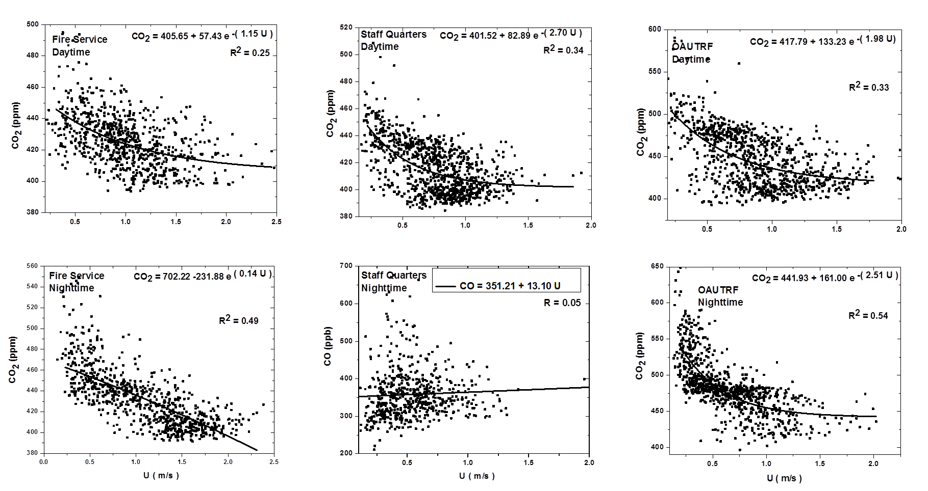
Supp.Fig 1 (b): Exponential fits of CO₂ (Day and Nighttime) to Wind Speed for Fire service, Staff Quarters and OAUTRF sites
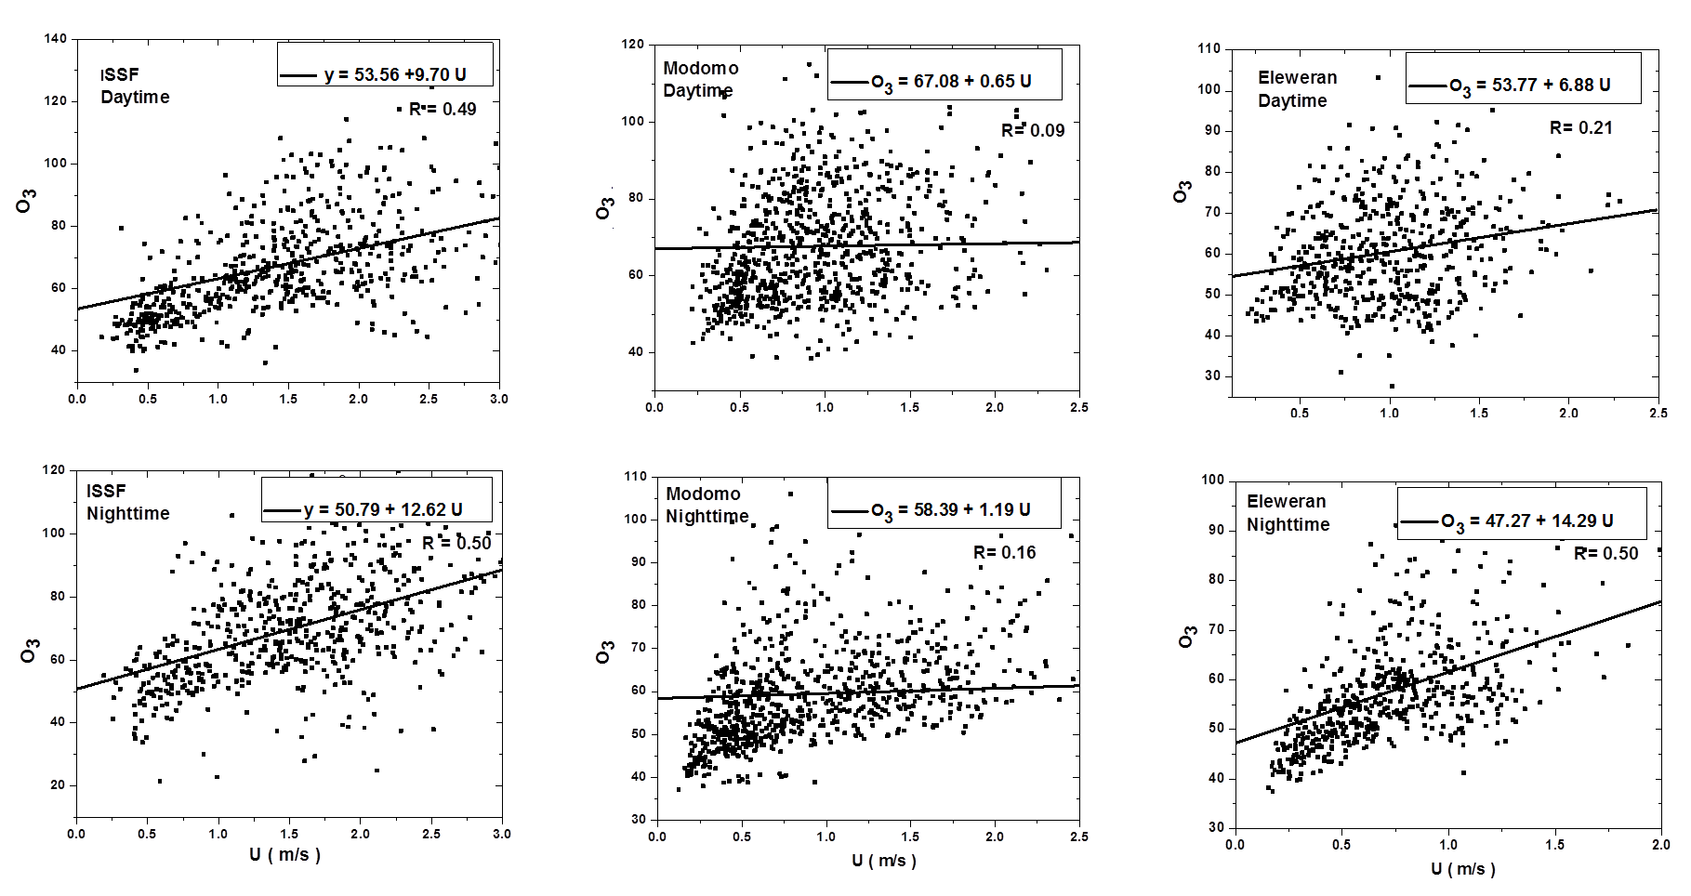
Supp.Fig 1 (c): Exponential fits of O₃ (Day and Nighttime) to Wind Speed for ISSF, Modomo and Eleweran sites

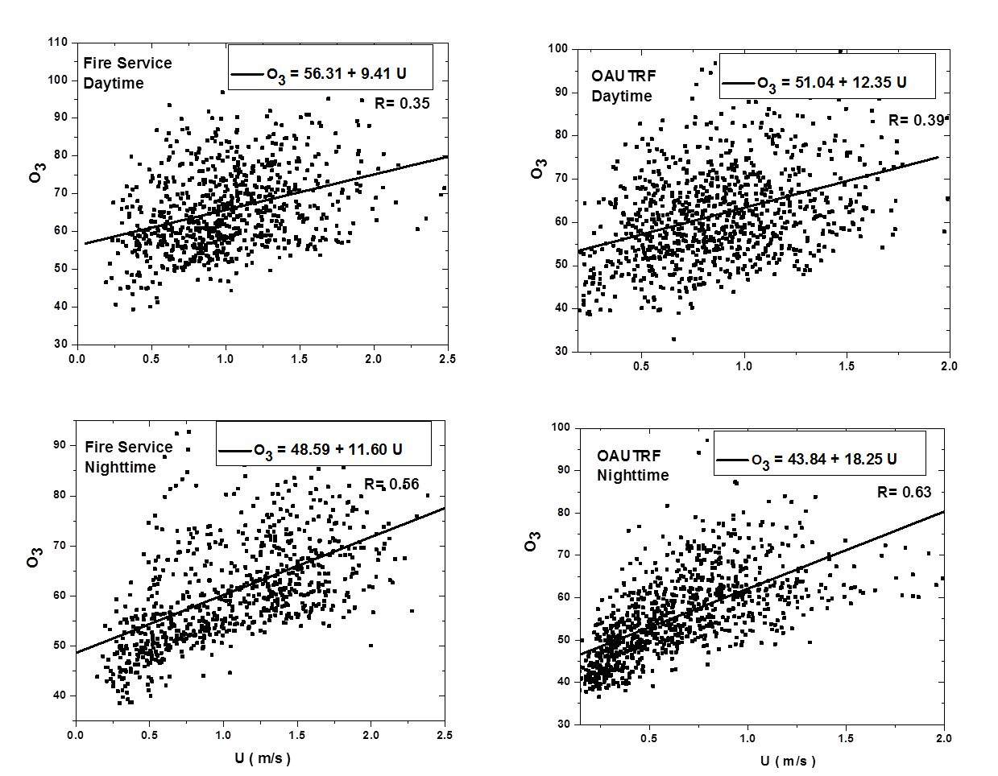
Supp.Fig 1 (d): Exponential fits of O₃ (Day and Nighttime) to Wind Speed for Fire service and OAUTRF sites
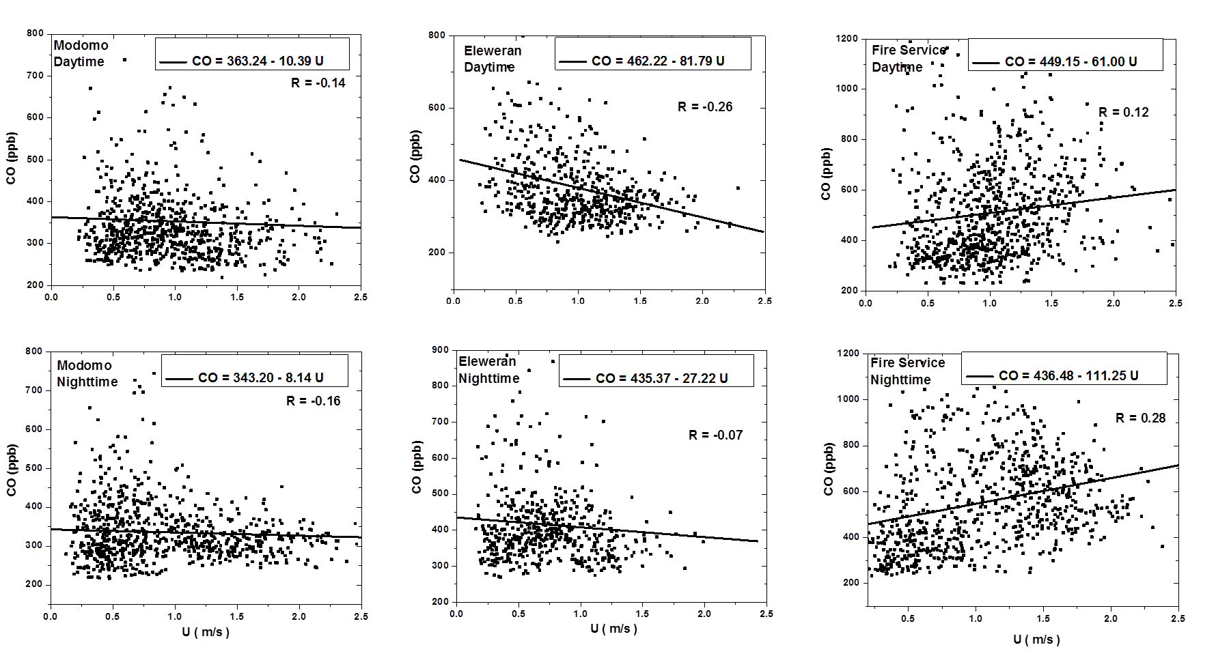
Supp.Fig 1 (e): Exponential fits of CO (Day and Nighttime) to Wind Speed for Modomo, Eleweran and Fire service sites

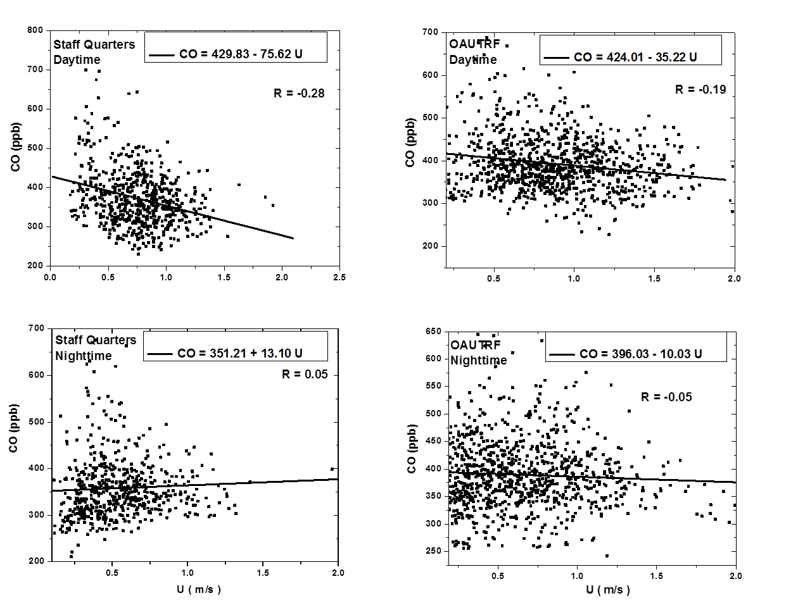
Supp.Fig 1 (f): Exponential fits of CO (Day and Nighttime) to Wind Speed for Staff Quarters and OAUTRF sites
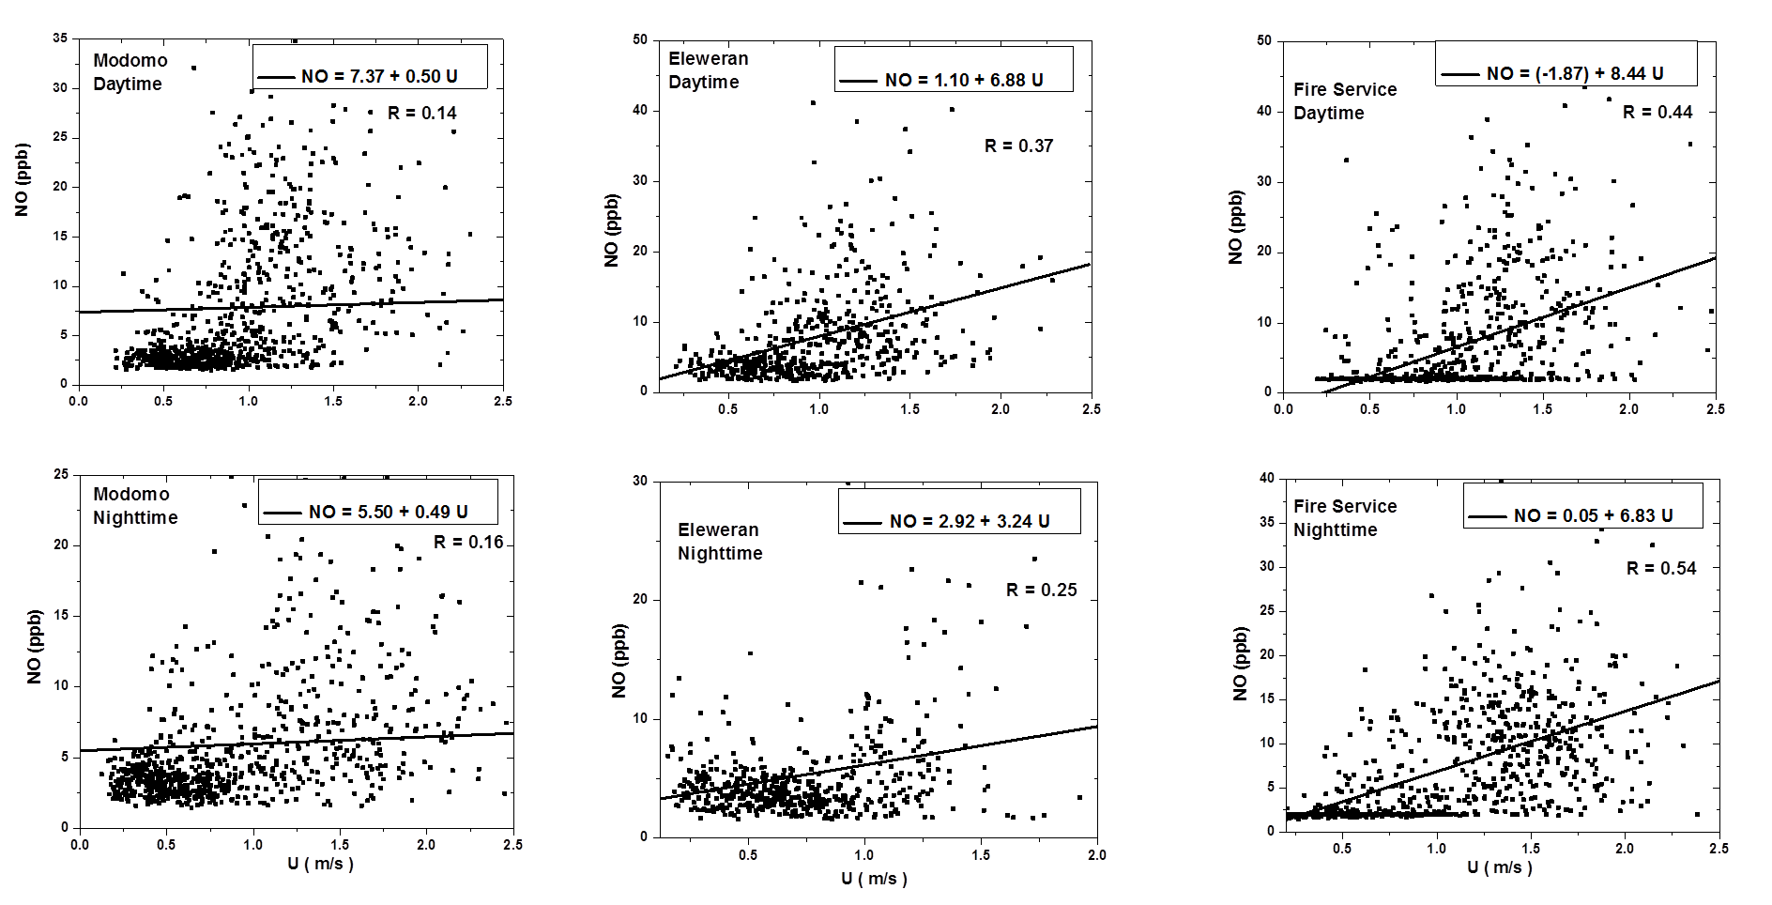
Supp.Fig 1 (g): Exponential fits of NO (Day and Nighttime) to Wind Speed for Modomo, Eleweran and Fire service sites
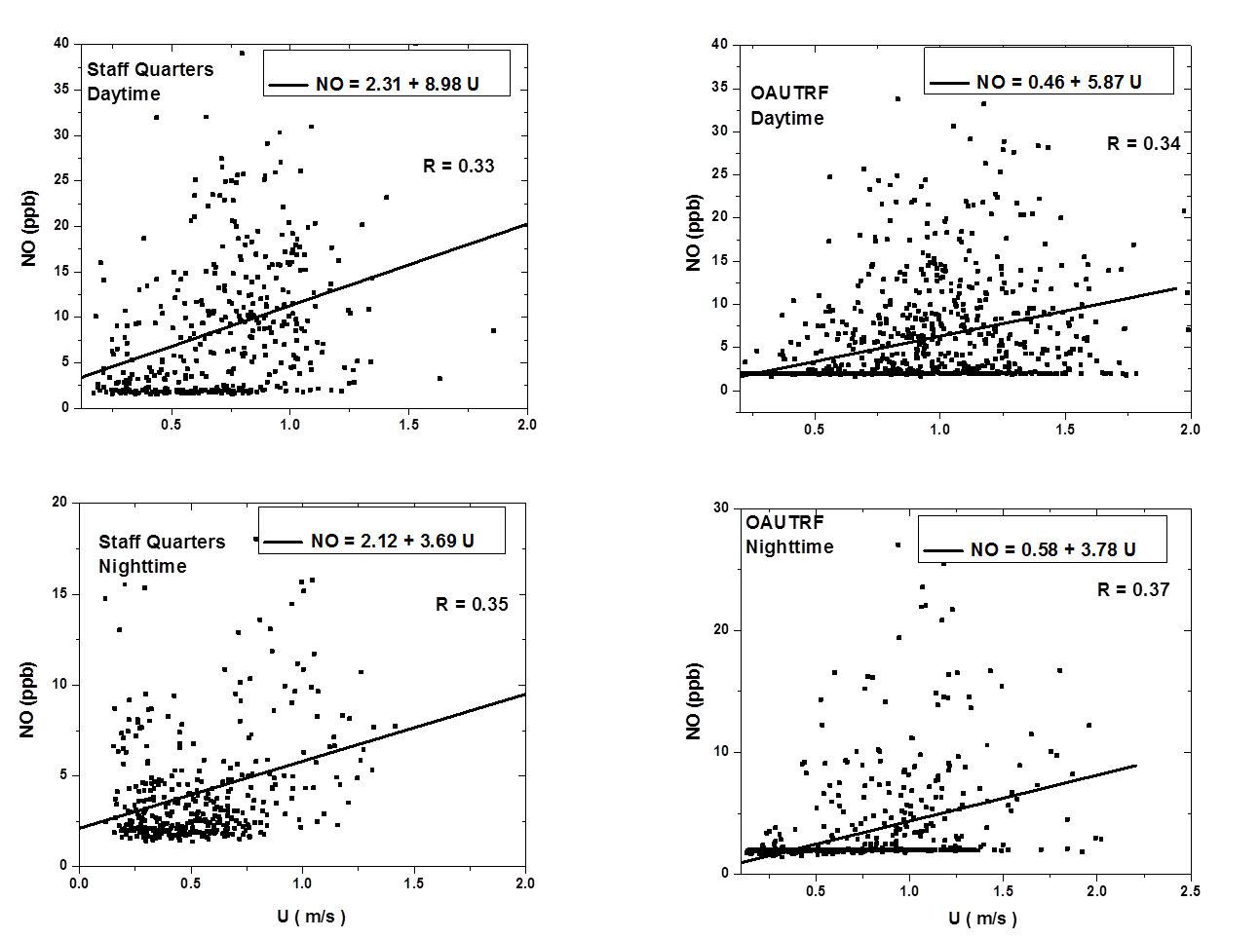
Supp.Fig 1 (h): Exponential fits of NO (Day and Nighttime) to Wind Speed for Staff Quarters and OAUTRF sites
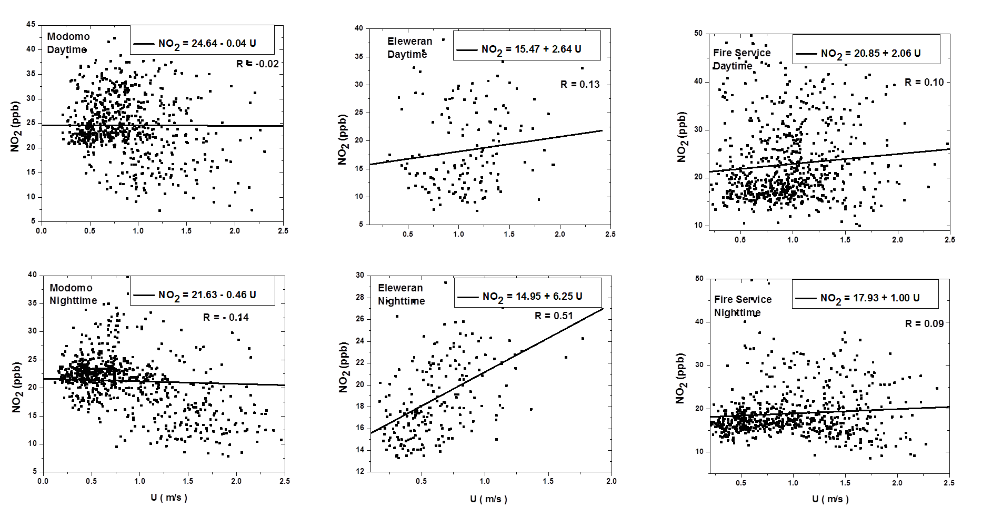
Supp.Fig 1 (i): Exponential fits of NO₂ (Day and Nighttime) to Wind Speed for Modomo, Eleweran and Fire Service sites
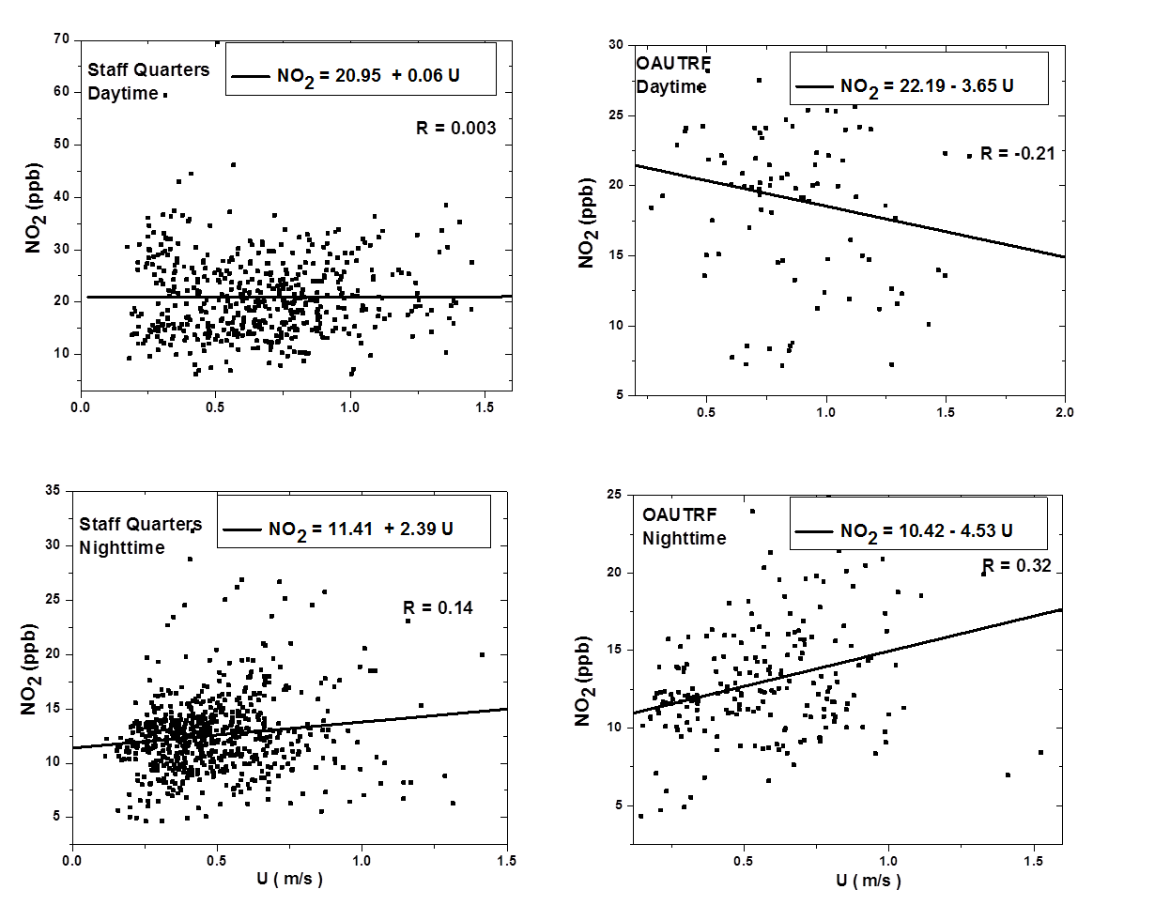
Supp.Fig 1 (j): Exponential fits of NO₂ (Day and Nighttime) to Wind Speed for Staff Quarters and OAUTRF sites
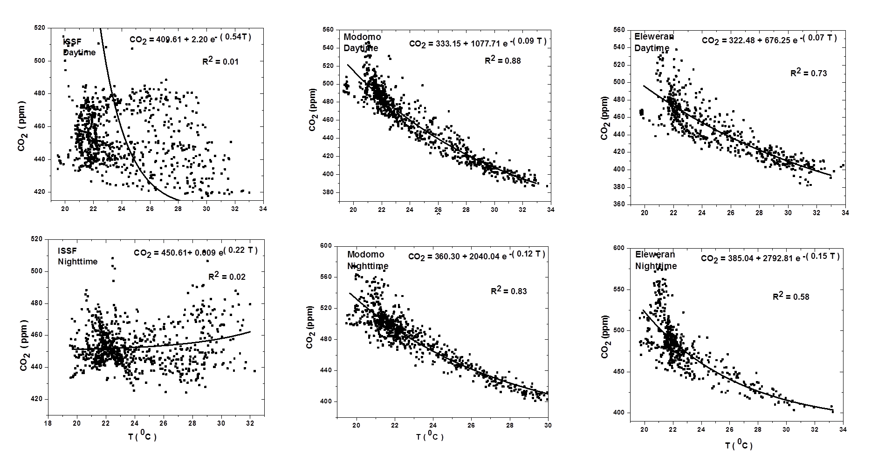
Supp.Fig 2 (a): Exponential fits of CO₂ (Day and Nighttime) to Temperature for ISSF, Modomo, and Eleweran sites
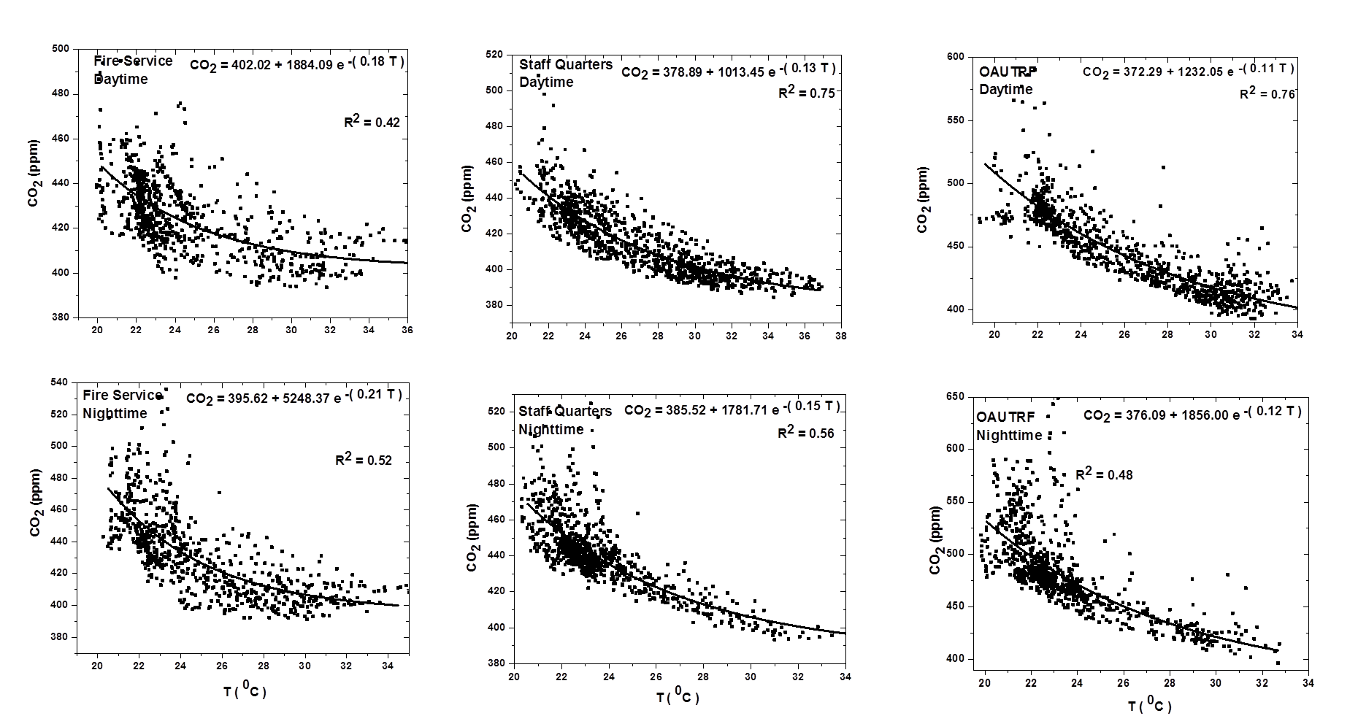
Supp.Fig 2 (b): Exponential fits of CO₂ (Day and Nighttime) to Temperature for Fire service, Staff Quarters and OAUTRF sites
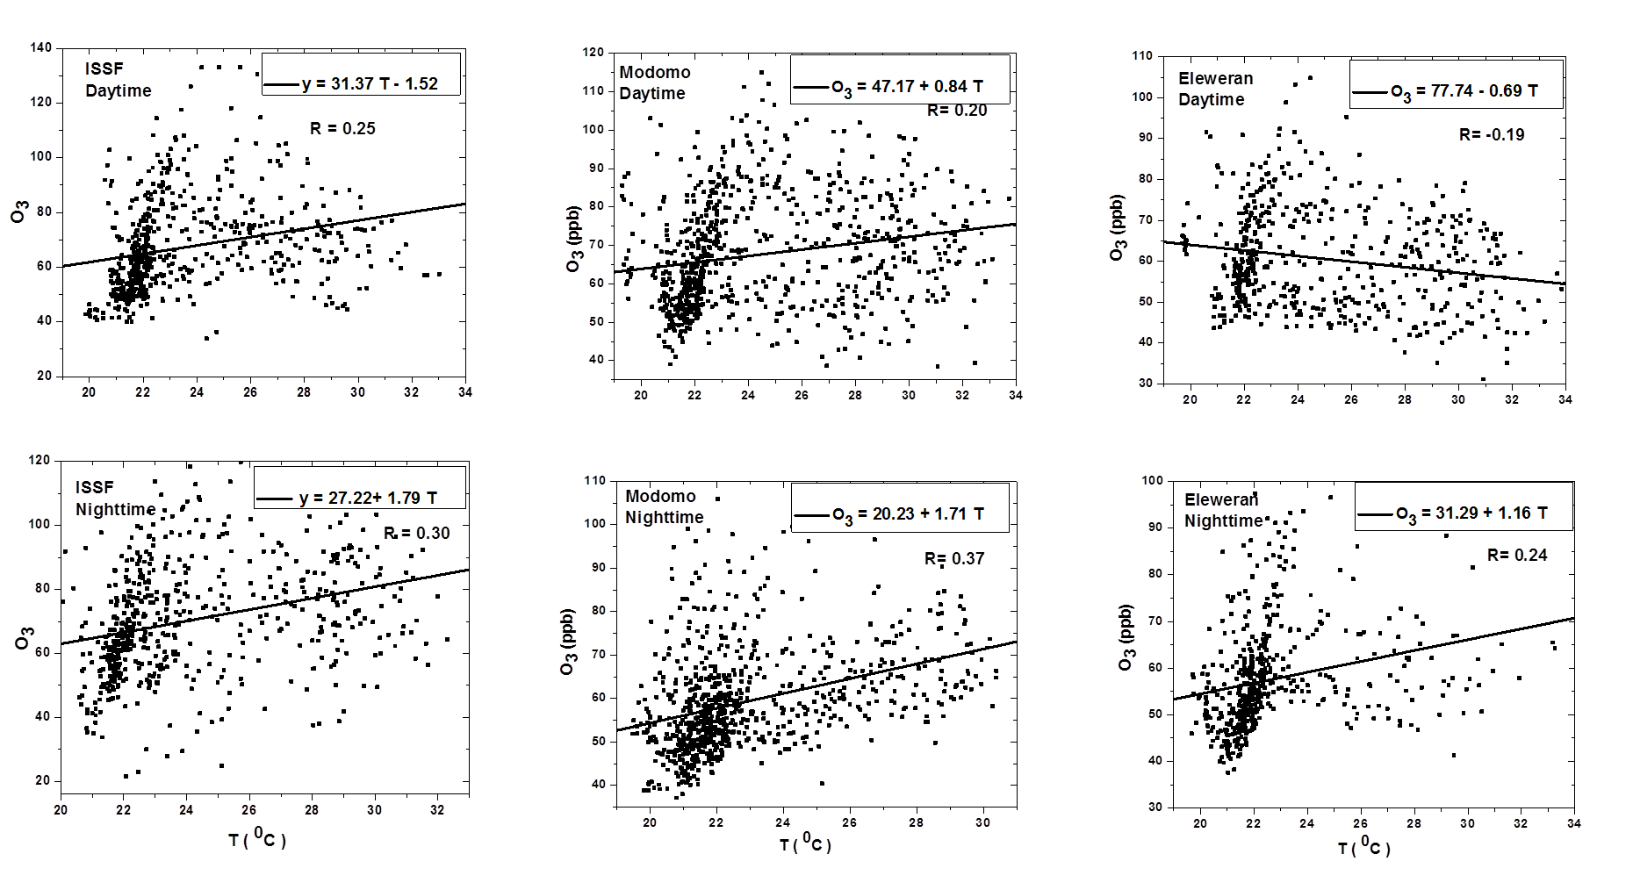
Supp.Fig 2 (c): Exponential fits of O₃ (Day and Nighttime) to Temperature for ISSF, Modomo and Eleweran sites
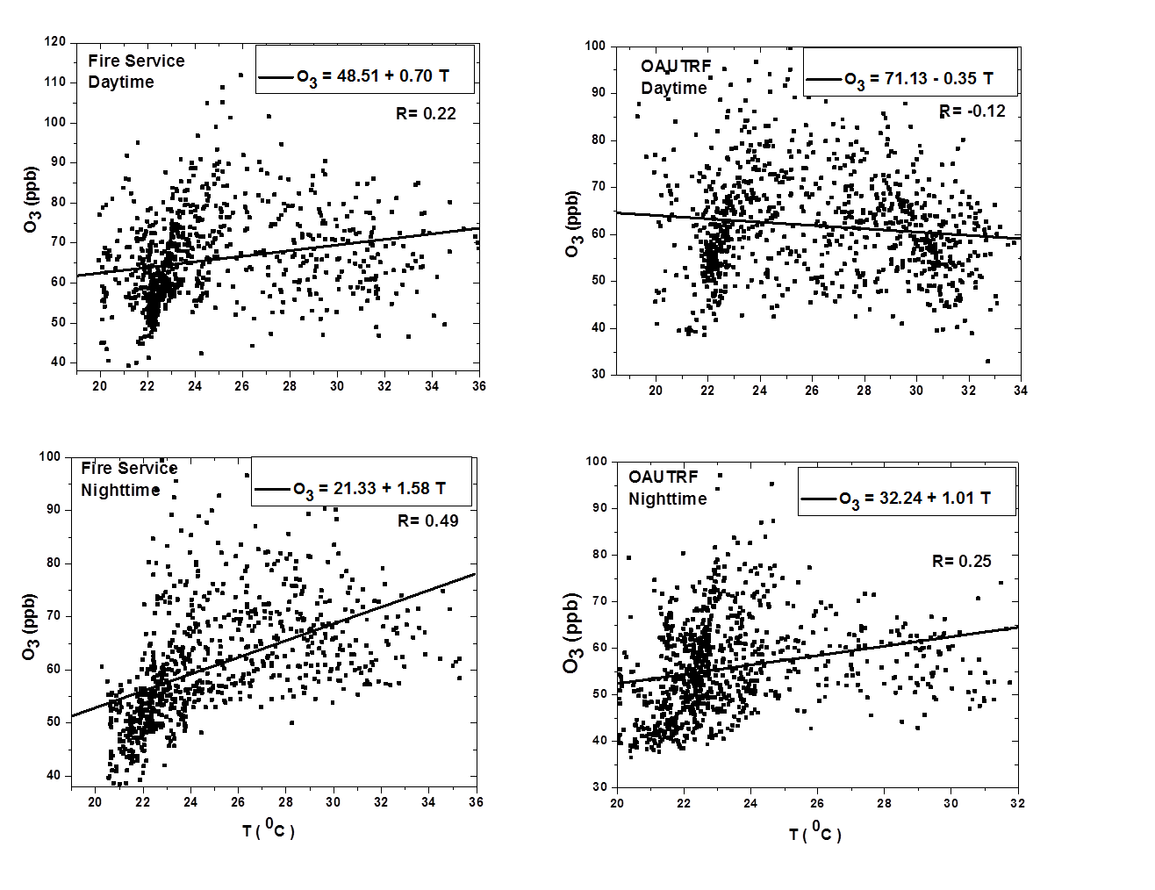
Supp.Fig 2 (d): Exponential fits of O₃ (Day and Nighttime) to Temperature for Fire Service and OAUTRF sites
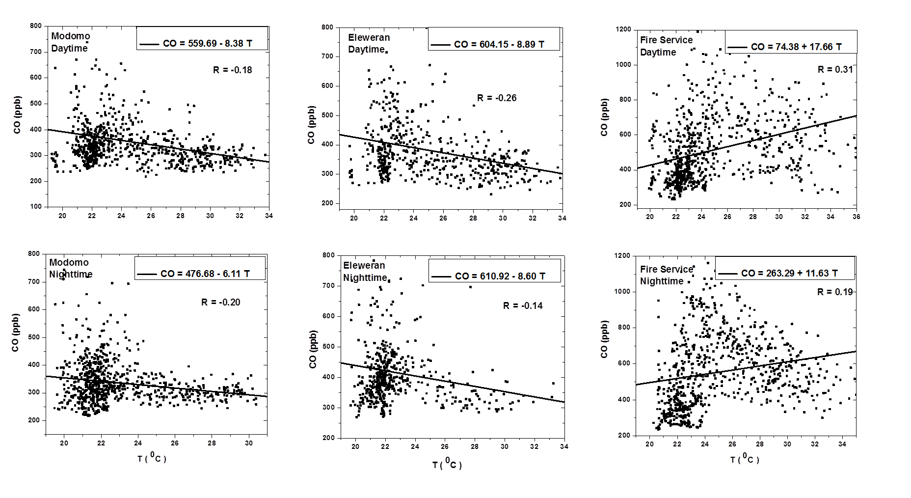
Supp.Fig 2 (e): Exponential fits of CO (Day and Nighttime) to Temperature for Modomo Eleweran and Fire service sites
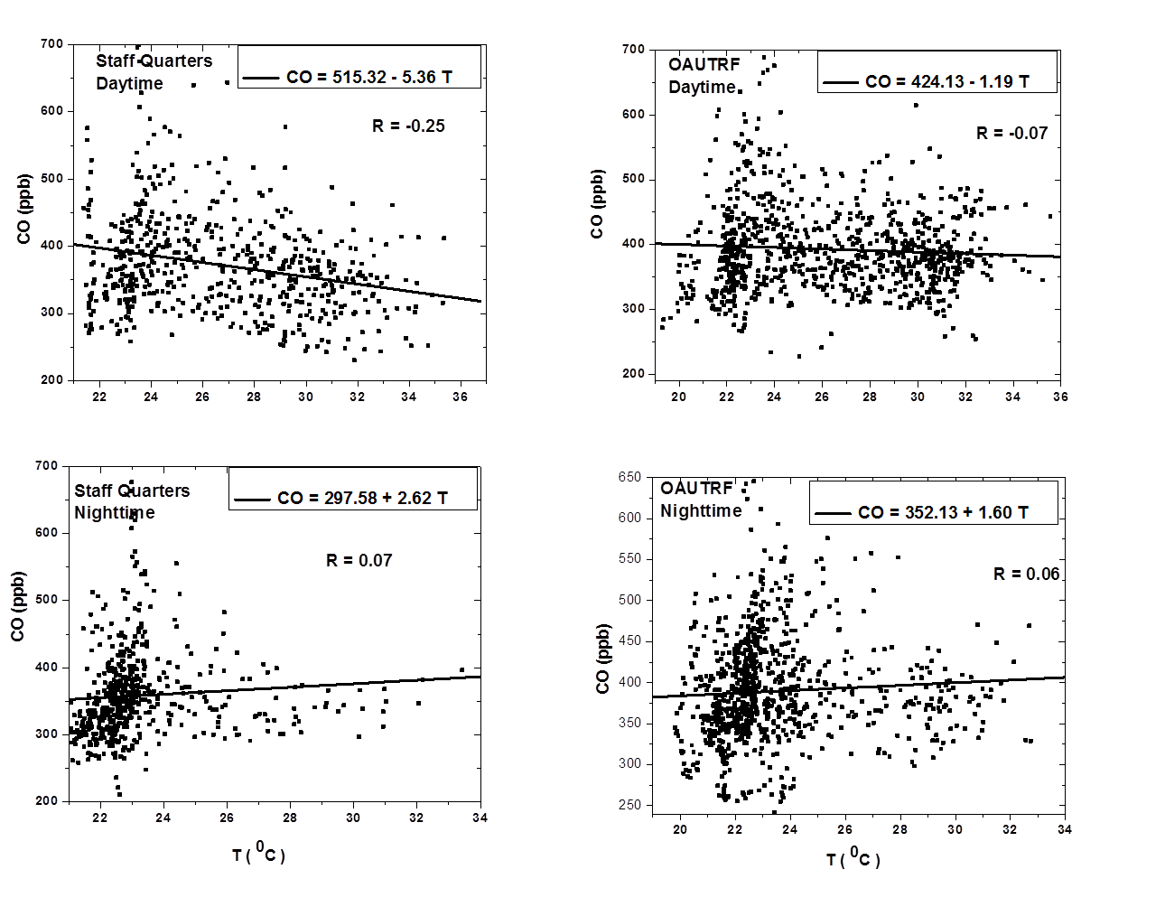
Supp.Fig 2 (f): Exponential fits of CO (Day and Nighttime) to Temperature for Staff Quarters and OAUTRF sites
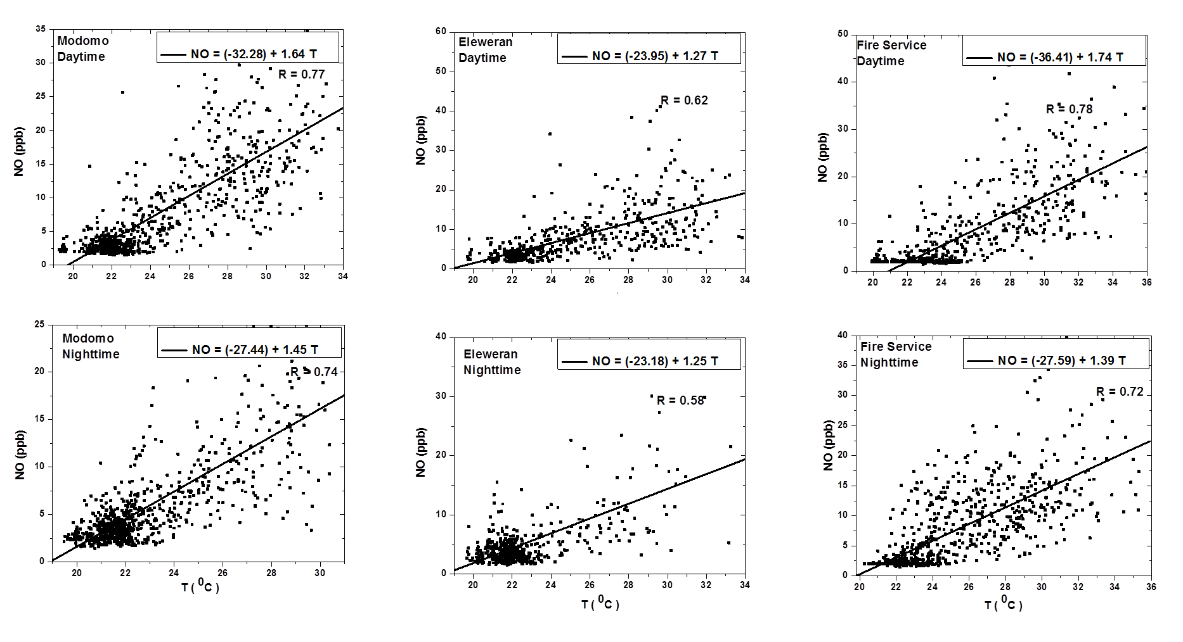
Supp.Fig 2 (g): Exponential fits of NO (Day and Nighttime) to Temperature for Modomo Eleweran and Fire service sites
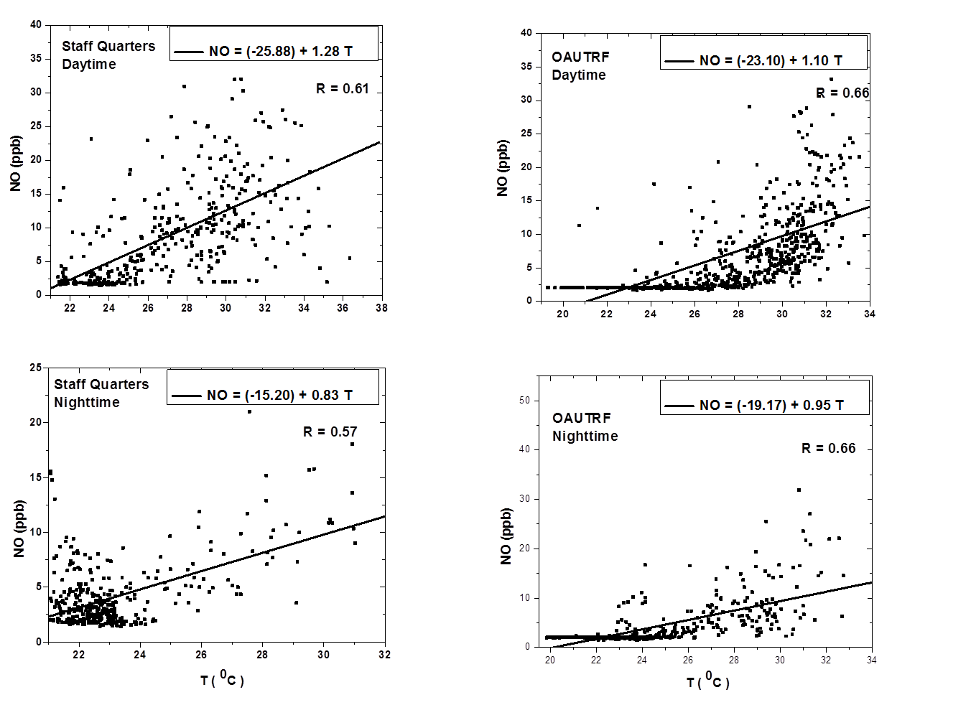
Supp.Fig 2 (h): Exponential fits of NO (Day and Nighttime) to Temperature for Staff Quarters and OAUTRF sites
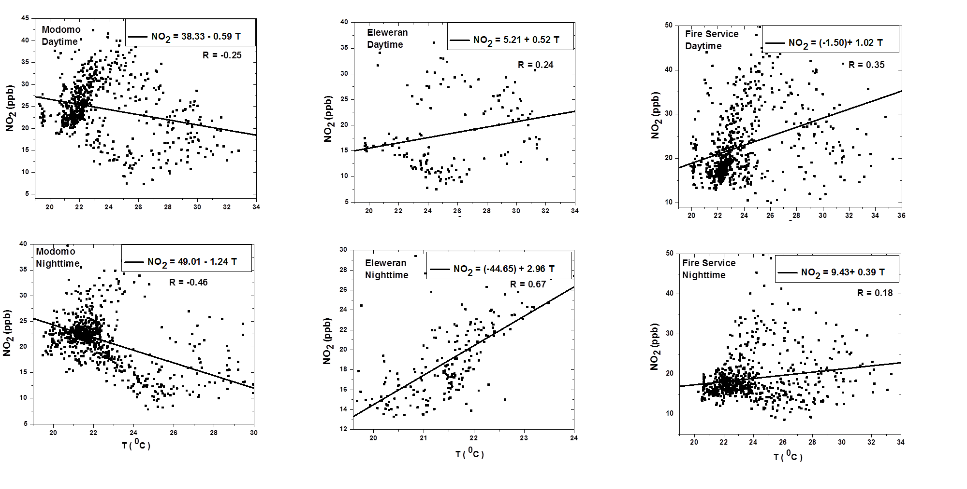
Supp.Fig 2 (i): Exponential fits of NO₂ (Day and Nighttime) to Temperature for Modomo, Eleweran and Fire service sites
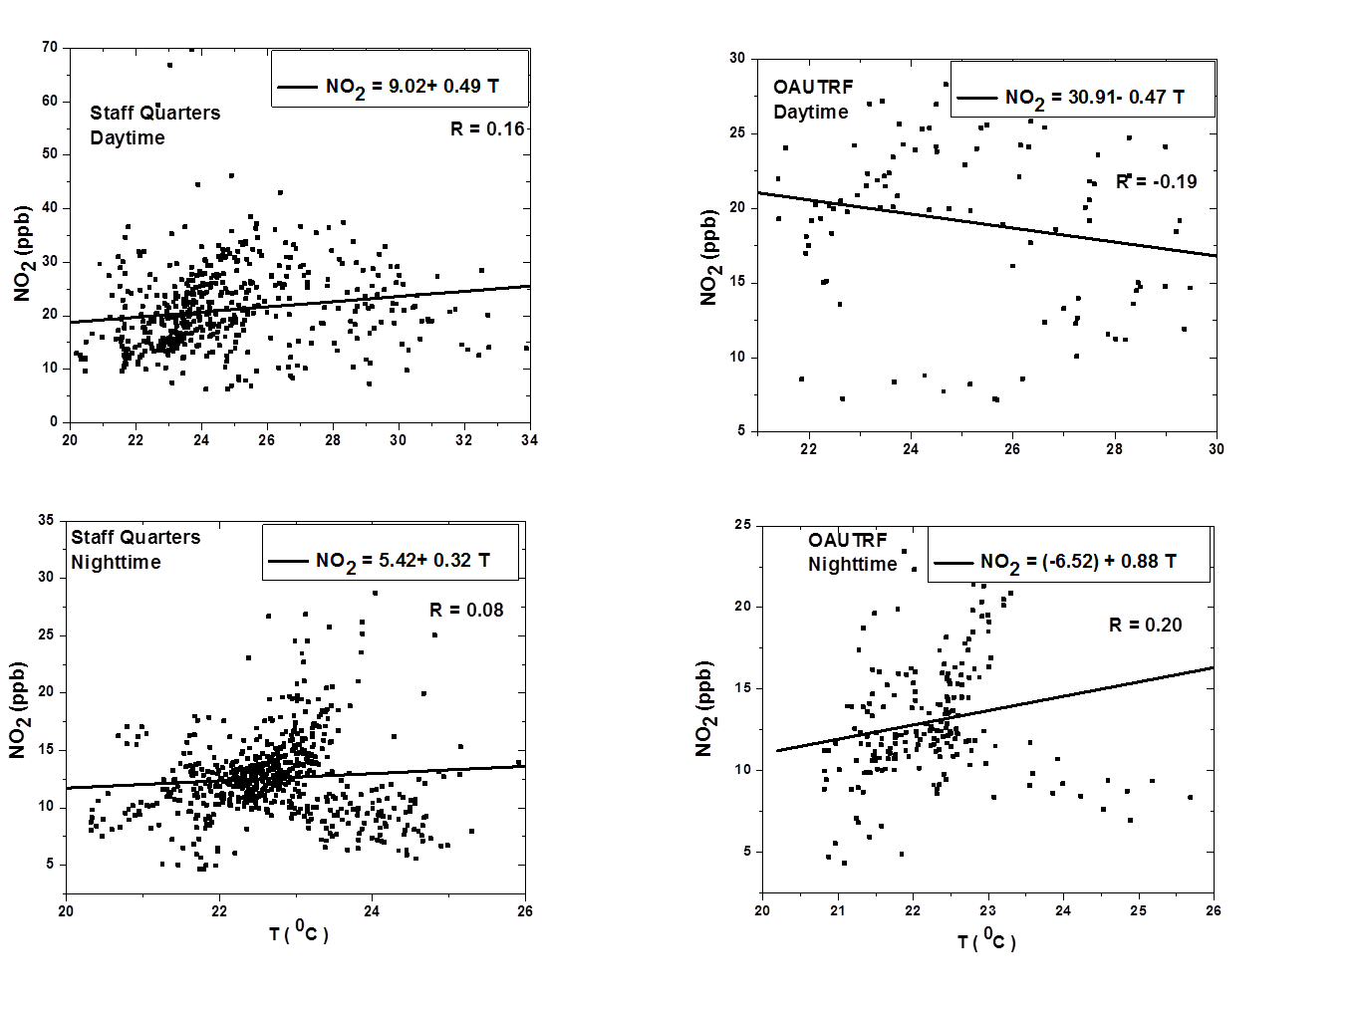
Supp.Fig 2 (j): Exponential fits of NO₂ (Day and Nighttime) to Temperature for Staff Quarters and OAUTRF sites
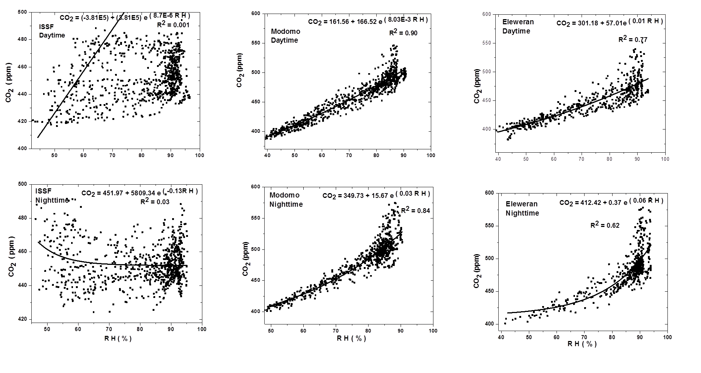Supp.Fig 3 (a): Exponential fits of CO₂ (Day and Nighttime) to Temperature for ISSF, Modomo and Eleweran sites
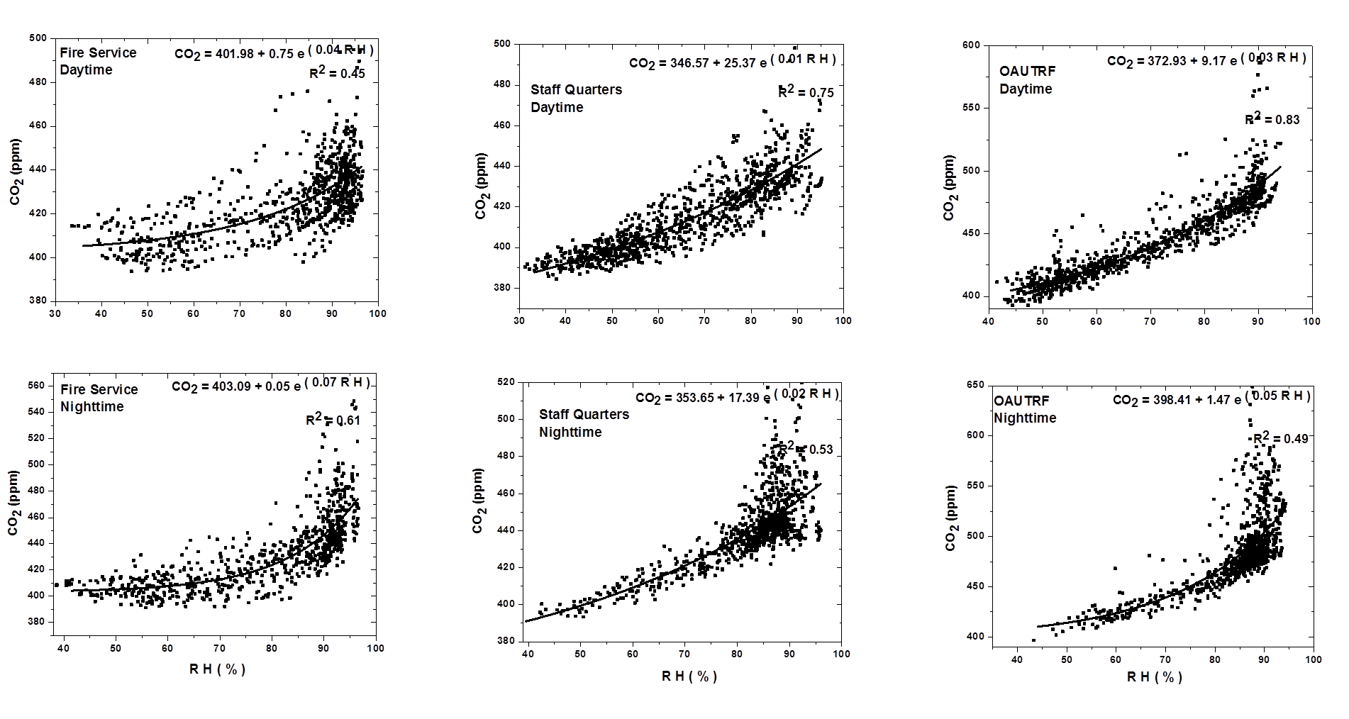
Supp.Fig 3 (b): Exponential fits of CO₂ (Day and Nighttime) to Temperature for Fire Service, Staff Quarters and OAUTRF sites
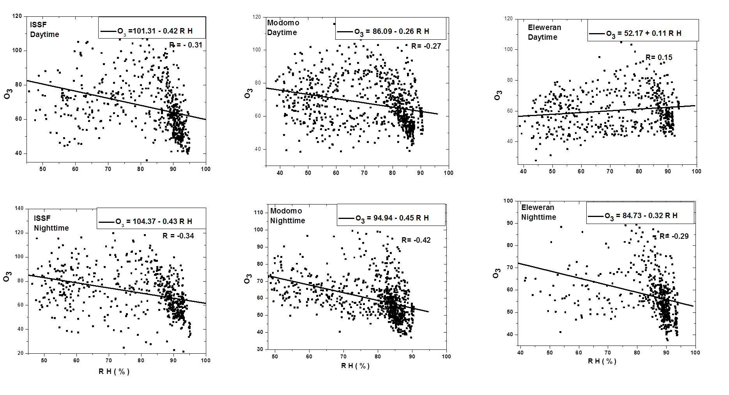
Supp.Fig 3 (c): Exponential fits of O₃ (Day and Nighttime) to Temperature for ISSF, Modomo and Eleweran sites
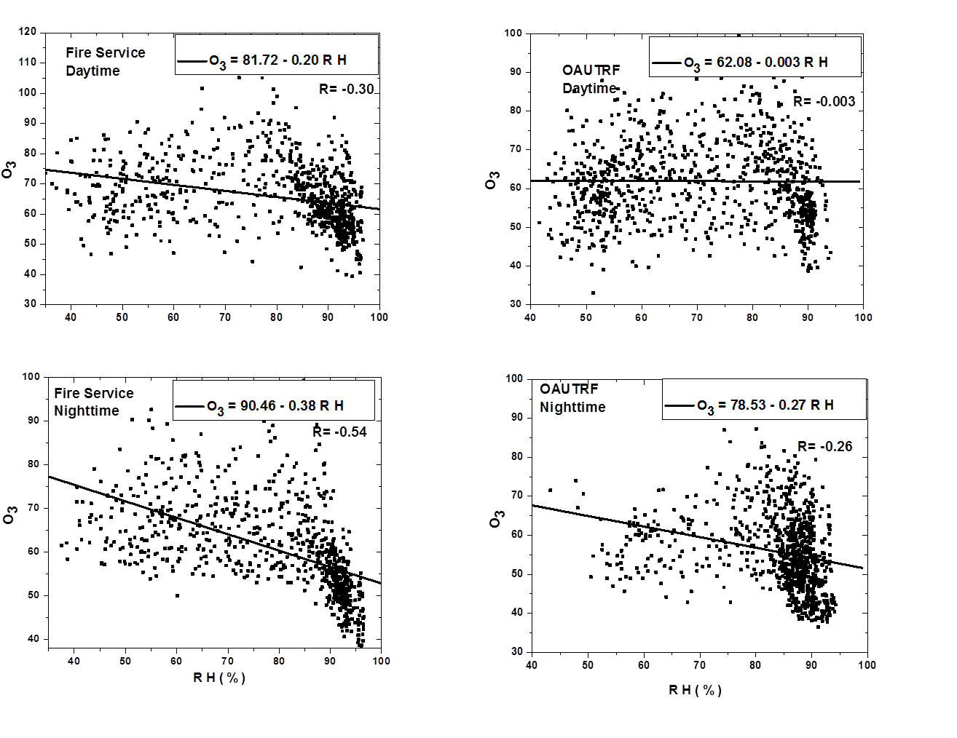
Supp.Fig 3 (d): Exponential fits of O₃ (Day and Nighttime) to Temperature for Fire Service and OAUTRF sites
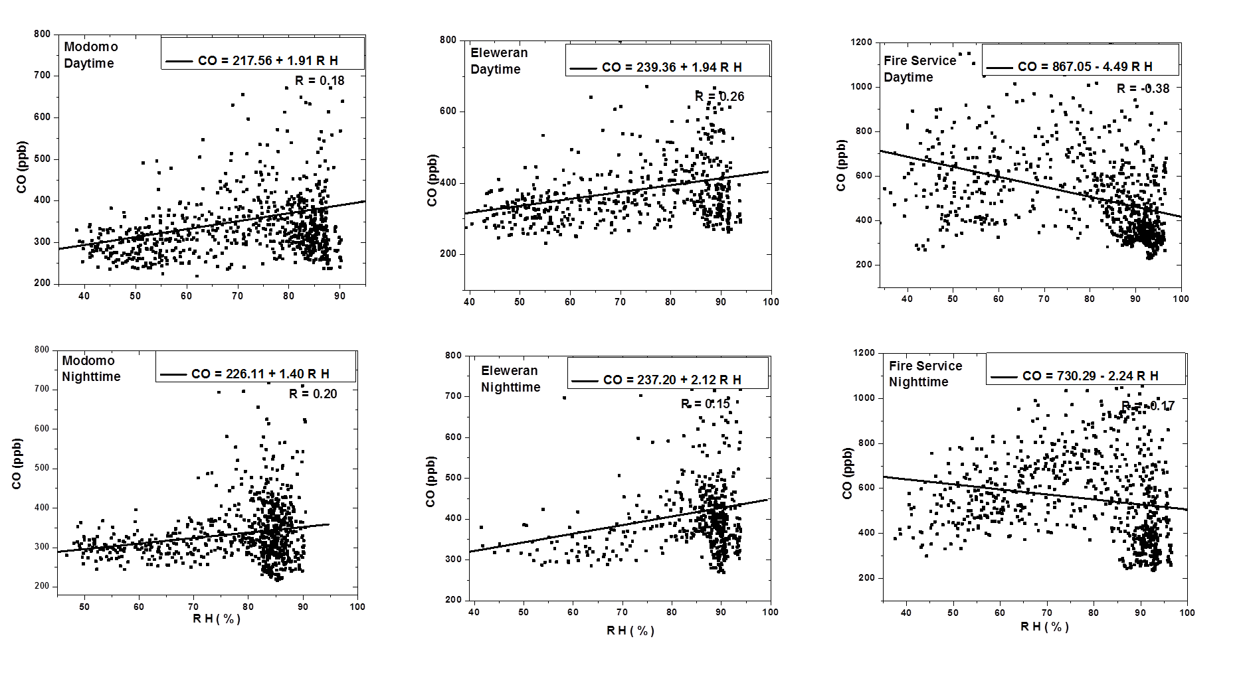
Supp.Fig 3 (e): Exponential fits of CO (Day and Nighttime) to Temperature for Modomo, Eleweran and Fire Service sites
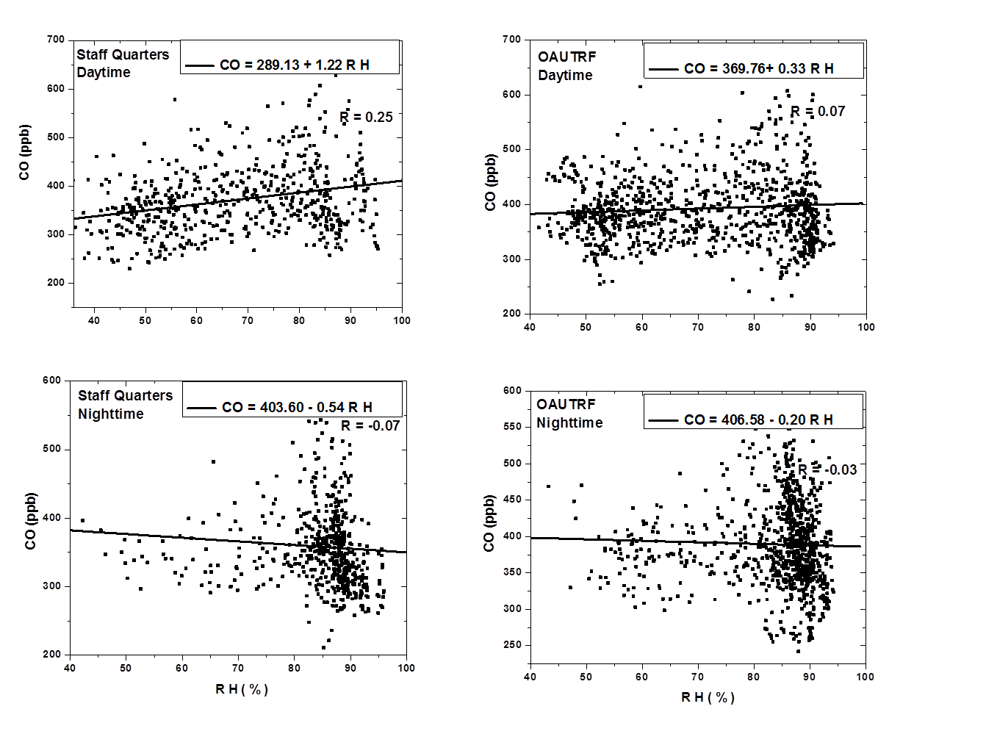
Supp.Fig 3 (f): Exponential fits of CO (Day and Nighttime) to Temperature for Staff Quarters and OAUTRF sites
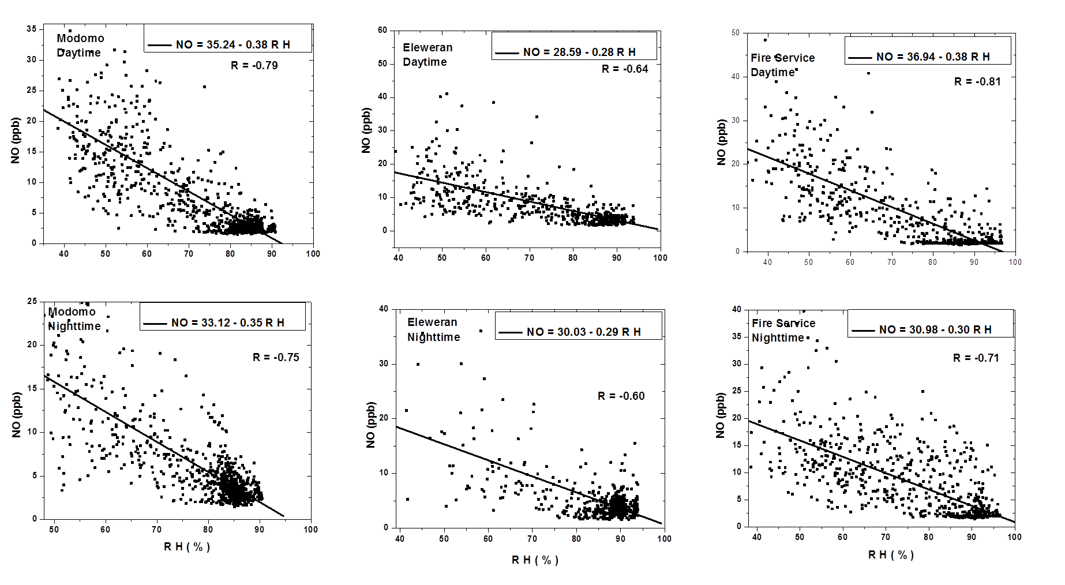
Supp.Fig 3 (g): Exponential fits of NO (Day and Nighttime) to Temperature for Modomo, Eleweran and Fire Service sites
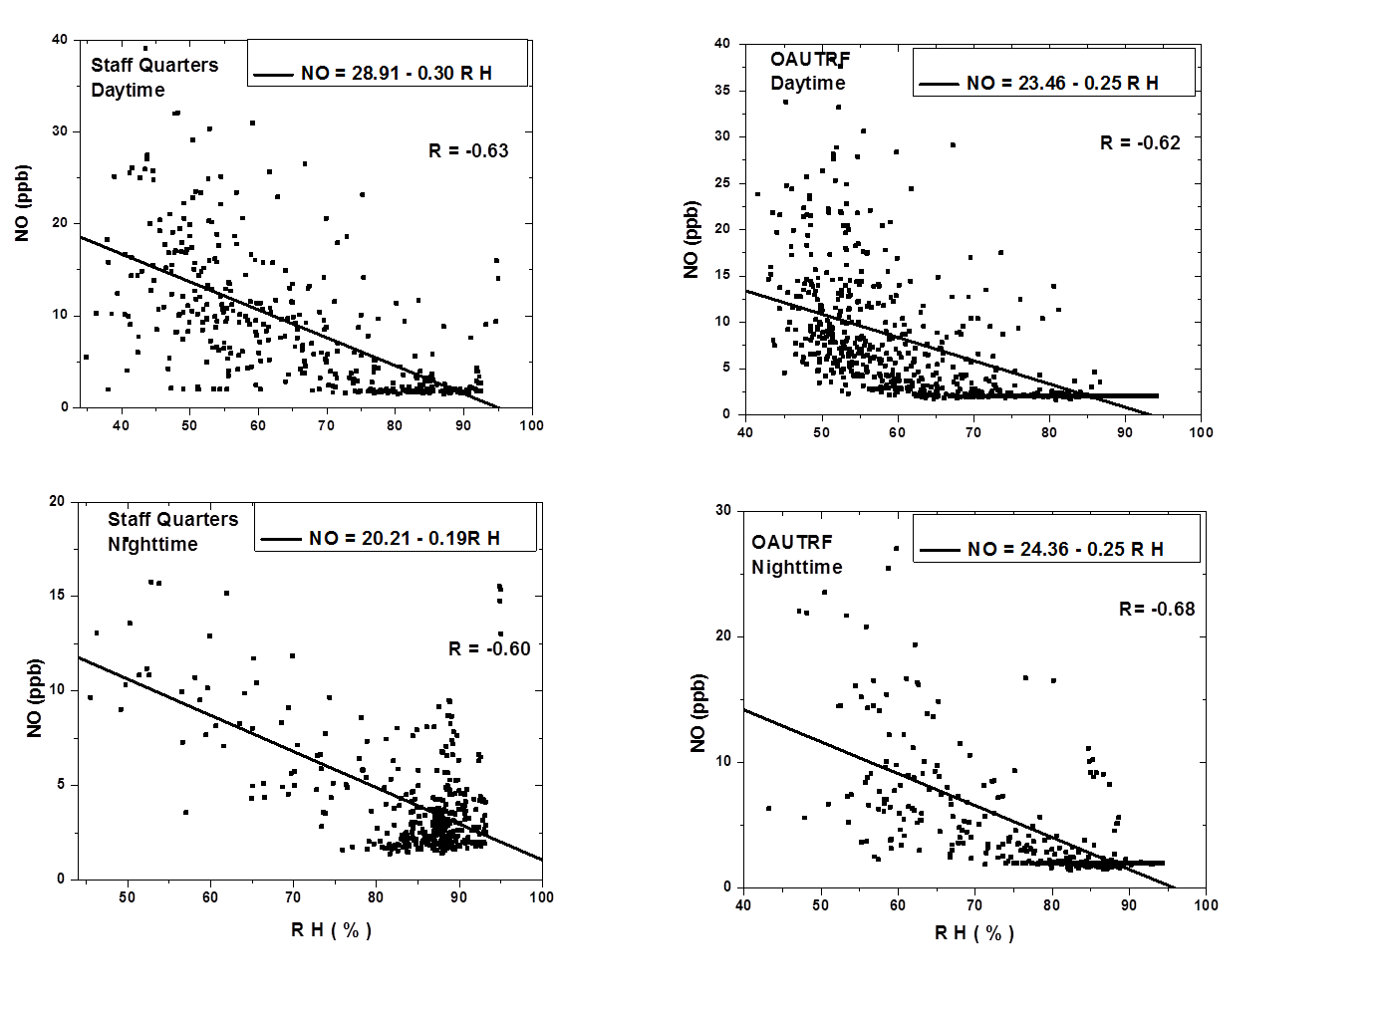
Supp.Fig 3 (h): Exponential fits of NO (Day and Nighttime) to Temperature for Staff Quarters and OAUTRF sites
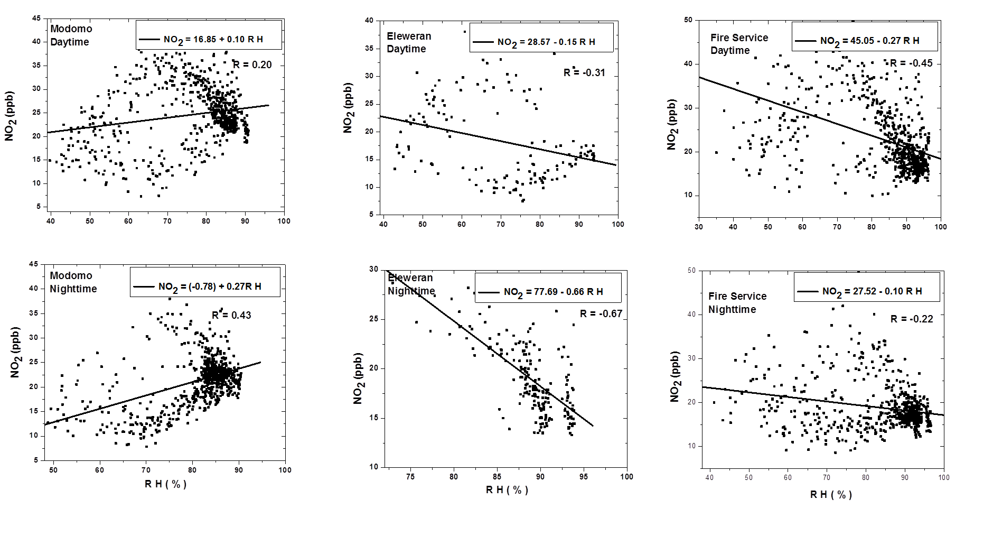
Supp.Fig 3 (i): Exponential fits of NO₂ (Day and Nighttime) to Temperature for Modomo, Eleweran and Fire Service sites
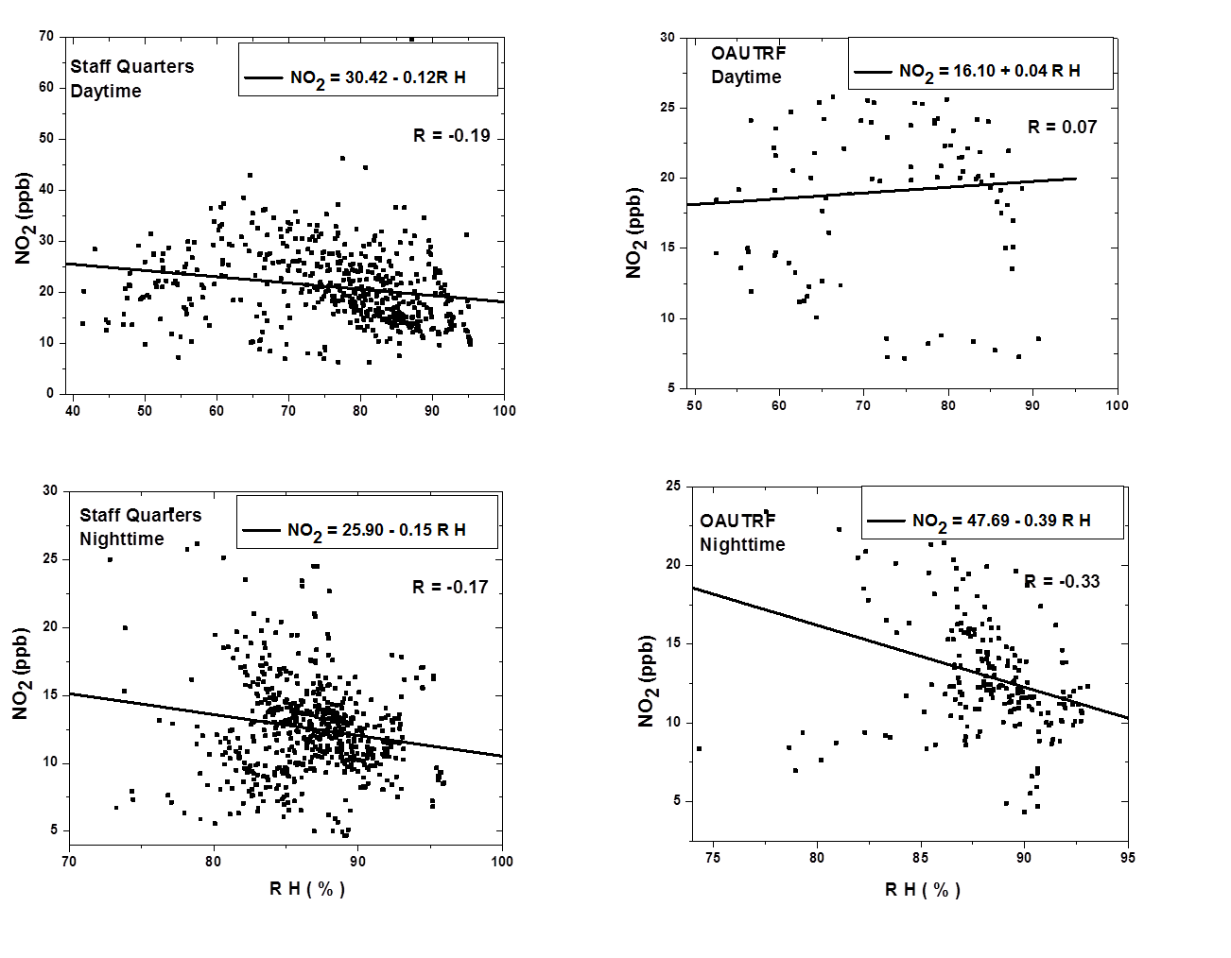
Supp.Fig 3 (j): Exponential fits of NO₂ (Day and Nighttime) to Temperature for Staff Quarters and OAUTRF sites.

