Heavy metal contamination in medicinal plants: Assessing carcinogenic and non-carcinogenic health risks

Mohammad Bashir Sulaiman¹, Auwal M. Adamu², Sulaiman Babayo Ali³, Uzoamaka Virginia Ezenobi⁴, Abdullahi Muhammad Gimba⁵, Oluyinka Omoyeni Akinlotan⁶, Auwal Abubakar⁷

¹Department of Chemistry, Northwest University Sokoto, Sokoto State, Nigeria
²Department of Pharmaceutical and Medicinal Chemistry, Gombe State University, Gombe State, Nigeria
³Department of Chemistry, Nigerian Army University Biu, Borno State, Nigeria
⁴Department of Chemistry, Michael Okpara University of Agriculture, Umudike Nigeria
⁵Department of Science Laboratory Technology, Gombe State Polytechnic, Bajoga, Gombe State, Nigeria
⁶Department of Chemistry, Kogi State College of Education (Technical) Kabba, Kogi State, Nigeria
⁷Department of General Studies, College of Health Sciences and Technology Kaltungu, Gombe State, Nigeria
*Corresponding author’s e-mail: sulaimanmbashir35@gmail.com; sulaiman.mbashir@nwus.edu.ng

Supplementary Material

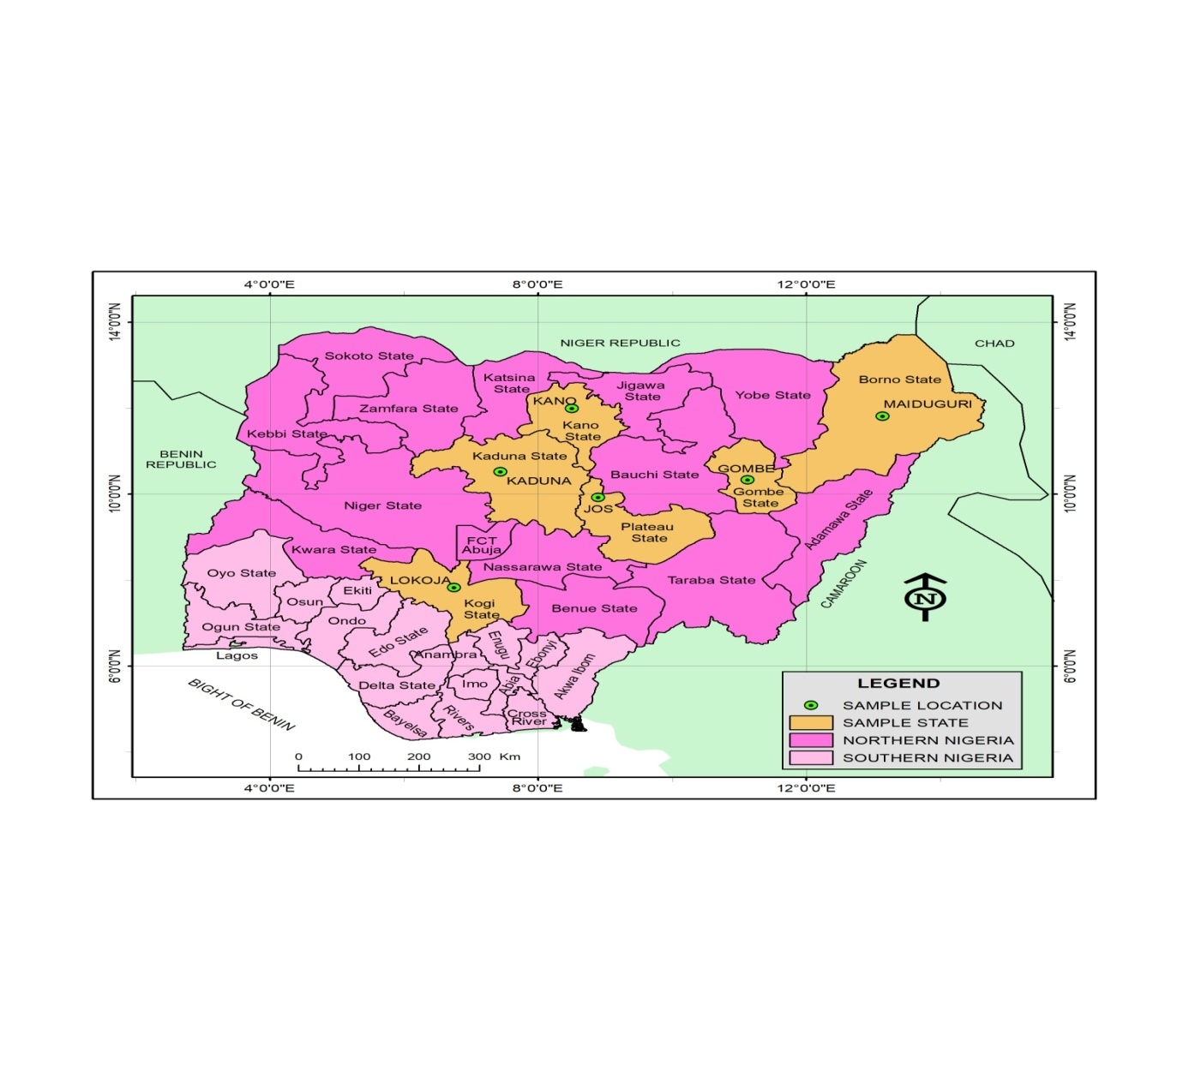
Fig. S1 A map of the study area showing sample locations

Table S1 Operation conditions of AAS for analysis of the heavy metals
_{Metals} | _{λ (nm)} | _{Slit (nm)} | _{Flame type} | _{Lamp current (mA)}
_{Pb} | _{283.3} | _{0.7} | _{Air-acetylene} | ₁₀
_{Cr} | _{357.9} | _{0.7} | _{Air-acetylene} | ₁₀
_{As} | _{193.7} | _{0.2} | _{Air-acetylene} | ₁₀
_{Cd} | _{228.8} | _{0.7} | _{Air-acetylene} | ₈
_{Zn} | _{213.9} | _{0.7} | _{Air-acetylene} | ₁₀
_{Cu} | _{324.7} | _{0.7} | _{Air-acetylene} | ₁₀
_{Ni} | _{232.0} | _{0.2} | _{Air-acetylene} | ₁₀
_{Fe} | _{248.3} | _{0.2} | _{Air-acetylene} | ₁₀

Table S2 The parameters and input assumptions for exposure assessment of metals via ingestion routes
_{Parameters} | _{Meaning} | _{Units} |  | _{Value} |  | _{References}
_{Parameters} | _{Meaning} | _{Units} | _{Non cancer} |  | _{cancer} | _{References}
_{Parameters} | _{Meaning} | _{Units} | _{Adults} | _{Children} |  | _{References}
_{C} | Concentration of metals in the plants | _{mg/kg}
_{FIR} | _{Daily consumption rate} | _{mg/day} | _{0.75} | _{0.25} |  | _{Ssempijja et al. (2020)}
_{BW} | _{Body weight} | _{kg} | ₆₀ | ₁₅ |  | _{USEPA (2001)}
_{EF} | _{Exposure frequency} | _{days/year} | ₃₆₅ | ₃₆₅ |  | _{USEPA (2004)}
_{ED} | _{Exposure duration} | _{years} | ₂₅ | ₆ | ₇₀ | _{USEPA (2001)}
_{BW} | _{Body weight} | _{kg} | ₆₀ | ₁₅ |  | _{USEPA (2001)}
_{ATnc} | _{Average time for carcinogens} | _{days} | _{ED×365 days} | _{ED×365 days} |  | _{USEPA (2001)}
_{ATc} | _{Average time for carcinogens} | _{days} | _{ED×365 days} | _{ED×365 days} | _{70×365 days} | _{USEPA (2001)}

Table S3 Estimated daily intakes (EDI) of the heavy metals in the in medicinal plant samples
_{Metals} | _{Age group} | _{RfD} | _{EDI}
_{Metals} | _{Age group} | _{RfD} | ₁ | ₂ | ₃ | ₄ | ₅ | ₆ | ₇ | ₈ | ₉ | ₁₀ | ₁₁ | ₁₂
_{Pb} | _{Children} | _{4.00×10}⁻⁰³ | _{2.85×10}⁻⁰⁵ | _{3.73×10}⁻⁰⁵ | _{5.53×10}⁻⁰⁵ | _{8.00×10}⁻⁰⁵ | _{3.17×10}⁻⁰⁵ | _{6.13×10}⁻⁰⁵ | _{8.12×10}⁻⁰⁵ | _{4.04×10}⁻⁰⁵ | _{1.45×10}⁻⁰⁴ | _{1.50×10}⁻⁰⁴ | _{5.22×10}⁻⁰⁵ | _{7.90×10}⁻⁰⁵
_{Pb} | _{Adults} | _{4.00×10}⁻⁰³ | _{2.03×10}⁻⁰⁵ | _{2.80×10}⁻⁰⁵ | _{4.15×10}⁻⁰⁵ | _{6.00×10}⁻⁰⁵ | _{9.50×10}⁻⁰⁵ | _{4.60×10}⁻⁰⁵ | _{6.09×10}⁻⁰⁵ | _{3.06×10}⁻⁰⁵ | _{1.09×10}⁻⁰⁵ | _{1.13×10}⁻⁰⁴ | _{3.79×10}⁻⁰⁵ | _{5.99×10}⁻⁰⁵
_{Cr} | _{Children} | _{3.00×10}⁻⁰³ | _{3.27×10}⁻⁰⁵ | _{1.64×10}⁻⁰⁵ | _{3.83×10}⁻⁰⁶ | _{1.95×10}⁻⁰⁵ | _{3.35×10}⁻⁰⁵ | _{2.02×10}⁻⁰⁵ | _{2.12×10}⁻⁰⁵ | _{3.47×10}⁻⁰⁵ | _{1.08×10}⁻⁰⁵ | _{7.17×10}⁻⁰⁶ | _{2.05×10}⁻⁰⁵ | _{1.58×10}⁻⁰⁵
_{Cr} | _{Adults} | _{3.00×10}⁻⁰³ | _{2.48×10}⁻⁰⁵ | _{1.24×10}⁻⁰⁵ | _{2.84×10}⁻⁰⁶ | _{1.46×10}⁻⁰⁵ | _{2.51×10}⁻⁰⁵ | _{1.51×10}⁻⁰⁵ | _{1.59×10}⁻⁰⁵ | _{2.60×10}⁻⁰⁵ | _{8.13×10}⁻⁰⁵ | _{5.38×10}⁻⁰⁶ | _{1.54×10}⁻⁰⁵ | _{1.19×10}⁻⁰⁵
_{As} | _{Children} | _{3.00×10}⁻⁰⁴ | _{0.00×10}⁻⁰⁰ | _{1.67×10}⁻⁰⁷ | _{3.33×10}⁻⁰⁶ | _{0.0010}⁻⁰⁰ | _{3.33×10}⁻⁰⁶ | _{0.0010}⁻⁰⁰ | _{0.0010}⁻⁰⁰ | _{3.33×10}⁻⁰⁶ | _{5.00×10}⁻⁰⁷ | _{8.33×10}⁻⁰⁷ | _{8.33×10}⁻⁰⁷ | _{0.0010}⁻⁰⁰
_{As} | _{Adults} | _{3.00×10}⁻⁰⁴ | _{0.0010}⁻⁰⁰ | _{1.25×10}⁻⁰⁷ | _{2.50×10}⁻⁰⁶ | _{0.0010}⁻⁰⁰ | _{2.50×10}⁻⁰⁶ | _{0.0010}⁻⁰⁰ | _{0.0010}⁻⁰⁰ | _{2.50×10}⁻⁰⁶ | _{3.75×10}⁻⁰⁷ | _{6.25×10}⁻⁰⁷ | _{6.25×10}⁻⁰⁷ | _{0.0010}⁻⁰⁰
_{Cd} | _{Children} | _{1.00×10}⁻⁰³ | _{8.50×10}⁻⁰⁶ | _{4.17×10}⁻⁰⁶ | _{1.00×10}⁻⁰⁶ | _{1.83×10}⁻⁰⁶ | _{2.33×10}⁻⁰⁶ | _{2.50×10}⁻⁰⁶ | _{0.0010}⁻⁰⁰ | _{5.17×10}⁻⁰⁶ | _{3.33×10}⁻⁰⁷ | _{0.0010}⁻⁰⁰ | _{6.67×10}⁻⁰⁷ | _{5.67×10}⁻⁰⁶
_{Cd} | _{Adults} | _{1.00×10}⁻⁰³ | _{6.38×10}⁻⁰⁶ | _{3.13×10}⁻⁰⁶ | _{7.50×10}⁻⁰⁷ | _{1.38×10}⁻⁰⁶ | _{1.75×10}⁻⁰⁶ | _{1.88×10}⁻⁰⁶ | _{0.0010}⁻⁰⁰ | _{3.88×10}⁻⁰⁶ | _{2.50×10}⁻⁰⁷ | _{0.0010}⁻⁰⁰ | _{5.00×10}⁻⁰⁵ | _{4.25×10}⁻⁰⁶
_{Zn} | _{Children} | _{4.00×10}⁻⁰² | _{3.28×10}⁻⁰⁴ | _{8.42×10}⁻⁰⁵ | _{1.07×10}⁻⁰⁴ | _{1.88×10}⁻⁰⁴ | _{3.35×10}⁻⁰⁴ | _{3.08×10}⁻⁰⁴ | _{3.61×10}⁻⁰⁴ | _{3.95×10}⁻⁰⁴ | _{3.42×10}⁻⁰⁴ | _{2.66×10}⁻⁰⁴ | _{2.74×10}⁻⁰⁴ | _{1.82×10}⁻⁰⁴
_{Zn} | _{Adults} | _{4.00×10}⁻⁰² | _{2.46×10}⁻⁰⁴ | _{6.35×10}⁻⁰⁵ | _{8.03×10}⁻⁰⁵ | _{1.41×10}⁻⁰⁴ | _{2.51×10}⁻⁰⁴ | _{2.31×10}⁻⁰⁴ | _{2.71×10}⁻⁰⁴ | _{2.95×10}⁻⁰⁴ | _{2.56×10}⁻⁰⁴ | _{1.99×10}⁻⁰⁴ | _{2.05×10}⁻⁰⁴ | _{1.36×10}⁻⁰⁴
_{Cu} | _{Children} | _{3.50×10}⁻⁰³ | _{8.48×10}⁻⁰⁵ | _{1.05×10}⁻⁰⁴ | _{1.80×10}⁻⁰⁴ | _{2.16×10}⁻⁰⁴ | _{9.52×10}⁻⁰⁵ | _{2.24×10}⁻⁰⁴ | _{4.93×10}⁻⁰⁴ | _{2.42×10}⁻⁰⁵ | _{2.12×10}⁻⁰⁴ | _{2.13×10}⁻⁰⁵ | _{7.35×10}⁻⁰⁵ | _{1.87×10}⁻⁰⁴
_{Cu} | _{Adults} | _{3.50×10}⁻⁰³ | _{6.36×10}⁻⁰⁵ | _{7.84×10}⁻⁰⁵ | _{1.41×10}⁻⁰⁴ | _{1.62×10}⁻⁰⁴ | _{7.14×10}⁻⁰⁵ | _{1.68×10}⁻⁰⁴ | _{3.70×10}⁻⁰⁴ | _{1.18×10}⁻⁰⁵ | _{1.59×10}⁻⁰⁴ | _{1.60×10}⁻⁰⁵ | _{5.51×10}⁻⁰⁵ | _{1.40×10}⁻⁰⁴
_{Ni} | _{Children} | _{2.00×10}⁻⁰² | _{3.25×10}⁻⁰⁵ | _{1.68×10}⁻⁰⁵ | _{1.60×10}⁻⁰⁵ | _{1.62×10}⁻⁰⁵ | _{2.73×10}⁻⁰⁵ | _{3.02×10}⁻⁰⁵ | _{3 02×10}⁻⁰⁵ | _{3.18×10}⁻⁰⁵ | _{2.37×10}⁻⁰⁴ | _{2.13×10}⁻⁰⁵ | _{2.53×10}⁻⁰⁵ | _{2.65×10}⁻⁰⁵
_{Ni} | _{Adults} | _{2.00×10}⁻⁰² | _{2.44×10}⁻⁰⁵ | _{1.26×10}⁻⁰⁵ | _{1.20×10}⁻⁰⁵ | _{1.21×10}⁻⁰⁵ | _{2.05×10}⁻⁰⁵ | _{2.26×10}⁻⁰⁵ | _{2.26×10}⁻⁰⁵ | _{2.39×10}⁻⁰⁵ | _{1.78×10}⁻⁰⁵ | _{1.60×10}⁻⁰⁵ | _{1.90×10}⁻⁰⁵ | _{1.99×10}⁻⁰⁵
_{Fe} | _{Children} | _{7.00×10}⁻⁰¹ | _{1.44×10}⁻⁰⁵ | _{1.36×10}⁻⁰³ | _{1.20×10}⁻⁰³ | _{1.20×10}⁻⁰³ | _{1.71×10}⁻⁰³ | _{1.63×10}⁻⁰³ | _{1.02×10}⁻⁰³ | _{1.45×10}⁻⁰³ | _{1.72×10}⁻⁰³ | _{1.73×10}⁻⁰³ | _{3.43×10}⁻⁰⁴ | _{5.05×10}⁻⁰⁴
_{Fe} | _{Adults} | _{7.00×10}⁻⁰¹ | _{1.08×10}⁻⁰⁵ | _{1.02×10}⁻⁰³ | _{9.02×10}⁻⁰⁴ | _{8.98×10}⁻⁰⁴ | _{1.29×10}⁻⁰³ | _{1.22×10}⁻⁰³ | _{7.66×10}⁻⁰⁴ | _{1.08×10}⁻⁰³ | _{1.29×10}⁻⁰³ | _{1.29×10}⁻⁰³ | _{2.57×10}⁻⁰⁴ | _{3.79×10}⁻⁰⁴

Table S4 Chronic daily intake (CDI) and cancer slope factor (CSF) of heavy metals in medicinal plants via ingestion
_{Metals} | _{Age group} | _{CSF} | _{CDI}
_{Metals} | _{Age group} | _{CSF} | ₁ | ₂ | ₃ | ₄ | ₅ | ₆ | ₇ | ₈ | ₉ | ₁₀ | ₁₁ | ₁₂
_{Pb} | _{Children} | _{8.50×10}⁻⁰³ | _{7.63×10}⁻⁰⁶ | _{1.00×10}⁻⁰⁵ | _{1.48×10}⁻⁰⁵ | _{2.14×10}⁻⁰⁵ | _{8.48×10}⁻⁰⁶ | _{1.64×10}⁻⁰⁵ | _{2.17×10}⁻⁰⁵ | _{4.04×10}⁻⁰⁵ | _{3.89×10}⁻⁰⁵ | _{4.02×10}⁻⁰⁵ | _{1.4×10}⁻⁰⁵ | _{2.14×10}⁻⁰⁵
_{Pb} | _{Adults} | _{8.50×10}⁻⁰³ | _{2.44×10}⁻⁰⁶ | _{3.20×10}⁻⁰⁵ | _{4.74×10}⁻⁰⁶ | _{6.86×10}⁻⁰⁶ | _{2.71×10}⁻⁰⁶ | _{5.26×10}⁻⁰⁶ | _{6.96×10}⁻⁰⁶ | _{3.06×10}⁻⁰⁵ | _{2.90×10}⁻⁰⁶ | _{1.29×10}⁻⁰⁵ | _{4.40×10}⁻⁰⁶ | _{6.84×10}⁻⁰⁶
_{Cr} | _{Children} | _{5.00×10}⁻⁰¹ | _{8.75×10}⁻⁰⁶ | _{4.42×10}⁻⁰⁶ | _{1.03×10}⁻⁰⁶ | _{5.22×10}⁻⁰⁶ | _{8.97×10}⁻⁰⁶ | _{5.40×10}⁻⁰⁶ | _{5.67×10}⁻⁰⁶ | _{9.29×10}⁻⁰⁶ | _{9.29×10}⁻⁰⁷ | _{1.92×10}⁻⁰⁶ | _{5.49×10}⁻⁰⁶ | _{4.24×10}⁻⁰⁶
_{Cr} | _{Adults} | _{5.00×10}⁻⁰¹ | _{2.80×10}⁻⁰⁶ | _{1.41×10}⁻⁰⁶ | _{3.29×10}⁻⁰⁷ | _{1.67×10}⁻⁰⁶ | _{2.87×10}⁻⁰⁶ | _{1.73×10}⁻⁰⁶ | _{1.81×10}⁻⁰⁶ | _{2.97×10}⁻⁰⁶ | _{8.13×10}⁻⁰⁵ | _{6.14×10}⁻⁰⁷ | _{1.78×10}⁻⁰⁶ | _{1.36×10}⁻⁰⁶
_{As} | _{Children} | _{1.50×10}⁰⁰ | _{0.00×10}⁻⁰⁰ | _{4.46×10}⁻⁰⁸ | _{8.93×10}⁻⁰⁸ | _{0.0010}⁻⁰⁰ | _{8.93×10}⁻⁰⁸ | _{0.0010}⁻⁰⁰ | _{0.0010}⁻⁰⁰ | _{8.93×10}⁻⁰⁸ | _{1.34×10}⁻⁰⁷ | _{2.23×10}⁻⁰⁷ | _{2.23×10}⁻⁰⁷ | _{0.0010}⁻⁰⁰
_{As} | _{Adults} | _{1.50×10}⁰⁰ | _{0.0010}⁻⁰⁰ | _{1.43×10}⁻⁰⁸ | _{2.86×10}⁻⁰⁸ | _{0.0010}⁻⁰⁰ | _{2.86×10}⁻⁰⁸ | _{0.0010}⁻⁰⁰ | _{0.0010}⁻⁰⁰ | _{2.86×10}⁻⁰⁸ | _{4.29×10}⁻⁰⁸ | _{7.14×10}⁻⁰⁸ | _{7.14×10}⁻⁰⁸ | _{0.0010}⁻⁰⁰
_{Cd} | _{Children} | _{3.80×10}⁻⁰¹ | _{2.28×10}⁻⁰⁶ | _{1.12×10}⁻⁰⁶ | _{2.68×10}⁻⁰⁷ | _{4.91×10}⁻⁰⁷ | _{6.25×10}⁻⁰⁷ | _{6.70×10}⁻⁰⁷ | _{0.0010}⁻⁰⁰ | _{1.38×10}⁻⁰⁶ | _{8.93×10}⁻⁰⁸ | _{0.0010}⁻⁰⁰ | _{1.79×10}⁻⁰⁷ | _{1.52×10}⁻⁰⁶
_{Cd} | _{Adults} | _{3.80×10}⁻⁰¹ | _{7.29×10}⁻⁰⁶ | _{3.57×10}⁻⁰⁷ | _{8.57×10}⁻⁰⁸ | _{1.57×10}⁻⁰⁷ | _{2.00×10}⁻⁰⁷ | _{2.15×10}⁻⁰⁷ | _{0.0010}⁻⁰⁰ | _{4.43×10}⁻⁰⁷ | _{2.86×10}⁻⁰⁸ | _{0.0010}⁻⁰⁰ | _{5.71×10}⁻⁰⁸ | _{4.86×10}⁻⁰⁷
_{Ni} | _{Children} | _{1.70×10}⁰⁰ | _{8.71×10}⁻⁰⁶ | _{4.51×10}⁻⁰⁶ | _{4.29×10}⁻⁰⁶ | _{4.33×10}⁻⁰⁶ | _{7.32×10}⁻⁰⁶ | _{8.08×10}⁻⁰⁶ | _{8.08×10}⁻⁰⁶ | _{8.53×10}⁻⁰⁶ | _{6.34×10}⁻⁰⁶ | _{5.71×10}⁻⁰⁶ | _{6.79×10}⁻⁰⁶ | _{7.27×10}⁻⁰⁶
_{Ni} | _{Adults} | _{1.70×10}⁰⁰ | _{2.79×10}⁻⁰⁶ | _{1.44×10}⁻⁰⁶ | _{1.37×10}⁻⁰⁶ | _{1.39×10}⁻⁰⁶ | _{2.34×10}⁻⁰⁷ | _{2.58×10}⁻⁰⁶ | _{2.58×10}⁻⁰⁶ | _{2.73×10}⁻⁰⁶ | _{2.03×10}⁻⁰⁶ | _{1.83×10}⁻⁰⁶ | _{2.17×10}⁻⁰⁶ | _{2.10×10}⁻⁰⁶

