Microplastics in Indoor Deposition Samples in University Classrooms

Mansoor Ahmad Bhat

Department of Environmental Engineering, Faculty of Engineering, Eskişehir Technical University, 26555 Eskişehir, Türkiye

Correspondence: Mansoor Ahmad Bhat
Email: mansoorahmadbhat@ogr.eskisehir.edu.tr

Address: Department of Environmental Engineering, Faculty of Engineering, Eskişehir Technical University, 26555 Eskişehir, Türkiye

ORCID: 0000-0001-7868-448X

Characteristics and sources of microplastics in four classrooms

- All classrooms were present on the first floor.
- Windows and doors are the major sources of ventilation for the classrooms.
- A maximum of two and a minimum of one lecture per day are given in each classroom, with 40 - 50 students typically in attendance, and the time per lecture is three hours.
- The clothing worn by students and faculty personnel and school-related goods, including backpacks, pens, erasers, and other such materials, are considered the origins of MPs in the classrooms.
- Shoes worn can bring MPs from outside into the classrooms.
- Windows and doors that allow for natural airflow may help MPs move from the outside environment into the classrooms.

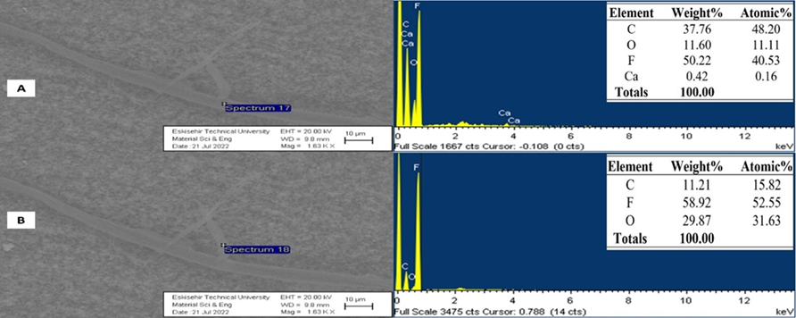
Fig. S1. SEM-EDX images of two microplastics found in the indoor deposition of university classroom two are classified by shape (A, B); Fiber. Chemical element concentrations are expressed as a percentage
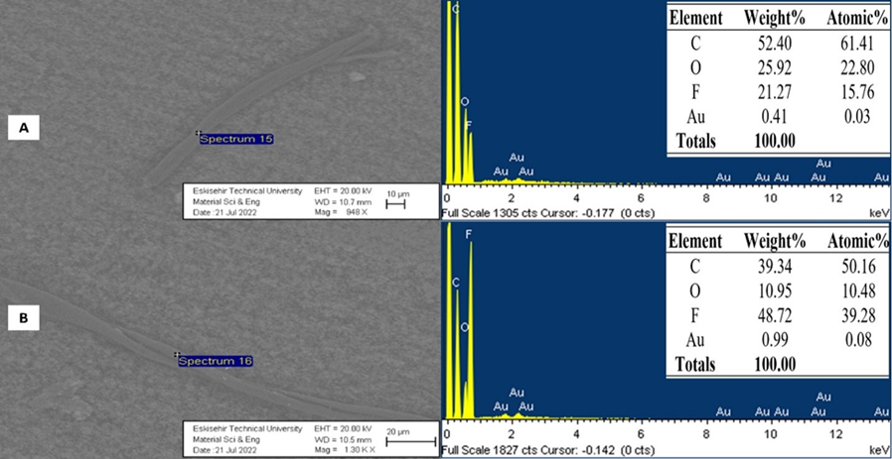
Fig. S2. SEM-EDX images of two microplastics found in the indoor deposition of university classroom three are classified by shape (A, B); Fiber. Chemical element concentrations are expressed as a percentage
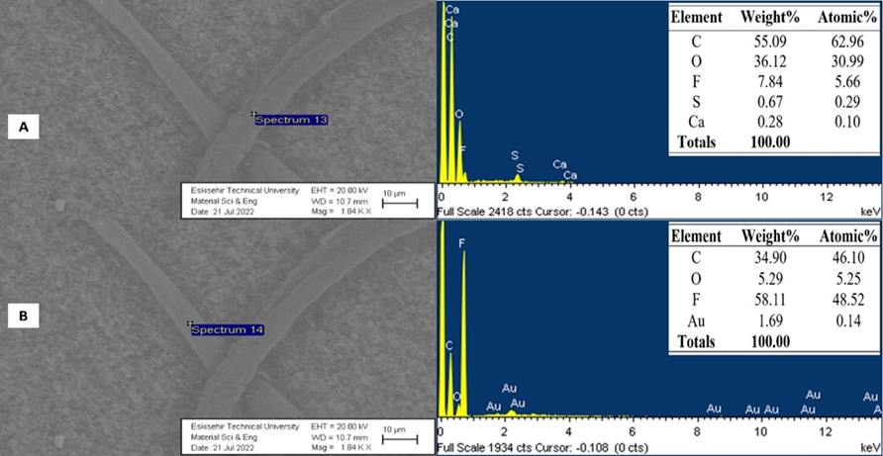
Fig. S3. SEM-EDX images of two microplastics found in the indoor deposition of university classroom four are classified by shape (A, B); Fiber. Chemical element concentrations are expressed as a percentage

