Table S1: Estimation of LST for sub-cities in Addis Ababa
Estimated LST (ºC) Value By increment of NDBI & NDVI
Sub City | Variable | 5% | 10% | 15% | 20% | 25%
Akaki | NDBI | 33.50 | 35.10 | 36.70 | 38.30 | 39.90
 | NDVI | 30.50 | 29.10 | 27,70 | 26.30 | 24.90
Lafto | NDBI | 32.62 | 34.22 | 35.82 | 37.42 | 39.02
 | NDVI | 29.62 | 28.22 | 26.82 | 25.42 | 24.02
Kolfe | NDBI | 30.44 | 32.04 | 33.64 | 35.24 | 36.84
 | NDVI | 27.44 | 26.04 | 24.64 | 23.24 | 21.84
Gulele | NDBI | 26.65 | 29.25 | 30.85 | 32.45 | 34.05
 | NDVI | 24.65 | 23.25 | 21.85 | 20.45 | 19.05
Ldeta | NDBI | 31.79 | 32.39 | 34.99 | 36.59 | 38.19
 | NDVI | 28.79 | 27.39 | 25.99 | 24.59 | 23.19
Chirkos | NDBI | 32.20 | 33.80 | 35.40 | 37.00 | 38.60
 | NDVI | 29.20 | 27.80 | 26.40 | 25.00 | 23.60
Arada | NDBI | 31.84 | 33.44 | 35.04 | 36.64 | 38.24
 | NDVI | 28.84 | 27.44 | 26.04 | 24.64 | 23.24
Addis/K | NDBI | 32.52 | 34.12 | 35.72 | 37.32 | 38.92
 | NDVI | 29.52 | 28.12 | 26.72 | 25.32 | 23.92
Bole | NDBI | 32.90 | 34.50 | 36.10 | 37.70 | 39.30
 | NDVI | 29.90 | 28.50 | 27.10 | 25.70 | 24.30
Yeka | NDBI | 29.64 | 31.24 | 32.84 | 34.44 | 36.04
 | NDVI | 26.64 | 25.24 | 23.84 | 22.44 | 21.04
Source: (Authors own Processing, 2021)

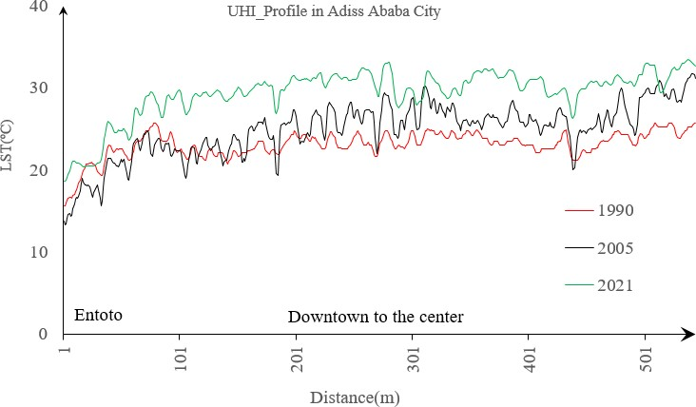
Figure S1: UHI Profile in Addis Ababa City in the years 1990, 2005, and 2021

