Additional file
The Additional file contains information on climate models used for future climate scenario data (supplementary material 1), parametrisation of fertilisers used for simulation (supplementary material 2), additional background information on the management data used to develop the management regimes (supplementary material 3, 4, 5), summary of climate metric of future climate scenarios (supplementary material 6), estimated changes in the SOC balance per one-unit-increases of selected properties (supplementary material 7, 8, 11), visualisations of effects of mean air temperature and precipitation on the SOC balance (supplementary material 9, 10), and a visualisation of the simulate SOC balance in dependence of clay content, climate scenarios and climate projection (supplementary material 12).

Supplementary material 1 Climate models used for acquiring future climate data
The {rcp} denotation corresponds to the RCP scenarios (e.g.: {rcp26}, {rcp45}, {rcp85}). Each model provided a unique climate projection under each RCP scenario.
a) ICHEC-EC-EARTH_{rcp}_r12i1p1_CLMcom-CCLM4-8-17_v1
b) ICHEC-EC-EARTH_{rcp}_r12i1p1_KNMI-RACMO22E_v1
c) ICHEC-EC-EARTH_{rcp}_r12i1p1_SMHI-RCA4_v1
d) ICHEC-EC-EARTH_{rcp}_r3i1p1_DMI-HIRHAM5_v1
e) MPI-M-MPI-ESM-LR_{rcp}1_r1i1p1_MPI-CSC-REMO2009_v1
f) MPI-M-MPI-ESM-LR_{rcp}_r2i1p1_MPI-CSC-REMO2009_v1

Supplementary material 2 Properties of the organic fertilisers as parametrised in the CDYOPSPA table in the CANDY database
Fertiliser type | Dry matter content  [M-%] | C content in dry matter  [M-%] | CN ratio in organic matter | Total CN ratio | Reference
cattle slurry | 8 | 34 | 16 | 7.77 | [63]
pig slurry | 8 | 31 | 13 | 4.66 | [63]
mixed slurry (pig + cattle) | 8 | 33 | 14.64 | 5.89 | [63]
cattle manure | 25 | 31 | 18 | 14.07 | [63]
sheep manure | 30 | 38 | 17.67 | 13.62 | [63]
digestate | 5.8 | 39.2 | 7.26 | 4.97 | [64]

Supplementary material 3 Selected descriptive statistics for the annual yield across all Hainich sites
Property | Original management data |  |  |  |  | DüV expected yield | Scenario yield | Scenario  N input
Property | Minimum | Maximum | Average | n
Yield <1 cut [dt DM ha⁻¹] | 10 | 51.85 | 28.19 | 20 |  | 40 | 30 | 41
Yield <2 cuts [dt DM ha⁻¹] | 55.67 | 72 | 63.78 | 24 |  | 55 | n. a. | n. a.
Yield <3 cuts [dt DM ha⁻¹] | 61.96 | 81.96 | 68.61 | 6 |  | 80 | 70 | 166
Yield <5 cuts [dt DM ha⁻¹] | n. a. | n. a. | n. a. | 0 |  | 110 | 100 | 282
The sites were grouped into those with up to one cut per year on average, one to up to two cuts and two to up to three cuts on average. No data is available for five cuts per year in the original data. The table also provides the expected yield according to the German Fertilisation Ordinance [65] corresponding to the respective number of cuts. It is evident that for one and three cuts per year on average, the original yield in the Hainich sites is approximately 10 dt ha⁻¹ lower than typical according to [65]. The scenario yield, which correspond to the developed management regimes M1, M2 and M3 respectively, is therefore also 10 dt lower than the expected yield. The last column provides the N requirement according to [65] corresponding to the scenario yield.

Supplementary material 4 Selected descriptive statistics for grazing properties for all 50 Hainich grassland sites, determined per year
Property | Minimum | Maximum | Average
Start grazing | April | November | July
End grazing | May | November | September
Grazing duration [d] | 5 | 273 | 93
Stocking rate [LU ha⁻¹] | 0.01 | 4.35 | 1.11

Supplementary material 5 Properties of sites with less than one cut per year on average (n = 20)
Property | Minimum | Maximum | Average
Start grazing | April | August | June
End grazing | July | October | September
Grazing duration [d] | 80 | 273 | 146
Stocking rate [LU ha⁻¹] | 0.14 | 4.35 | 1.70

Supplementary material 6 Summary of future climate metrics for the Hainich Biodiversity Exploratory
RCP scenario | Projection | AAM |  |  | MIV |  |  | IVM
RCP scenario | Projection | tmp | prc | glob | tmp | prc | glob | tmp | prc | glob
2.6 | a | 9.67 | 606.62 | 1009.08 | 7.36 | 3.43 | 753.96 | 0.73 | 86.52 | 40.61
2.6 | b | 9.72 | 678.02 | 1036.53 | 7.17 | 3.77 | 781.52 | 0.76 | 104.61 | 49.14
2.6 | c | 9.93 | 624.48 | 1016.12 | 7.34 | 3.65 | 692.23 | 0.75 | 107.37 | 31.34
2.6 | d | 9.54 | 632.20 | 1015.52 | 7.24 | 3.64 | 735.42 | 0.67 | 112.04 | 40.43
2.6 | e | 9.75 | 673.29 | 1002.52 | 6.99 | 3.84 | 803.48 | 0.68 | 101.84 | 44.88
2.6 | f | 9.76 | 643.60 | 1017.12 | 7.16 | 3.70 | 815.75 | 0.65 | 99.72 | 47.37
4.5 | a | 10.24 | 628.36 | 994.27 | 7.30 | 3.64 | 750.62 | 0.82 | 123.07 | 45.13
4.5 | b | 10.35 | 691.29 | 1030.86 | 7.15 | 3.92 | 783.37 | 0.88 | 100.97 | 46.32
4.5 | c | 10.53 | 639.75 | 1010.98 | 7.23 | 3.73 | 691.63 | 0.91 | 105.24 | 28.63
4.5 | d | 10.08 | 666.29 | 1004.03 | 7.15 | 3.78 | 734.16 | 0.72 | 104.16 | 40.03
4.5 | e | 9.86 | 686.99 | 981.91 | 7.14 | 3.93 | 792.26 | 0.87 | 101.97 | 49.76
4.5 | f | 10.09 | 657.97 | 987.29 | 6.93 | 3.78 | 805.96 | 0.84 | 101.88 | 46.13
8.5 | a | 11.00 | 647.56 | 983.15 | 7.18 | 3.95 | 745.59 | 1.28 | 112.27 | 44.92
8.5 | b | 11.18 | 709.14 | 1016.97 | 7.00 | 4.11 | 774.52 | 1.40 | 132.60 | 54.24
8.5 | c | 11.37 | 669.70 | 1001.74 | 7.15 | 3.97 | 688.89 | 1.39 | 109.67 | 33.23
8.5 | d | 10.93 | 694.43 | 1006.25 | 7.12 | 4.21 | 740.03 | 1.14 | 125.89 | 47.53
8.5 | e | 10.70 | 692.49 | 968.18 | 6.94 | 3.98 | 788.54 | 1.19 | 107.29 | 56.15
8.5 | f | 10.80 | 709.52 | 969.75 | 7.02 | 4.13 | 800.88 | 1.18 | 107.69 | 50.00
With: average annual mean values (AAM), mean intra-annual variability (MIV) representing seasonality, and inter-annual variability (IVM) representing the long-term change for air temperature (tmp, °C), precipitation (prc, mm) and global radiation (glob, J cm⁻²). Projection designations correspond to supplementary material 1.

Supplementary material 7 Estimated change in the ambient SOC balance in dependence of the LUI mean and slope
Level of LUI mean | Estimated change in SOC balance per one unit increase of the LUI slope
0.2 | 0.24
0.4 | 0.20
0.6 | 0.16
0.8 | 0.11
1.0 | 0.07
1.2 | 0.03
1.4 | -0.01
1.6 | -0.05
1.8 | -0.09
2.0 | -0.13
2.2 | -0.17
2.4 | -0.21
2.6 | -0.25
2.8 | -0.30
3.0 | -0.34
Results presented as per one unit increases of the LUI slope (i.e. long-term intensification) for different levels of LUI mean across the 50 Hainich grassland sites in the ambient period (2008 – 2017, based on the best ambient CM).

Supplementary material 8 Estimated change in the future SOC balance in dependence of clay content and bulk density
Level of soil clay content [M-%] | Estimated change in SOC balance [M-%] per one unit increase of soil bulk density [g cm⁻³]
5 | 0.25
10 | 0.14
15 | 0.03
20 | -0.08
25 | -0.19
30 | -0.30
35 | -0.41
40 | -0.52
45 | -0.63
50 | -0.73
55 | -0.84
60 | -0.95
65 | -1.06
70 | -1.17
Results presented as per one unit increases of the soil bulk density for different levels of soil clay content across the 50 Hainich grassland sites in the ambient period (2008 – 2017, based on the best ambient CM).
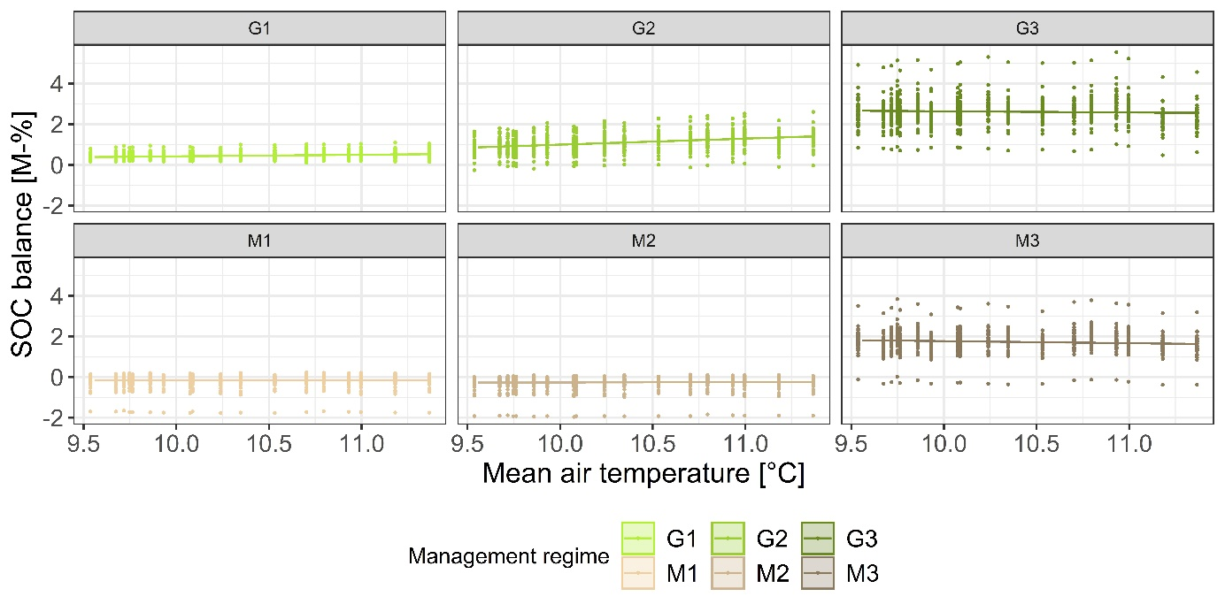
Supplementary material 9 Linear regression (lines) of the effect of mean air temperature on the future SOC balance
Effects were extracted from the best candidate model and grouped by the management regimes (G: grazing; M: mowing; 1: extensive; 2: moderate; 3: intensive). The SOC balance simulated with CANDY is additionally plotted (point features) for reference.
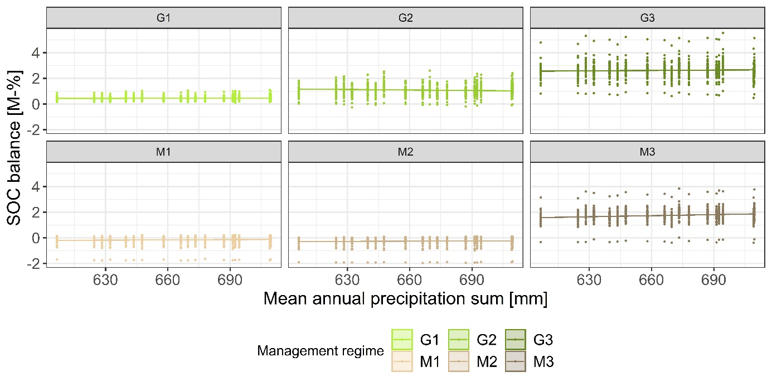
Supplementary material 10 Linear regression (lines) of the effect of annual precipitation sum on the future SOC balance
Effects were extracted from the best candidate model and grouped by the management regimes (G: grazing; M: mowing; 1: extensive; 2: moderate; 3: intensive). The SOC balance simulated with CANDY is additionally plotted (point features) for reference.

Supplementary material 11 Estimated change in the future SOC balance in dependence of initial SOC and precipitation sum
Level of initial SOC content [M-%] | Estimated change in SOC balance [M-%] per 100 units increase of annual precipitation sum [mm]
3.53 | 0.0584
3.73 | 0.0595
3.93 | 0.0605
4.13 | 0.0616
4.33 | 0.0626
4.53 | 0.0637
4.73 | 0.0648
4.93 | 0.0658
5.13 | 0.0669
5.33 | 0.0679
5.53 | 0.0690
Results presented per one unit increase of the annual precipitation sum for different levels of the initial SOC content across the 50 Hainich grassland sites in the future period (2017 – 2100, based on the best future CM).
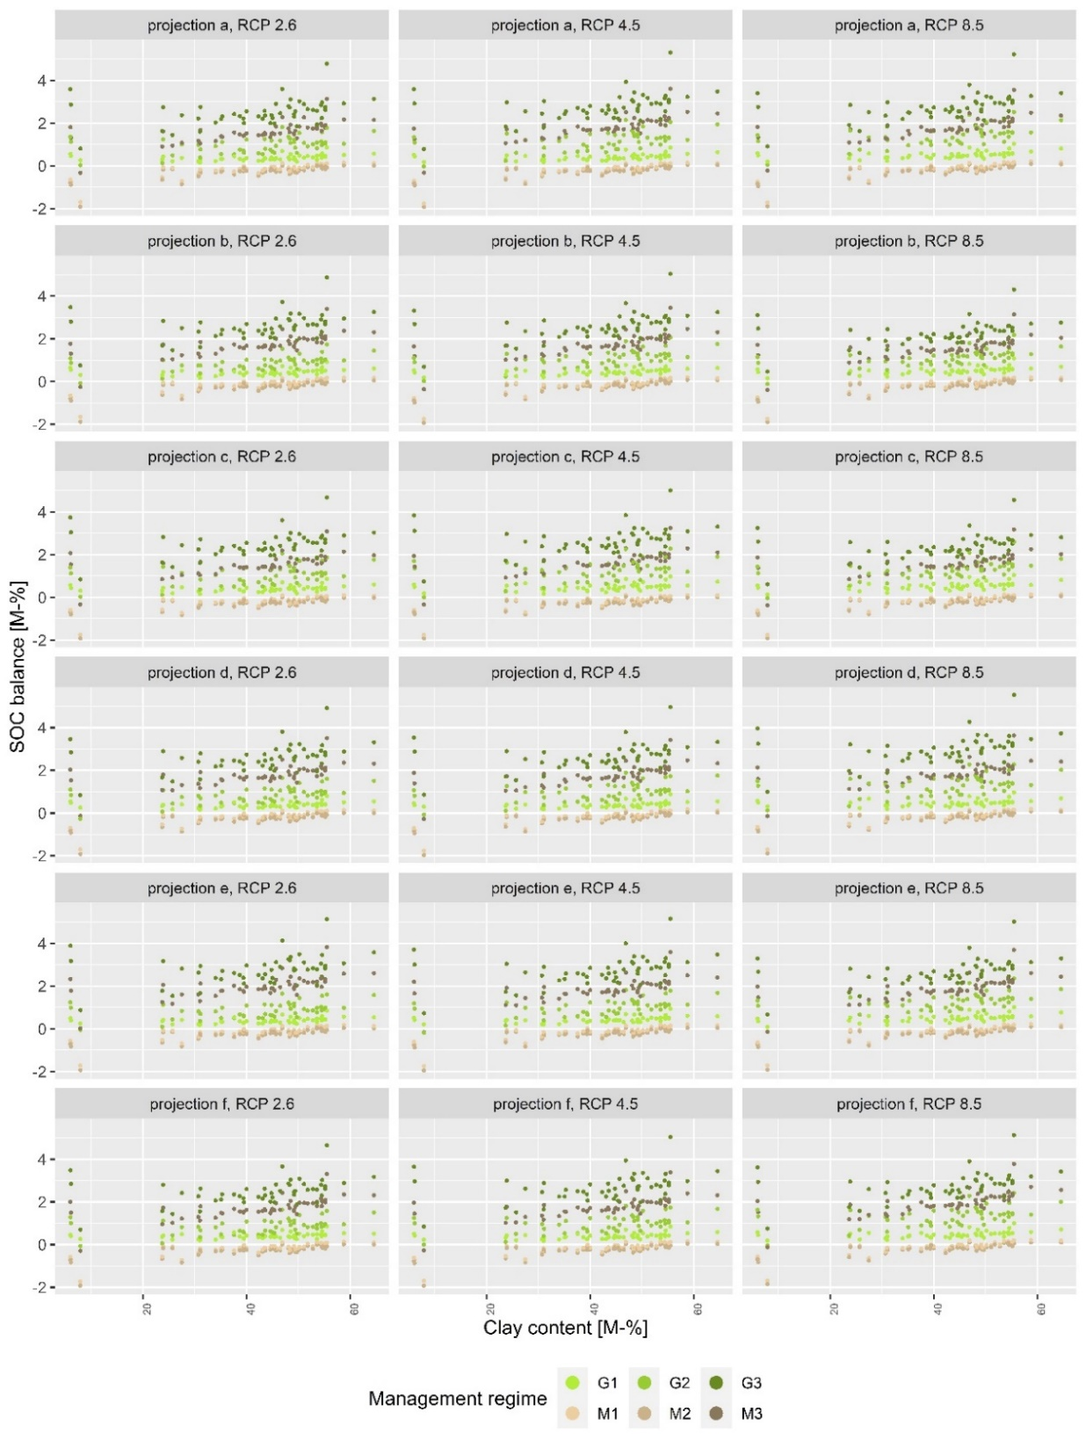
Supplementary material 12 Simulated change in future SOC contents in dependence of climate projection and RCP scenario
Climate model designations according to supplementary material 1. Climate projections change row-wise, RCP scenarios column-wise. The topsoil clay content of the 50 Hainich grassland sites is spread along the x-axis. The graph shows 1) increasing SOC contents with increasing clay content, 2) visible differences in the SOC balance between different sites, 3) small differences between different climate projections as well as scenarios, and 3) large differences between management regimes, particularly grazing and mowing, thereby substantiating a low uncertainty due to climate data.

