Evaluation of Temporal Convolutional Networks and Ensemble Machine Learning Models for Meteorological Drought Prediction in the Nigerian Sudano-Sahelian Zone
Muhammad Lawal Abubakar^{1,2,*}, Auwal F. Abdussalam^{1,2}, Zaharaddeen Isa^{1,2}, Muhammad Sambo Ahmed^{1,2}, Abubakar Sadiq Musa¹, Jonah Birga¹, Ismail Mohammed³
¹ Department of Geography and Sustainability Studies, Kaduna State University, Nigeria
² Climate Research Group, Kaduna State University, Kaduna, Nigeria
³ Department of Geography, Federal University Dutsin-Ma, Katsina, Nigeria

Supplementary File
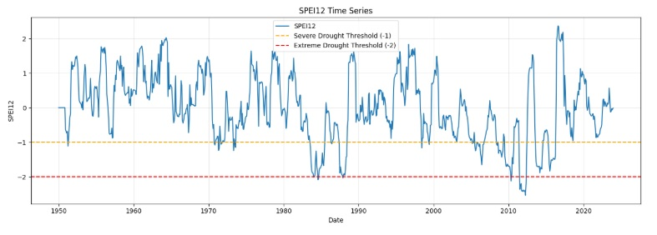 |  | 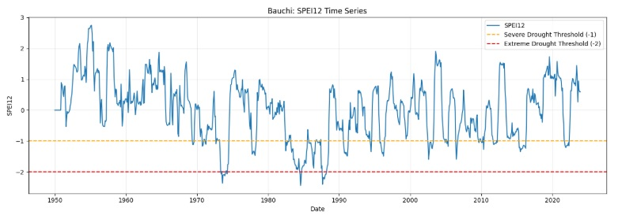
a) |  | b)
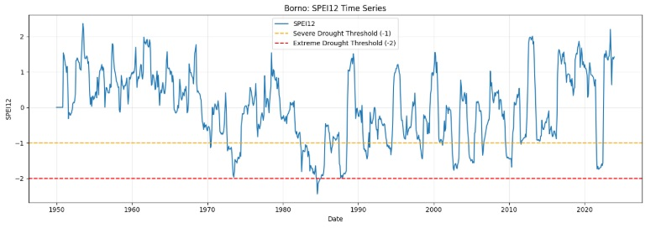 |  | 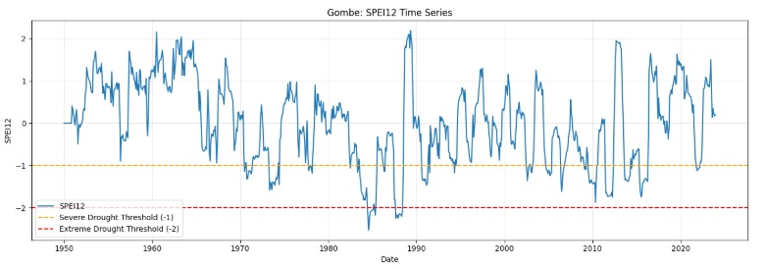
c) |  | d)
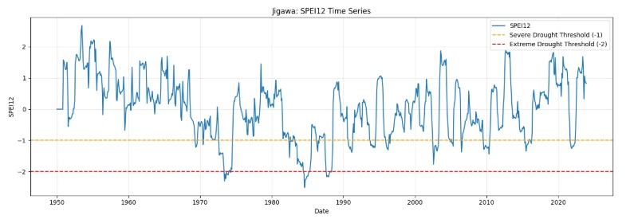 |  | 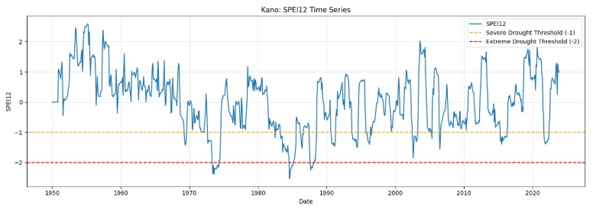
e) |  | f)
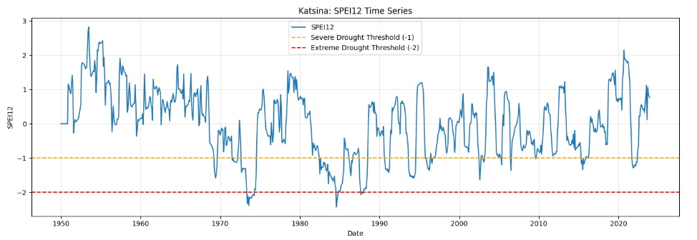 |  | 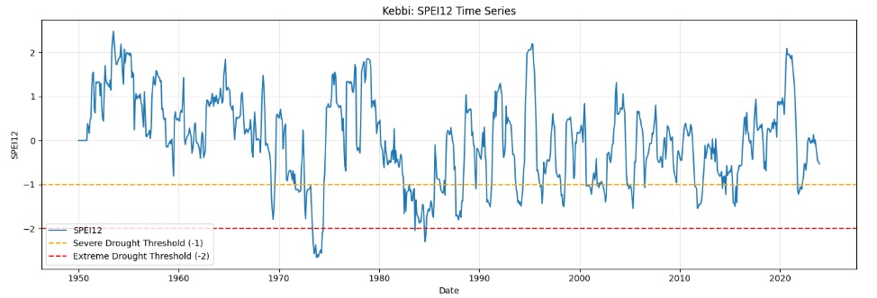
g) |  | h)
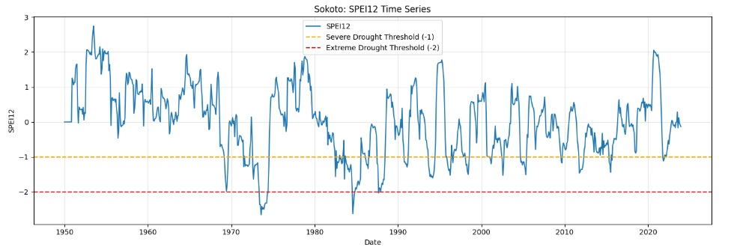 |  | 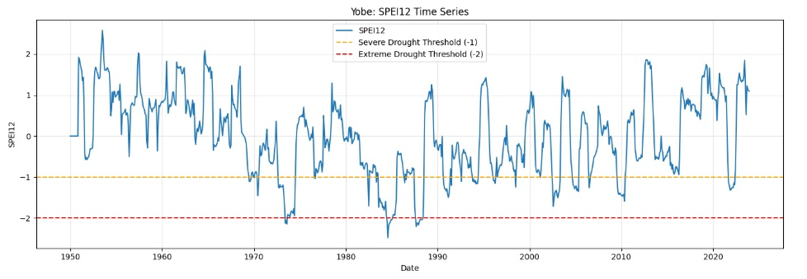
i) |  | j)
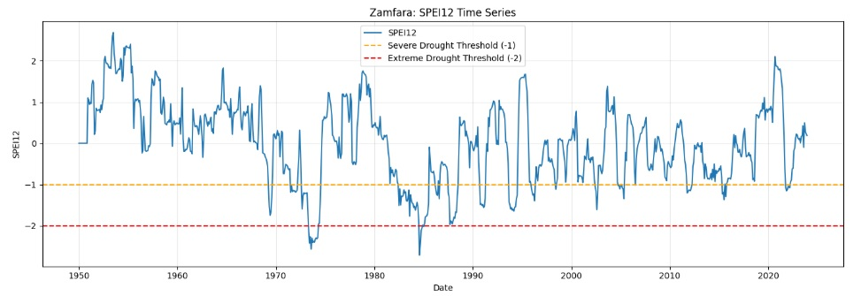
k)
Figure S1: Drought characteristics using SPEI for a) Adamawa b) Bauchi c) Borno d) Gombe e) Jigawa f) Kano g) Katsina h) Kebbi i) Sokoto j) Yobe and k) Zamfara

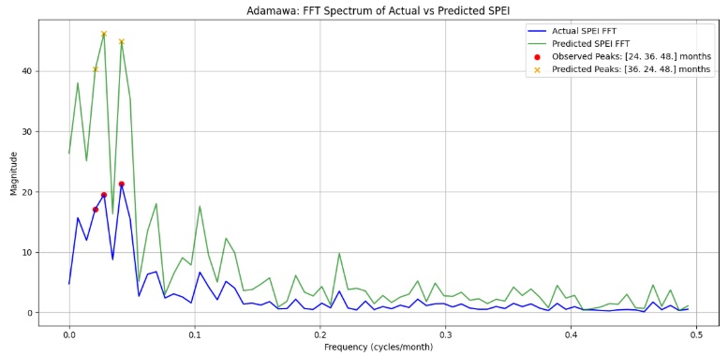 |  | 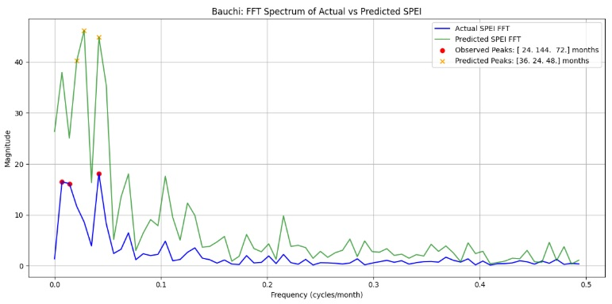
a) |  | b)
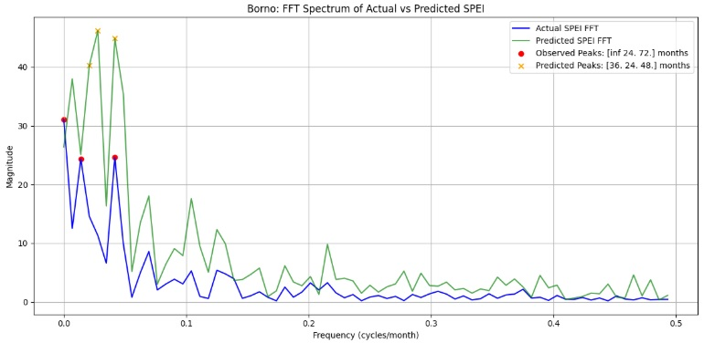 |  | 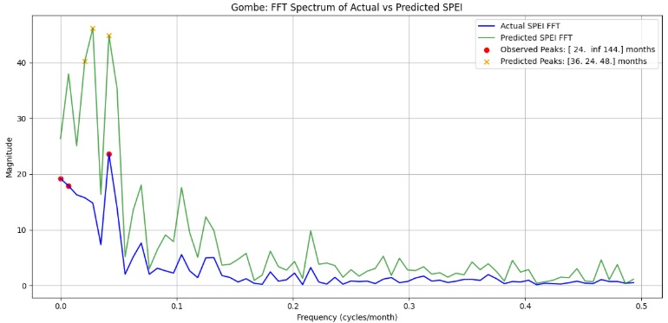
c) |  | d)
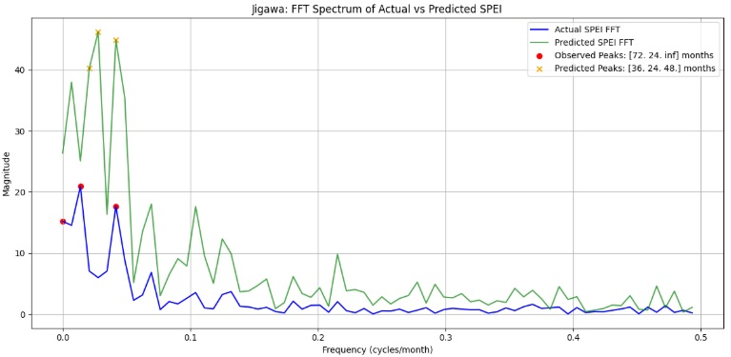 |  | 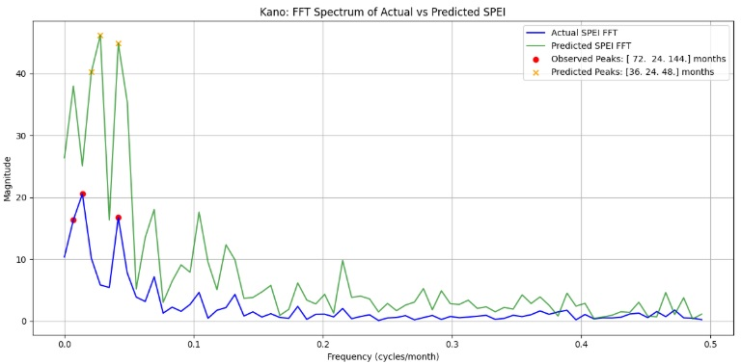
e) |  | f)
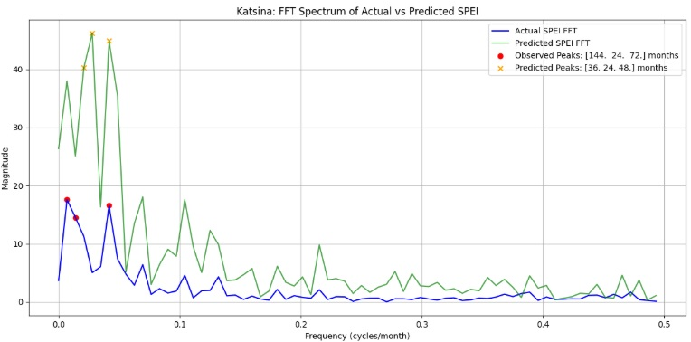 |  | 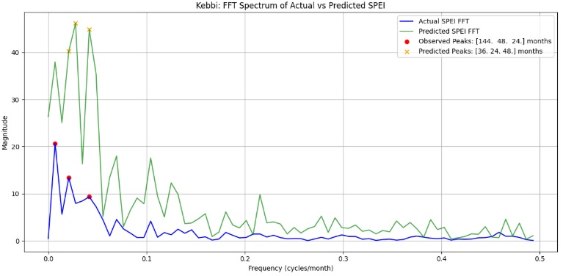
g) |  | h)
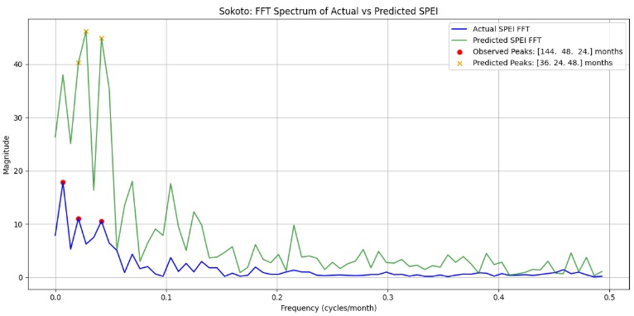 |  | 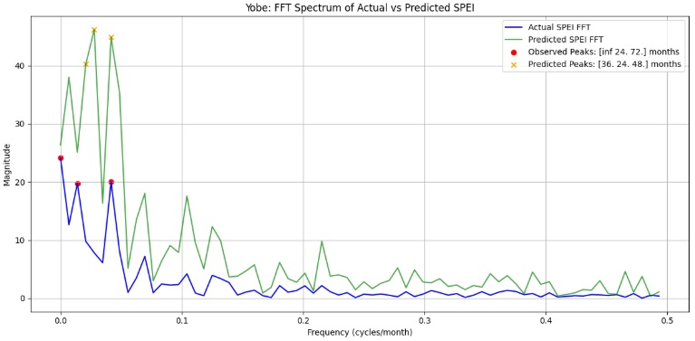
i) |  | j)
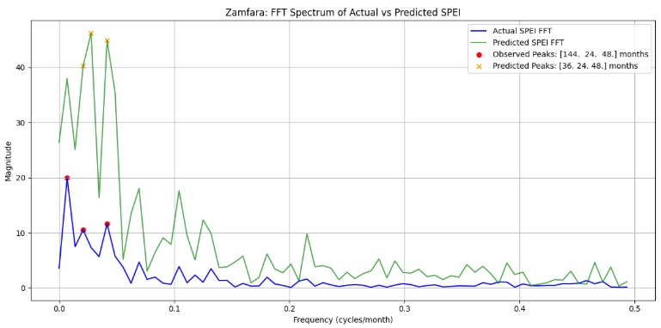
k)
Figure S2: Dominant drought cycles identified by FFT for a) Adamawa b) Bauchi c) Borno d) Gombe e) Jigawa f) Kano g) Katsina h) Kebbi i) Sokoto j) Yobe and k) Zamfara

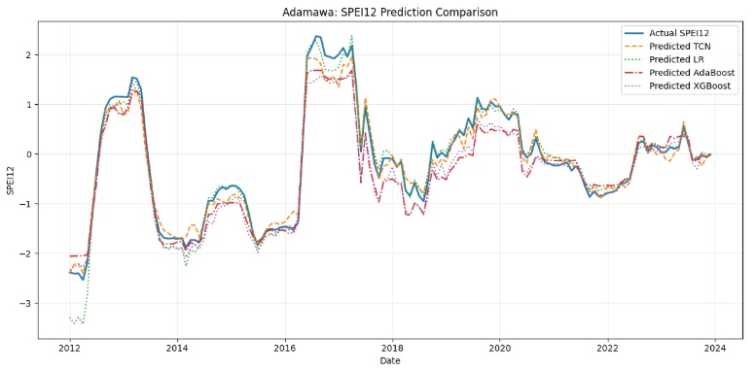 |  | 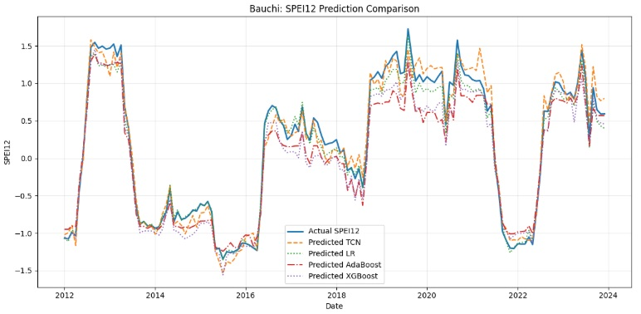
a) |  | b)
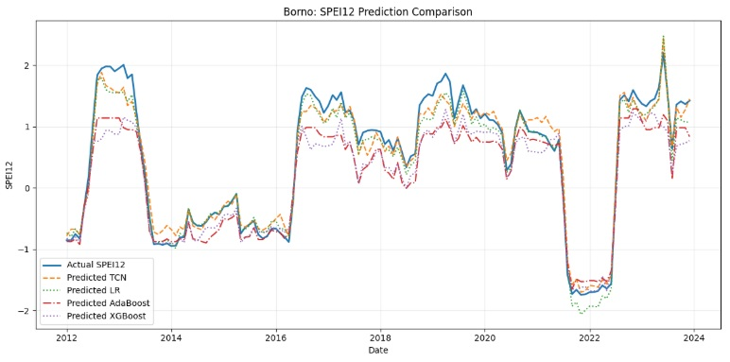 |  | 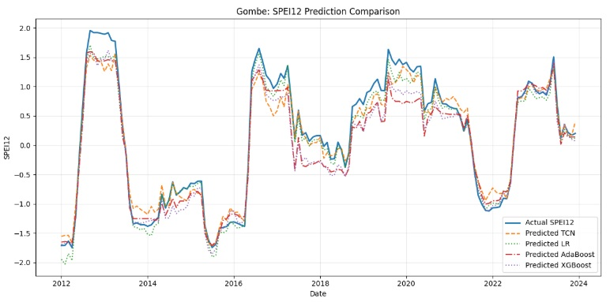
c) |  | d)
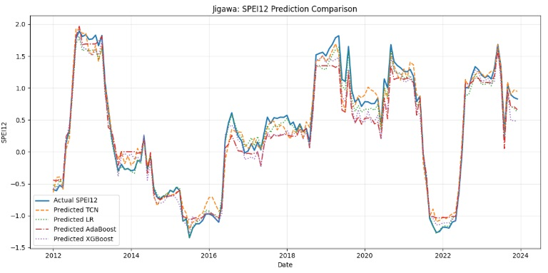 |  | 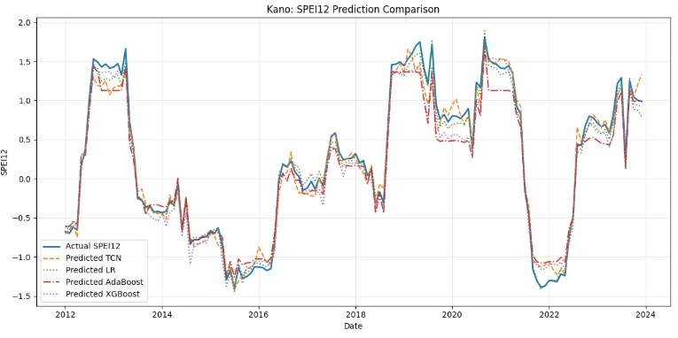
e) |  | f)
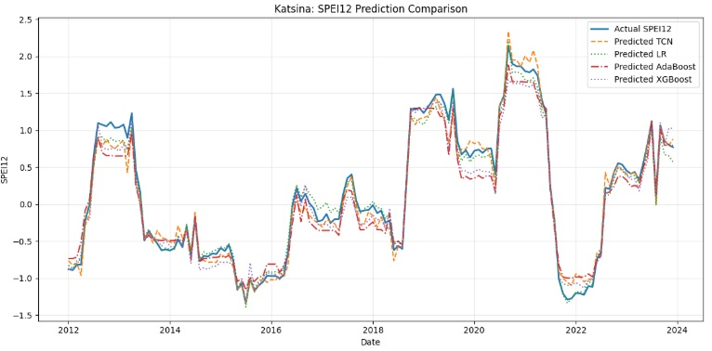 |  | 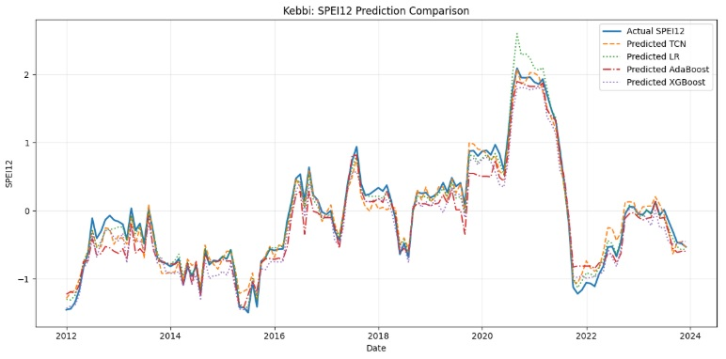
g) |  | h)
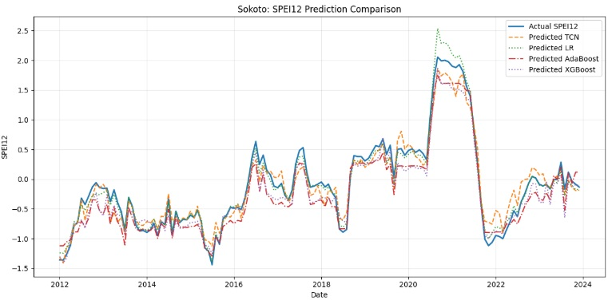 |  | 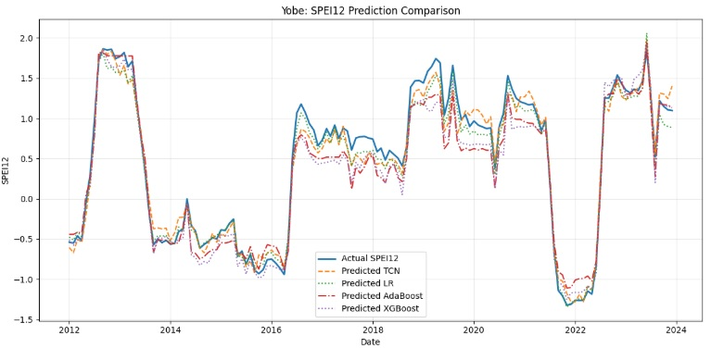
i) |  | j)
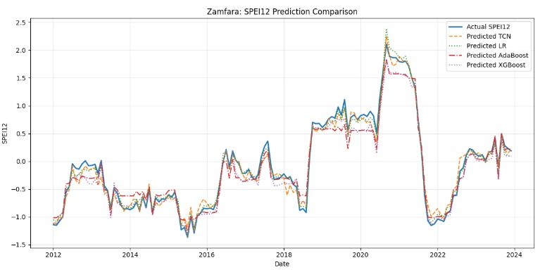
k)
Figure S3: TCN Drought Prediction with Metrics for a) Adamawa b) Bauchi c) Borno d) Gombe e) Jigawa f) Kano g) Katsina h) Kebbi i) Sokoto j) Yobe and k) Zamfara

