Supplementary Data 1F.

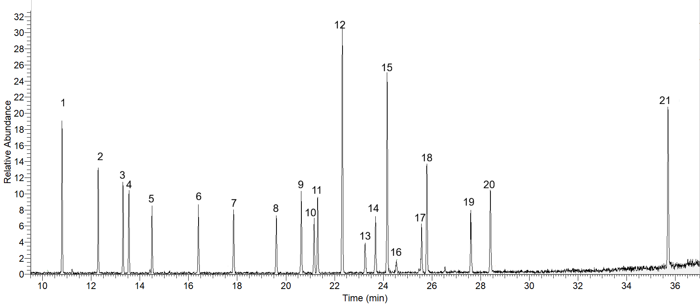
Figure 1S. Chromatogram of Pesticide mixtures containing 1.0 µg/mL. Peaks are : 1– xylene, 2 -α-BHC, 3-γ-BHC, 4-β-BHC, 5-δ-BHC, 6- Heptachlor, 7- Aldrin, 8-Heptachlor epoxide, 9-γ-Chlordane, 10-α-Chlordane, 11-Endosulfan I, 12-p,p’DDE, 13-Endrin, 14-Endosulfan II, 15-p,p’-DDD, 16- Endrine aldehyde, 17-Endosulfan sulfate, 18- o,p’-DDT, 19-Endrine Ketone,20- Methoxychlor, 21 decachlorpbiphenyl.

Supplementary Data 2F- Calibration curves

