A Supranational Machine Learning Approach to Assess Wildfire Losses under Climate Change in Southeastern Europe

Supplementary material

- Framework for wildfire susceptibility used in the study

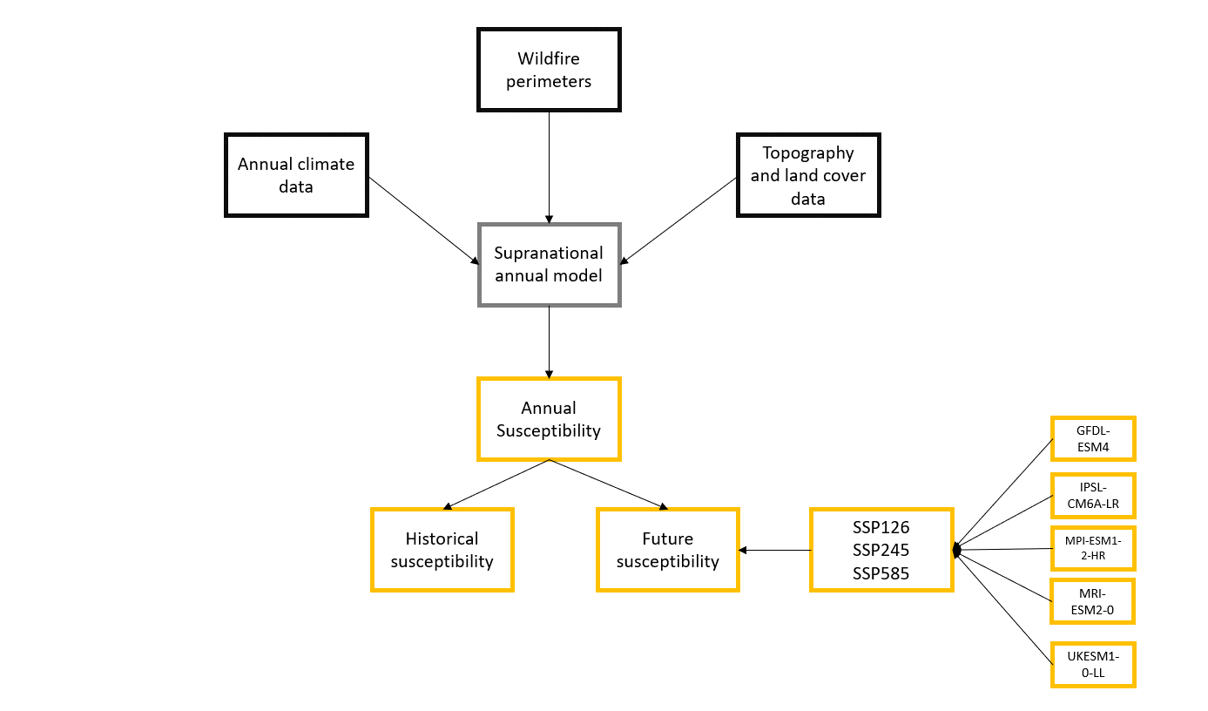
Fig. 1 schematic representation of the methodology for assessing wildfire susceptibility at national/regional scale. Topographic and annual climate variables are coupled with wildfire occurrences to train a regional machine-learning model. The model is able to reproduce annual wildfire susceptibility for both past and future climate conditions, considering different climate change scenarios and five climate model configurations

- Detailed tables for exposed assets included in the study and their economic value and vulnerabilities
The calculation of AAL follows the fundamental risk assessment formulation:

R = f (H, V, E)
Where risk is a function of hazard (H), vulnerability (V), and exposure (E), wildfire hazard, while defined as the likelihood and severity of fire occurrence, does not inherently carry a probabilistic component. A wildfire occurrence probability function is introduced to integrate a probabilistic component, approximating the annual likelihood of burning per hazard based on historical burned area records. This probability component enables the assessment of expected damages on exposed assets, considering both present conditions and future climate projections.

The exposure assessment identifies key infrastructure and natural assets at risk, categorized into eight primary classes:
Table 1. Main assets considered in the study and the indicators for which the risk/losses are assessed
Category | Source | Indicators
Healthcare facilities | GEM | Economic value  Number of beds
Educational buildings | GEM | Economic value  Number of units/occupants
Residential buildings | GEM | Economic value  Number of structures  Number of residents
Industrial facilities | GEM | Economic value  Number of structures
Commercial infrastructure | GEM | Economic value  Number of structures
Broadleaves forests | CORINE | Economic value  Hectares of forest exposed
Coniferous forests | CORINE | Economic value  Hectares of forest exposed
Road's network | JRC / OSM | Kilometers of primary and secondary roads

The Global Earthquake Model (GEM) database provides economic valuations for infrastructure categories, updated at five-year intervals from 2025 to 2050, reflecting socio-economic changes. Forest economic values are estimated using tree species market prices and stand densities, as detailed in the following table.
Table 2. Economic Values for broadleaves and Coniferous forests (before harvesting)
Tree | Price per m³ (BGN) | Density (m³/ha)
Coniferous large sized | 127.5 | 268
Coniferous small sized | 55.1 | 268
Deciduous large sized | 121.1 | 150
Deciduous medium and small-sized | 78.8 | 150

In this section we provide the explicit vulnerability tables used in the loss model. Tables 3–4 summarize, for each wildfire hazard (intensity) class and asset type, the percentage damage applied to exposed economic values. Vulnerability defines the expected damage level per hazard class, incorporating factors such as fire intensity, asset resilience, and fire suppression efforts. While exposure quantifies the assets at risk, vulnerability functions define the expected level of damage these assets would sustain under varying wildfire intensities. Vulnerability tables categorize damage levels based on historical wildfire impact assessments, particularly adapting classifications from Californian wildfire studies (CAL FIRE Study, 2023). The vulnerability component of the methodology quantifies the degree of expected damage given the severity of a wildfire event. Vulnerability functions are derived from Californian wildfire damage classification systems and are adapted to match fuel type classifications. Infrastructure vulnerability functions are sourced from GEM, while forest vulnerability is estimated based on fire severity and species flammability. The following tables summarize vulnerability estimates for key asset categories.

Table 3. Vulnerability Table for GEM infrastructure categories (percentage damage by wildfire hazard class)
Intensity (Fuel Type) | Potential damage [%] | Damage description
Low (Grassland & cropland) | 0 | Not affected
Medium (Low Flammable forests) | 1 - 9 | Affected
High (Bushes/shrubs) | 10 - 25 | Minor
Very High (High flammable forests) | 26 - 50 | Major

For forested areas, wildfire impact varies significantly depending on fire behavior and species composition. High-flammability forests, such as Mediterranean pine, sustain higher damage percentages than low-flammability deciduous forests.

Table 4. Vulnerability Table for forests (percentage damage by wildfire hazard class)
Intensity (Fuel Type) | Potential damage [%] | Damage description
Medium  (Low Flammable forests) | 10 | Affected
Very High  (High flammable forests) | 80 | Major

- Validation of Wildfire Losses
Finally, it is important to consider the variability and uncertainty in these loss estimates. Wildfire impacts can be highly variable from year to year, and an average annual loss does not capture the possibility of exceptionally bad fire seasons. To evaluate this, we compared the model's country-level loss projections against historical loss patterns and also calculated the losses associated with extreme percentile events. Figure 2 illustrates the historical burn probability distribution across the hazard classes (used in our model), which underpins the AAL calculations. Even for the highest hazard class, the average fraction of area burned per year was only a few percent, meaning that in most years, the majority of each high-hazard zone did not burn. However, during extreme years, much larger areas burned (as indicated by the spread of the distribution). Translating this to losses, we find that the interannual variability of actual losses is high – for example, in Croatia, the year 2017 saw wildfire damages several times greater than the long-term average due to a convergence of extreme weather and ignition events. Our validation analysis indicates that the model's mean predictions (AAL) align well with the observed average losses over the past decade, especially for the less fire-prone countries, but it underestimates the sporadic extreme losses in countries like Greece and Croatia. To capture those extremes, we computed a 100-year return period loss (essentially, the level of loss one might expect in a very severe fire year that has a 1% chance of occurrence). We found that for Greece and Croatia, the 100-year event loss is substantially higher than the mean—exceeding it by a factor of 2 or more—whereas, for Bulgaria and Romania, the 100-year loss is not dramatically above the mean (since even a "worst-case" fire year in those countries is constrained by fuel and climate).
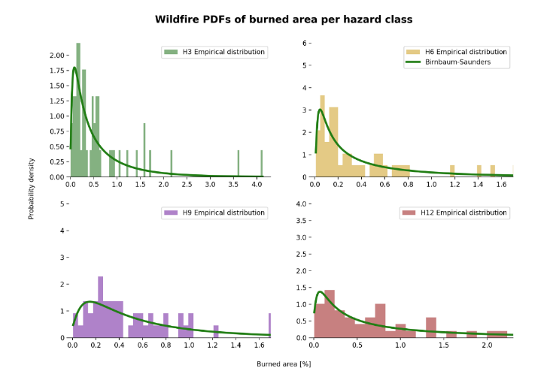
Fig. 2 Probability distribution per hazard class. Each data point represents the percentage of burned area inside each class

We present a comparison of modeled and observed losses in Figure 3. In each country's panel, the yellow curve represents the actual annual wildfire losses (estimated from observed burned areas and exposed values) in the historical period, which shows considerable year-to-year fluctuation. The horizontal black line indicates the modeled AAL (baseline) for that country, and the red line denotes the model's 1-in-100-year loss estimate. In Bulgaria and Romania, the yellow curve (observations) stays relatively low, and the peaks are well captured by the average (black line), indicating that an average year is a reasonable representation of their experience. In Greece and Croatia, however, the yellow curve has pronounced spikes (e.g., Greece 2007 or 2021, Croatia 2017) that lie well above the black line. The model's red line (extreme percentile) in those cases aligns more closely with these spikes, suggesting that using an "average ± range" (with the range defined by something like the 100-year event) provides a more comprehensive picture of wildfire risk. In practice, this means that risk management strategies should not only plan for the expected average damages but also prepare for the possibility of catastrophic wildfire seasons that, while rare, can cause loss amounts far above the norm.

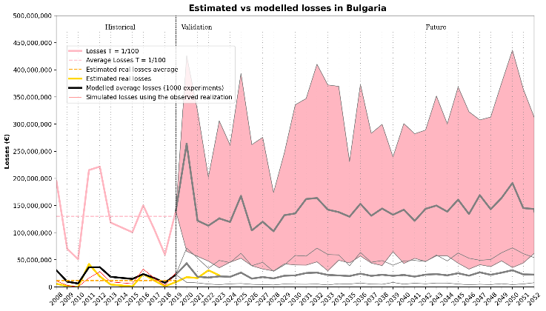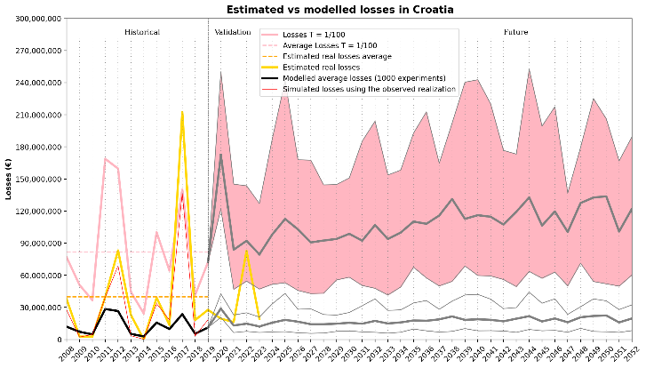

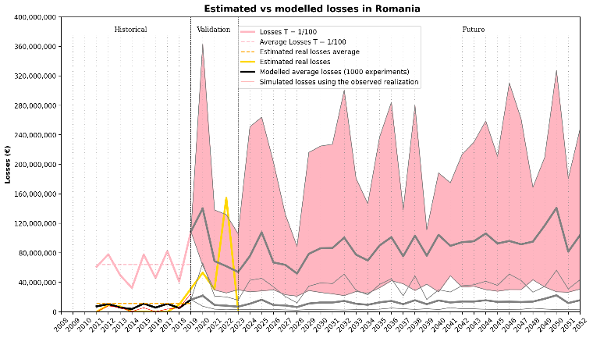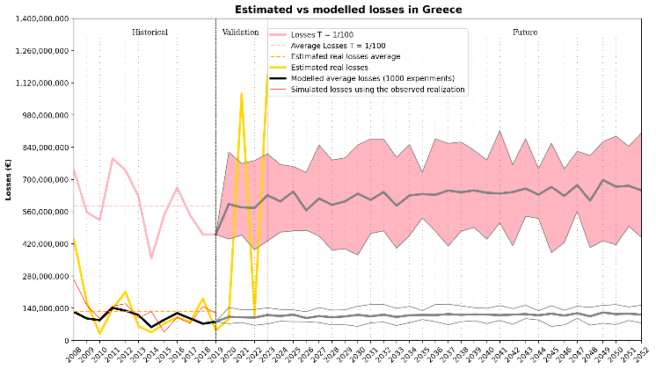
Fig. 3 Modeled vs. observed wildfire loss comparison and variability. This figure should contain, for each country, a visualization of observed annual losses (perhaps as a line plot of year-to-year losses or a bar chart), along with the model's average annual loss (horizontal line) and an indication of the 100-year return period loss (upper bound). It highlights how closely the model reproduces mean losses and how it relates to extreme-year losses

