Supplementary Table

Supplementary Table 1: Composite score descriptive statistics
Attributes | Value
Cropland pixels (n) | 318248
Mean | 460.4
Std dev | 184.6
Coef. of variation | 40.10%
Minimum | 0
P25 | 321.7
Median (P50) | 440
P75 | 612.1
Maximum | 1185
Inter-quartile range | 290.5

Supplementary Figures

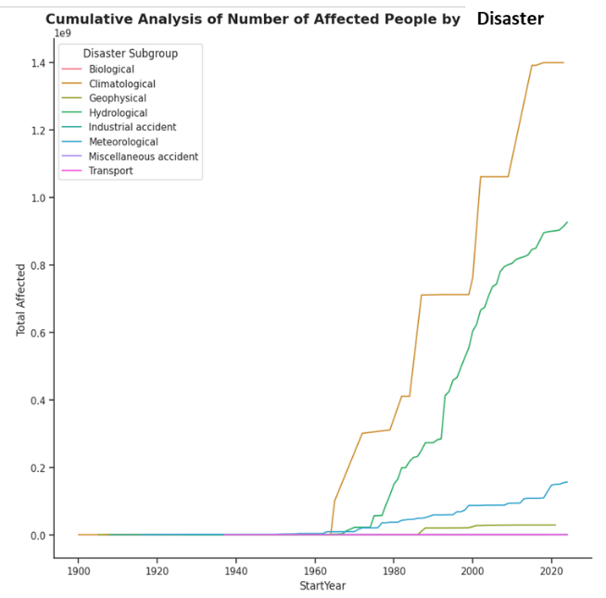
Supplementary Figure 1 Analysis of population impacted by disasters globally (Derived from Data Source – EM-DAT - https://www.emdat.be/)

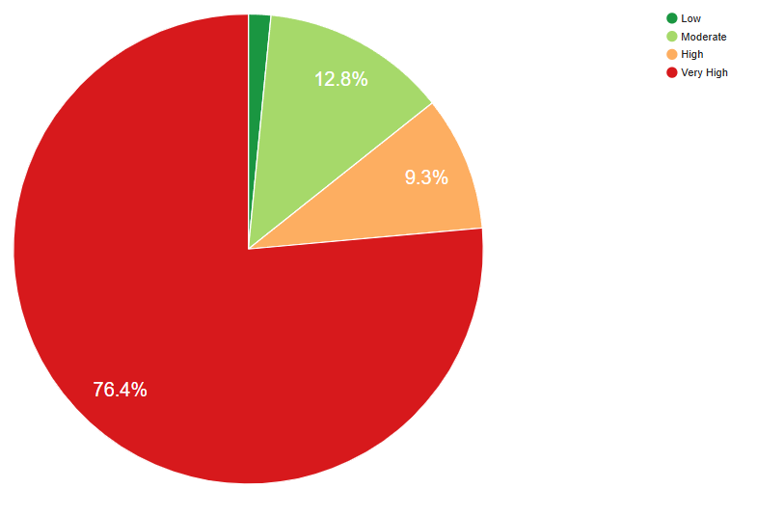
Supplementary Figure 2: Risk-class area distribution for Odisha

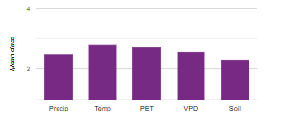
Supplementary Figure 3: Driver dominance (mean class, cropland)
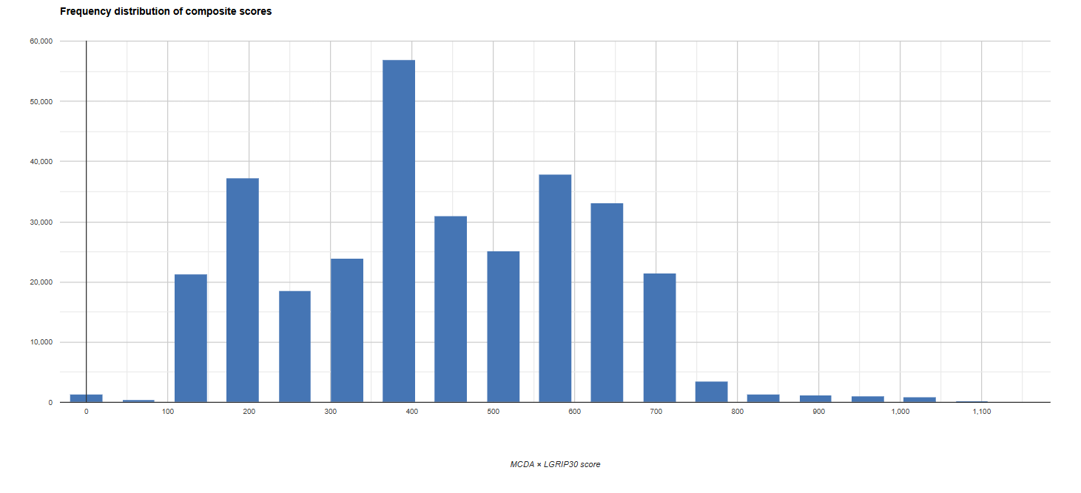
Supplementary Figure 4: Distribution of composite scores

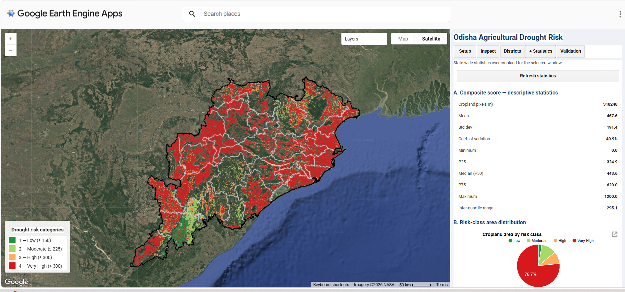

Supplementary Figure 5: GEE App screenshot for agricultural drought risk of Odisha
(Statistics window)

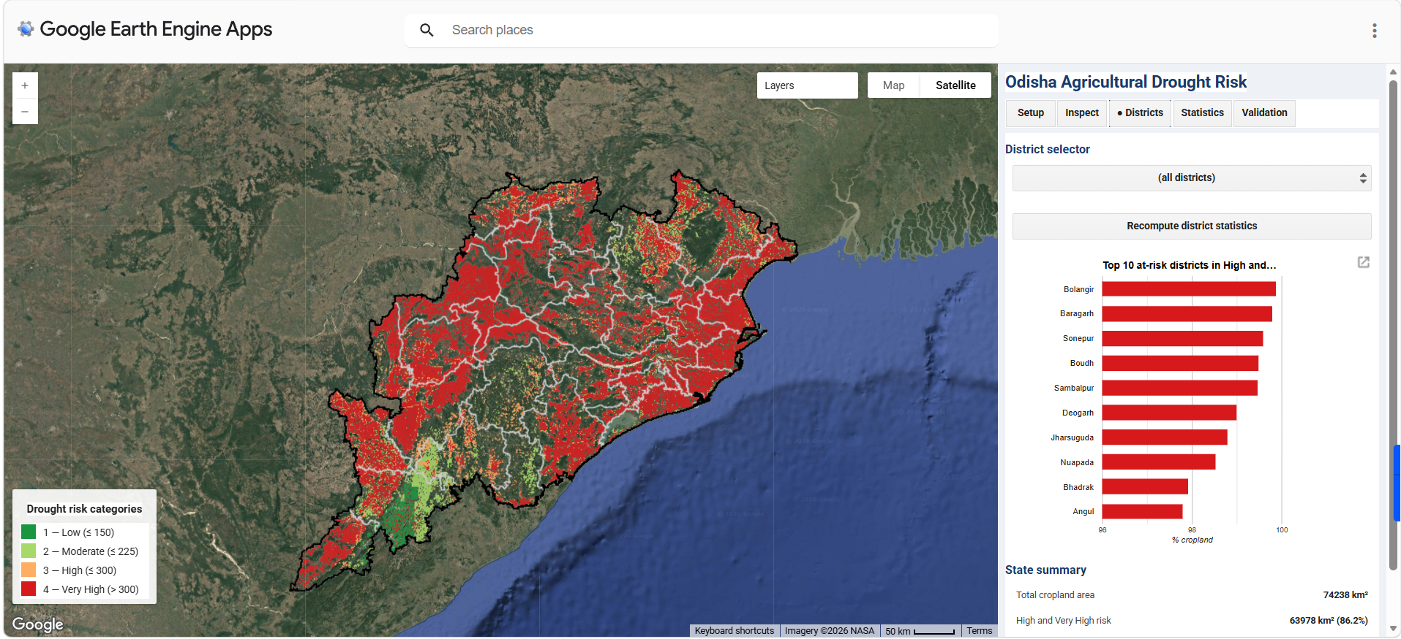
Supplementary Figure 6: GEE App screenshot for agricultural drought risk of Odisha
(Districts window)

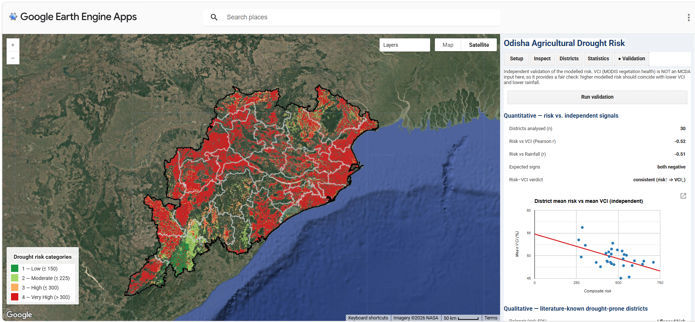

Supplementary Figure 7: GEE App screenshot for agricultural drought risk of Odisha (validation window)

