Supporting Information

Optimizing bendability of flexible electronic devices using a neutral layer strategy
Majiaqi Wu^{1, 2} ⋅ Maoliang Jian² ⋅ Jianhua Zhang^{2,} * ⋅ Lianqiao Yang^{2,} *
¹ School of Microelectronics, Shanghai University, Shanghai 201800, China
² Key Laboratory of Advanced Display and System Applications, Ministry of Education, Shanghai University, Shanghai 200072, China

* Corresponding authors: jhzhang@oa.shu.edu.cn (J.H. Zhang), yanglianqiao@i.shu.edu.cn (L.Q. Yang).

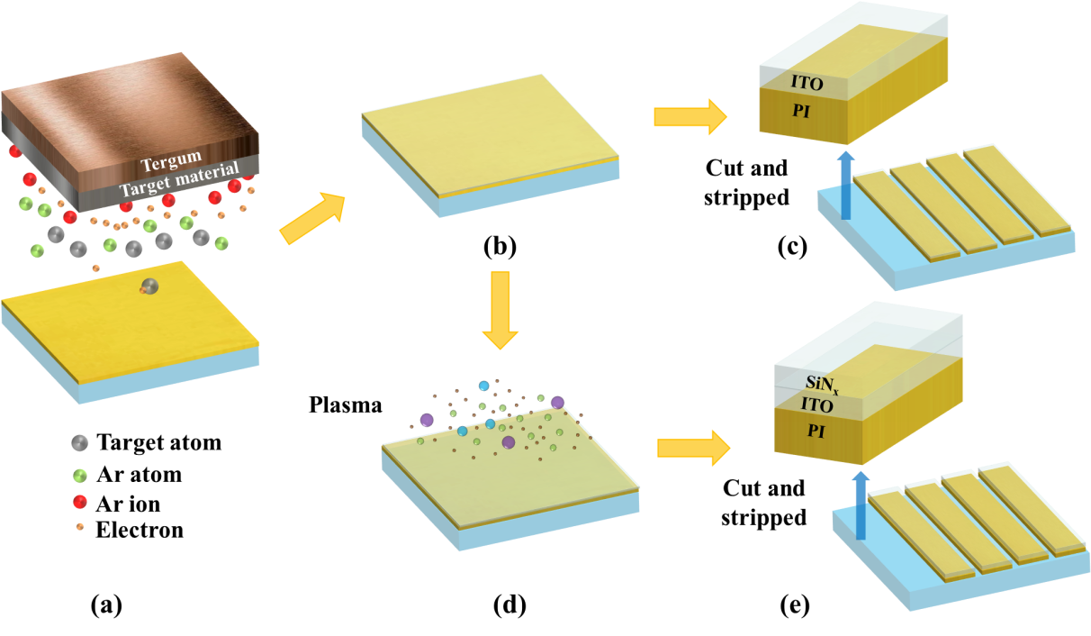
Fig. S1 The preparation process of flexible electrode: a sputtered film, b ITO/PI composite film structure was formed, d grown SiN_{x} film, and c, e cut and stripped ITO/PI and SiN_{x}/ITO/PI composite film from the glass substrate, respectively.

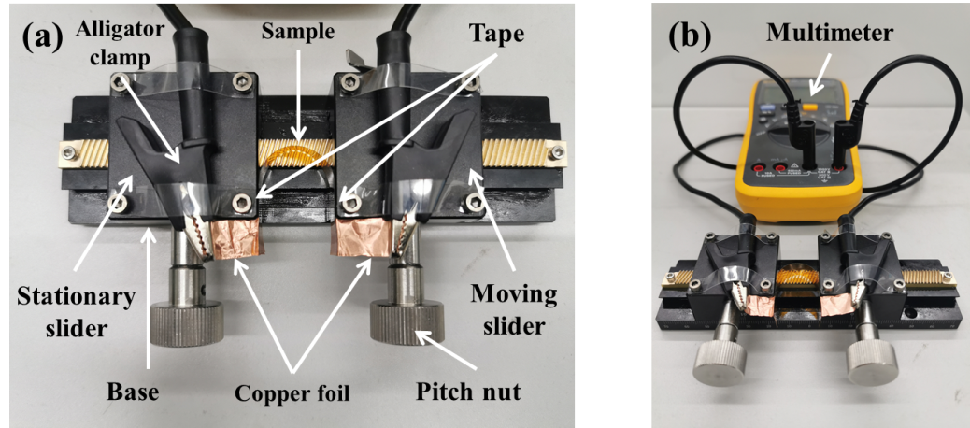
Fig. S2 a X-axis displacement console. b Dynamic bending test device.
In Fig. S2a, the sample is fixed to the side of the stationary and the moving slider by tape, and the end of the sample is connected with conductive copper foil for the alligator clamp to hold, and the alligator clamp is fixed on the two sliders respectively and moves with the moving slider. By adjusting the pitch nut on the moving slider, the slider can move left and right on the base, so as to control the bending radius, and the measurement accuracy is 0.1 mm. In Fig. S2b, the alligator clamps are connected to a multimeter and the resistance change during bending can be observed.
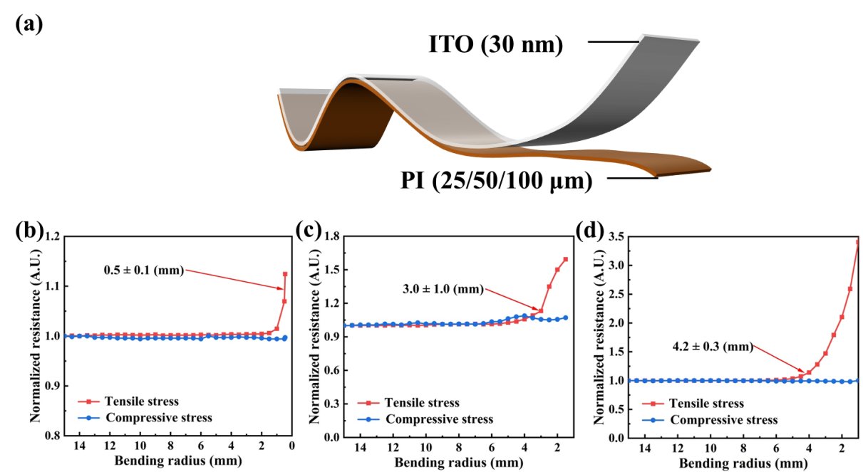
Fig. S3 a Schematic diagram of the flexible electrode. b−d Variation of normalized resistance with different bending radii on 25 μm, 50 μm and 100 μm substrates.

