Supporting Information

Rationally tailored passivation molecules to minimize interfacial energy loss for efficient perovskite solar cells
Taoran Gengª, Jike Dingª, Zuolin Zhangª, Mengjia Liª, Taoran Gengª, Hongjian Chenª, Thierry Pauporté^{b*}, Rundong Wan^{c*}, Jiangzhao Chen^{c*}, Cong Chen^{a*}
ª State Key Laboratory of Reliability and Intelligence of Electrical Equipment, School of Materials Science and Engineering, Hebei University of Technology, Tianjin 300401, China
^{b} Chimie ParisTech, PSL Research University, CNRS, Institut de Recherche de Chimie Paris (IRCP), UMR8247, Paris, F-75005 France
^{c} Faculty of Materials Science and Engineering, Kunming University of Science and Technology, Kunming 650093, China

¹ These authors contributed equally to this work.
*Corresponding authors
E-mail: thierry.pauporte@chimieparistech.psl.eu, rwan69@kust.edu.cn, jzchen@kust.edu.cn (J.C.), chencong@hebut.edu.cn (C.C)

Table S1. The fitting lifetime of short τ₁, longer τ₂ and average τ_{avg} from the TRPL curves
 | τ₁(ns) | τ₂(ns) | A₁ | A₂ | T(ns)
Control | 448.02 | 2 010.99 | 0.97 | 0.03 | 645.63
TFBA | 562.02 | 1 277.53 | 0.85 | 0.15 | 762.37
TFB | 740.26 | 1 805.20 | 0.91 | 0.09 | 950.37
PTF | 8.42 | 2 535.55 | 0.22 | 0.78 | 2 533.25

Table S2. Photovoltaic parameters of control and TFBA, TFB, and PTF modified devices
PSCs | Scan direction | Voc(V) | Jsc(mA/cm²) | FF(%) | PCE(%) | HI
Control | RS | 1.16 | 25.72 | 76.87 | 23.13 | 8.26
Control | FS | 1.15 | 25.68 | 71.52 | 21.22 | 8.26
TFBA | RS | 1.17 | 25.77 | 79.94 | 24.22 | 4.13
TFBA | FS | 1.14 | 25.59 | 78.99 | 23.22 | 4.13
TFB | RS | 1.17 | 25.96 | 80.40 | 24.55 | 2.93
TFB | FS | 1.14 | 25.93 | 80.10 | 23.83 | 2.93
PTF | RS | 1.18 | 26.22 | 82.54 | 25.57 | 1.64
PTF | FS | 1.17 | 26.00 | 81.50 | 25.25 | 1.64

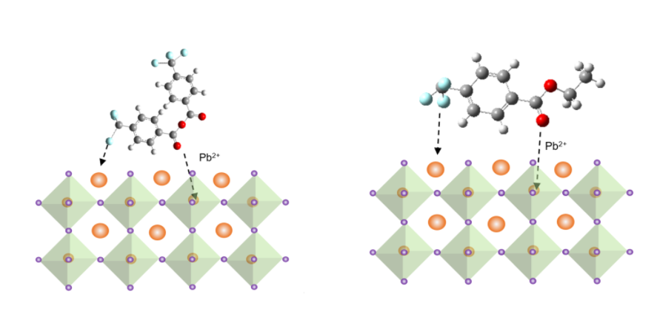
Figure S1. Schematic diagram of the interaction between passivation molecules and acceptor-like defects.

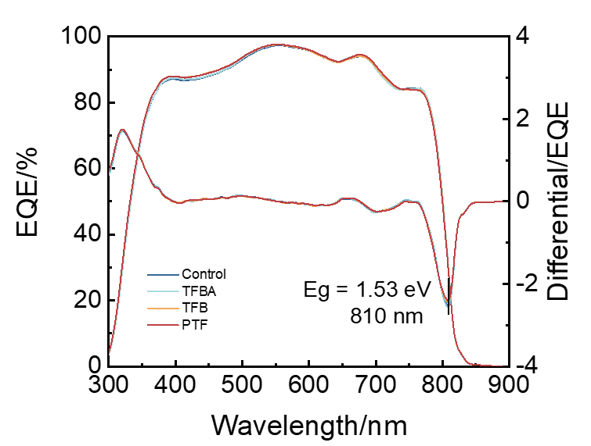
Figure S2. External quantum efficiency for control and TFBA, TFB, and PTF-modified PSCs devices.

Figure S3. Statistical distribution diagram of the Jsc and FF parameters of the control and PTF-modified devices employing conventional bandgap 1.53 eV-perovskite.

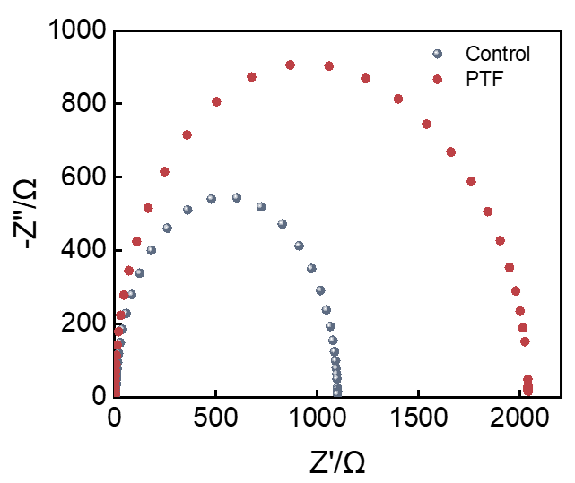
Figure S4. Nyquist plots of the PSCs with and without PTF passivation under a bias of 0 V in the frequency range of 1 MHz to 0 Hz under 1 sun illumination conditions at room temperature.

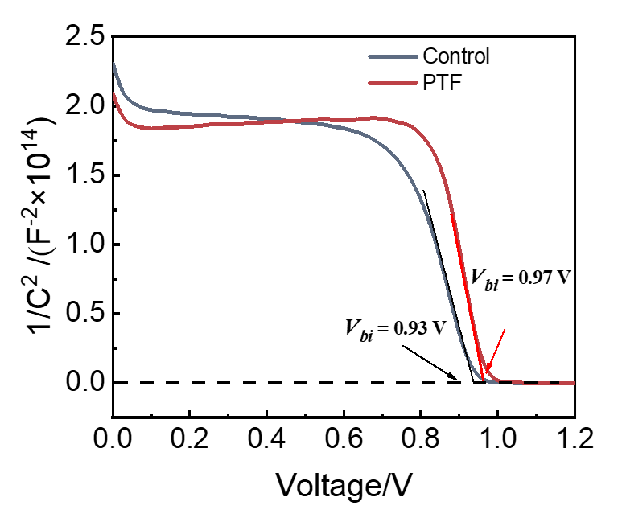
Figure S5. Mott−Schottky plots of the control and PTF-modified PSCs.

Figure S6. Dark I−V curves of the electron-only devices (ITO/SnO₂/perovskite/PCBM/Ag) with and without PTF.

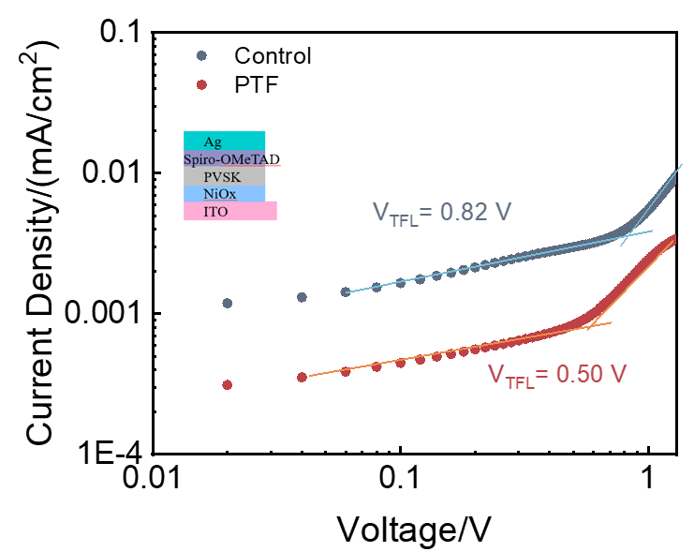
Figure S7. Dark I−V curves of the hole-only devices (ITO/NiOx/perovskite/Spiro-OMeTAD/Ag) with and without PTF.

Figure S8. The thermal stability test of standard control and PTF-modified devices at 85°C.

