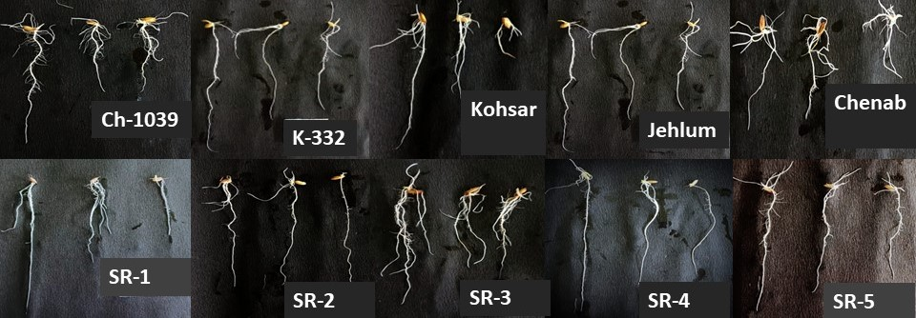

Figure S1: Variation for response to PEG-6000 for root length and root biomass in ten rice varieties released by SKUAST-K

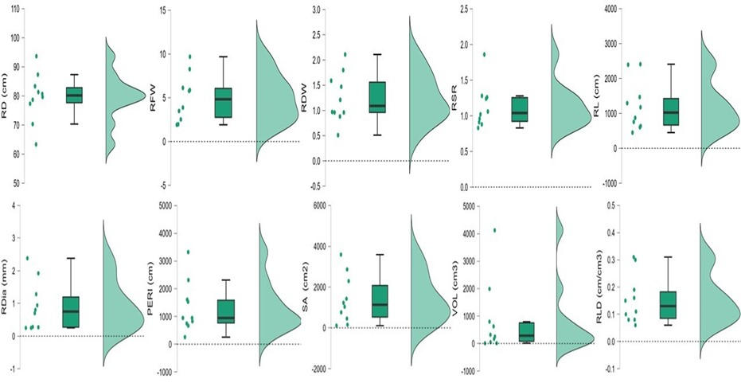
Figure S2: Graphical representation of variation in root traits in ten rice varieties released by SKUAST-K between 1956-2017
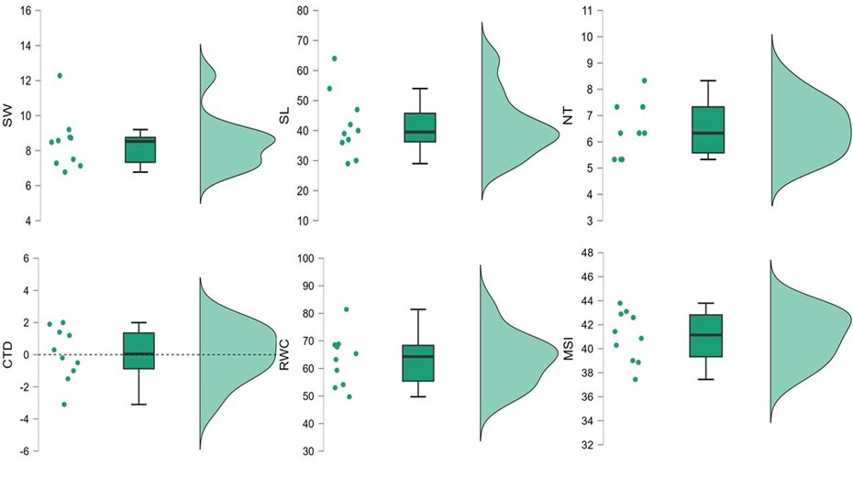
Figure S3: Graphical representation of variation in shoot and physiological traits in ten rice varieties released by SKUAST-K between 1956-2017

