Supplementary information
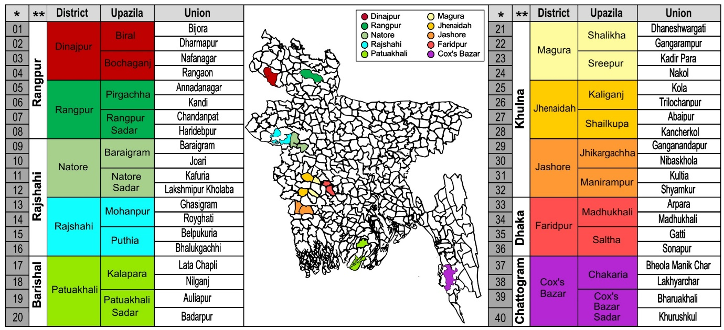
Supplementary Information 1: Survey Locations (40 Unions, 20 Upazila, 10 Districts), with each Union collecting 5 samples for 5 villages, totaling 1,000 samples.
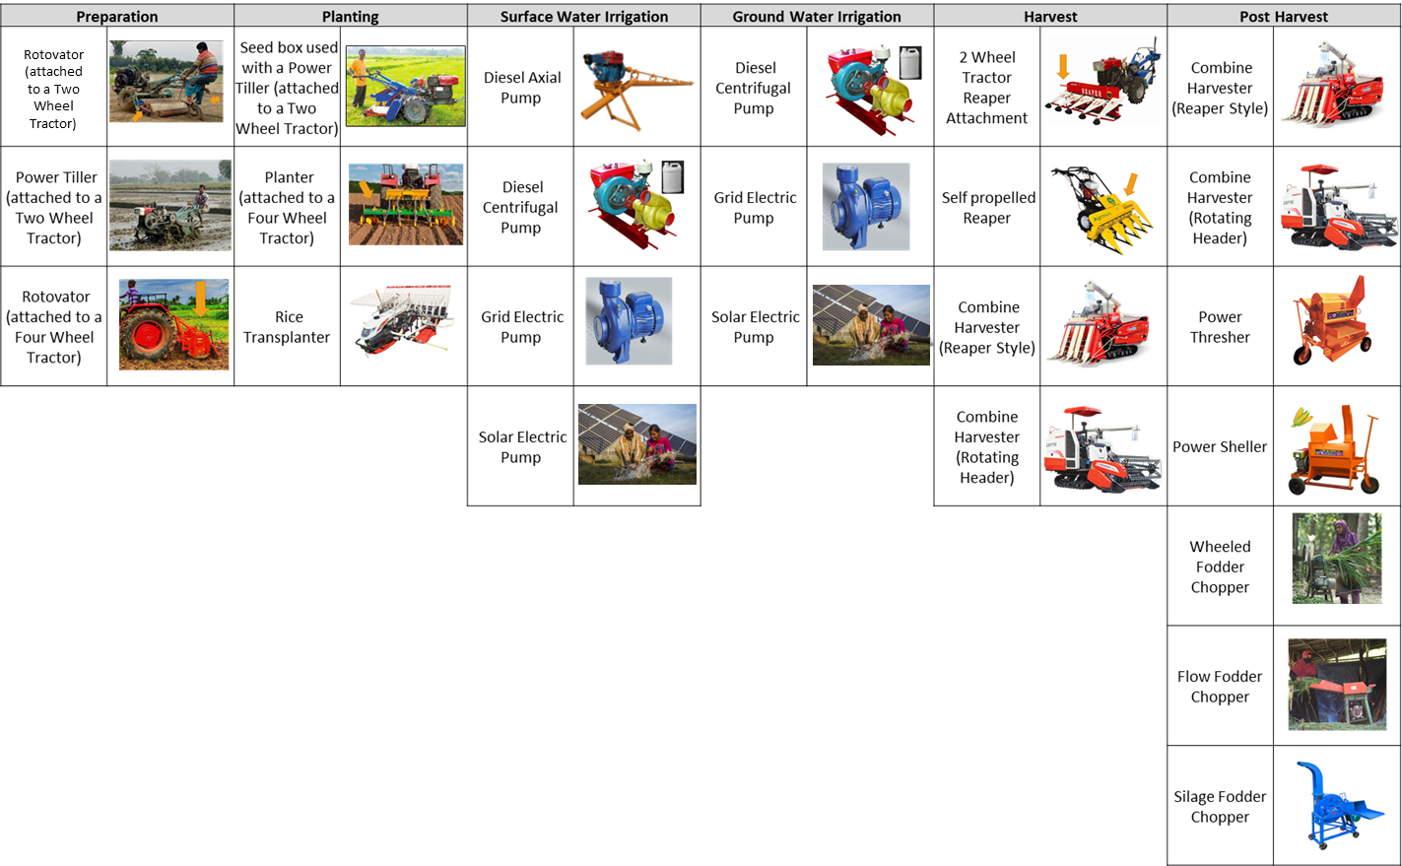
Supplementary Information 2: Machinery surveyed (22 Machines). This work reports on Harvest and post-harvest machinery.

Supplementary Information 3: Respondent summary statistics
 | % Male Respondents | Average Age | Years of Farming Experience | % Completed Middle school or higher | Size (deciles) | Household Members | Off farm earning household members
Cox's Bazar | 99% | 45.6 | 24.5 | 50% | 198.7 | 6.6 | 1.2
Faridpur | 99% | 47.5 | 39.8 | 17% | 176.4 | 5.7 | 0.5
Magura | 100% | 47.4 | 32.1 | 38% | 197.8 | 5.5 | 0.6
Jhenaidah | 100% | 47.1 | 26.0 | 50% | 221.7 | 5.0 | 0.5
Jashore | 100% | 51.3 | 27.3 | 43% | 134.1 | 4.7 | 0.6
Patuakhali | 97% | 47.8 | 21.5 | 34% | 312.3 | 5.2 | 1.0
Rajshahi | 98% | 46.7 | 21.8 | 25% | 113.0 | 4.5 | 0.6
Natore | 99% | 41.2 | 21.5 | 40% | 91.2 | 4.7 | 0.7
Rangpur | 95% | 47.1 | 25.8 | 43% | 158.7 | 5.2 | 0.8
Dinajpur | 100% | 48.5 | 29.0 | 42% | 232.9 | 5.6 | 0.6
Total | 99% | 47.0 | 27.5 | 34% | 183.3 | 5.3 | 0.7

Supplementary Information 3: Current binary adoption rates (2021) for each machinery type.
District | Reaper (2-Wheel Tractor) | Self-propelled Reaper | Combine Harvester (Reaper Style) | Combine Harvester (Full Header) | Power Thresher | Power Sheller | Wheeled Fodder Chopper | Flow Fodder Chopper | Silage Fodder Chopper |  | Any Harvest | Any Post Harvest |  | Any Harvest or Post Harvest
Dinajpur | 0% | 0% | 11% | 0% | 72% | 59% | 36% | 0% | 0% |  | 11% | 90% |  | 90%
Rangpur | 0% | 0% | 8% | 0% | 31% | 40% | 6% | 0% | 0% |  | 8% | 61% |  | 63%
Rajshahi | 0% | 0% | 4% | 0% | 81% | 6% | 7% | 2% | 1% |  | 4% | 82% |  | 83%
Natore | 0% | 0% | 4% | 0% | 58% | 39% | 13% | 1% | 0% |  | 4% | 61% |  | 61%
Jhenaidah | 0% | 3% | 5% | 0% | 79% | 8% | 49% | 1% | 0% |  | 8% | 86% |  | 87%
Magura | 0% | 0% | 1% | 0% | 23% | 1% | 21% | 0% | 0% |  | 1% | 40% |  | 41%
Faridpur | 0% | 0% | 0% | 0% | 66% | 0% | 0% | 0% | 0% |  | 0% | 66% |  | 66%
Jashore | 0% | 0% | 0% | 0% | 43% | 0% | 52% | 0% | 0% |  | 0% | 59% |  | 59%
Patuakhali | 0% | 0% | 7% | 13% | 96% | 4% | 1% | 0% | 0% |  | 18% | 96% |  | 97%
Cox's Bazar | 0% | 0% | 3% | 0% | 89% | 0% | 0% | 0% | 0% |  | 3% | 89% |  | 89%
Total | 0.0% | 0.3% | 4.3% | 1.3% | 63.8% | 15.7% | 18.5% | 0.4% | 0.1% |  | 5.7% | 73.0% |  | 73.6%

