Supplementary file
Table S1: Regulation and legislation of biostimulants in different countries
Country/Region | Legislation/Regulation  (Regulatory authority) | Key points
European Union | EU Fertilising Products Regulation (Regulation (EU) 2019/1009)  (European Commission) | - Biostimulants are considered a distinct category apart from fertilizers and pesticides. These are defined as products that enhance one or more characteristics of plants or their rhizosphere, such as nutrient use efficiency, tolerance to abiotic stress, crop yield and product quality, and nutrient availability.  - Biostimulant registration is required to meet specific labeling, safety, efficacy, and contaminant standards, including limits on heavy metals.  - Once a biostimulant is granted an EU-type certificate, the marketer can affix the CE mark, and the product will have access to the whole EU market.  - Enforced from July 2022, providing a uniform regulatory framework was provided across the EU.
United States | Guidance on Plant Biostimulants  (USDA, EPA) | - The Plant Biostimulant Act was proposed to create a federal definition and clear regulatory pathway for biostimulants, but it has not yet passed. Hence, USA lacks a federal definition for biostimulants.  - Products are regulated based on their primary claims on their primary claims. If products claim to promote growth, the USDA regulates them; if pest control claims, then the EPA handles them.
India | Fertilizer (Control) Order, 1985 (amended 2021)  (Central biostimulants Committee) | - Biostimulants are formally recognized as distinct products from fertilizers and pesticides.  - Defined biostimulants as substances or microorganisms or a combination of both that stimulate physiological processes in plants and improve plant growth, yield, crop quality, nutrient uptake, and tolerance to stress without being directly nutritive.  - All biostimulants must be registered with CBC, including detailed information on composition, application, and safety.  - Labels must include information on active ingredients, application rates, and the biostimulant effect.  - Recent amendments introduced specific quality and safety standards for biostimulants, facilitating better market transparency.
China | Plant Growth Regulator and Soil Conditioner Regulation  (Ministry of Agriculture and Rural Affairs) | - Currently, there is no explicit definition of biostimulants; products are classified under plant growth regulators or soil conditioners.  - Registration and adherence to safety standards are required, particularly concerning product contaminants.
Brazil | Lei 6.894/1980  (Ministry of Agriculture, and Livestock) | - Biostimulants are classified under the Lei 6.894/1980 as Inoculant: substance containing microorganisms with an action favorable to plant development and stimulant or biofertilizer: product containing an active ingredient capable of improving, directly or indirectly, the development of plants.  - Registration is mandatory, with a thorough evaluation of safety, efficacy, and environmental impact before products can enter the market.  - Manufacturers must adhere to MAPA labeling requirements, providing clear usage instructions.

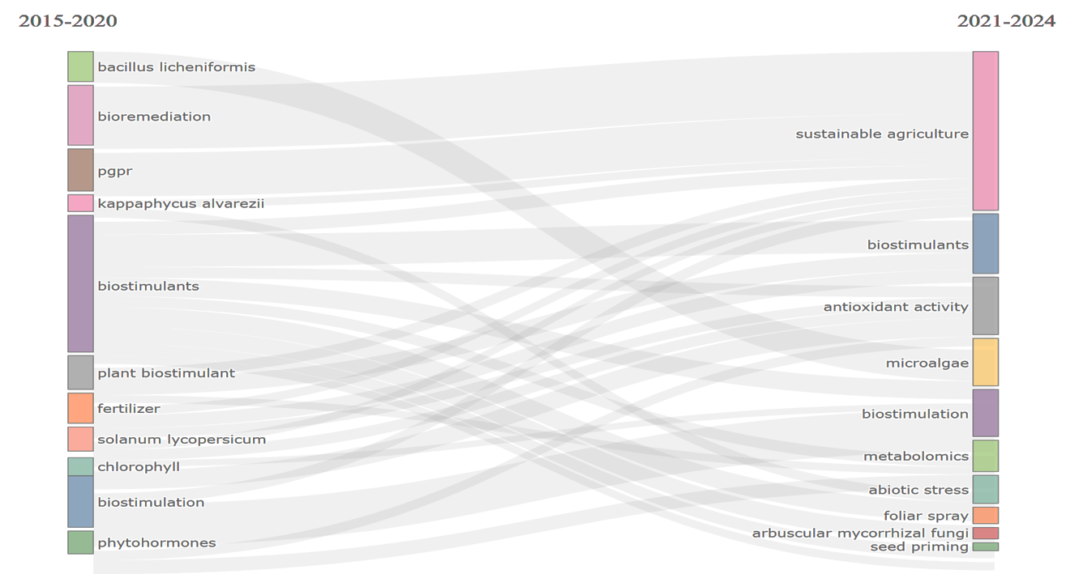
Figure.S1 Thematic evaluation of biostimulant research

