Table S1: Details of experimental materials used in the study and developed at IARI, New Delhi
S.N. | Genotype | Pedigree/Parentage | Prod Condition
1 | HD3171 | PBW343/HD2879 | Rainfed, Timley sown
2 | DW1616 | HW5028/HD2643//UP2565 | Irrigated, Timely sown
3 | HD2864 | DL509-2/DL377-8 | Irrigated, Late sown
4 | HD3086 | DBW14HD2733/HUW468 | Irrigated, Timely Sown
5 | HD3249 | PBW343*2/KUKUNA//SRTU/3/PBW343*2/KHVKAI | Irrigated, Timely Sown
6 | DW1627 | DW1422/WR1441//HRLSN-7 | Irrigated, Timely Sown
7 | DW1628 | DW1411/HP1744//DW1440 | Irrigated, Timely sown
8 | DW1629 | HD2967/LBE2003-1//LBRL-11 | Irrigated, Late sown
9 | HD3184 | HD2844/F81513//MILAN-2/3/WH730 | Irrigated, Timely sown
10 | HD3252 | BABX/LR43//BABAX/6/MOR/VEE#5DUCULA/3/DUCULA/4/MILAN/5/BAU/NILAN/7/SKAUZ/BAV92 | Irrigated, Timely sown
11 | DW1630 | CL2762/HP1744//CHIRYA3 | Irrigated, Late sown
12 | HD2932 | KAUZ/STAR//HD2643
13 | DW1631 | HD2967/ CHIRYA3//DW1451 | Irrigated, Late sown
14 | DW1632 | HD2998/HD2733//DW1432 | Irrigated, Late sown
15 | WR544 | NW 2078/CL1739//HD2960 | Irrigated, V Late sown
16 | HD3255 | SOKOLL//PBW343*R/KUKUNA/3/ATTAILA/  PASTOR | Irrigated, Timely sown
17 | DW1633 | VL796/HD2009//HD3003 | Irrigated, Late sown
18 | DW1634 | HD2682/CL3156//WH542 | Irrigated, Late sown
19 | DW1635 | UP2338/WR1909//NING8319//HD2967 | Irrigated, Late sown
20 | HD3090 | SFW/VAISHALI//UP2405 | Irrigated, Late sown
21 | HD 3262 | VL796/HD2009//HD3003 | Irrigated, Timely sown
22 | DW1636 | HD2998/HD3160//PDW621-50 | Irrigated, Late sown
23 | DW1637 | HD2967/HD3027 | Irrigated, Late sown
24 | DW1638 | HD2967/HP1744//LBRL1 | Irrigated, Late sown
25 | DW1639 | HD2998/HD2894//PS940 | Irrigated, Late Sown
26 | DW1640 | HD2967/LBR1724//VHW4668 | Irrigated, Late sown
27 | HD3318 |  | Irrigated, Late Sown
28 | HD3265 | DW1311/HD2894/HW5028 | Irrigated, Timely sown
29 | DW1642 | HD2967/HD2844/F81-513//MAILAN2/3/WH730 | Irrigated, V. Late sown
30 | DW1643 | HD 2967/E-4870 | Irrigated, V. Late sown
31 | DW1644 | HD2998/DW1403 | Irrigated, V. Late sown
32 | DW1645 | HD2921/HPW277//PBW 621-50 | Irrigated, V. Late sown
33 | HD3059 | KAUZ//ALTAR84/AOS/3/MILAN/KAUZ/4/HUITES | Irrigated, Late sown
34 | HD3266 | TRCH/5/REH/HARE//2*BCN/CROC-1AE.SQUARROSA(213)//PGO/4/HUITES | Irrigated,Late sown
35 | DW1615 | NW 2078/CL1739//HD2960 | Irrigated, Timely sown
36 | HDCSW18 | PBW343/CL1538 | CA Early sown

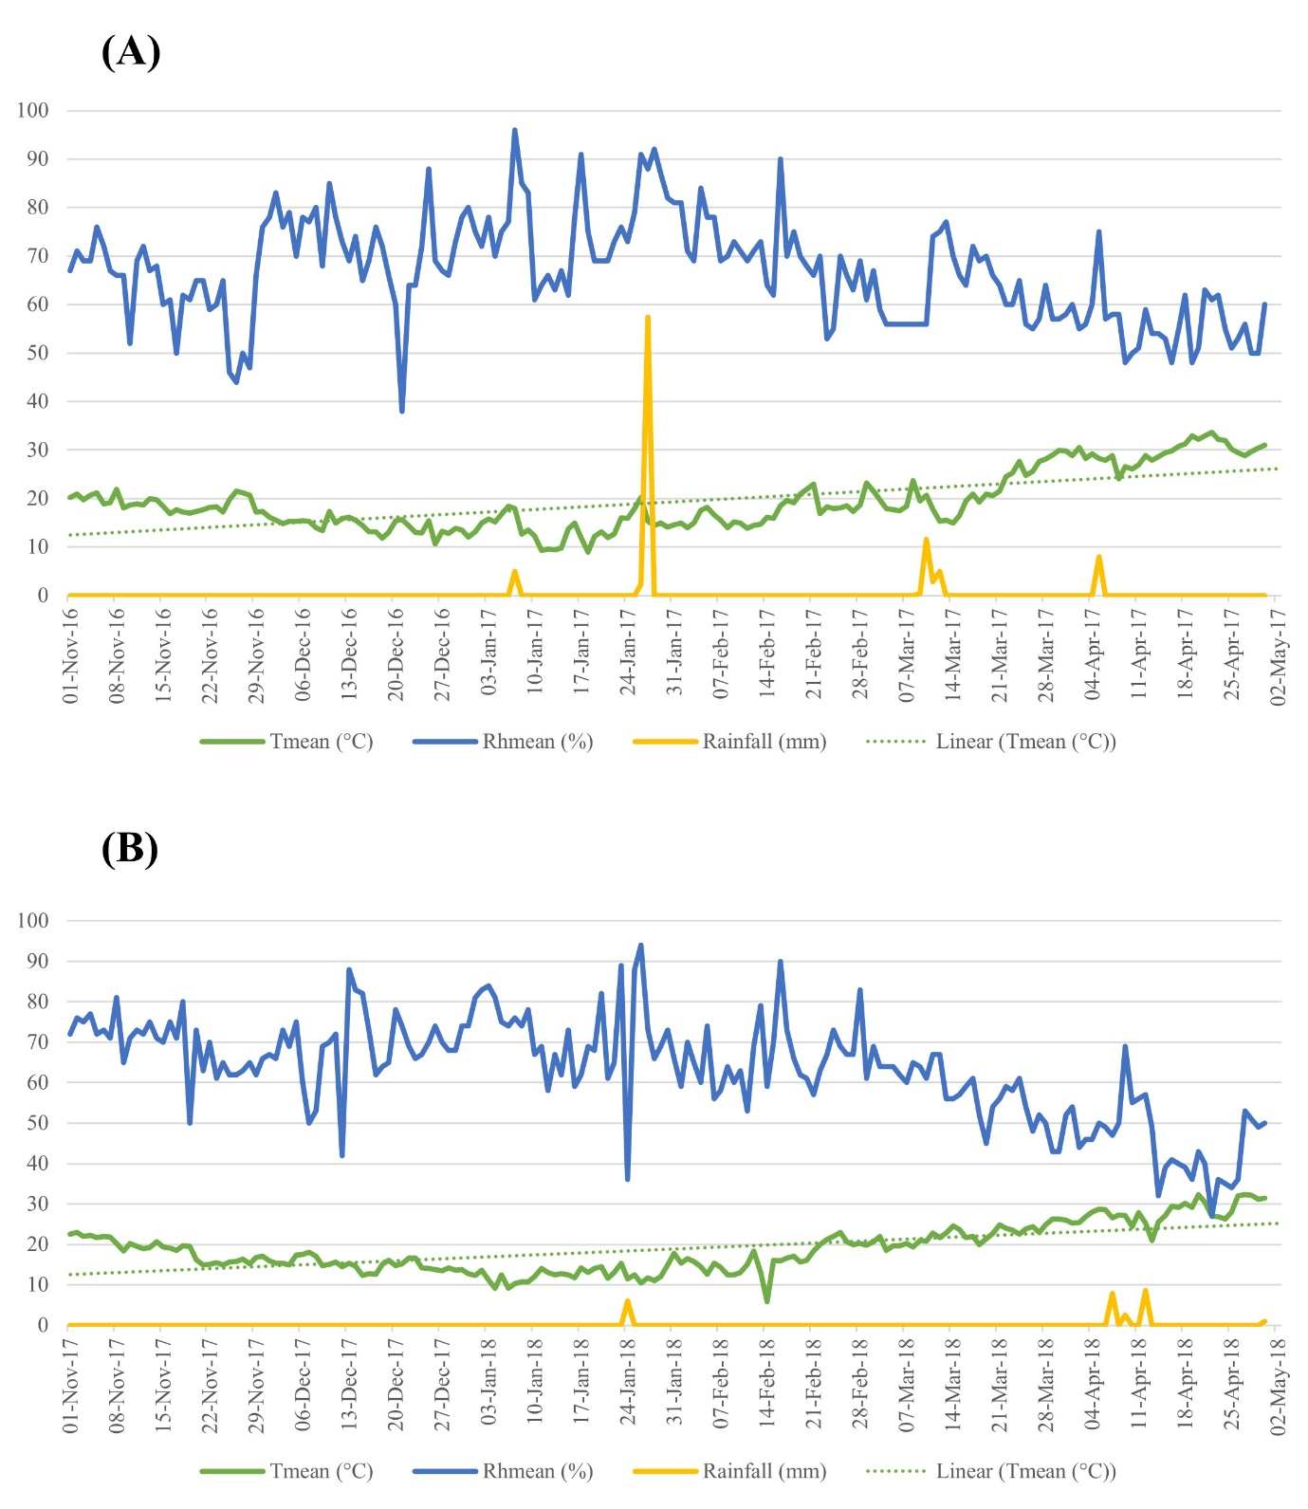
Figure S1: The weather data for the two seasons (2016–2017 and 2017–2018) is presented in Figure S1A and Figure S1B, respectively. Key weather parameters, including mean temperature (Tmean), relative humidity (RHmean), and rainfall, were recorded during the wheat-growing period from November to May.

