Supplemental Material
Table S1: Seeding rates and fertilizer applications for three saltwater-intruded farms along the Lower Eastern Shore of Maryland by year and treatment.
Site | Year | Treatment | Seeding Rate  (seeds m⁻²) | Fertilizer  (kg ha⁻¹) | Cover Crop  (kg ha⁻¹)
Farm 1 | 2019 | Barley | 297 | 89 N
Farm 1 | 2019 | Sorghum | 297 | 84 N + 89 N | 36 (Rye); 22 (Rapeseed)
Farm 1 | 2019 | Soybean | 480 | 89 N + 53 K
Farm 1 | 2020 | Barley | 371 |  | 22 (Rapeseed)
Farm 1 | 2020 | Sorghum | 297 | 84 N
Farm 1 | 2020 | Soybean | 457 | 32 K
Farm 3 | 2018 | Barley | 297
Farm 3 | 2018 | Sorghum | 198 | 84 N | 36 (Rye); 22 (Rapeseed)
Farm 3 | 2018 | Soybean | 480 | 39 K | 36 (Rye); 22 (Rapeseed)
Farm 3 | 2019 | Barley | 371 | 46 N + 89 N
Farm 3 | 2019 | Sorghum | 198 | 84 N + 89 N
Farm 3 | 2019 | Soybean | 480 | 89 N + 53 K
Farm 3 | 2020 | Barley | 371 |  | 22 (Rapeseed)
Farm 3 | 2020 | Sorghum | 297 | 84 N
Farm 3 | 2020 | Soybean | 457 | 32 K
Farm 6 | 2018 | Barley | 297
Farm 6 | 2018 | Sorghum | 198 | 67 N | 36 (Rye); 22 (Rapeseed)
Farm 6 | 2018 | Soybean | 480 | 32 K | 36 (Rye); 22 (Rapeseed)
Farm 6 | 2019 | Barley | 371 | 26 N
Farm 6 | 2019 | Barley | 445 | 26 N
Farm 6 | 2019 | Sorghum | 198 | 84 N
Farm 6 | 2019 | Soybean | 480 | 53 K
Farm 6 | 2020 | Barley | 371 |  | 22 (Rapeseed)
Farm 6 | 2020 | Sorghum | 297 | 84 N
Farm 6 | 2020 | Soybean | 457 | 32 K

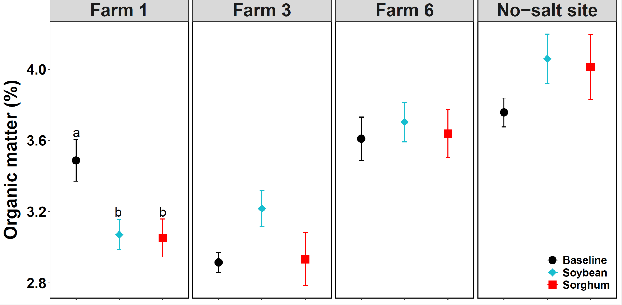
Figure S1: Organic matter (%) in topsoil (0–10 cm) at three saltwater-intruded field sites and one no-salt site on the Lower Eastern Shore of Maryland, measured in 2018 (baseline) and yYear 4. Different letters indicate significant differences (p < 0.05) among crop rotation within each year and across years based on Tukey’s post- hoc pairwise comparisons. Error bars are the standard error of the means.

