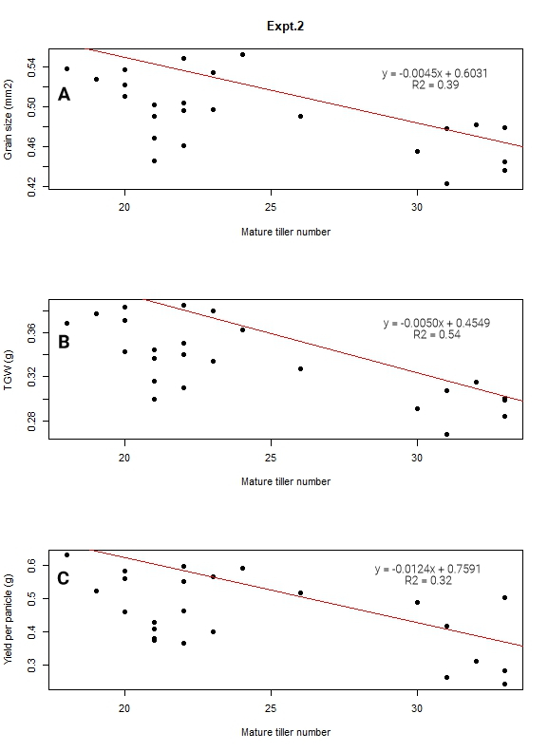
Supplementary Figure 1. The relationship of mature tiller number per plant with grain size (A), TGW (B), and yield per panicle (C) in expt.2.

