Supplementary Material

Supplementary Figures and Tables

Supplementary Figures

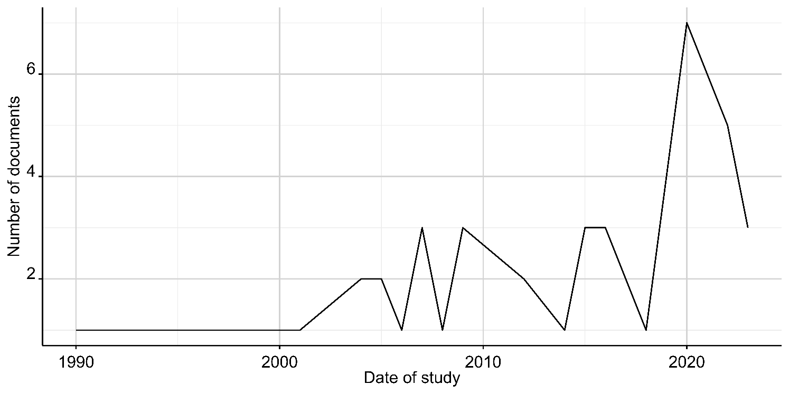Figure S1. Documents on silvopastoral systems adoption in Latin America through time.
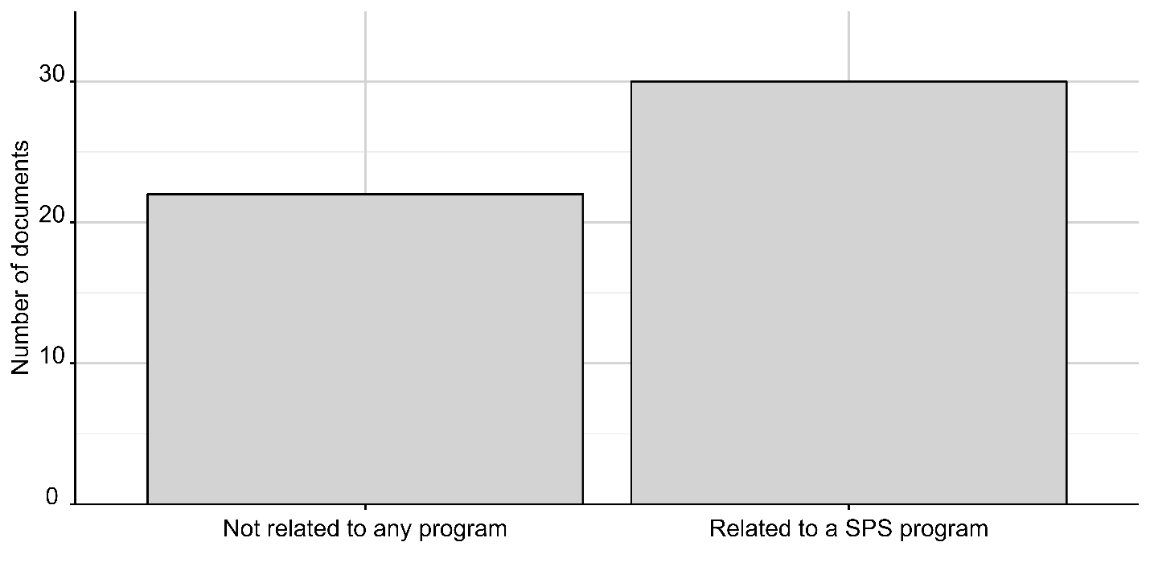
Figure S2. Number of documents included in the systematic literature review that are related to SPS promotion programs and that are not related to any.
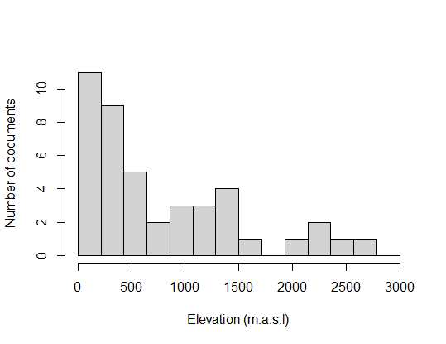
Figure S3. Histogram of the elevation of the study sites of the documents included in this literature review. (m.s.a.l= meters above the sea level).
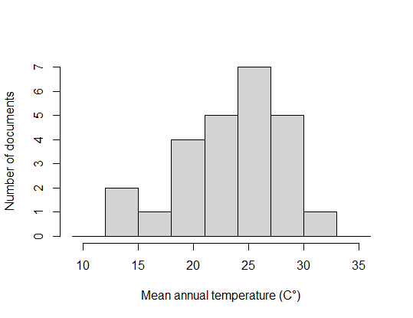
Figure S4. Histogram of the mean annual temperature of the study sites of the documents included in this literature review.

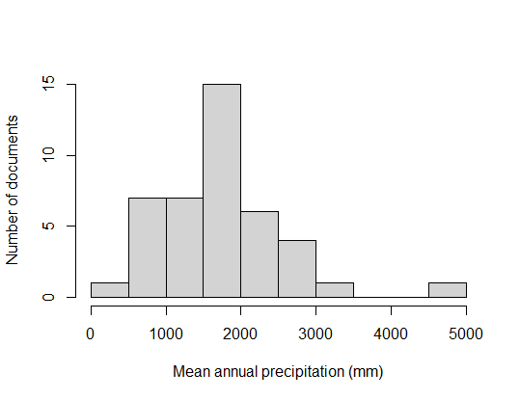
Figure S5. Histogram of the mean annual precipitation of the study sites of the documents included in this literature review.

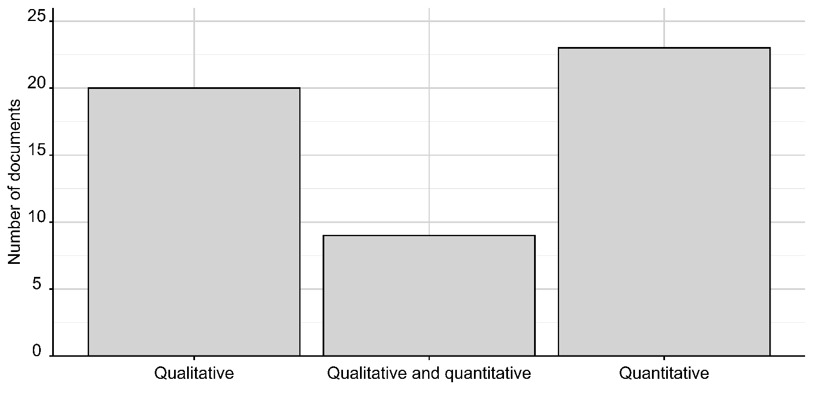
Figure S6. Methodological approaches used in the documents included in this literature review.

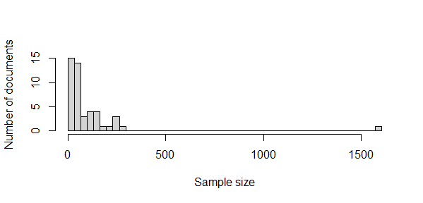
Figure S7. Histogram of the sample sizes of the documents included in this literature review.

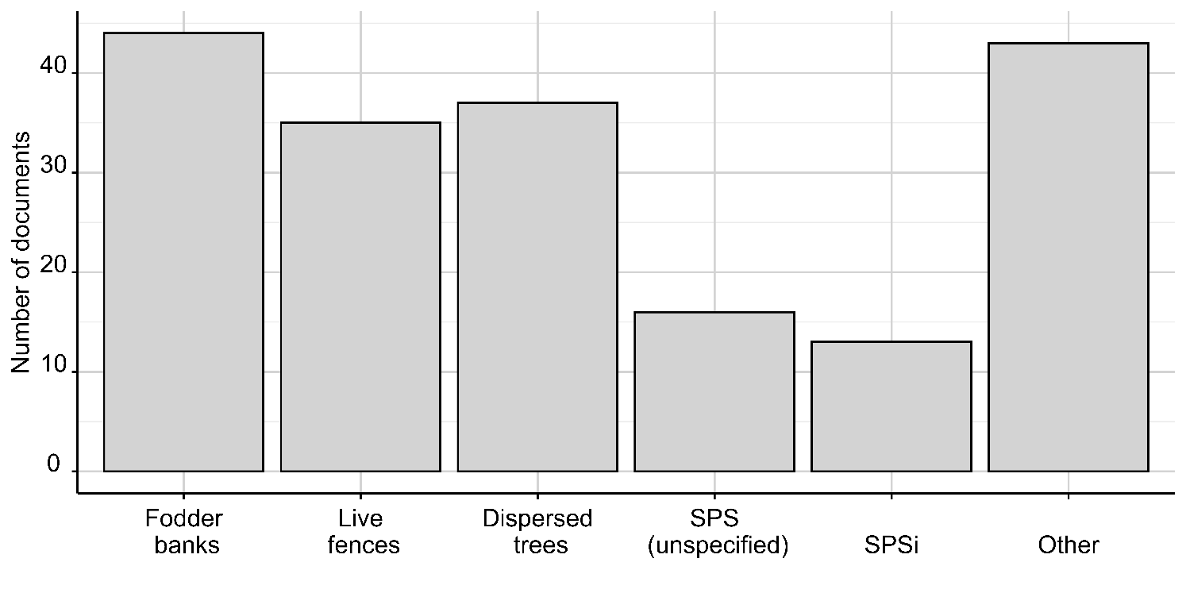

Figure S8. Types of SPS studied on the documents included in this literature review. Note: most documents studied a combination of SPS type (e.g., Live fences, fodder banks, dispersed trees and intensive SPS (SPSi)).

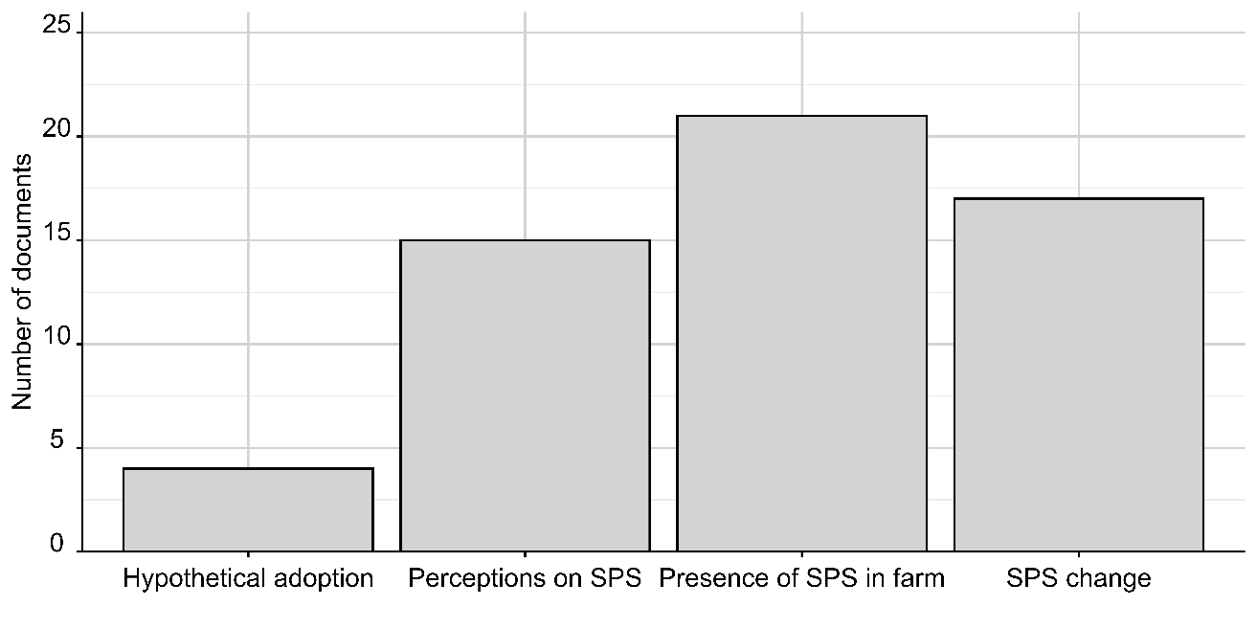
Figure S9. Adoption measurement in the documents included in this literature review. Some documents used methods such as choice experiment or hypothetical scenarios where farmers adopted SPS, others studied the perceptions of farmers on SPS, while others used field observations or satellite images to identify the presence of SPS in the farms or measure the changes of SPS occupation on the farms across time.

Supplementary tables
Table S1. Search terms used on the databases for the systematic search of documents.
 | Adoption |  | SPS | Cattle farming | Latin America
"adoption" OR "adopción" OR "adoção" OR "incentives" OR "incentives" OR "motivation" OR "motivación" OR "motivação" OR perception* OR attitude* OR "decision making" OR "tome de decisions" OR "tomeda de decisões" OR "innovation adoption" OR "adopción de innovaciones" OR "adoção de inovações" OR "farmers" OR "agricultures" OR "farmers' attitudes" OR "attitudes de los agricultures" OR "attitudes dos agricultures" OR adoption OR adopción OR adoção OR adopt OR implementación OR implementação |  | "Silvopastoral systems" OR "sistemas silvopastoriles" OR "sistemas silvopastoris" OR silvopast* OR "intensive silvopastoral systems" OR "sistemas silvopastorales intensives" OR "sistemas silvopastoris intensives" |  | "cattle farming" OR "criar ganado" OR "criação de gads" OR livestock OR "ganado" OR "gads" OR "livestock production" OR "producción de ganado" OR "produção de gads" OR "livestock system" OR "sistema de ganado" OR "sistema de gads" | "developing country" OR "pads en desarrollo" OR "pads em desenvolvimento" OR "global south" OR "sur global" OR "global sul" OR "third world" OR "termer mundo" OR "terceiro mundo" OR underdeveloped OR "subdesarrollado" OR "subdesenvolvido" OR columbia OR colombia OR brasil OR brazil OR bolivia OR chile OR "french guiana" OR "guyana frances" OR "developing nation" OR "nación en desarrollo" OR "nação em desenvolvimento" OR "low income country" OR "pads de banjos ingress" OR "pads de baixa rend" OR "emergent nations" OR "naciones emergences" OR "nações emergences" OR "emergent country" OR "pads emergence" OR guyana OR paraguay OR peru OR suriname OR venezuela OR ecuador OR "south america" OR "suramérica" OR "latin america" OR "latinoamérica" OR argentina OR uruguay OR mexico OR "costa rica" OR "el salvador" OR guatemala OR honduras OR nicaragua OR panama OR belize OR cuba OR "dominican republic" OR "república dominican" OR haiti

Table S2. Main subcategories for each factor category and the number of appearances in articles, number pf reported variables in total for that subcategory and examples of variables reported for each subcategory.
Factor Category | Subcategory | Count articles | Number of variables reported | Examples
Economic incentives | Payments for ecosystem services (PES) | 14 | 35 | Has PSE, type of PSE scheme, amount of PES, PES duration
Economic incentives | Economic incentives different to PES | 12 | 15 | Tax breaks, subsidies, financial incentives
Economic incentives | Access to credit | 7 | 7 | Access to credit
Economic incentives | Provision of trees and seeds | 5 | 6 | Provision of trees, provision of seed nurseries
Economic incentives | SPS promotion policies | 3 | 4 | SPS promotion projects
Economic incentives | Land value increase | 2 | 2 | Land value increase
Economic incentives | Economic disincentives | 1 | 1 | Potential fines
Information transfer | Presence of technical assistance (TA) | 21 | 28 | Presence of TA, lack of TA.
Information transfer | Knowledge/Awareness of SPS | 16 | 29 | Knowledge of SPS, illness management, awareness of SPS
Information transfer | Social networks | 15 | 27 | Social connections, association membership with other SPS farmers
Information transfer | Previous participation in local projects/workshops | 14 | 21 | Participation in workshops, field days, participation in previous projects
Information transfer | Other information transfer | 3 | 5 | Number of sources of institutional information, poor communication between institutions
Ecosystem services/ disservices | Regulating services | 20 | 53 | Soil recovery, shade, clean air
Ecosystem services/ disservices | Provision services | 19 | 58 | Forage production, wood, fruit
Ecosystem services/ disservices | Supporting services | 19 | 32 | Increase in biodiversity, water protection
Ecosystem services/ disservices | Ecosystem disservices | 9 | 9 | Trees competing with grass, plant toxicity, trees harming cows
Ecosystem services/ disservices | Cultural services | 8 | 9 | Property beauty, scenic beauty
Farm characteristics | Vulnerability to climate change | 14 | 15 | Extended drought, climate change risk, anomalies in rain, risk of fire
Farm characteristics | Farm size | 13 | 17 | Farm size, farm area, paddock area, property size
Farm characteristics | Forest | 9 | 13 | Forest area, presence of forest, alder plantations, native vegetation
Farm characteristics | Other farm characteristics | 8 | 13 | Soil conditions, altitude, slope, watershed
Farm characteristics | Accessibility to farm | 5 | 8 | Accessibility to farm, type of access to the property
Farm characteristics | Seed availability on farm | 3 | 4 | Access to local seeds from their own farm
Farmer characteristics | Demographics | 17 | 39 | Age, education level, gender
Farmer characteristics | Preferences and values | 13 | 35 | Emotional ties to land, environmental and altruistic beliefs, business as usual beliefs, traditional ranching preference
Farmer characteristics | Expectation of profit | 11 | 13 | Income increase expectation, two outputs one plot, income stability
Farmer characteristics | Wealth | 10 | 15 | Wealth, land ownership, gross income from cattle ranching
Farmer characteristics | Risk | 8 | 8 | Risk adversity, perceived economic risk
Farmer characteristics | Family size | 7 | 8 | Family size, household size
Farmer characteristics | Other farmers' characteristics | 5 | 7 | Years of experience, living in or out of the farm
Management | Management complexity/ cost | 17 | 34 | Management complexity, labor, management cost
Management | Main farm product | 11 | 16 | Meat, dual purpose, milk, or meat
Management | Time for investment recovery | 7 | 8 | Time for trees to grow, time to receive benefits, time to recover investment
Management | Other management | 9 | 14 | Type of SPS, tree species used, paddock age
Management | Productivity (cows or milk) | 7 | 12 | Number of cows, average milk production (L)
Management | Limit the access of cows to streams | 2 | 4 | Limit cow access to streams
Management | Low management complexity | 1 | 1 | Low management complexity
Market conditions | Production costs | 19 | 26 | Implementation cost (trees, seeds, fertilizer cost), dependency on external input, input cost
Market conditions | Lack of market for sustainable products | 9 | 10 | Lack of market for sustainable products (wood, meat, and milk produced under SPS), premium market prices
Market conditions | Price instability | 7 | 7 | Price instability
Market conditions | Other market | 5 | 7 | Role of middleman in trading, green certifications, international agreements
Market conditions | Barriers to SPS policy implementation | 3 | 4 | Scarce funding for training in SPS, lack of territorial planning, poor coordination between national and local government
Market conditions | Access to seeds | 2 | 2 | Lack of access to seeds and plants in the market

Table S3. Summary of findings from the subset of quantitative studies (N=24) of factors influencing adoption of SPS in Latin America. Specific subcategories, their effect on adoption and references. +/U/− indicate positive and significant, not significant, negative, and significant, respectively. The effect bolded is the effect with the most evidence from literature (more documents found such effect).
Factor category | Subcategory | Effect | Selected references
Information  transfer | Presence of technical assistance | +/U/- | +: (A. Calle, 2020b; Cancino et al., 2016; Carriazo et al., 2020; Casasola Coto et al., 2007; López, 2007);  U: (Cerrud et al., 2004)  -: (Jara-Rojas et al., 2020; Oliva, 2018)
Information  transfer | Social networks | +/U/ - | +: (Cerrud et al., 2004; Garbach et al., 2012; Rasch et al., 2021; Zabala et al., 2022);  U: (Frey et al., 2012; Stefano et al., 2020);  -: (Garbach et al., 2012; Rasch et al., 2021)
Information  transfer | Knowledge/  Awareness on SPS | +/ U | +: (Cancino et al., 2016; Ibrahim et al., 2001; Love & Spaner, 2005);  U: (Cerrud et al., 2004)
Information  transfer | Previous participation in projects/workshops | +/ - | +: (Cancino et al., 2016; Jara-Rojas et al., 2020);  -: (Love & Spaner, 2005)
Economic  incentives | Payments for ecosystem services (PES) | +/ U | +: (Carriazo et al., 2020; Raes et al., 2017; Rasch et al., 2021; Stefano et al., 2020) ;  U: (Cerrud et al., 2004; Pagiola et al., 2016)
Economic  incentives | Economic incentives different to PES | + / U | +: (A. Calle, 2020b; Cancino et al., 2016; López, 2007);  U: (Zabala et al., 2022)
Economic  incentives | Access to credit | + / U | +: (Jara-Rojas et al., 2020; Maza Rojas, 2004);  U: (Cerrud et al., 2004)
Economic  incentives | Provision of trees and seeds | + | +: (A. Calle, 2020b; Cancino et al., 2016)
Management | SPS management complexity/ cost | +/U/- | +: (Garbach et al., 2012),  U: (Maza Rojas, 2004; Stefano et al., 2020);  -: (A. Calle, 2020b; Frey et al., 2012; Ibrahim et al., 2001)
Management | Main farm product | +/U/- | +: (Jara-Rojas et al., 2020; López, 2007);  U: (Raes et al., 2017);  -: (Ibrahim et al., 2001; Oliva, 2018; Zabala et al., 2022)
Management | Farm productivity (number of cows or liters of milk) | +/ U | +: (Jara-Rojas et al., 2020; Vargas-dela Mora, 2021);  U: (Oliva, 2018)
Management | Time for investment recovery | - | -: (Casasola Coto et al., 2007; Frey et al., 2012)
Farmer  characteristics | Demographics | +/ U/ - | +: (Cancino et al., 2016; B. Torres et al., 2018);  U: (Garbach et al., 2012; Rasch et al., 2021);  -: (López, 2007)
Farmer  characteristics | Preferences and values | +/ U/ - | +: (A. Calle, 2020b; Raes et al., 2017; B. Torres et al., 2018);  U: (Stefano et al., 2020)  -: (Raes et al., 2017)
Farmer  characteristics | Wealth | +/ U/ - | + : (López, 2007; Maza Rojas, 2004);  U: (Cerrud et al., 2004; Zabala et al., 2022)  -: (Love & Spaner, 2005)
Farmer  characteristics | Expectation of profit from SPS | + | +: (A. Calle, 2020b; Frey et al., 2012)
Farmer  characteristics | Family size | +/ U | +: (Casasola Coto et al., 2007; Rasch et al., 2021);  U: (Cerrud et al., 2004; Vargas-dela Mora, 2021)
Farmer  characteristics | Risk aversion | - | -: (A. Calle, 2020b; Ibrahim et al., 2001)
Farm  characteristics | Vulnerability to climate change | +/ U/ - | +: (Frey et al., 2012; Ibrahim et al., 2001);  U: (Raes et al., 2017);  -: (A. Calle, 2020b)
Farm  characteristics | Farm size | +/U/ - | +: (Carriazo et al., 2020; Maza Rojas, 2004);  U: (Oliva, 2018; Tarbox et al., 2020);  -: (Frey et al., 2012; Love & Spaner, 2005)
Farm  characteristics | Presence of forest | +/ U/ - | +: (Love & Spaner, 2005);  U: (Oliva, 2018);  -: (Raes et al., 2017)
Farm  characteristics | Accessibility to farm | +/ U | +:(Cerrud et al., 2004; Vargas-dela Mora, 2021)  U: (Cerrud et al., 2004; Vargas-dela Mora, 2021)
Farm  characteristics | Seed availability in farm | + | +: (Tarbox et al., 2020)
Ecosystem services/ disservices | Regulating services | + | +: (A. Calle, 2020b; Cancino et al., 2016; Joseph et al., 2019; Love & Spaner, 2005; Oliva, 2018)
Ecosystem services/ disservices | Provision services | + | +: (Camargo et al., 2005; Frey et al., 2012; Garbach et al., 2012; Ibrahim et al., 2001; Joseph et al., 2019)
Ecosystem services/ disservices | Supporting services | +/U/- | +: (Cerrud et al., 2004; Love & Spaner, 2005);:  U: (Oliva, 2018);  -: (Tarbox et al., 2020)
Ecosystem services/ disservices | Ecosystem disservices | - | -: (Cancino et al., 2016; Frey et al., 2012; Garbach et al., 2012)
Ecosystem services/ disservices | Cultural services | +/- | +:(A. Calle, 2020b)  -:(Garbach et al., 2012)
Market  conditions | Production costs | +/- | +: (Cancino et al., 2016);  -: (Camargo et al., 2005; Love & Spaner, 2005; Maza Rojas, 2004; Tarbox et al., 2020)
Market  conditions | Lack of market for sustainable products | - | -: (A. Calle, 2020b; Camargo et al., 2005; Ibrahim et al., 2001; Jacobi et al., 2017)
Market  conditions | Price stability | +/- | +: (Ibrahim et al., 2001);  -: (Cancino et al., 2016)
Market  conditions | Other market | +/- | +:(Cancino et al., 2016);  -: (Cancino et al., 2016)

