Supplementary Materials
Supplementary Figures
Figure S1. The study employed a dual approach: (i) a field experiment using a randomized complete block design with three pollination treatments to quantify effects on yield and seed quality; and (ii) a semi-structured farmer survey (n = 179) to assess knowledge, awareness, and current pollination management practices. The experimental component established the biophysical potential of pollination services, while the survey component assessed the socio-cultural readiness of farming communities to realize this potential.
Figure S2. Location of study sites in Degua Tembien woreda, Tigray, Ethiopia, based on latitude and longitude coordinates. Sites fall within the mid altitude agroecological zone (~2,000–2,500 m.a.s.l.).
FARMER SURVEY
n = 179 farmers
Assess:
- Knowledge of pollinators
- Awareness of pollination services
- Current practices: agrochemical practices, and beekeeping intentions.
INTEGRATED FINDINGS
- Biophysical potential:
- 49.1% yield increase
- Enhanced quality (germination, oil and protein)
- Social reality:
- Low awareness (93.2%)
- Few practices
IMPLICATION:
- Technical + social intervention needed to realize potential
STUDY DESIGN
FIELD EXPERIMENT
3 Treatments:
- Honeybee-only
- Open pollination
- Pollinator-exclusion
Traits measured:
- Yield, and yield components
- TKW, Germination, Moisture
- Oil, Protein
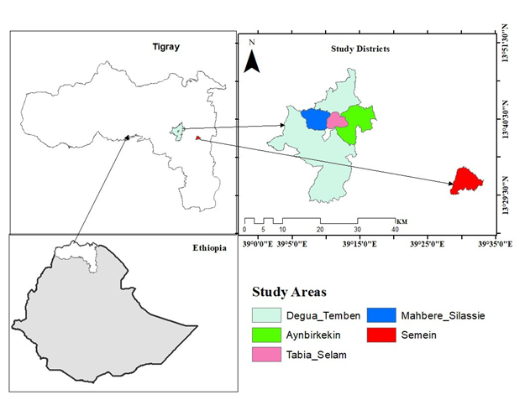

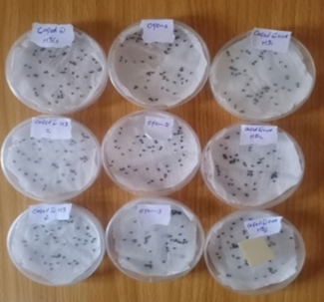
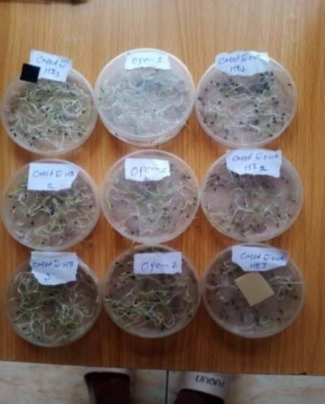
Figure S3. Germination percentage among treatments. Germination percentage was assessed using 60 seeds per plot following International Seed Testing Association (ISTA) protocols (51). Seeds were placed on moist filter paper in Petri dishes (a) and incubated at 25 °C for 7 days; seeds showing visible radicle emergence (b) were scored as germinated.
A
B
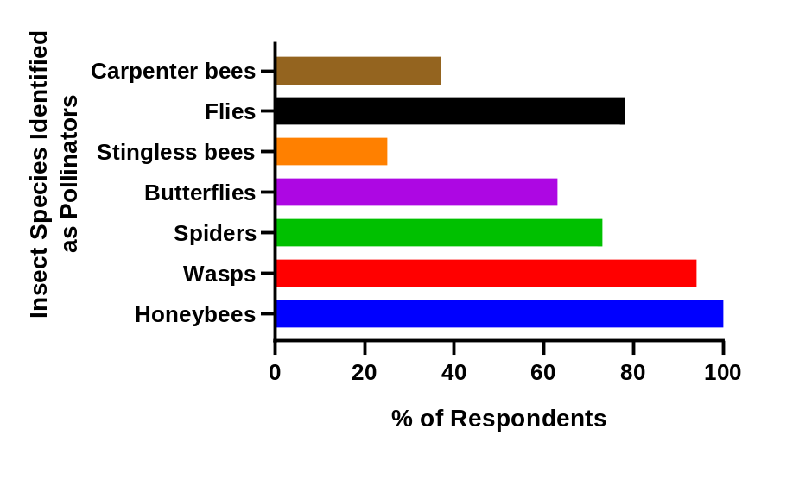
Figure S4. Farmers’ recognition of insect pollinator species (% of respondents). All respondents identified honeybees (Apis mellifera) as pollinators, whereas awareness of other insects, such as stingless bees (Meliponini), carpenter bees (Xylocopa caffra), wasps (Polistes canadensis), flies (Lucilia sericata), butterflies (Hemiargus ceraunus), and beetles (Mylabris pustulata), was minimal.

Survey Questionnaire (Appendix I)
Section A: Demographic Information
- Age of respondent (years): ___
- Sex: ☐ Male ☐ Female
- Educational level: ☐ No formal education ☐ Primary ☐ Secondary ☐ College/University
- Farming experience (years): ___
- Household size: ___
Section B: Knowledge and Awareness of Pollination
- Have you ever heard the term “pollination”? ☐ Yes ☐ No
- If yes, how would you define pollination in your own words? __________________________
- Do you know which agents (insects, wind, etc.) are involved in pollination? ☐ Yes ☐ No
  - If yes, please list them: __________________________
Section C: Role of Insect Pollinators
- Do you believe insect pollinators influence crop yield? ☐ Yes ☐ No ☐ Not sure
- Do you believe insect pollinators influence crop quality? ☐ Yes ☐ No ☐ Not sure
- Which insect pollinators are most common in your area? __________________________
- Have you observed honeybees visiting Nigella sativa flowers? ☐ Yes ☐ No
Section D: Beekeeping Practices
- Do you keep honeybee colonies? ☐ Yes ☐ No
- If yes, what is the main purpose?
☐ Honey production ☐ Pollination ☐ Both ☐ Other (specify): __________
- How many colonies do you currently manage? ___
Section E: Agrochemical Use
- Do you use chemical inputs (fertilizers, pesticides, herbicides) on your crops? ☐ Yes ☐ No
- If yes, which types of chemicals do you commonly apply? __________________________
- Do you think chemical use affects honeybees or other pollinators? ☐ Yes ☐ No ☐ Not sure
- Have you ever observed negative effects of chemicals on honeybees? ☐ Yes ☐ No
- If yes, please describe: __________________________
Section F: Farmers’ Perceptions and Experiences
- In your opinion, how important are honeybees for crop production?
☐ Very important ☐ Moderately important ☐ Not important
- Would you be willing to use honeybee colonies specifically for pollination services? ☐ Yes ☐ No
- What challenges do you face in managing pollination or beekeeping? __________________________
- What support or training would help you improve pollination practices? __________________________

