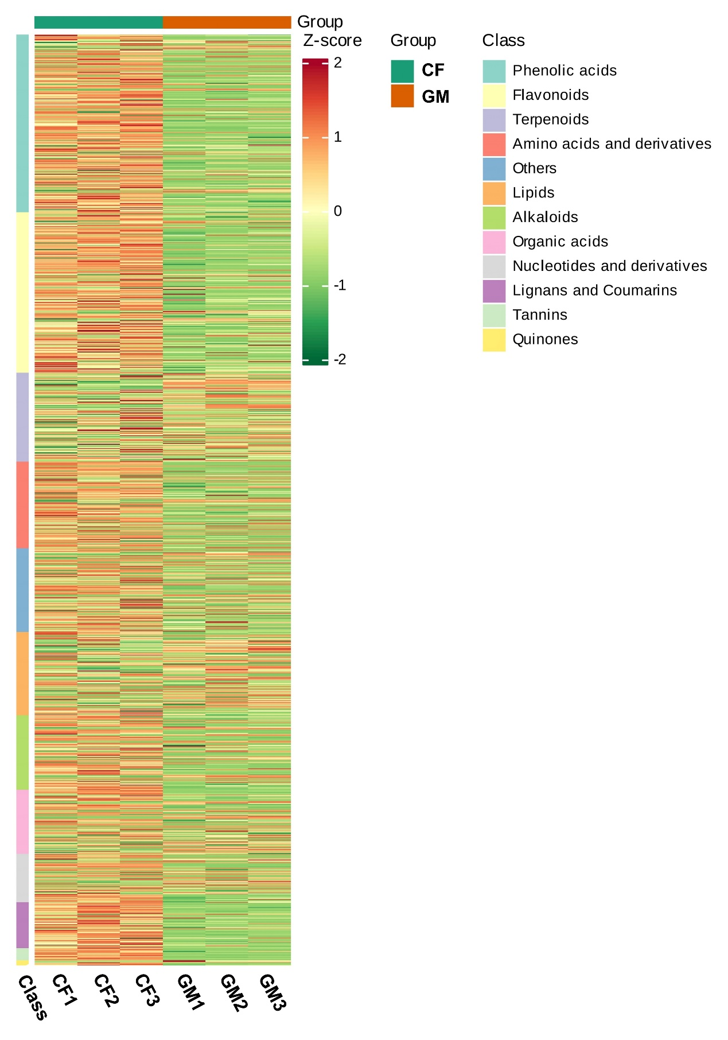Supplementary Fig. S1. Enrichment analysis of DAMs in GM and CF.

