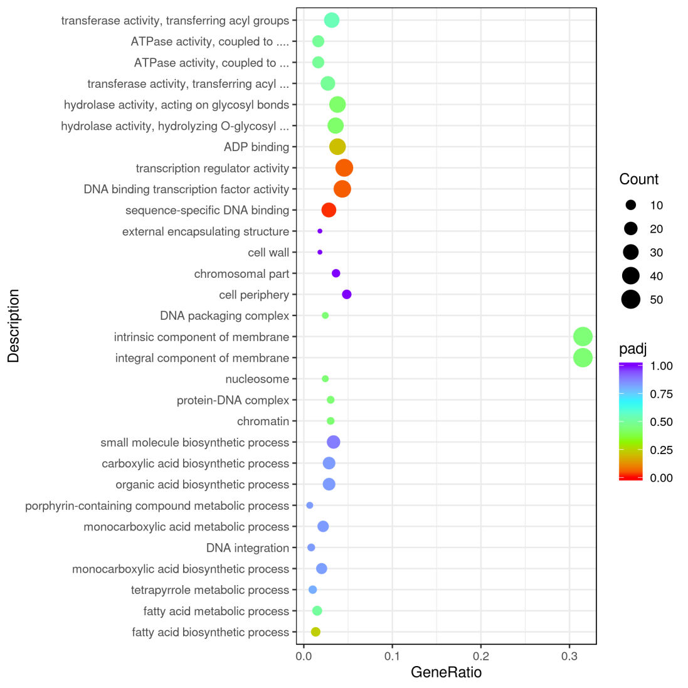
Supplementary Fig. S4. GO enrichment of differential expressed genes.

