Identifying and testing adaptive management options to increase river catchment system resilience using a Bayesian Network model
Supplementary Material
Kerr Adams^{1,2}, Marc J. Metzger², Rachel Helliwell¹, Nicola Melville³, Christopher (Kit) J. A. Macleod¹, Jim Pritchard³, Katie Edwards⁴, and Miriam Glendell¹
¹The James Hutton Institute, Craigiebuckler, Aberdeen, Scotland, UK
²University of Edinburgh, Institute of Geography, School of Geoscience, Edinburgh, Scotland, UK
³Scottish Environment Protection Agency, Angus Smith Building Eurocentral, Holytown, Scotland, UK
⁴Scottish Water, Buchanan Gate Business Park, Stepps, Scotland, UK

A: Bayesian Network model description, equations, discretisation, parameterisation and justifications
Table S1: Variables in the Bayesian Network variable log from Adams, et al. ¹, which have been updated due to the additional management scenario variable.
Variable Name | Identifier | Type | Equation | States & Discretisation if applicable. |  |  |  |  |  | Supporting Information
Simulation | i | Deterministic | -- | Green Road (GR) |  |  |  |  |  | Supporting information available in Adams et al., (2023), these variable allow for the management scenarios to be measured alongside current and future change scenarios.
 |  |  |  | Business As Usual (BAU)
 |  |  |  | Fossil Fuelled Development (FFD)
 |  |  |  | Current
Precipitation Change | j | Deterministic | -- | Extreme Low Rainfall (ExLR)
 |  |  |  | Annual
 |  |  |  | Extreme High Rainfall (ExHIR)
Management Scenario | m | Deterministic | -- | No Management |  |  |  |  |  | Deterministic input node for simulating management scenarios. No management scenario ensures no changes are made to the model under simulations i. Each of the remaining management scenarios make changes to child variables based on the parameters detailed in Table S2.
 |  |  |  | Standard
 |  |  |  | Nature Based
 |  |  |  | BAT
 |  |  |  | Resource Centre
Climate Precipitation Choice | CPC | Deterministic | -- | Green Road & ExLR |  |  |  |  |  | Deterministic node that combines Precipitation Anomaly with the Simulation node to enable the selection of precipitation anomaly scenarios under the different diverse future pathway scenarios.
 |  |  |  | Green Road & Annual
 |  |  |  | Green Road & ExHIR
 |  |  |  | BAU & ExLR
 |  |  |  | BAU & Annual
 |  |  |  | BAU & ExHIR
 |  |  |  | FFD & ExLR
 |  |  |  | FFD & Annual
 |  |  |  | FFD & ExHIR
 |  |  |  | Current & ExLR
 |  |  |  | Current & Annual
 |  |  |  | Current & ExHIR
Precipitation Change Anomaly (%) | PA | Equation | $$PA=β_{ij}$$ | State |  | From |  | To |  | Supporting information available in Adams et al., (2023), these variable allow for the management scenarios to be measured alongside current and future change scenarios.
 |  |  |  | ExLR |  | 0 |  | 0.75
 |  |  |  | Annual |  | 0.75 |  | 1.1
 |  |  |  | ExHIR |  | 1.1 |  | 2.5
Population Equivalent Change | PC | Deterministic | -- | GR
 |  |  |  | BAU
 |  |  |  | FFD
 |  |  |  | Current
Land Cover Change | LCC | Deterministic | -- | GR
 |  |  |  | BAU
 |  |  |  | FFD
 |  |  |  | Current
Wastewater sub-model
Daily Effluent Flow (Ml/d) | Ef | Equation | $${Ef}_{ik}=β_{k}×{PA}_{ij}+{PC}_{ik}×γ_{k}×m$$ | ‘’ |  |  |  |  |  | Stakeholders highlighted that the flow of effluent discharge Ef at WwTWs k as a significant wastewater system variable. Changes in ${PA}_{ij}$and ${PC}_{ik}$ under different simulations i were identified as potentially influencing${Ef}_{ik}$. To measure potential impacts on ${Ef}_{ik}$we derived the distribution $β_{k}$ to represent the current Ef distribution for k, derived from the Scottish Water Strategic Study. We multiply current Ef distributions with the % anomaly change in PA_{ij} which is assumed to lead to a change in run-off and infiltration which currently influence Ef. ${PC}_{ik}$ is multiplied by the 1 PE value of 200 litres per day waste sewage flow $γ_{k}$ and added to $β_{k}$ to represent the influence of changes in ${PC}_{ik}$ on Ef.  Different management scenario m influence ${Ef}_{ik}.$ Parameter values for m can be found in Table S2.  Discretisation of states is based on the >3 DWf (3DWf) licence condition at setting for storm overflow detailed in the SEPA Supporting Guidance (WAT-SG-13) document which is a standard threshold set for calculating the Flow to Full Treatment (FFT) limit for WwTWs. The FFT for values for each WwTW k are described as anything three times greater than DWF leads to the risk of the sewer overflow. The resilient threshold c is therefore set as three times the DWf at treatment works k. The high-risk threshold u is set at six times the DWF. Thresholds for states low (L) and moderate (M) risk, b₁ are uniformised between c and u Ml/d.
Spill Event | SP | Equation | $${SE}_{is}={IF}_{eq}({If}_{ik})$$ | State |  | From |  | To |  | Supporting information available in Adams et al., (2023), these variable are influenced by changes in effluent flow dependent on the management scenarios being measured.
 |  |  |  | Resilient |  | 0 |  | c
 |  |  |  | L |  | c |  | b₁
 |  |  |  | M |  | b₁ |  | b₂
 |  |  |  | H |  | b₂ |  | u
Wastewater Phosphorus Load (kg/d) | P | Equation | $$P_{ik}=(β_{km}+{PC}_{ik}×γ_{k})×{Ef}_{ik}$$ | State |  | From |  | To
 |  |  |  | Resilient |  | 0 |  | c
 |  |  |  | L |  | c |  | b
 |  |  |  | M |  | b |  | u
 |  |  |  | H |  | u |  | inf
Total Phosphorus Load (kg/d) | TPL | Equation | $${TPL}_{is}=\sum{P_{ik}+IF({If}_{ik}≥c, 1.05, 0)}$$ | ‘’
Land Management sub-model
Land Cover (Ha) | LC | Equation | $${LC}_{ivs}=A_{ivs}$$ | -- |  |  |  |  |  | Supporting information available in Adams et al., (2023), these variables allow for the management scenarios to be measured alongside current and future change scenarios.
Septic Tanks | ST | Equation | $${ST}_{is}=T_{is}$$ | --
Land Cover Phosphorus Applications(kg/d) | PD | Equation | ${PD}_{ivs}={LCC}_{ivs}×γ_{vs}×m$ | State |  | From |  | To |  | The application demand of P, PD, to agricultural land (kg/d) under varying simulations i for land cover type v in water body sub-catchment s was highlighted as an important land management system component. The demand for P is influenced by the proportion of different land cover categories ${LC}_{ivs}$ and their associated P demands per Ha, which is represented as a coefficient $γ_{vs}$ for different land covers v in water body sub catchments s. Current P (kg/d) loadings taken from a ADAS UK Ltd model of rural diffuse pollution provided by SEPA. P loadings per Ha of each land cover type v in water body sub-catchment s are calculated to quantify coefficients for $γ_{vs}$.  Different management scenario m influence ${PD}_{ivs}.$ Parameter values for m can be found in Table S2.  The discretisation of ${PD}_{ivs}$ sets the resilient c value as the current P loadings for each land cover type in each water body sub catchment s which, the high-risk u value is set as two times the c value. Thresholds for states low (L) and moderate (M) risk, b₁ are uniformised between c and u (kg/d).
 |  |  |  | Resilient |  | 0 |  | c
 |  |  |  | L |  | c |  | b₁
 |  |  |  | M |  | b₁ |  | u
 |  |  |  | H |  | u |  | inf
Septic Tank Phosphorus (kg d⁻¹) | STP | Equation | $${STP}_{is}={ST}_{is}×γ_{is} ×m$$ |  |  |  |  |  |  | The volume of P from Septic Tanks, STP, (kg/d) under varying simulations i was highlighted as an important land management system variable. Current P (kg/d) loadings from septic tanks are taken from a ADAS UK Ltd model of rural diffuse pollution provided by SEPA. P loadings per ST in water body sub-catchment s are calculated to quantify coefficients for $γ_{vs}$. ${STP}_{is}$ is calculated by multiplying ${ST}_{is}$ by $γ_{is}$.  Different management scenario m influence ${STP}_{is}.$ Parameter values for m can be found in Table S2.  The discretisation of ${STP}_{is}$ sets the resilient c value as the current P loadings for ${STP}_{is}$, the high-risk u value is set as two times the c value. Thresholds for states low (L) and moderate (M) risk, b₁ are uniformised between c and u (kg/d).
Total Diffuse Phosphorus (kg/d) | TDP | Equation | ${DP}_{ivs}=({PD}_{ivs}+{STP}_{is})×{PA}_{ij}$ | ‘’ |  |  |  |  |  | Supporting information available in Adams et al., (2023), this variable is influenced by the changes in diffuse phosphorus sources dependent on the management scenario being measured.
Irrigation Demand (ML/year) | ID | Equation | $${ID}_{is}=β_{s}×∆{LC}_{ivs}×\left(1+1-{PA}_{ij}\right)×m$$ | ‘’ |  |  |  |  |  | Stakeholders highlighted irrigation demand, ID, in the catchment could be influenced by changes in land cover and climate. The variable focuses on surface water abstractions as stakeholder’s highlighted increases in ID could impact future surface water flows. Current ID in each waterbody sub catchment, s, is represented as a truncated normal distribution $β_{s}$, where mean and standard deviation values are quantified by analysing annual irrigation abstraction licence return data (Ml/year) from 2008-2019 provided by SEPA. To quantify the potential change in ${ID}_{is}$the equation variable multiplies the current ID $β_{s}$ with the % change in ${LC}_{ivs},$,$∆{LC}_{ivs},$ to represent the change in irrigation demand from the change in arable cover which is the main source of irrigation demand the catchment. $β_{s}$, is also multiplied by the inverse of ${PA}_{ij}$ to represent the potential change in ${ID}_{is}$ due to a reduction of ${PA}_{ij}$increasing demand and increases in ${PA}_{ij}$ increasing demand.  Different management scenario m influence ${ID}_{is}.$ Parameter values for m can be found in Table S2.  The discretisation of ${ID}_{is}$sets the resilient c value as 50% of the sum of all licence volumes (ML/year) in each waterbody sub catchment s. The high-risk value u is set as the total licence volume (ML/day) in each waterbody sub catchment s. The values for L and M risk, b_{1,} are then uniformised between c and u (ML/day).
Water Resource sub-model
Public Commercial Demand | PCD | Deterministic | -- | GR |  |  |  |  |  | Supporting information available in Adams et al., (2023), these variables allow for the management scenarios to be measured alongside current and future change scenarios.
 |  |  |  | BAU
 |  |  |  | FFD
 |  |  |  | Current
Leakage | L | Deterministic | -- | GR
 |  |  |  | BAU
 |  |  |  | FFD
 |  |  |  | Current
Water Resource Abstraction Demand (Ml/d) | WA | Equation | $${WA}_{it}={(β}_{t}+\left({PC}_{it}×γ\right))×{PCD}_{it}×L_{it} ×m$$ | State |  | From |  |  | To | Stakeholders highlighted that the demand for drinking water and water resource services WA is likely to change in the future due to changes in population served in the catchment PC, the demand by commercial business PCD and leakage from assets L. The current demand for water resources (ML/day)$β_{t}$ is derived by analysing annual abstraction data for all Scottish Water boreholes in the catchment from 2014-2018 provided by SEPA and Scottish Water. The change in PC under simulation i for the entire catchment t is multiplied by the coefficient $γ$ which represents the normal consumption rate of 165 l/d per person per day identified by Scottish Water to represent the influence of PC on WA for the entire catchment t. The $β_{t}$ distribution is also multiplied by a % change in ${PCD}_{it}$ and $L_{it}$. As there is limited data to represent changes in ${PCD}_{it}$ and $L_{it}$, therefore % change values for different simulations i are used to represent a direction of change associated with interpretations of SSP narratives. A % reduction in demand and leakage is assumed for the GR simulation due to the associated increased efficient use of water described in the narrative. For the BAU and FFD narrative a % increase values are assumed, with a greater % increase value for the FFD simulation.  Different management scenario m influence ${WA}_{it}.$  Parameter values for m can be found in Table S2.  The resilient threshold value c is set at 75% of the nominal borehole capacity (Ml/day) of all boreholes in the catchment and the high-risk threshold values u is set at 95% of the nominal borehole capacity. The values for L and M risk, b₁, are then uniformised between c and u (ML/day).
 |  |  |  | Resilient |  | 0 |  |  | c
 |  |  |  | L |  | c |  |  | b₁
 |  |  |  | M |  | b₁ |  |  | u
 |  |  |  | H |  | u |  |  | inf
 |  |  |  | H |  | -10 |  | u
 |  |  |  | M |  | u |  | b₁
 |  |  |  | L |  | b₁ |  | c
 |  |  |  | Resilient |  | c |  | inf
Good Status | GS | Equation | $$GS=\sum{IF({SWQ}_{ism}})$$ | State | From |  | To |  |  | SWQ variables are discretised using threshold values set by the Water Framework Directive (WFD) status threshold (mg/l) values determined by SEPA for each waterbody sub-catchment s, across future change scenarios i and management scenarios m  Using the example of SWQ in sub-catchment 6200 using the IF statement equation can be explained as follows:  IF the reactive phosphorus concentration in waterbody sub-catchment 6200 is >= 1046 µg L⁻¹, then compute the index value 3 (bad status), >= 191 µg L⁻¹, 2 (poor status), >=78, 1 (moderate status), else 0 (good status).  A sum of all indexed IF statement equation values for 10,000 samples is generated for GS. The sum must equal zero for good status to be achieved. The maximum value is 15 (3x the five parent variables). Moderate, poor and bad threshold values are uniformised between 1 (c) and 15 (u).
 |  |  |  | Good | 0 |  | c
 |  |  |  | Moderate | c |  | b₁
 |  |  |  | Poor | b₁ |  | b₂
 |  |  |  | Bad | b₂ |  | u

B: Bayesian Network Model Visualisation

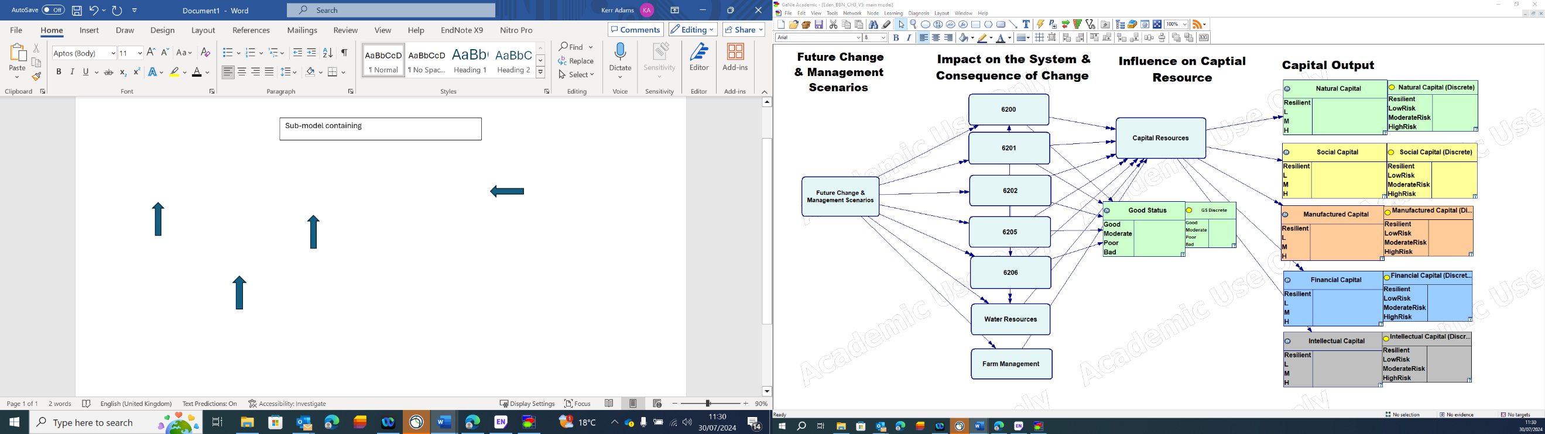
Figure S1: Box A providing an overview of the Bayesian Network Model structure
Sub-model including future climatic and socioeconomic change scenarios. See Box B for more detail.
Sub-models, for each sub-catchment and catchment wide systems considered in the BN model, sub-catchments 6200-6206 include wastewater and land management systems. (See Box C, Box D and E for more detail).
Additional model output to test effectiveness of management options, based on the framing statement. Parent nodes are the RP concentrations at each sub-catchment which are indexed in the continuous equation-based variable (left) and probabilistic outputs are presented in the discrete variable (right).
Capital outputs informed by wider capital resources, which were the model outputs of importance of the Adams et al. (2023) paper for understanding and comparing the impacts of future climatic and socioeconomic scenarios.
Box A

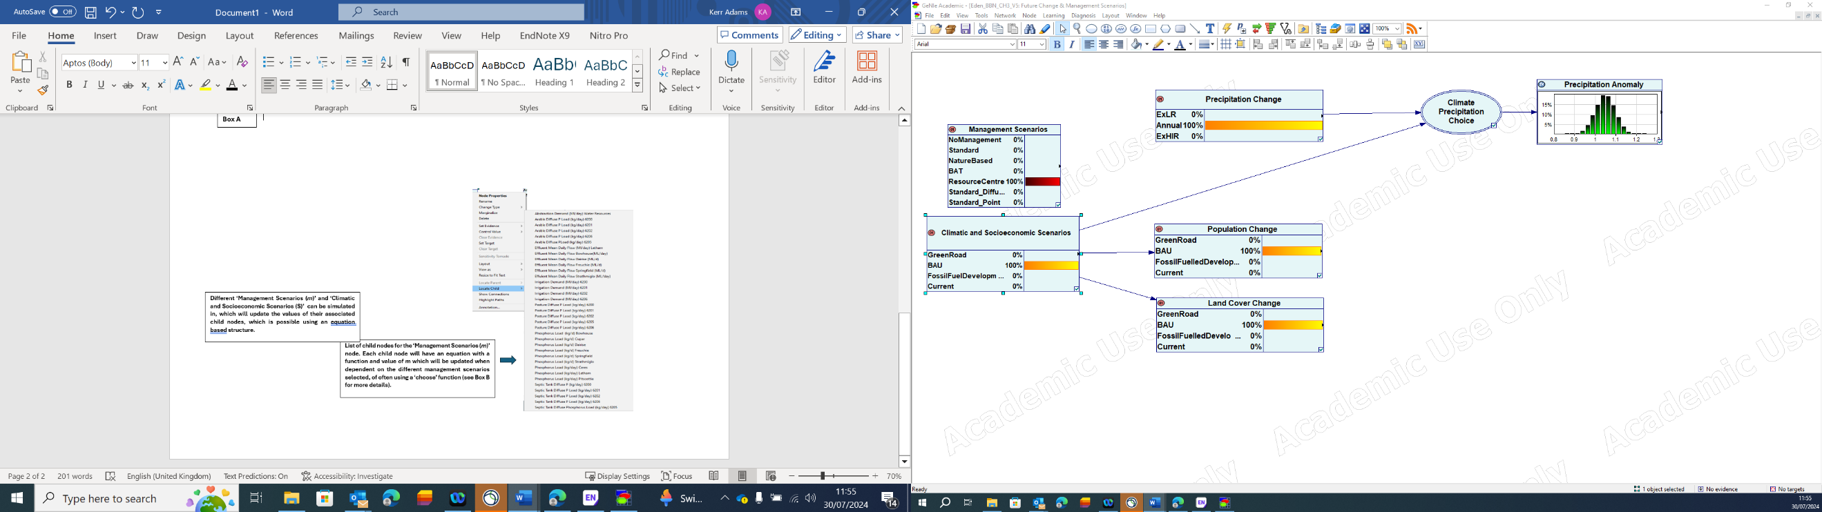
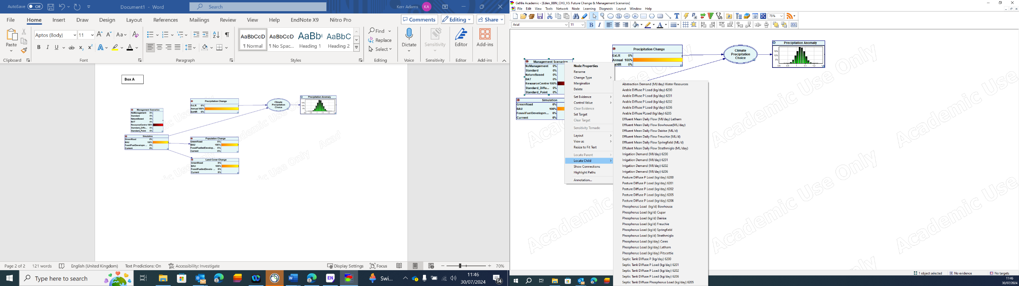
Box B
List of child nodes for the ‘Management Scenarios (m)’ node. Each child node will have an equation with a function and value of m which will be updated dependent on the different management scenarios selected using a ‘choose’ function (see Box C for more details).
Different ‘Management Scenarios (m)’ and ‘Climatic and Socioeconomic Scenarios (S)’ can be simulated together, updating the values of their associated child nodes, which is possible using an equation-based structure.
Figure S2: Box B: Overview of the Management and Climatic and Socioeconomic Scenarios sub-model


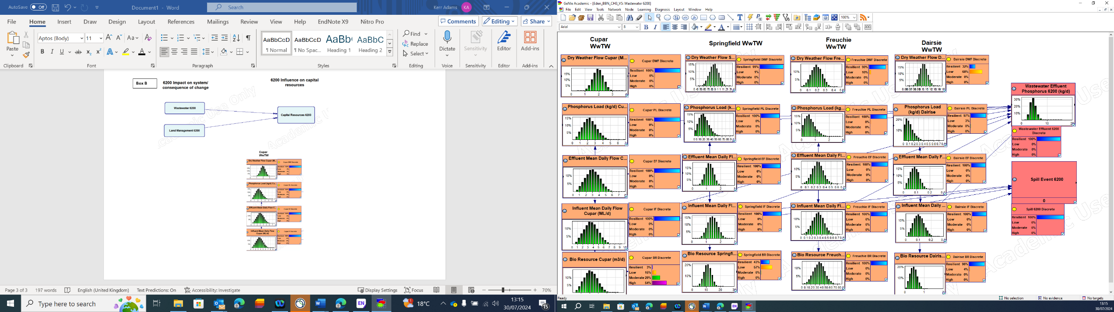
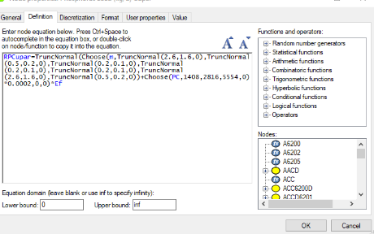
Box C
The sub-catchment 6200 sub-model contains both a wastewater and land management sub-model (see Box D for land management). In sub-catchment 6200, there are four wastewater treatment works, for which important variables as seen by stakeholder experts have been mapped, including dry weather, influent and effluent flows, and phosphorus loads. Phosphorus concentrations for each works, as shown to the right for the works at Cupar, take on a distribution of RP concentrations dependant on the ‘Management Scenario (m)’. The concentration is also dependant on the future scenarios for population change ‘PC’ where 1 population equivalent adds 0.002 µg of RP per litre of daily effluent flow at the works ‘Ef’. The total phosphorus loads for all works is summed in the ‘Wastewater Effluent Phosphorus 6200 node (P_{ik}).
The management scenario ‘m’ determines the reactive phosphorus concentrations at each works. For the resource centre scenario, the mean phosphorus concentration (µg/l) and standard deviation at Cupar will be 0.2,0.1 for the resource centre management scenario.
Figure S3: Box C: Overview of Wastewater Management sub-model for sub-catchment 6200

Figure S3: Box C: Overview of Wastewater Management sub-model for sub-catchment 6200

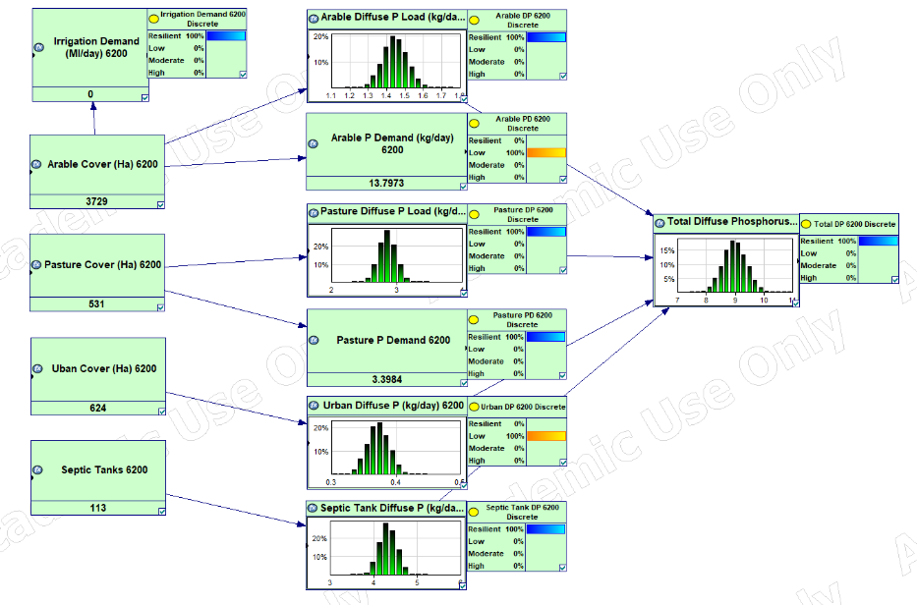
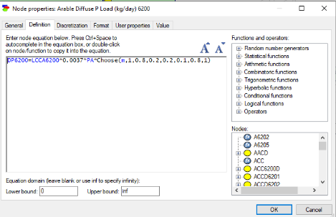
Box D
Representation of the land management sub-model in sub-catchment 6200 sub-model. Expert stakeholders highlighted that diffuse RP loads from arable, pasture and urban land cover and septic tanks all influenced RP concentration in the sub-catchment. The equation for arable phosphorus loads is shown to the right. One hectare of arable land (LCCA6200) contributes 0.0037 kg or RP per day (based on outputs from a SAGIS model). Precipitation change (PA) influences the amount of diffuse run-off. Both land cover and precipitation change values change dependant of the climatic and socioeconomic scenario being simulated. Different management scenario (m) assign a % reduction of RP loads. For the Resource Centre management scenario, diffuse arable sources are reduced by 90%. The total phosphorus loads for all diffuse is summed in the ‘Total Diffuse Phosphorus 6200 node (TDP).
Figure S4: Box D: Overview of Land Management Sub-model in sub-catchment 6200

Figure S4: Box D: Overview of Land Management Sub-model in sub-catchment 6200
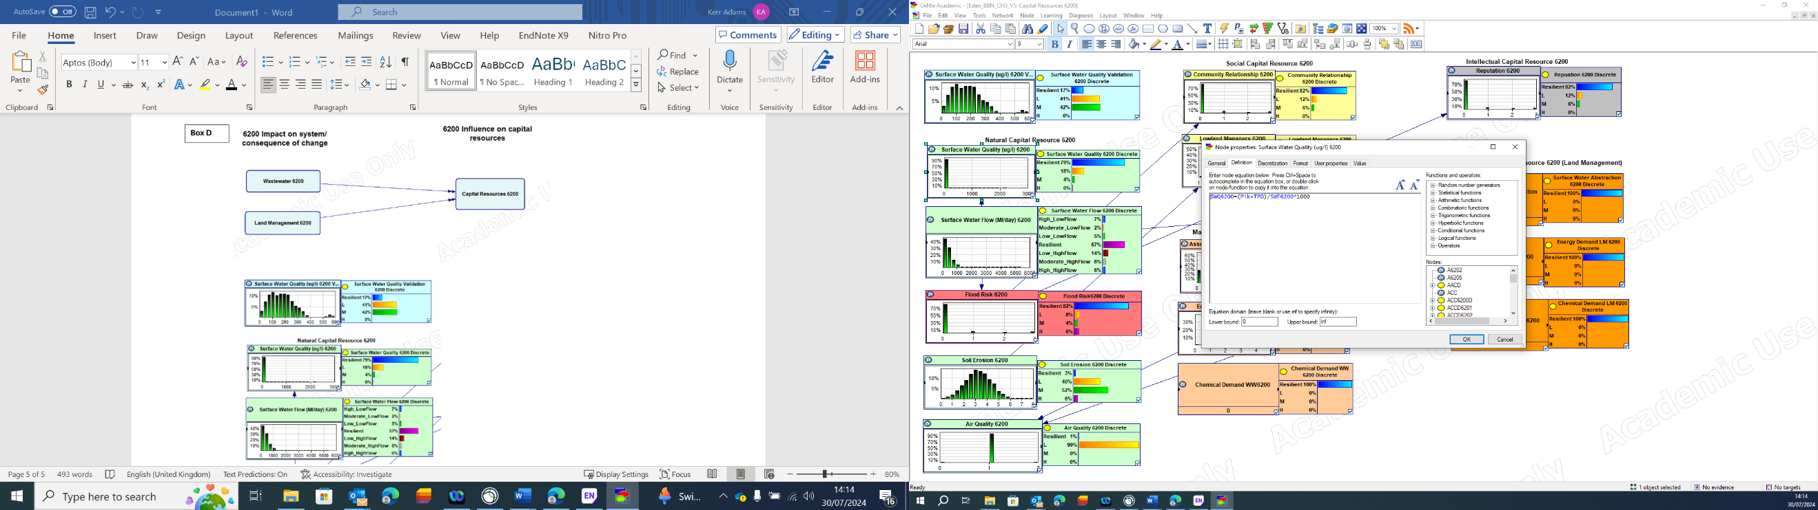
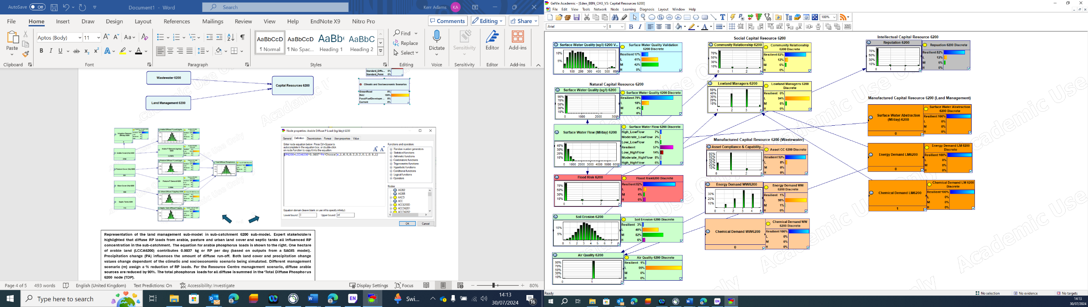
Box E
Capital resources are in sub-catchment 6200 that influence the ‘Good Status’ output variable is shown (please note wider capital resources as outlined in Adams et al., 2023 are included but not shown from simplicity). Surface water quality in sub catchment 6200 (SWQ6200) measures the reactive phosphorus concentration (µg/l) at the outlet of sub-catchment 6200, which takes the sum of wastewater phosphorus (P_{ik}) and total diffuse phosphorus loads (kg/day) for the sub catchment, which is converted into (µg/l) using the surface water flow (SWF) in the sub-catchment. Note the this is the point at which the BN model is validated. The discretised resilient to high risk is the equivalent to Good-Bad water framework directive status for RP concentrations. The same process described in boxes B,C and D are replicated for the reaming sub-catchments, where the discrete SWQ variables are indexed to give the probabilistic measure of achieving ‘Good Status’ in the model output as shown in Box A.
Figure S5: Box E: Overview of Capital Resources sub-model for sub-catchment 6200

Figure S5: Box E: Overview of Capital Resources sub-model for sub-catchment 6200

C: Management scenario parametrisation, justification and data sources
Table S2: Management scenario parametrisation, justification and data sources
 | Management Scenario
 | No Management |  |  |  | Standard Scenarios |  |  |  | Nature Based |  |  |  | Best Available Technology |  |  |  | Resource Centre
Model Variable | β |  |  | m | β |  |  | m | β |  |  | m | β |  |  | m | β |  |  | m | Value Justification and Data Source
Model Variable | M | SD | T |  | M | SD | T |  | M | SD | T |  | M | SD | T |  | M | SD | T
Wetland Effluent Flows (Ml/day)
Springfield | -- | -- | -- | 1 | -- | -- | -- | 1 | -- | -- | -- | 0.5 | -- | -- | -- | 1 | -- | -- | -- | 1 | Stakeholders identified the use of Constructed Wetlands as a management option for reducing Wastewater Effluent P concentrations. Wetland treatment options would include effluent flow reductions (Ml/day) ² by 50%, which is a value highlighted by the project team with similar values identified by ³. At sites and management scenarios where wetlands are considered, a value of 0.5 is applied to effluent flow, else a value of one maintains current flow conditions.
Freuchie | -- | -- | -- | 1 | -- | -- | -- | 1 | -- | -- | -- | 0.5 | -- | -- | -- | 1 | -- | -- | -- | 1
Dairsie | -- | -- | -- | 1 | -- | -- | -- | 1 | -- | -- | -- | 0.5 | -- | -- | -- | 1 | -- | -- | -- | 0.5
Strathmiglo | -- | -- | -- | 1 | -- | -- | -- | 1 | -- | -- | -- | 0.5 | -- | -- | -- | 0.5 | -- | -- | -- | 0.5
Bowhouse | -- | -- | -- | 1 | -- | -- | -- | 1 | -- | -- | -- | 0.5 | -- | -- | -- | 1 | -- | -- | -- | 1
Wastewater Phosphorus Treatment Concentrations (mg/l)
Cupar | 2.6 | 1.6 | 0 | -- | 0.5 | 0.1 | 0 | -- | 0.2 | 0.1 | 0 | -- | 0.2 | 0.1 | 0 | -- | 0.2 | 0.1 | 0 | -- | Stakeholders identified different Phosphorus treatment options which could be applied at different sites across the catchment. Under a standard scenario, stakeholders identified ferric dosing as a treatment option. The β value for the standard scenario is based on ferric dosing concentrations of P take from the Eden Water Quality Strategic Study. An ultra-low P Nereda treatment technology was also identified, which would change β value to a mean P concentration of 0.2 mg/l which is also taken from the Eden Water Quality Strategic Study. The ultra-low P treatment option is applied to varying sites across nature based, best available technology and resource centre management scenarios. Wetland treatment options were also highlighted as reducing P loads from wastewater treatment works. A 50% reduction in P concentrations, was identified by stakeholders. With the 50% effluent flow reduction and overall, 50% P reduction is consistent with literature findings from previous studies ^{3,4}.
Springfield | 3.7 | 1.6 | 0 | -- | 0.5 | 0.1 | 0 | -- | 1.85 | 0.8 | 0 | -- | 0.2 | 0.1 | 0 | -- | 0.2 | 0.1 | 0 | --
Freuchie | 4.42 | 2.59 | 0 | -- | 0.5 | 0.1 | 0 | -- | 2.21 | 1.3 | 0 | -- | 0.2 | 0.1 | 0 | -- | 2.21 | 1.3 | 0 | --
Dairsie | 2.7 | 1.8 | 0 | -- | 0.5 | 0.1 | 0 | -- | 1.62 | 1.08 | 0 | -- | 0.2 | 0.1 | 0 | -- | 1.62 | 0.9 | 0 | --
Strathmiglo | 2.1 | 1.3 | 0 | -- | 0.5 | 0.1 | 0 | -- | 1.05 | 0.65 | 0 | -- | 1.05 | 0.65 | 0 | -- | 1.05 | 0.65 | 0 | --
Bowhouse | 2.8 | 1.4 | 0 | -- | 0.5 | 0.1 | 0 | -- | 1.4 | 0.7 | 0 | -- | 0.2 | 0.1 | 0 | -- | 0.2 | 0.1 | 0 | --
Ceres | 2.5 | 1.5 | 0 | -- | 0.5 | 0.1 | 0 | -- | 0.5 | 0.2 | 0 | -- | 0.2 | 0.1 | 0 | -- | 0.2 | 0.1 | 0 | --
Pitscottie | 4.2 | 2.5 | 0 | -- | 0.5 | 0.2 | 0 | -- | 0.5 | 0.2 | 0 | -- | 0.5 | 0.2 | 0 | -- | 0.5 | 0.2 | 0 | --
Letham | 2.3 | 1.4 | 0 | -- | 0.5 | 0.1 | 0 | -- | 0.5 | 0.2 | 0 | -- | 0.5 | 0.2 | 0 | -- | 0.5 | 0.2 | 0 | --
GBR, RSUDS, Cover Crops and Minimum Tillage, and Septic Tanks Treatment - Diffuse Phosphorus Load (kg d⁻¹)
Arable | -- | -- | -- | 1 | -- | -- | -- | 0.8 | -- | -- | -- | 0.2 | -- | -- | -- | 0.2 | -- | -- | -- | 0.1 | Stakeholders identified that 100% General Binding Rules (GBR) compliance as the standard management option for reducing diffuse P sources from Arable fields. Stakeholders highlighted that 100% GBR compliance would yield an 20% reduction in diffuse P which is supported by reductions for 2m buffers identified by Balana, et al. ⁵.For nature based, best available technology and resource centre scenarios, stakeholders identified a combination of Rural Sustainable Drainage Systems (RSuDs) and Magic Margins options for reducing Diffuse P from arable sources. We use an upper estimate of 80% P reductions based on findings for RSuDs and buffer strip methods ^{6,7}. For the resource centre scenario, the reduction in P was increased to 90% to reflect an increase in P application efficiency associated with the use of Struvite for fertiliser application and the use of cover crops and minimum tillage in the catchment,
Pasture | -- | -- | -- | 1 | -- | -- | -- | 0.8 | -- | -- | -- | 0.8 | -- | -- | -- | 0.8 | -- | -- | -- | 0.8 | Stakeholders identified that 100% General Binding Rules (GBR) compliance as the standard management option for reducing diffuse P sources from Pasture fields. Stakeholders highlighted that 100% GBR compliance would yield an 20% reduction in diffuse P, which we maintain across all management scenarios.
Septic Tanks | -- | -- | -- | 1 | -- | -- | -- | 0.5 | -- | -- | -- | 0.5 | -- | -- | -- | 0.5 | -- | -- | -- | 0.5 | Stakeholders highlighted that a 50% P reduction was possible via a septic tank investigation and associated improvements, as highlighted in the Eden Water Quality Strategic Study. The improvements are considered across all management scenarios.
Agriculture Water Efficiency - Irrigation Demand (Ml/year)
6200 | -- | -- | -- | 1 | -- | -- | -- | 0.6 | -- | -- | -- | 0 | -- | -- | -- | 0 | -- | -- | -- | 0 | Stakeholders identified that in the standard scenario irrigation efficiency improvements could be achieved by coupling soil moisture sensors and irrigation scheduling. We apply a 40% reduction in irrigation demand based on findings from ⁸. This option is applied across all scenarios in waterbody sub catchments 6202 and 6206. For nature based, best available technology and resource centre scenarios in waterbody sub-catchments 6200 and 6201 stakeholders identified that lagoons would allow for the storage of water for irrigation, which would eliminate the need for surface water abstractions, therefore a value of zero is applied.
6201 | -- | -- | -- | 1 | -- | -- | -- | 0.6 | -- | -- | -- | 0 | -- | -- | -- | 0 | -- | -- | -- | 0
6202 | -- | -- | -- | 1 | -- | -- | -- | 0.6 | -- | -- | -- | 0.6 | -- | -- | -- | 0.6 | -- | -- | -- | 0.6
6206 | -- | -- | -- | 1 | -- | -- | -- | 0.6 | -- | -- | -- | 0.6 | -- | -- | -- | 0.6 | -- | -- | -- | 0.6
Water Resource Water Efficiency Campaigns - Abstraction Demand (Ml/day)
Water Resource | -- | -- | -- | 1 | -- | -- | -- | 0.85 | -- | -- | -- | 0.85 | -- | -- | -- | 0.85 | -- | -- | -- | 0.85 | Stakeholders identified that a water efficiency campaign would reduce abstraction demands (ML/day). We assume a water efficiency campaign would achieve a 15% reduction in abstraction demand across all scenarios based on the findings of Manouseli, et al. ⁹.

References

1 Adams, K. J. et al. Developing a Bayesian network model for understanding river catchment resilience under future change scenarios. Hydrol. Earth Syst. Sci. 27, 2205-2225, doi:10.5194/hess-27-2205-2023 (2023).
2 Almuktar, S. A., Abed, S. N. & Scholz, M. Wetlands for wastewater treatment and subsequent recycling of treated effluent: a review. Environmental Science and Pollution Research 25, 23595-23623 (2018).
3 Cooper, R. J., Hawkins, E., Locke, J., Thomas, T. & Tosney, J. Assessing the environmental and economic efficacy of two integrated constructed wetlands at mitigating eutrophication risk from sewage effluent. Water and Environment Journal 34, 669-678 (2020).
4 Land, M. et al. How effective are created or restored freshwater wetlands for nitrogen and phosphorus removal? A systematic review. Environmental Evidence 5, 9, doi:10.1186/s13750-016-0060-0 (2016).
5 Balana, B. B. et al. Integrating economic and biophysical data in assessing cost‐effectiveness of buffer strip placement. Journal of environmental quality 41, 380-388 (2012).
6 Stutter, M., Costa, F. B. & Ó hUallacháin, D. The interactions of site-specific factors on riparian buffer effectiveness across multiple pollutants: A review. Science of The Total Environment 798, 149238, doi:https://doi.org/10.1016/j.scitotenv.2021.149238 (2021).
7 Environment Agency, E. Rural Sustainable Drainage Systems (RSuDS). (Environment AgencY, Environment Agency, Horizon House, Deanery Road,
Bristol, BS1 5AH 2016).
8 Adams, K. & Kovacs, K. The adoption rate of efficient irrigation practices and the consequences for aquifer depletion and further adoption. Journal of Hydrology 571, 244-253, doi:https://doi.org/10.1016/j.jhydrol.2019.01.040 (2019).
9 Manouseli, D., Kayaga, S. M. & Kalawsky, R. Evaluating the Effectiveness of Residential Water Efficiency Initiatives in England: Influencing Factors and Policy Implications. Water Resources Management 33, 2219-2238, doi:10.1007/s11269-018-2176-1 (2019).

β represents a distribution where M is the mean value; SD is the standard deviation and T is the truncated value for the distribution which is typically zero to prevent values being non-negative.
m represents the quantified value applied based on the information provided in Table 5 of the manuscript.
Standard Scenario 1 applies only diffuse arable and pasture reduction values and maintain ‘No Management Scenario’ values for Wastewater Phosphorus Treatment Concentrations (mg/l). Standard Scenario 2 applies only Wastewater Phosphorus Treatment Concentrations (mg/l) under the ‘Standard Scenario’ heading. Standard Scenario 3 includes both diffuse and wastewater reduction values, plus septic tank and water efficiency savings.

