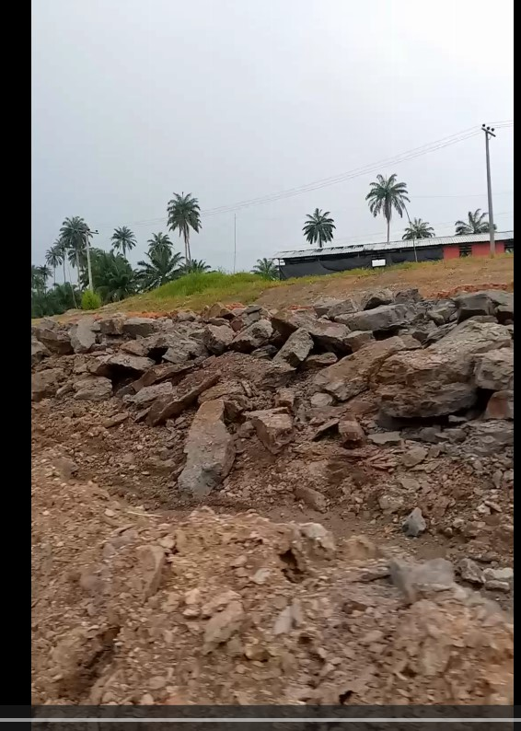
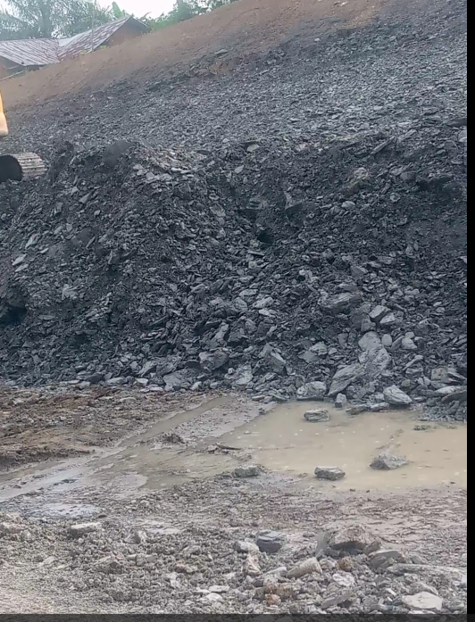
Photograph B. Ekenkpon shale boulders (first picture) and rock fragments(second picture) excavated during earthworks operation during road construction

