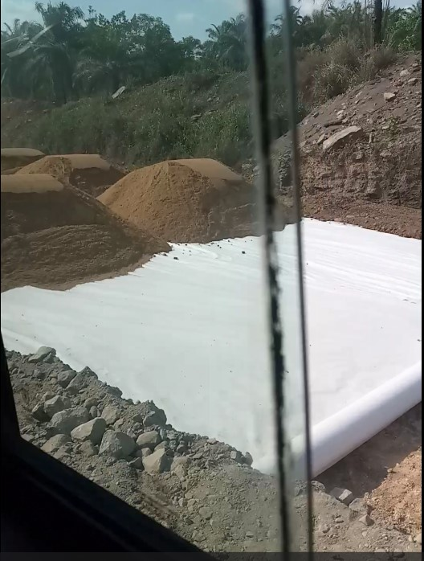
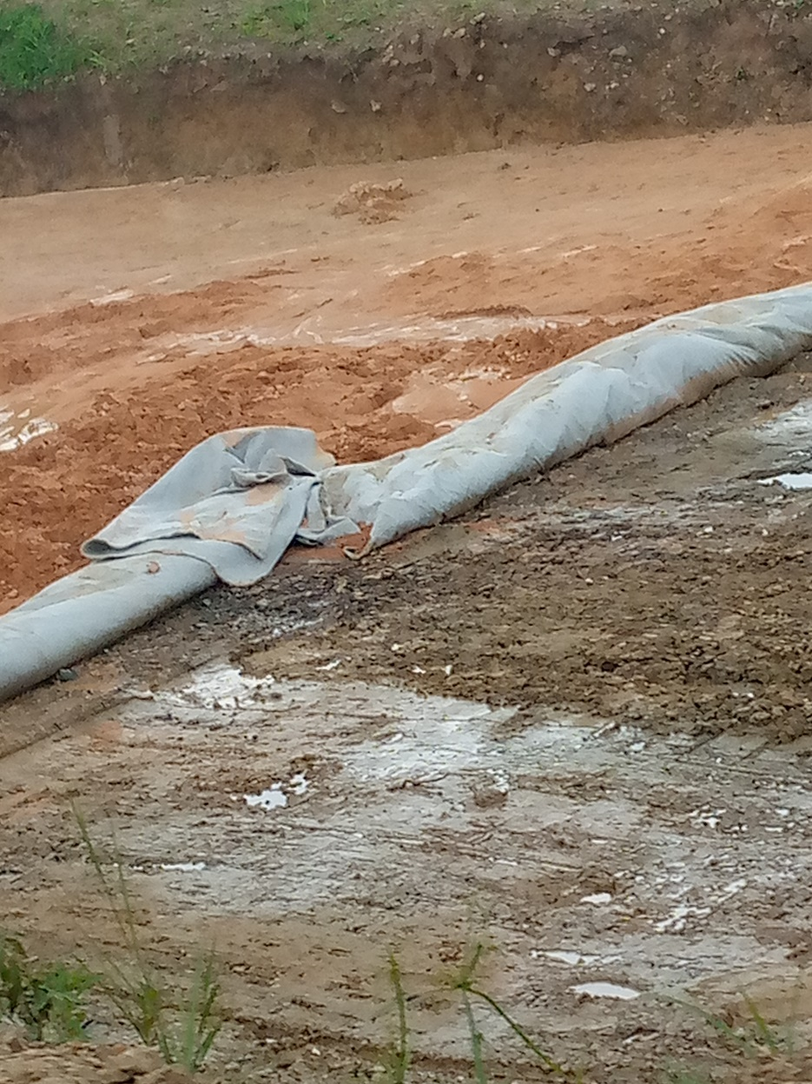

Photograph C. Geotextile used as separator between subgrade and other layers of pavement.

