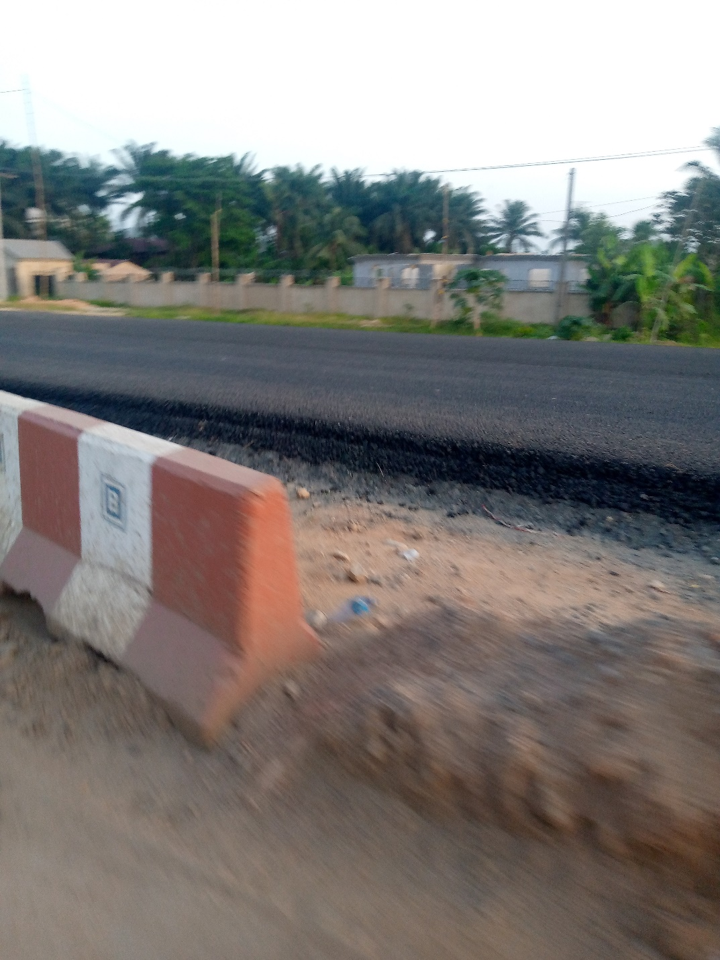

Photograph D. Bound base laid on top of stone base materials in new pavement construction

