SUPPLEMENT
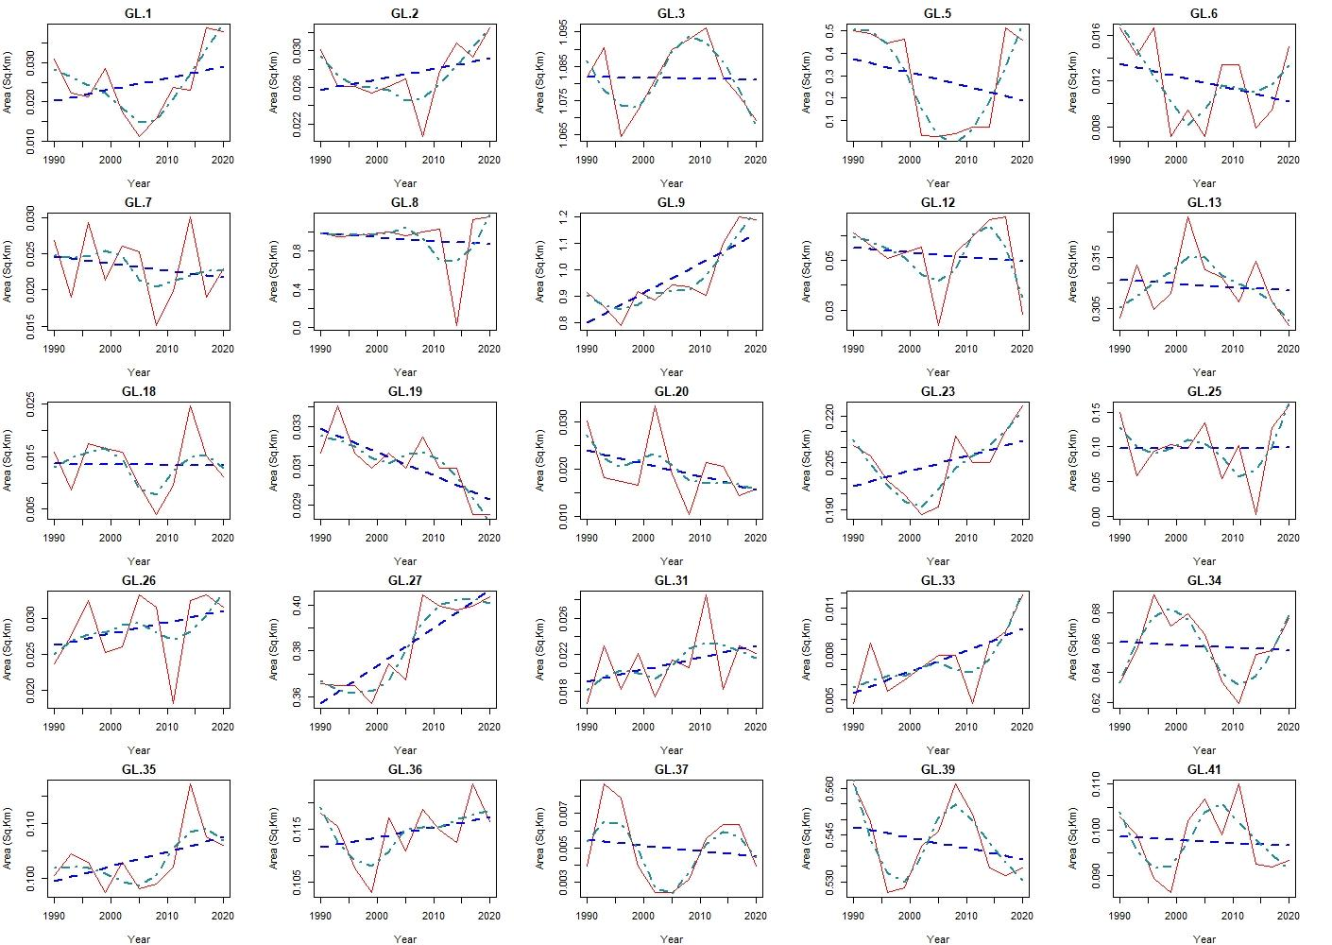
Figure S1a: Dynamics of the area of GLs with 11 timestamps (Red line), along with fitted curves of linear model (Blue dashed) and loess model (Dark cyan dash and dot). (Read left to right, Cont.)
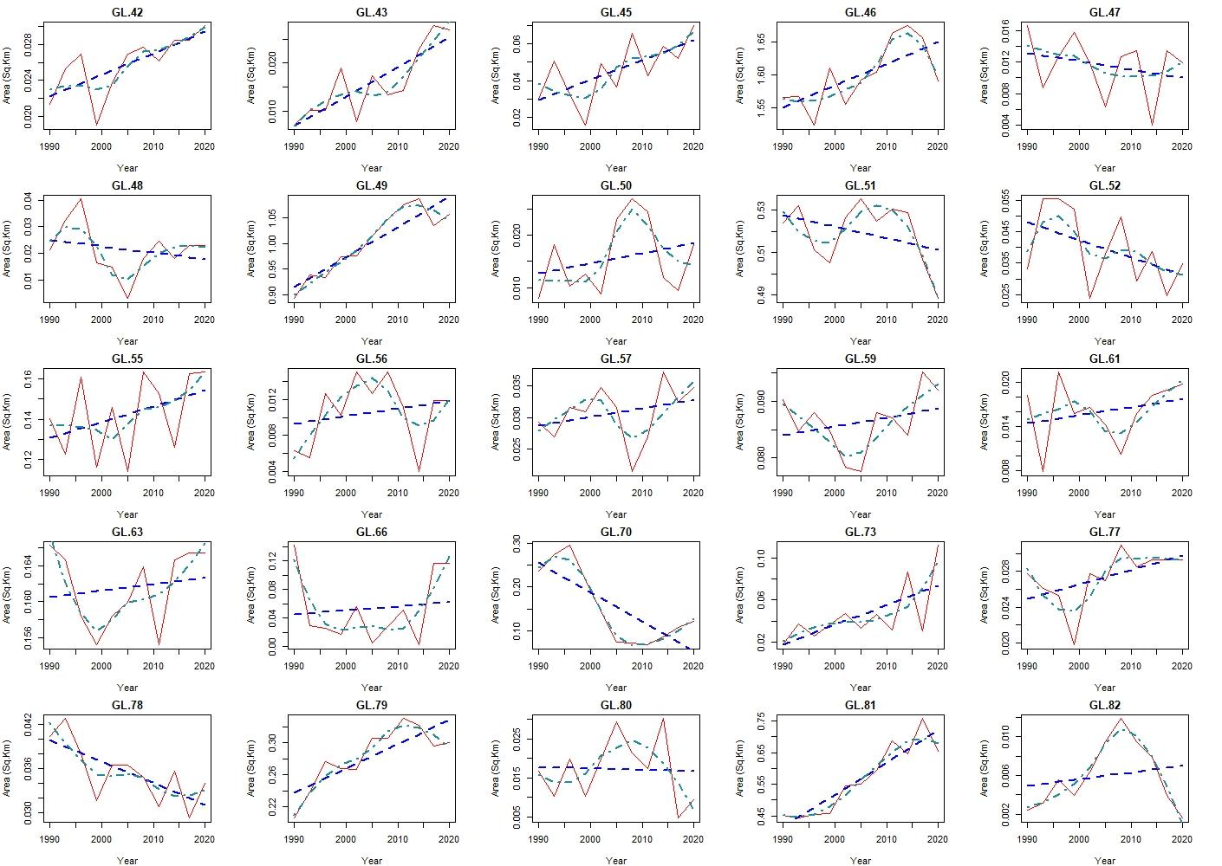
Figure S1b: Dynamics of the area of GLs with 11 timestamps (Red line), along with fitted curves of linear model (Blue dashed) and loess model (Dark cyan dash and dot). (Read left to right, Cont.)
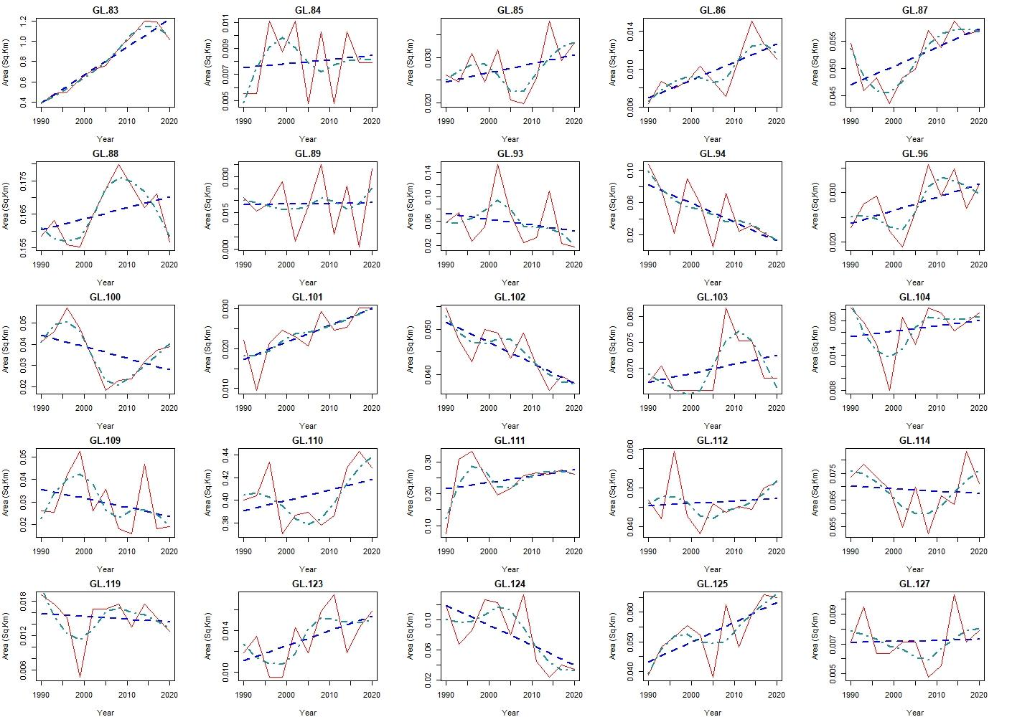
Figure S1c: Dynamics of the area of GLs with 11 timestamps (Red line), along with fitted curves of linear model (Blue dashed) and loess model (Dark cyan dash and dot). (Read left to right, Cont.)
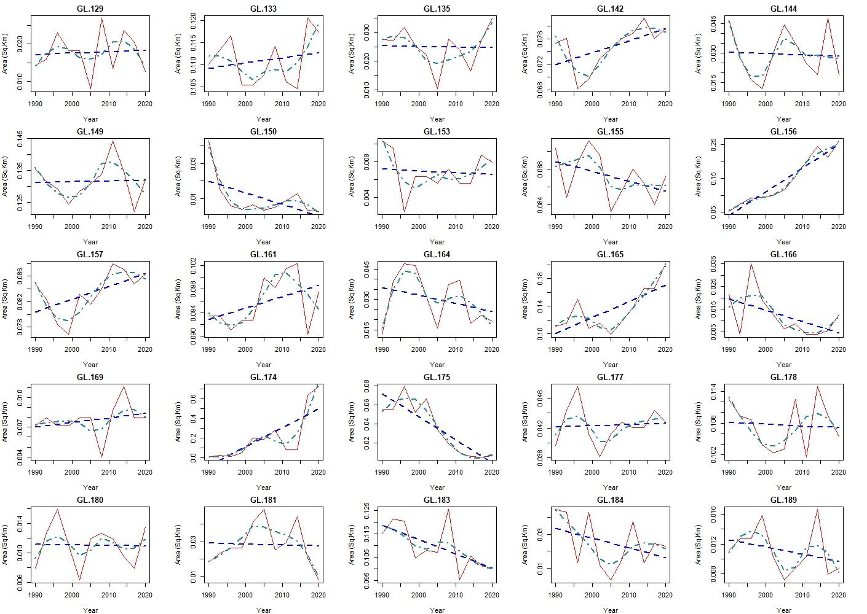
Figure S1d: Dynamics of the area of GLs with 11 timestamps (Red line), along with fitted curves of linear model (Blue dashed) and loess model (Dark cyan dash and dot). (Read left to right, Cont.)
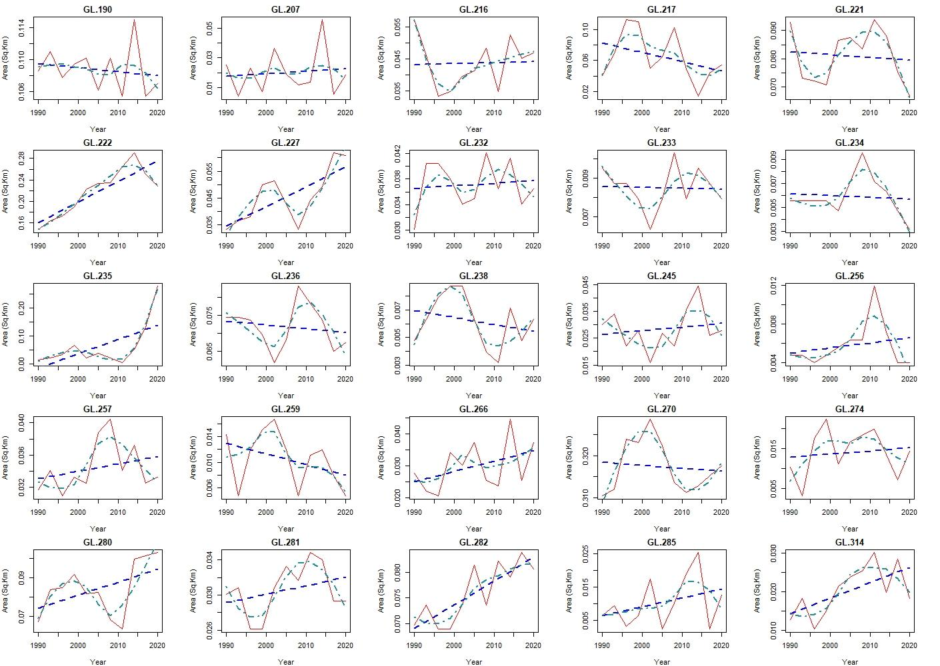
Figure S1e: Dynamics of the area of GLs with 11 timestamps (Red line), along with fitted curves of linear model (Blue dashed) and loess model (Dark cyan dash and dot). (Read left to right, Cont.)
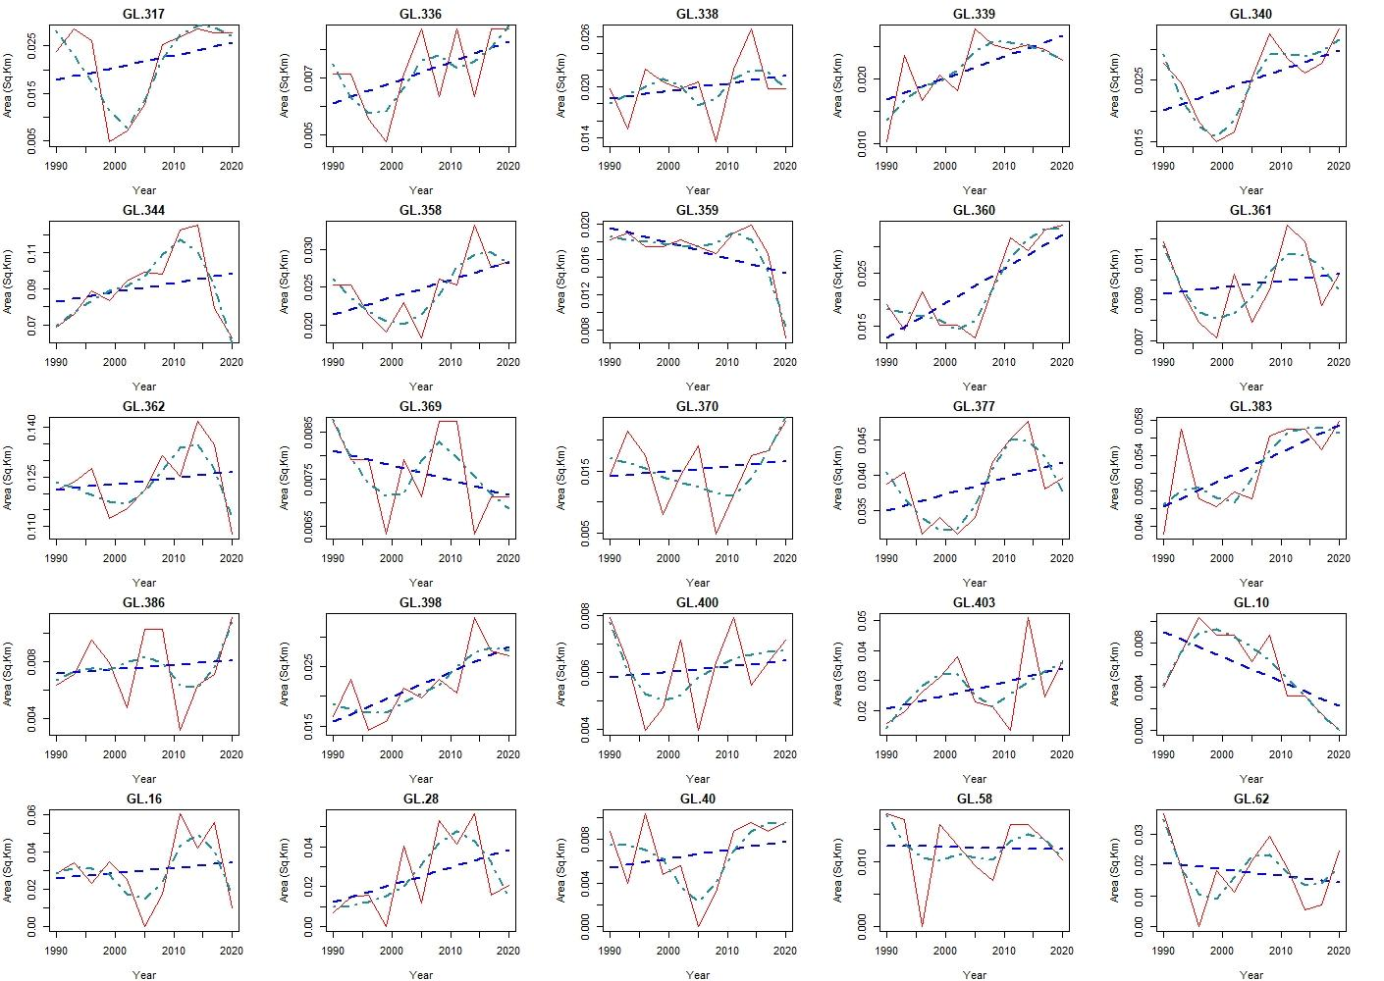
Figure S1f: Dynamics of the area of GLs with 11 timestamps, up to ULID 403 (Read left to right). GLs with ULID 10 and beyond have 10 timestamps. (Read left to right, Cont.). Also, fitted curves of linear model (Blue dashed) and loess model (Dark cyan dash and dot) are included.
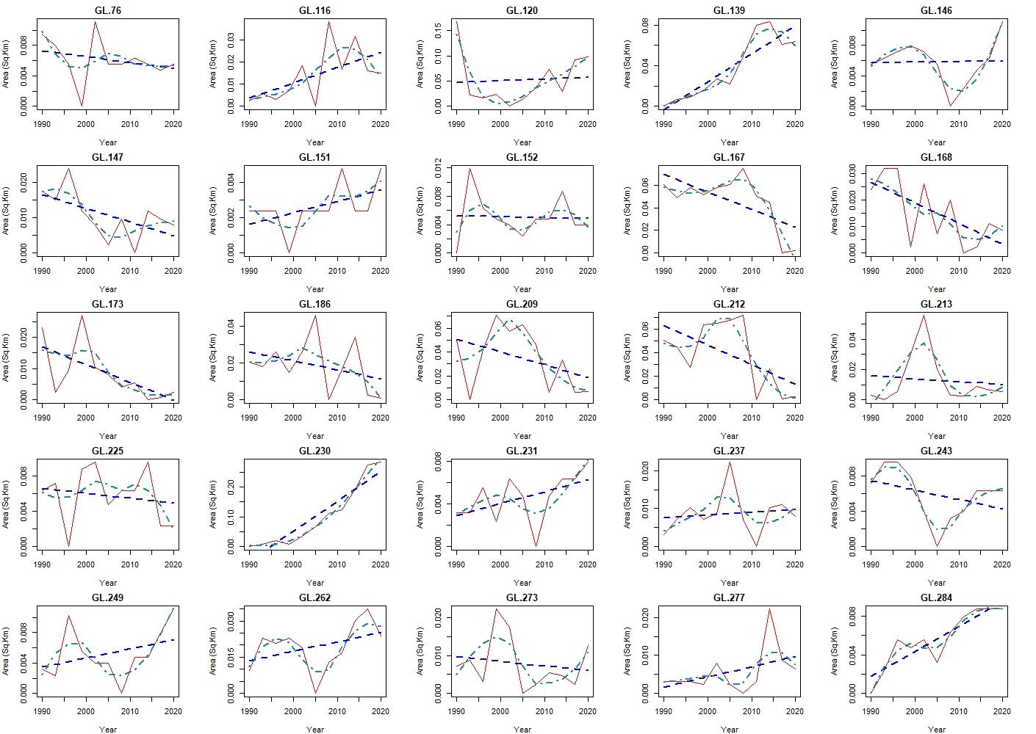
Figure S1g: Dynamics of the area of GLs with 10 timestamps (Red line), along with fitted curves of linear model (Blue dashed) and loess model (Dark cyan dash and dot). (Read left to right, Cont.).
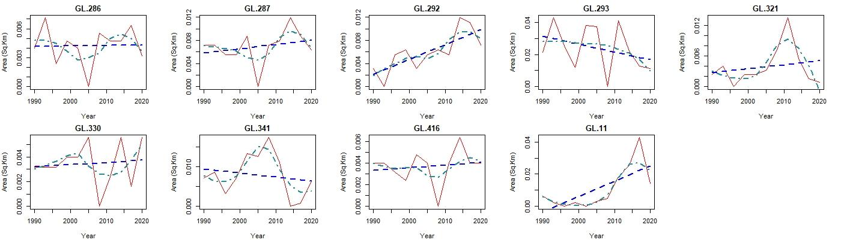
Figure S1h. Dynamics of the area of GLs with 10 timestamps (Red line), along with fitted curves of linear model (Blue dashed) and loess model (Dark cyan dash and dot) (Read left to right).

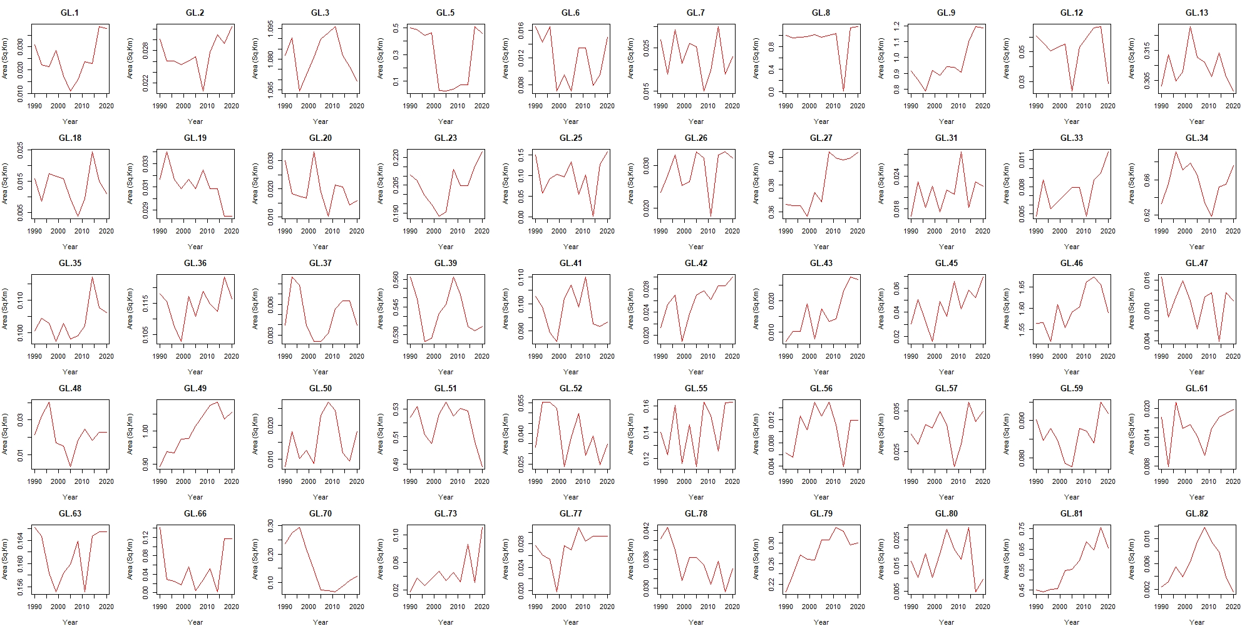
Figure S2a: Dynamics of the area of GLs with 11 timestamps. (Read left to right, Cont.)
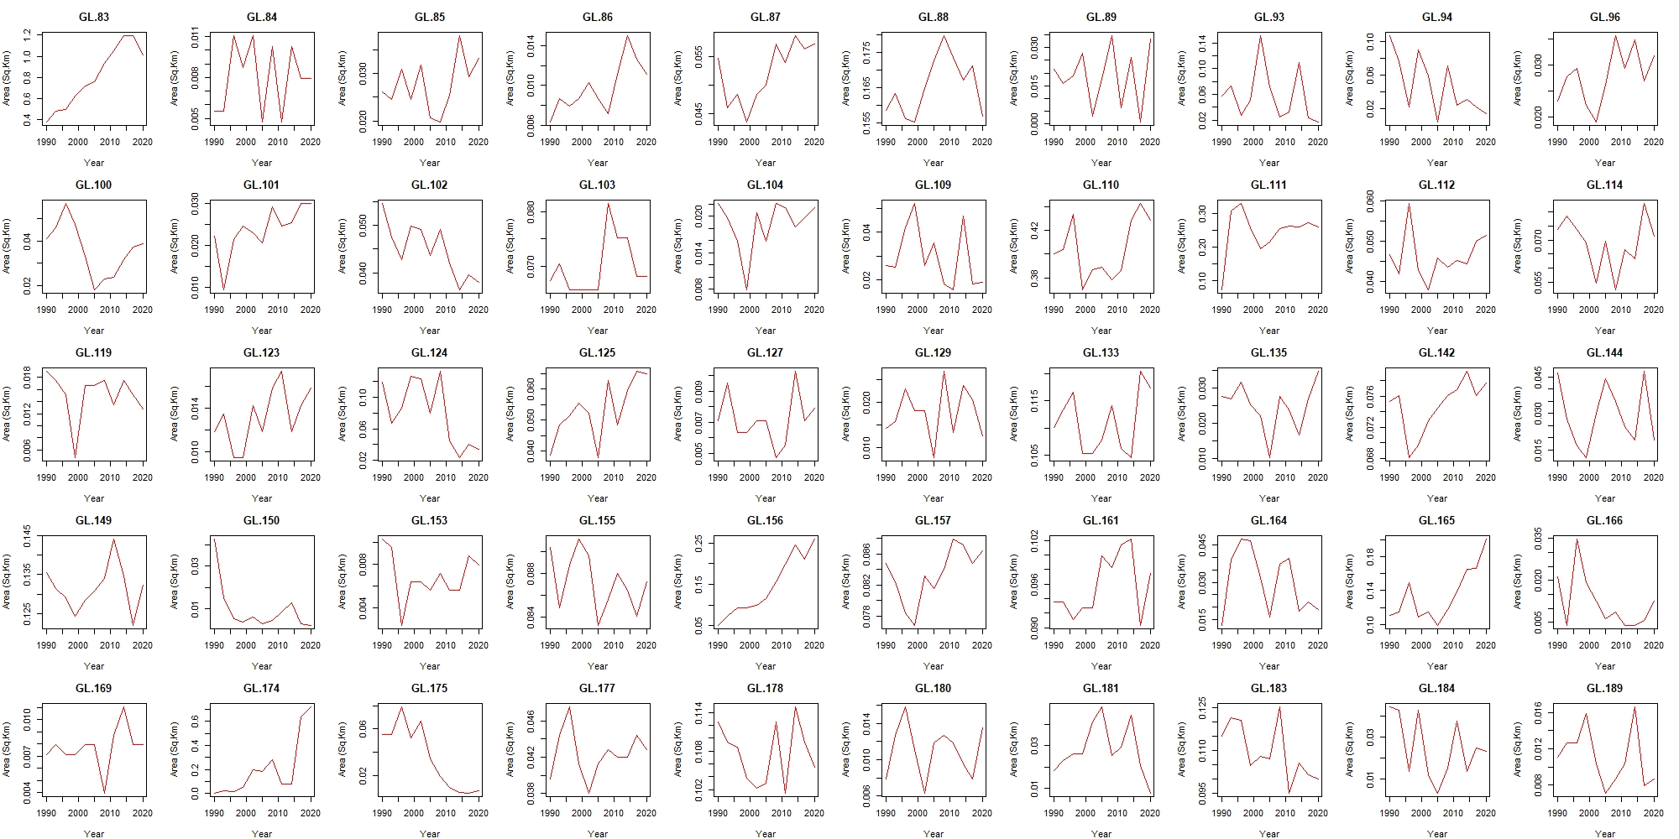
Figure S2b: Dynamics of the area of GLs with 11 timestamps. (Read left to right, Cont.)
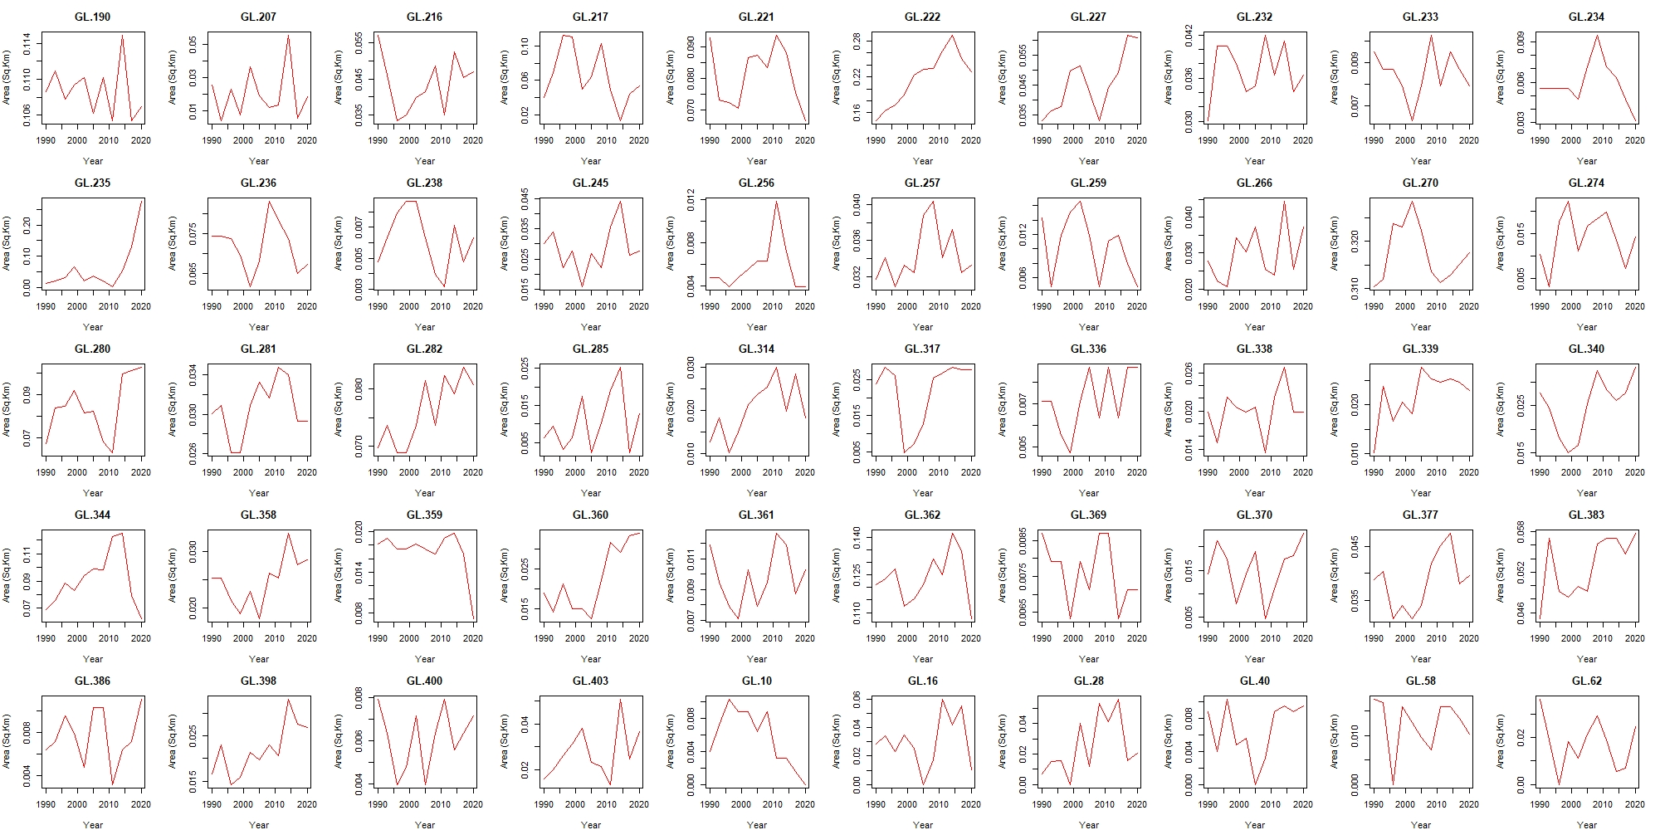
Figure S2c: Dynamics of the area of GLs with 11 timestamps, up to ULID 403 (Read left to right). GLs with ULID 10 and beyond have 10 timestamps. (Read left to right, Cont.)
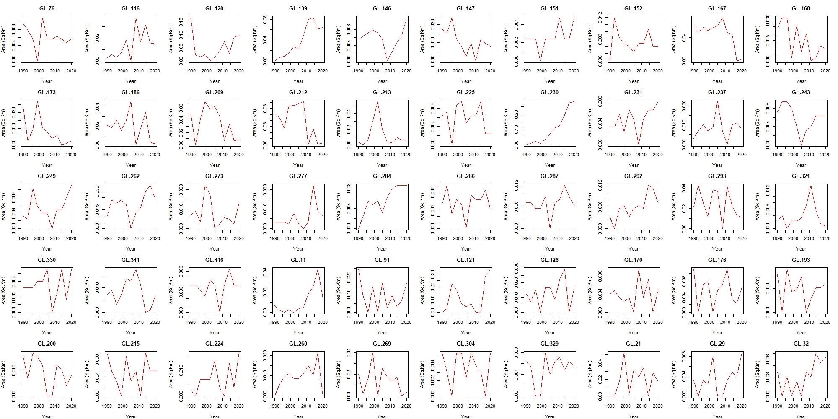
Figure S2d: Dynamics of the area of GLs with 10 timestamps, up to ULID 416 (Read left to right). GLs with ULID 11 to 329 have 9 timestamps. GLs with ULID 21 and beyond have 8 timestamps (Read left to right, Cont.)
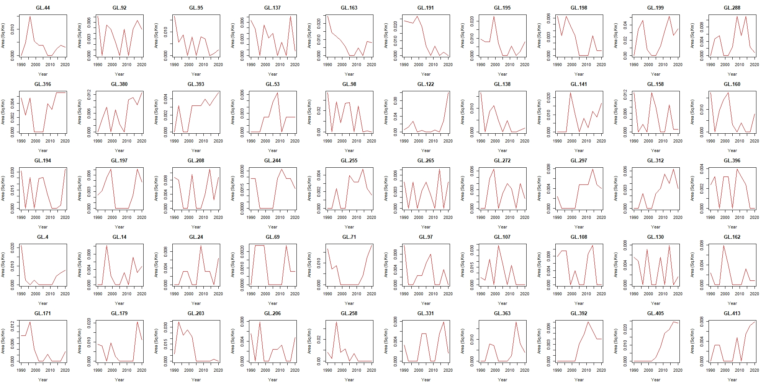
Figure S2e: Dynamics of the area of GLs with 8 timestamps, up to ULID 393 (Read left to right). GLs with ULID 53 to 396 and beyond have 7 timestamps. GLs with ULID 4 to 413 have 6 timestamps (Read left to right, Cont.)
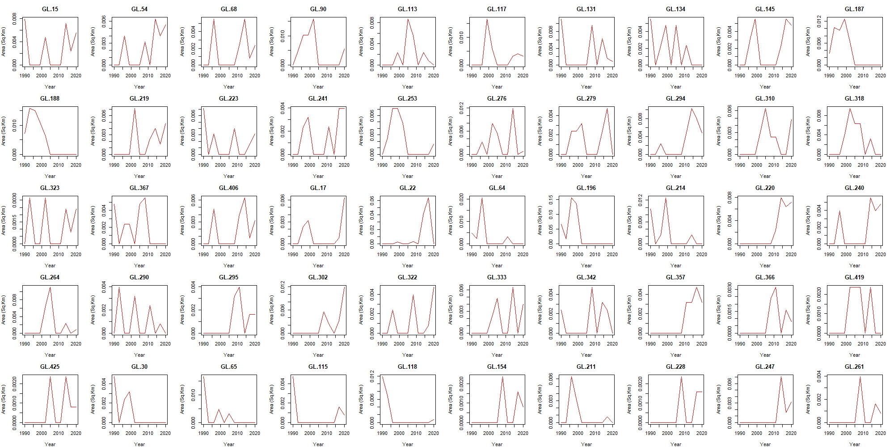
Figure S2f: Dynamics of the area of GLs with 5 timestamps, from ULID 15 to 406 (Read left to right). GLs with ULID 17 to 425 have 4 timestamps (Read left to right). GLs with ULID 30 and beyond have 3 timestamps (Read left to right, Cont.)
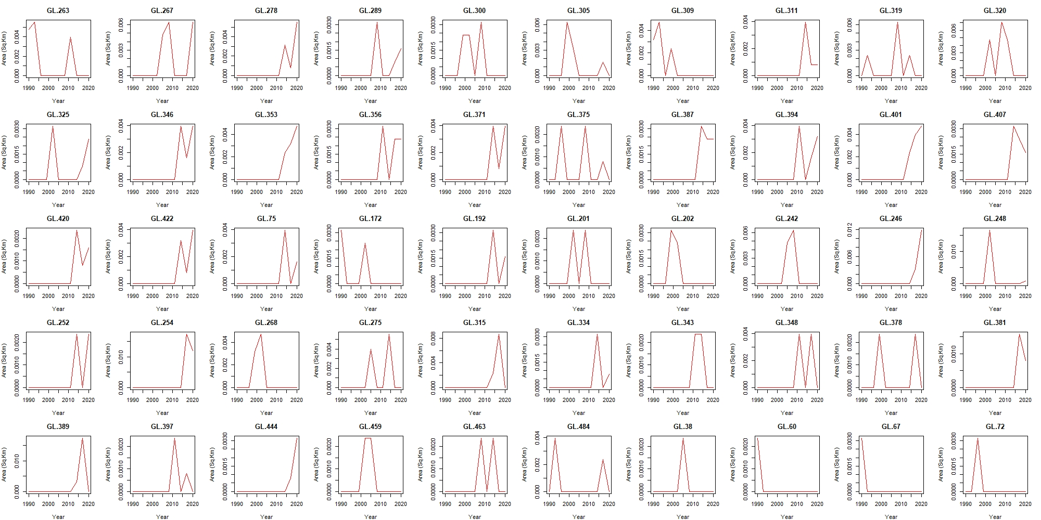
Figure S2g: Dynamics of the area of GLs with 3 timestamps, ULID 263 to 422 (Read left to right). GLs with ULID 75 to 484 have 2 timestamps (Read left to right). GLs with ULID 38 and beyond have 2 timestamps (Read left to right, Cont.)
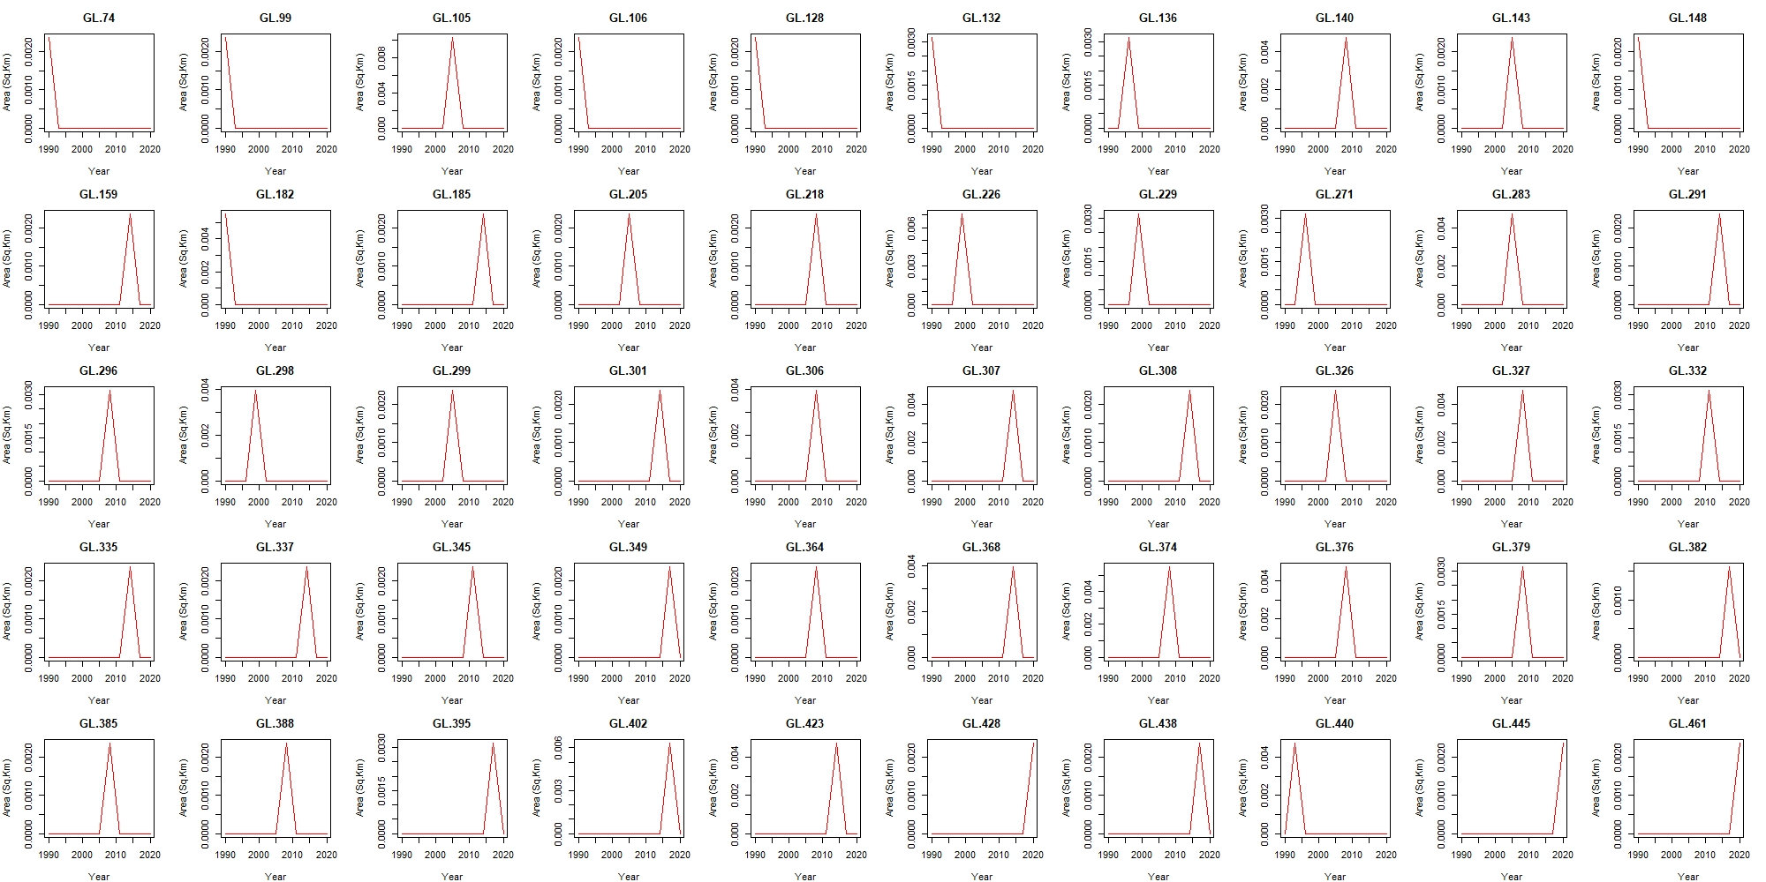
Figure S2f. GLs with ULID 74 and beyond have 1 timestamp (Read left to right, Cont.).
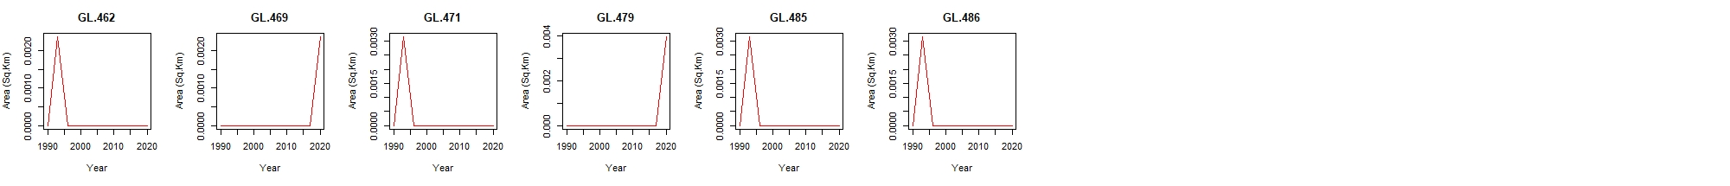
Figure S2g: (Cont.) GLs with ULID 462 to 486 have only 1 timestamp.

Table S1: Performance of ANN and RFC in various imbalance tests.
