Supplementary Table 1: Spatially thinned geocoordinates of the species used for modelling
S. No. | Scientific_name | Latitude (°N) | Longitude (°E)
 | Betula utilis | 30.8778 | 77.4944
 | Betula utilis | 31.22237 | 77.97145
 | Betula utilis | 31.80571 | 77.59989
 | Betula utilis | 31.81443 | 77.51153
 | Betula utilis | 31.84895 | 77.35308
 | Betula utilis | 31.86342 | 77.42268
 | Betula utilis | 31.96072 | 77.37834
 | Betula utilis | 31.96831 | 77.58274
 | Betula utilis | 31.9685 | 77.4462
 | Betula utilis | 31.98902 | 77.51443
 | Betula utilis | 32.0291 | 76.9812
 | Betula utilis | 32.03335 | 77.19503
 | Betula utilis | 32.03572 | 77.43489
 | Betula utilis | 31.3416 | 78.4392
 | Betula utilis | 32.06515 | 76.93099
 | Betula utilis | 32.0931 | 77.0294
 | Betula utilis | 32.1098 | 77.3375
 | Betula utilis | 32.2078 | 76.6812
 | Betula utilis | 32.21329 | 77.2445
 | Betula utilis | 32.2253 | 77.11222
 | Betula utilis | 32.2613 | 77.2496
 | Betula utilis | 32.2642 | 76.6484
 | Betula utilis | 32.26428 | 77.1436
 | Betula utilis | 32.3307 | 77.2144
 | Betula utilis | 31.3591 | 78.3756
 | Betula utilis | 32.36954 | 77.12987
 | Betula utilis | 32.37676 | 77.27941
 | Betula utilis | 32.4128 | 76.618
 | Betula utilis | 32.45997 | 77.13495
 | Betula utilis | 32.4941 | 76.74931
 | Betula utilis | 32.50185 | 76.98507
 | Betula utilis | 32.56439 | 77.02042
 | Betula utilis | 32.58749 | 76.91861
 | Betula utilis | 32.6723 | 76.69163
 | Betula utilis | 32.71157 | 76.65063
 | Betula utilis | 32.73908 | 76.43421
 | Betula utilis | 32.75808 | 76.64766
 | Betula utilis | 32.76046 | 76.59261
 | Betula utilis | 32.87203 | 76.85716
 | Betula utilis | 31.3884 | 78.2306
 | Betula utilis | 32.9653 | 76.47849
 | Betula utilis | 32.9872 | 76.218
 | Betula utilis | 33.01962 | 76.48201
 | Betula utilis | 33.09091 | 76.48355
 | Betula utilis | 33.1513 | 76.46982
 | Betula utilis | 32.0325 | 78.2724
 | Betula utilis | 32.54955 | 77.08404
 | Betula utilis | 32.63185 | 77.23263
 | Betula utilis | 32.68383 | 76.81145
 | Betula utilis | 32.73009 | 76.86483
 | Betula utilis | 31.3939 | 78.2929
 | Betula utilis | 31.4068 | 77.8623
 | Betula utilis | 31.4823 | 78.1449
 | Betula utilis | 31.4864 | 78.0642
 | Betula utilis | 31.5014 | 77.9833
 | Betula utilis | 31.5041 | 77.9078
 | Betula utilis | 31.5158 | 78.1989
 | Betula utilis | 31.538 | 77.4255
 | Betula utilis | 31.5748 | 78.1465
 | Betula utilis | 31.609 | 77.7022
 | Betula utilis | 31.656 | 77.8319
 | Betula utilis | 31.66053 | 77.51487
 | Betula utilis | 31.2012 | 78.1119
 | Betula utilis | 31.20307 | 78.02014
 | Betula utilis | 31.6984 | 77.9955
 | Betula utilis | 31.70107 | 77.49047
 | Betula utilis | 31.70905 | 77.5833
 | Betula utilis | 31.75417 | 77.4675
 | Betula utilis | 31.76993 | 77.63244
 | Betula utilis | 31.77467 | 77.55048
 | Betula utilis | 31.7776 | 78.4406

Supplementary Table 2: Variance Inflation Factor values of the selected variables
Variable | VIF | SqrtVIF
aspect | 2.941599 | 1.715109
bio_11 | 2.200652 | 1.483459
bio_2 | 1.793143 | 1.339083
bio_19 | 2.404659 | 1.550696
Abbreviation used: VIF=Variance Inflation Factor; and Sqrt= Square root

Supplementary Table 3: Pearson correlation among the selected environmental variables
Variables | aspect | bio_1 | bio_2 | bio_3 | bio_4 | bio_5 | bio_6 | bio_7 | bio_8 | bio_9 | bio_10 | bio_11 | bio_12 | bio_13 | bio_14 | bio_15 | bio_16 | bio_17 | bio_18 | bio_19 | dem | dni | fao_soil | hfootp_geo | lc | slope | soil_data
tri | 0 | -0.2 | -0.18 | -0.11 | 0.03 | -0.22 | -0.17 | -0.06 | -0.12 | -0.19 | -0.22 | -0.18 | -0.12 | -0.12 | -0.06 | -0.08 | -0.12 | -0.08 | -0.08 | -0.07 | 0.22 | 0.07 | 0.07 | -0.09 | 0.14 | 0.03 | 0.06
aspect |  | 0.02 | 0.01 | 0.03 | -0.02 | 0.01 | 0.02 | -0.01 | 0.01 | 0.01 | 0.02 | 0.02 | 0.02 | 0.02 | 0.02 | 0 | 0.02 | 0.02 | 0.02 | 0.03 | -0.02 | -0.01 | 0.02 | 0.03 | 0.02 | 0.07 | 0.01
bio_1 |  |  | 0.15 | 0.85 | -0.82 | 0.99 | 0.99 | -0.54 | 0.89 | 0.99 | 1 | 1 | 0.88 | 0.87 | 0.47 | 0.64 | 0.87 | 0.67 | 0.83 | 0.56 | -1 | -0.39 | -0.44 | 0.48 | -0.82 | -0.05 | -0.42
bio_2 |  |  |  | 0.24 | 0.3 | 0.29 | 0.07 | 0.65 | 0.17 | 0.14 | 0.23 | 0.11 | -0.09 | 0.09 | -0.5 | 0.39 | 0.09 | -0.36 | -0.1 | -0.38 | -0.17 | 0.26 | -0.08 | -0.1 | -0.07 | -0.01 | -0.03
bio_3 |  |  |  |  | -0.83 | 0.81 | 0.86 | -0.58 | 0.78 | 0.86 | 0.82 | 0.86 | 0.76 | 0.72 | 0.46 | 0.51 | 0.72 | 0.67 | 0.73 | 0.55 | -0.82 | -0.17 | -0.45 | 0.42 | -0.75 | 0 | -0.41
bio_4 |  |  |  |  |  | -0.73 | -0.87 | 0.9 | -0.77 | -0.84 | -0.76 | -0.86 | -0.87 | -0.76 | -0.7 | -0.42 | -0.76 | -0.85 | -0.86 | -0.73 | 0.8 | 0.37 | 0.38 | -0.49 | 0.74 | 0.02 | 0.37
bio_5 |  |  |  |  |  |  | 0.97 | -0.41 | 0.88 | 0.97 | 1 | 0.98 | 0.84 | 0.87 | 0.37 | 0.69 | 0.87 | 0.58 | 0.79 | 0.47 | -0.99 | -0.34 | -0.43 | 0.44 | -0.8 | -0.06 | -0.4
bio_6 |  |  |  |  |  |  |  | -0.62 | 0.89 | 0.99 | 0.98 | 1 | 0.9 | 0.88 | 0.53 | 0.61 | 0.88 | 0.72 | 0.85 | 0.61 | -0.99 | -0.4 | -0.45 | 0.49 | -0.83 | -0.05 | -0.43
bio_7 |  |  |  |  |  |  |  |  | -0.48 | -0.56 | -0.46 | -0.59 | -0.68 | -0.49 | -0.79 | -0.08 | -0.49 | -0.83 | -0.66 | -0.75 | 0.51 | 0.38 | 0.29 | -0.43 | 0.53 | 0 | 0.29
bio_8 |  |  |  |  |  |  |  |  |  | 0.88 | 0.88 | 0.89 | 0.81 | 0.84 | 0.34 | 0.7 | 0.84 | 0.56 | 0.81 | 0.43 | -0.88 | -0.3 | -0.35 | 0.4 | -0.74 | -0.05 | -0.34
bio_9 |  |  |  |  |  |  |  |  |  |  | 0.98 | 0.99 | 0.89 | 0.88 | 0.48 | 0.65 | 0.88 | 0.68 | 0.84 | 0.57 | -0.99 | -0.4 | -0.44 | 0.48 | -0.82 | -0.05 | -0.41
bio_10 |  |  |  |  |  |  |  |  |  |  |  | 0.99 | 0.85 | 0.87 | 0.41 | 0.66 | 0.87 | 0.61 | 0.8 | 0.51 | -1 | -0.38 | -0.44 | 0.46 | -0.81 | -0.06 | -0.41
bio_11 |  |  |  |  |  |  |  |  |  |  |  |  | 0.9 | 0.88 | 0.5 | 0.63 | 0.88 | 0.7 | 0.85 | 0.59 | -0.99 | -0.39 | -0.44 | 0.49 | -0.83 | -0.05 | -0.42
bio_12 |  |  |  |  |  |  |  |  |  |  |  |  |  | 0.94 | 0.64 | 0.6 | 0.95 | 0.82 | 0.96 | 0.74 | -0.87 | -0.4 | -0.39 | 0.48 | -0.75 | -0.03 | -0.38
bio_13 |  |  |  |  |  |  |  |  |  |  |  |  |  |  | 0.37 | 0.81 | 1 | 0.6 | 0.94 | 0.48 | -0.86 | -0.33 | -0.32 | 0.38 | -0.7 | -0.04 | -0.31
bio_14 |  |  |  |  |  |  |  |  |  |  |  |  |  |  |  | -0.16 | 0.39 | 0.92 | 0.55 | 0.92 | -0.46 | -0.35 | -0.35 | 0.48 | -0.48 | 0.01 | -0.34
bio_15 |  |  |  |  |  |  |  |  |  |  |  |  |  |  |  |  | 0.8 | 0.1 | 0.66 | -0.03 | -0.64 | -0.13 | -0.11 | 0.15 | -0.46 | -0.05 | -0.1
bio_16 |  |  |  |  |  |  |  |  |  |  |  |  |  |  |  |  |  | 0.62 | 0.94 | 0.51 | -0.87 | -0.34 | -0.32 | 0.39 | -0.7 | -0.04 | -0.31
bio_17 |  |  |  |  |  |  |  |  |  |  |  |  |  |  |  |  |  |  | 0.75 | 0.96 | -0.65 | -0.38 | -0.4 | 0.52 | -0.64 | -0.01 | -0.38
bio_18 |  |  |  |  |  |  |  |  |  |  |  |  |  |  |  |  |  |  |  | 0.66 | -0.81 | -0.33 | -0.34 | 0.43 | -0.71 | -0.02 | -0.33
bio_19 |  |  |  |  |  |  |  |  |  |  |  |  |  |  |  |  |  |  |  |  | -0.55 | -0.4 | -0.37 | 0.5 | -0.56 | 0 | -0.36
dem |  |  |  |  |  |  |  |  |  |  |  |  |  |  |  |  |  |  |  |  |  | 0.41 | 0.43 | -0.48 | 0.81 | 0.05 | 0.41
dni |  |  |  |  |  |  |  |  |  |  |  |  |  |  |  |  |  |  |  |  |  |  | 0.04 | -0.33 | 0.27 | 0.03 | 0.08
fao_soil |  |  |  |  |  |  |  |  |  |  |  |  |  |  |  |  |  |  |  |  |  |  |  | -0.2 | 0.41 | 0.01 | 0.82
hfootp_geo |  |  |  |  |  |  |  |  |  |  |  |  |  |  |  |  |  |  |  |  |  |  |  |  | -0.42 | 0.02 | -0.22
lc |  |  |  |  |  |  |  |  |  |  |  |  |  |  |  |  |  |  |  |  |  |  |  |  |  | -0.05 | 0.39
slope |  |  |  |  |  |  |  |  |  |  |  |  |  |  |  |  |  |  |  |  |  |  |  |  |  |  | 0.01

Supplementary Table 4: MaxEnt model metrics using different combinations of features
FC | RM | auc.train | AICc | delta.AICc
L | 1 | 0.738148 | 1544.363 | 152.9271
LQ | 1 | 0.887647 | 1391.436 | 0
H | 1 | 0.89382 | 1407.598 | 16.16212
LQH | 1 | 0.894226 | 1402.995 | 11.55881
LQHP | 1 | 0.895495 | 1408.434 | 16.99789
LQHPT | 1 | 0.897292 | 1402.652 | 11.21581
L | 2 | 0.739909 | 1545.064 | 153.628
LQ | 2 | 0.88322 | 1393.655 | 2.218812
H | 2 | 0.887858 | 1405.385 | 13.94896
LQH | 2 | 0.889233 | 1398.917 | 7.481399
LQHP | 2 | 0.892463 | 1404.1 | 12.66366
LQHPT | 2 | 0.892463 | 1404.1 | 12.66366
L | 3 | 0.741753 | 1545.969 | 154.5332
LQ | 3 | 0.874226 | 1399.867 | 8.430933
H | 3 | 0.88009 | 1410.927 | 19.49144
LQH | 3 | 0.880338 | 1402.67 | 11.23391
LQHP | 3 | 0.881631 | 1405.01 | 13.57368
LQHPT | 3 | 0.881631 | 1405.01 | 13.57368
L | 4 | 0.743394 | 1547.077 | 155.6411
LQ | 4 | 0.87382 | 1402.166 | 10.73045
H | 4 | 0.873439 | 1414.848 | 23.41195
LQH | 4 | 0.87382 | 1402.166 | 10.73045
LQHP | 4 | 0.871531 | 1402.357 | 10.9215
LQHPT | 4 | 0.871531 | 1402.357 | 10.9215
L | 5 | 0.744752 | 1548.386 | 156.9496
LQ | 5 | 0.873313 | 1404.739 | 13.30335
H | 5 | 0.870361 | 1419.8 | 28.36446
LQH | 5 | 0.873313 | 1404.739 | 13.30335
LQHP | 5 | 0.870203 | 1407.266 | 15.83042
LQHPT | 5 | 0.870203 | 1407.266 | 15.83042
Abbreviation used: FC = Feature Combination; RM= Regulation Multiplier; L = linear; Q = quadratic; H = Hinge; P = Product; T = Threshold; AICc = Akaike minimal Information Criterion

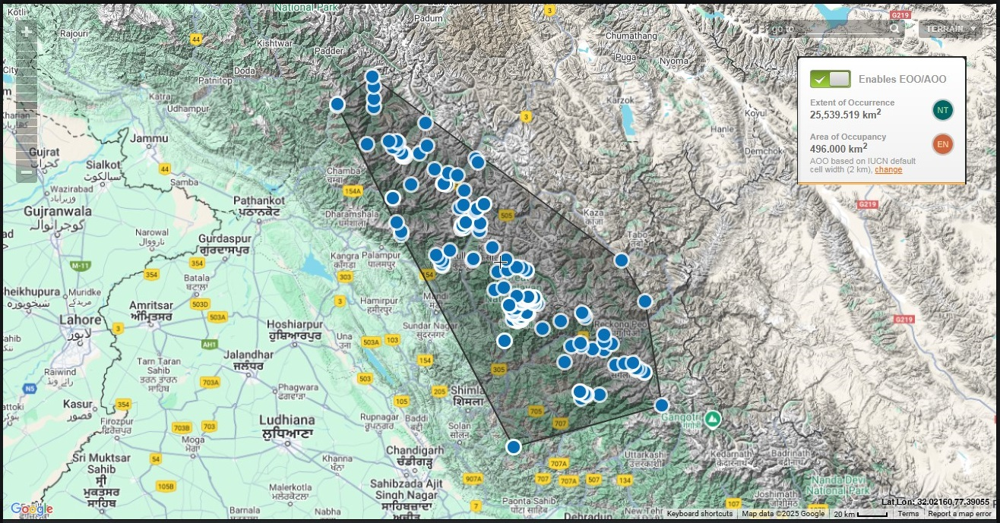
Supplementary Fig. 1: Area of Occupancy and Extent of Occurrence of the B. utilis

