An assessment of climate change impacts on stream phosphorus using a climate model ensemble and Bayesian Belief Networks – Supplementary Information
Authors: Negri C.^{1,2,3,4}(0000-0001-8917-5322), Cowdery E.²(0000-0002-6538-6296), Schurch N.⁴(0000-0001-9068-9654), Wade A. J.³(0000-0002-5296-8350), Mellander P.-E.¹(0000-0002-7261-6758), Glendell M.²(0000-0003-0110-9879)

Authors’ Affiliations: ¹Agricultural Catchments Programme, Teagasc Environment Research Centre, Johnstown Castle, Co. Wexford Y35 Y521, Ireland, ² Environmental and Biochemical Sciences Department, The James Hutton Institute, Craigiebuckler, Aberdeen AB15 8QH, United Kingdom, ³University of Reading, Department of Geography and Environmental Science, Whiteknights, Reading, RG6 6AB, United Kingdom, ⁴Biomathematics and Statistics Scotland, Craigiebuckler, Aberdeen AB15 8QH, United Kingdom, ⁵Ecological Sciences Department, The James Hutton Institute, Craigiebuckler, Aberdeen AB15 8QH, United Kingdom.
Corresponding Author: Camilla Negri, email: camilla.negri@torontomu.ca, c.negri@pgr.reading.ac.uk, address: University of Reading, Department of Geography and Environmental Science, Whiteknights, Reading, RG6 6AB.

Supplementary Information

Figure captions
Fig. S1 BBN Sensitivity to changes in mean and standard deviation in the discharge (Q) node across the four catchments, from top left to bottom rights: Timoleague, Ballycanew, Castledockrell, and Dunleer. The effect is shown on the median log10(TRP) concentration (mg l⁻¹). For all catchments, sensitivity is visible along changes in the January mean Q (along the x axis), but not for changes in the January standard deviation of Q (along the y axis). The same results were obtained for the months of April and August. 7
Fig. S2 Mean monthly TRP concentrations (mg l⁻¹) in the four catchments. The predictions for the BBN baseline are shown in black while the observations (2009-2016) are shown in dashed dark green. Predicted TRP concentrations were log-transformed before calculating the means, and then converted back to normal values. Results are shown for the NSE calibration of the SMART model only. 9

Table captions
Table S1 Lognormal (µ±ơ) (base e) discharge (Q) distribution parameters obtained for the HadGEM2-ES model in the Timoleague catchment across the two scenarios (RCP 4.5 and 8.5) and the three time periods (2010-2039, 2040-2069, 2070-2099) using the NSE-calibrated daily Q time series against the parameters used in the baseline period (BBN baseline). 3
Table S2 Marginal probabilities of Environmental Quality Standard exceedance predicted with model ensemble under the two RCP scenarios and across the three time periods. Probability of exceedance is also shown for the observations (Observed) and the BBN (BBN baseline) in the reference period (2009-2016) [1]. Results are shown for the NSE-calibrated inputs only. 4
Table S3 Mean log₁₀(TRP) (mg l⁻¹) predicted with model ensemble under the two RCP scenarios and across the three time periods. Concentrations are also shown for the observations (obs) and the BBN (BBN baseline) in the reference period (2009-2016) [1]. All concentrations have been filtered by the instrument’s detection limit (0.01-5.00 mg l⁻¹). 5
Table S4 Mean monthly TRP concentration (mg l⁻¹) in the four catchments as predicted by each model in September using the RCP 8.5 scenarios. Predicted TRP concentrations were log-transformed before calculating the means, and then converted back to normal values. Results are shown for the NSE calibration of the SMART model only. Concentrations are also shown for the observations (obs) and the BBN (BBN baseline) in the reference period (2009-2016). 6

Table S1 Lognormal (µ±ơ) (base e) discharge (Q) distribution parameters obtained for the HadGEM2-ES model in the Timoleague catchment across the two scenarios (RCP 4.5 and 8.5) and the three time periods (2010-2039, 2040-2069, 2070-2099) using the NSE-calibrated daily Q time series against the parameters used in the baseline period (BBN baseline).
month | RCP 4.5 - 2010-2039 | RCP 4.5 - 2040-2069 | RCP 4.5 - 2070-2099 | RCP 8.5 - 2010-2039 | RCP 8.5 - 2040-2069 | RCP 8.5 - 2070-2099 | BBN baseline [1]
January | 13.58 ± 0.15 | 13.76 ± 0.14 | 13.69 ± 0.13 | 13.64 ± 0.15 | 13.52 ± 0.18 | 13.69 ± 0.18 | 13.80±0.10
February | 13.41 ± 0.13 | 13.59 ± 0.16 | 13.35 ± 0.15 | 13.59 ± 0.13 | 13.58 ± 0.19 | 13.56 ± 0.19 | 13.80±0.10
March | 13.14 ± 0.12 | 13.10 ± 0.15 | 13.10 ± 0.16 | 13.1 ± 0.14 | 13.00 ± 0.13 | 13.29 ± 0.16 | 12.80±0.10
April | 12.78 ± 0.12 | 12.79 ± 0.15 | 12.73 ± 0.14 | 12.74 ± 0.11 | 12.73 ± 0.13 | 12.66 ± 0.13 | 12.60±0.10
May | 12.43 ± 0.13 | 12.22 ± 0.10 | 12.21 ± 0.11 | 12.42 ± 0.12 | 12.53 ± 0.15 | 12.3 ± 0.13 | 12.20±0.10
June | 11.92 ± 0.09 | 11.77 ± 0.08 | 11.75 ± 0.08 | 12.03 ± 0.11 | 12.00 ± 0.11 | 11.77 ± 0.09 | 12.20±0.20
July | 11.55 ± 0.06 | 11.4 ± 0.06 | 11.47 ± 0.08 | 11.46 ± 0.05 | 11.46 ± 0.07 | 11.33 ± 0.06 | 12.20±0.30
August | 11.38 ± 0.08 | 11.19 ± 0.06 | 11.23 ± 0.07 | 11.46 ± 0.09 | 11.18 ± 0.07 | 11.14 ± 0.07 | 12.10±0.40
September | 11.33 ± 0.10 | 11.23 ± 0.11 | 11.39 ± 0.15 | 11.53 ± 0.13 | 11.25 ± 0.11 | 11.17 ± 0.11 | 12.10±0.40
October | 11.95 ± 0.19 | 12.27 ± 0.27 | 12.14 ± 0.24 | 12.17 ± 0.22 | 11.81 ± 0.19 | 12.22 ± 0.29 | 12.40±0.20
November | 12.84 ± 0.27 | 12.61 ± 0.24 | 13.18 ± 0.29 | 13.18 ± 0.27 | 13.02 ± 0.32 | 13.42 ± 0.32 | 13.40±0.10
December | 13.63 ± 0.20 | 13.67 ± 0.22 | 13.75 ± 0.21 | 13.55 ± 0.21 | 13.48 ± 0.24 | 13.76 ± 0.22 | 13.60±0.20

Table S2 Marginal probabilities of Environmental Quality Standard exceedance predicted with model ensemble under the two RCP scenarios and across the three time periods. Probability of exceedance is also shown for the observations (Observed) and the BBN (BBN baseline) in the reference period (2009-2016) [1]. Results are shown for the NSE-calibrated inputs only.
Timoleague
 | RCP 4.5 | RCP 8.5 | Observed (2009-2016) | BBN baseline [24]
2009-2016 | - | - | 80% | 88%
2010-2039 | 87% | 87% | - | -
2040-2069 | 87% | 87% | - | -
2070-2099 | 87% | 87% | - | -
Ballycanew
 | RCP 4.5 | RCP 8.5 | Observed (2009-2016) | BBN baseline [24]
2009-2016 | - | - | 88% | 61%
2010-2039 | 78% | 79% | - | -
2040-2069 | 78% | 79% | - | -
2070-2099 | 78% | 79% | - | -
Castledockrell
 | RCP 4.5 | RCP 8.5 | Observed (2009-2016) | BBN baseline [24]
2009-2016 | - | - | 28% | 18%
2010-2039 | 21% | 22% | - | -
2040-2069 | 22% | 21% | - | -
2070-2099 | 22% | 21% | - | -
Dunleer
 | RCP 4.5 | RCP 8.5 | Observed (2009-2016) | BBN baseline [24]
2009-2016 | - | - | 99% | 55%
2010-2039 | 77% | 77% | - | -
2040-2069 | 78% | 77% | - | -
2070-2099 | 77% | 77% | - | -

Table S3 Mean log₁₀(TRP) (mg l⁻¹) predicted with model ensemble under the two RCP scenarios and across the three time periods. Concentrations are also shown for the observations (obs) and the BBN (BBN baseline) in the reference period (2009-2016) [1]. All concentrations have been filtered by the instrument’s detection limit (0.01-5.00 mg l⁻¹).
Timoleague
 | RCP 4.5  (NSE) | RCP 4.5 (logNSE) | RCP 8.5  (NSE) | RCP 8.5 (log NSE) | obs | BBN baseline [1]
2009-2016 | - | - | - | - | -1.27±0.24 | 1.28±0.18
2010-2039 | 1.29±0.17 | 1.29±0.17 | 1.29±0.17 | 1.29±0.17 | - | -
2040-2069 | 1.29±0.17 | 1.28±0.18 | 1.29±0.17 | 1.28±0.18 | - | -
2070-2099 | 1.29±0.17 | 1.28±0.18 | 1.29±0.17 | 1.28±0.18 | - | -
Ballycanew
 | RCP 4.5  (NSE) | RCP 4.5 (log NSE) | RCP 8.5  (NSE) | RCP 8.5 (log NSE) | obs | BBN baseline [1]
2009-2016 | - | - | - | - | -1.20±0.24 | 1.15±0.38
2010-2039 | 1.15±0.38 | 1.15±0.38 | 1.15±0.38 | 1.15±0.38 | - | -
2040-2069 | 1.15±0.38 | 1.15±0.38 | 1.15±0.38 | 1.15±0.38 | - | -
2070-2099 | 1.15±0.38 | 1.15±0.38 | 1.15±0.38 | 1.15±0.38 | - | -
Castledockrell
 | RCP 4.5  (NSE) | RCP 4.5 (log NSE) | RCP 8.5  (NSE) | RCP 8.5 (log NSE) | obs | BBN baseline [1]
2009-2016 | - | - | - | - | 1.62±0.28 | -1.61±0.29
2010-2039 | 1.60±0.28 | 1.60±0.28 | 1.60±0.29 | 1.60±0.29 | - | -
2040-2069 | 1.60±0.29 | 1.60±0.29 | 1.60±0.28 | 1.60±0.28 | - | -
2070-2099 | 1.60±0.29 | 1.60±0.29 | 1.61±0.29 | 1.61±0.29 | - | -
Dunleer
 | RCP 4.5  (NSE) | RCP 4.5 (log NSE) | RCP 8.5  (NSE) | RCP 8.5 (log NSE) | obs | BBN baseline [1]
2009-2016 | - | - | - | - | -1.02±0.22 | 1.05±0.49
2010-2039 | 1.04±0.49 | 1.05±0.49 | 1.05±0.48 | 1.05±0.49 | - | -
2040-2069 | 1.04±0.49 | 1.05±0.49 | 1.05±0.49 | 1.05±0.49 | - | -
2070-2099 | 1.04±0.49 | 1.05±0.48 | 1.04±0.49 | 1.04±0.49 | - | -

Table S4 Mean monthly TRP concentration (mg l⁻¹) in the four catchments as predicted by each model in September using the RCP 8.5 scenarios. Predicted TRP concentrations were log-transformed before calculating the means, and then converted back to normal values. Results are shown for the NSE calibration of the SMART model only. Concentrations are also shown for the observations (obs) and the BBN (BBN baseline) in the reference period (2009-2016).
Timoleague
 | CNRM-CM5 | EC-EARTH | HadGEM2 | MIROC5 | MPI-ESM-LR | model ensemble | obs | BBN baseline [1]
2009-2016 | - | - |  | - |  | - | 0.05 | 0.07
2010-2039 | 0.06 | 0.06 | 0.07 | 0.06 | 0.06 | 0.06 | - | -
2040-2069 | 0.06 | 0.07 | 0.08 | 0.06 | 0.06 | 0.06 | - | -
2070-2099 | 0.06 | 0.07 | 0.08 | 0.06 | 0.06 | 0.06 | - | -
Ballycanew
 | CNRM-CM5 | EC-EARTH | HadGEM2 | MIROC5 | MPI-ESM-LR | model ensemble | obs | BBN baseline [1]
2009-2016 | - | - |  | - |  | - | 0.07 | 0.08
2010-2039 | 0.07 | 0.07 | 0.08 | 0.07 | 0.07 | 0.07 | - | -
2040-2069 | 0.07 | 0.07 | 0.09 | 0.07 | 0.07 | 0.07 | - | -
2070-2099 | 0.07 | 0.07 | 0.09 | 0.07 | 0.07 | 0.07 | - | -
Castledockrell
 | CNRM-CM5 | EC-EARTH | HadGEM2 | MIROC5 | MPI-ESM-LR | model ensemble | obs | BBN baseline [1]
2009-2016 | - | - |  | - |  | - | 0.03 | 0.03
2010-2039 | 0.03 | 0.04 | 0.08 | 0.02 | 0.02 | 0.03 | - | -
2040-2069 | 0.03 | 0.03 | 0.07 | 0.02 | 0.02 | 0.02 | - | -
2070-2099 | 0.03 | 0.04 | 0.07 | 0.02 | 0.02 | 0.02 | - | -
Dunleer
 | CNRM-CM5 | EC-EARTH | HadGEM2 | MIROC5 | MPI-ESM-LR | model ensemble | obs | BBN baseline [1]
2009-2016 | - | - |  | - |  | - | 0.15 | 0.09
2010-2039 | 0.09 | 0.09 | 0.11 | 0.09 | 0.09 | 0.09 | - | -
2040-2069 | 0.09 | 0.09 | 0.11 | 0.09 | 0.09 | 0.09 | - | -
2070-2099 | 0.09 | 0.09 | 0.11 | 0.09 | 0.09 | 0.09 | - | -

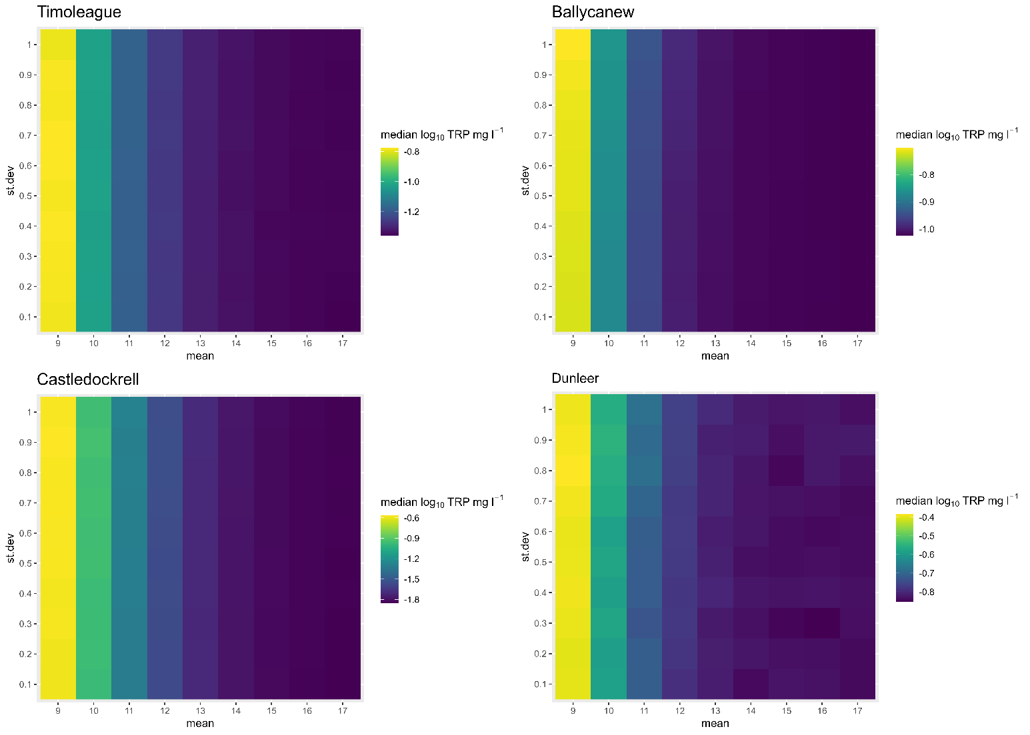
Fig. S1 BBN Sensitivity to changes in mean and standard deviation in the discharge (Q) node across the four catchments, from top left to bottom rights: Timoleague, Ballycanew, Castledockrell, and Dunleer. The effect is shown on the median log10(TRP) concentration (mg l⁻¹). For all catchments, sensitivity is visible along changes in the January mean Q (along the x axis), but not for changes in the January standard deviation of Q (along the y axis). The same results were obtained for the months of April and August.

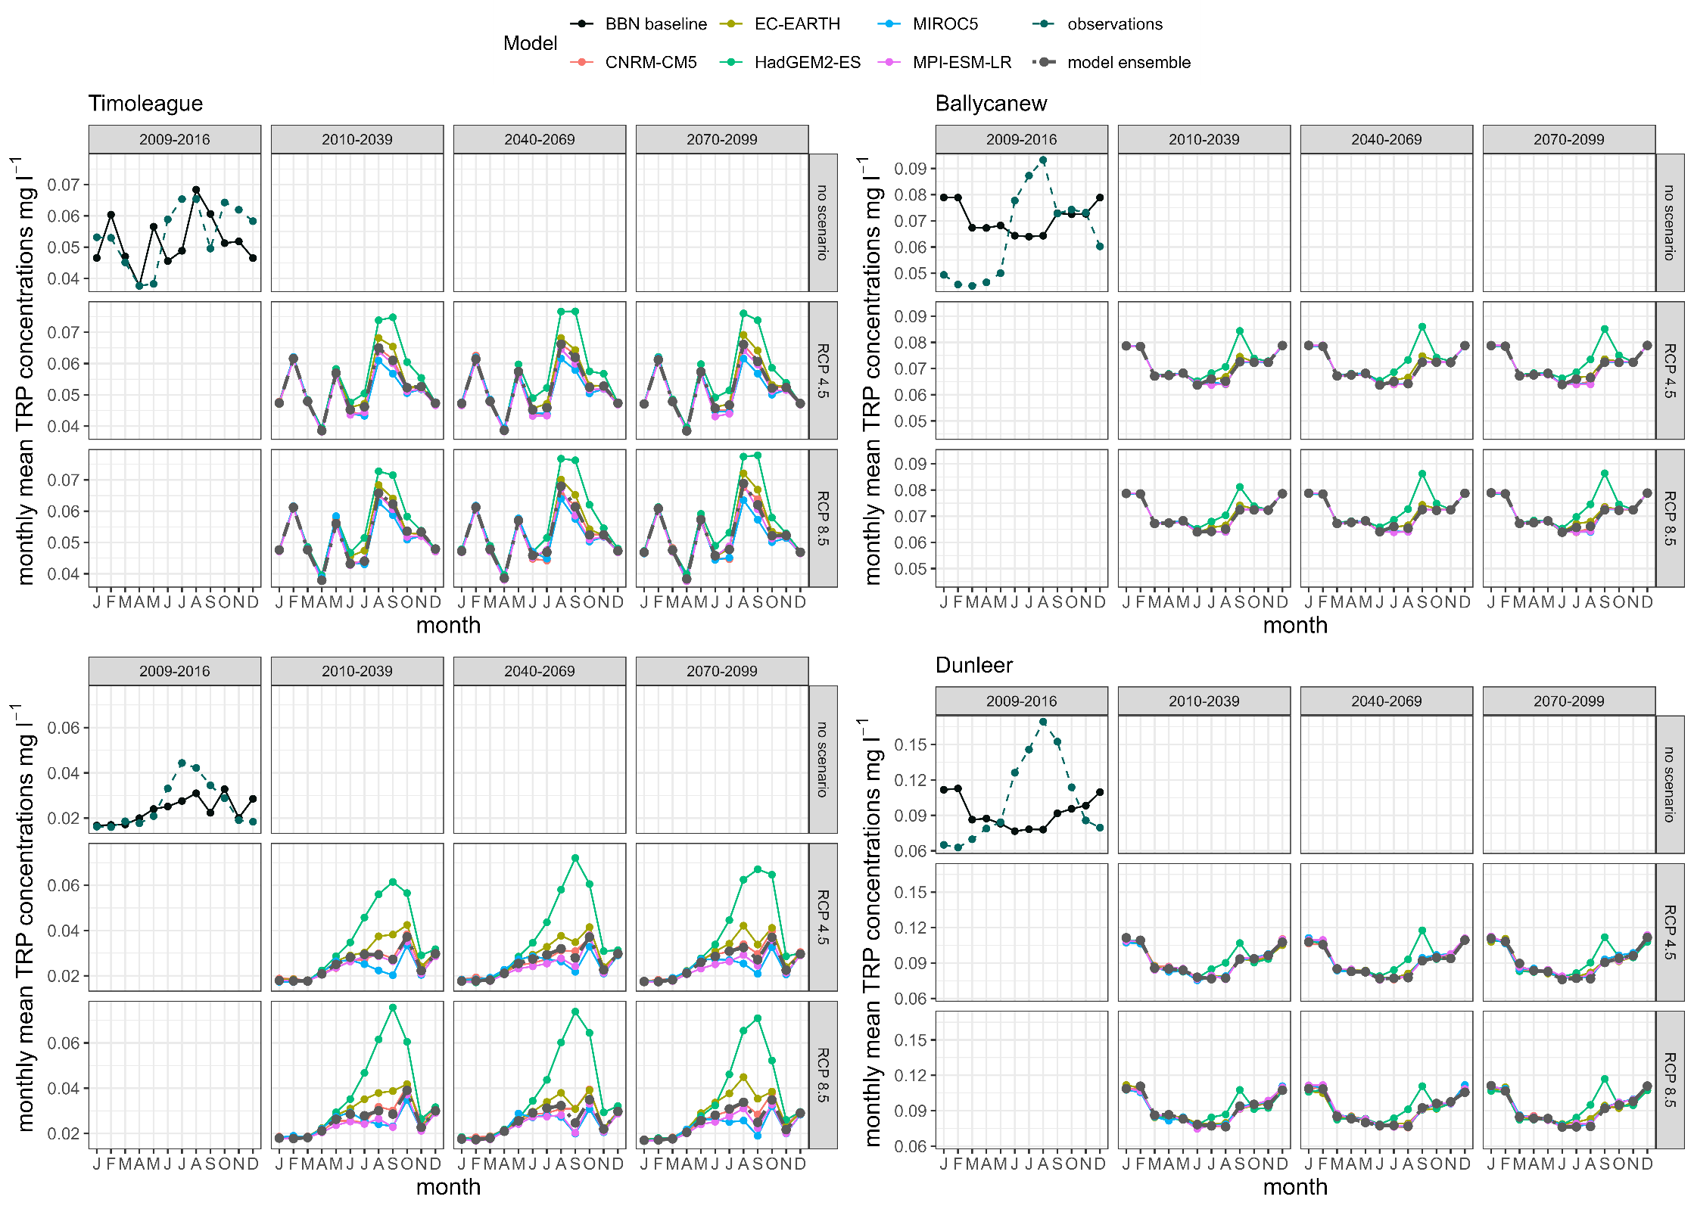
Fig. S2 Mean monthly TRP concentrations (mg l⁻¹) in the four catchments. The predictions for the BBN baseline are shown in black while the observations (2009-2016) are shown in dashed dark green. Predicted TRP concentrations were log-transformed before calculating the means, and then converted back to normal values. Results are shown for the NSE calibration of the SMART model only.

Bibliography
[1] Negri C, Schurch N, Wade AJ, Mellander P-E, Stutter M, Bowes MJ, et al. Transferability of a Bayesian Belief Network across diverse agricultural catchments using high-frequency hydrochemistry and land management data. Sci Total Environ 2024;949:174926. https://doi.org/10.1016/j.scitotenv.2024.174926.

