Supplementary Material for “Spatiotemporal analysis of land degradation and soil erosion dynamics in the Chambal badlands using machine learning and geospatial techniques”

Table S1 Overall change detection matrix for Chambal Division (1992-2024) (Area in sq. km)
2024/  1992 | Ravines | Water Bodies | Agriculture | Barren Land | Built-up Area | Forest | Total
Ravines | 1039.58 | 3.14 | 1030.828 | 202.02 | 14.144 | 57.098 | 2346.8
Water Bodies | 2.753 | 62.807 | 63.779 | 16.753 | 7.063 | 22.462 | 175.6
Agriculture | 20.509 | 8.5 | 5795.64 | 117.032 | 84.854 | 31.524 | 6057.8
Barren Land | 72.147 | 5.375 | 1019.125 | 176.923 | 29.439 | 45.754 | 1348.8
Built-up Area | 0.455 | 0.458 | 12.002 | 1.490 | 99.97 | 0.676 | 115.06
Forest | 58.385 | 6.561 | 536.134 | 66.312 | 16.175 | 5348.19 | 6031.9
Total | 1193.83 | 86.8 | 8457.5 | 580.5 | 251.645 | 5505.6 | 16075.9

Table S2 Overall change detection matrix for Bhind District (1992-2024) (Area in sq. km)
2024/  1992 | Ravines | Water Bodies | Agriculture | Barren Land | Built-up Area | Forest | Total
Ravines | 416.707 | 0.220 | 555.187 | 144.259 | 7.964 | 24.553 | 1148.89
Water Bodies | 0.993 | 10.344 | 25.779 | 5.197 | 3.784 | 2.783 | 48.88
Agriculture | 14.046 | 0.199 | 2414.514 | 48.401 | 29.943 | 4.744 | 2511.847
Barren Land | 56.619 | 2.392 | 487.852 | 88.862 | 12.704 | 9.594 | 658.023
Built-up Area | 0.017 | 0.027 | 3.641 | 0.233 | 51.270 | 0.032 | 55.22
Forest | 0.602 | 0.018 | 31.599 | 3.314 | 1.191 | 14.504 | 51.228
Total | 488.984 | 13.2 | 3518.572 | 290.266 | 106.856 | 56.21 | 4474.088

Table S3 Overall change detection matrix for Morena District (1992-2024) (Area in sq. km)
2024/  1992 | Ravines | Water Bodies | Agriculture | Barren Land | Built-up Area | Forest | Total
Ravines | 546.09 | 1.7352 | 362.843 | 41.8653 | 3.8025 | 6.2523 | 962.5883
Water Bodies | 1.7451 | 33.700 | 21.1671 | 7.704 | 1.8378 | 5.7267 | 71.8807
Agriculture | 5.2785 | 4.7394 | 2241.49 | 43.8714 | 45.4743 | 9.9918 | 2350.845
Barren Land | 7.3476 | 2.3823 | 242.9059 | 50.626 | 11.3661 | 16.686 | 331.3139
Built-up Area | 0.340 | 0.2034 | 7.2279 | 1.138 | 39.280 | 0.5679 | 48.7572
Forest | 57.5622 | 1.4058 | 163.2081 | 35.0325 | 9.6588 | 961.927 | 1228.794
Total | 618.3634 | 44.1661 | 3038.842 | 180.2372 | 111.4195 | 1001.152 | 4994.18

Table S4 Overall change detection matrix for Sheopur District (1992-2024) (Area in sq. km)
2024/  1992 | Ravines | Water Bodies | Agriculture | Barren Land | Built-up Area | Forest | Total
Ravines | 77.1426 | 1.188 | 113.1795 | 15.4449 | 2.412 | 26.3331 | 235.7001
Water Bodies | 0.0144 | 18.81 | 15.1677 | 3.906 | 1.4841 | 11.9646 | 51.3468
Agriculture | 1.1853 | 3.1941 | 1139.791 | 24.7878 | 9.4536 | 16.7949 | 1195.207
Barren Land | 8.1999 | 0.5094 | 290.4357 | 37.6281 | 5.2812 | 20.2689 | 362.3232
Built-up Area | 0.1008 | 0.2286 | 1.161 | 0.1233 | 9.538 | 0.0765 | 11.2282
Forest | 0.2214 | 5.1381 | 341.682 | 28.0143 | 5.3451 | 4373.32 | 4753.721
Total | 86.8644 | 29.0682 | 1901.417 | 109.9044 | 33.514 | 4448.758 | 6609.526

Table S5 Expected changes in the LULC of the Chambal Division in 2056
Class | Area in sq. km (1992) | % Area (1992) | Area in sq. km (2056) | % Area (2056) | Percentage Change
Agricultural Land | 6057.81 | 37.68 | 10378..09 | 64.55 | 71.31
Barren Land | 1348.7 | 8.38 | 293.36 | 1.82 | -78.24
Built-up land | 115.07 | 0.71 | 479.85 | 2.98 | 317
Forest Land | 6031.99 | 37.52 | 4535.58 | 28.21 | -24.80
Ravines | 2346.88 | 14.59 | 357.05 | 2.22 | -84.78
Water | 175.52 | 1.09 | 32.04 | 0.19 | -81.74
Chambal Division | 16075.97 | 100 | 16075.97 | 100 | 0

Table S6 Sample Size and Model Evaluation Summary
Set (2008) | Sample Size | Accuracy (High-risk) | Accuracy (Low-risk)
Training | 1400 | 0.91 | 0.86
Testing | 600 | 0.88 | 0.85
Set (2024) | Sample Size | Accuracy (High-risk) | Accuracy (Low-risk)
Training | 1400 | 0.91 | 0.87
Testing | 600 | 0.89 | 0.86
Set (2040) | Sample Size | Accuracy (High-risk) | Accuracy (Low-risk)
Training | 1400 | 0.93 | 0.89
Testing | 600 | 0.89 | 0.87
Set (2056) | Sample Size | Accuracy (High-risk) | Accuracy (Low-risk)
Training | 1400 | 0.94 | 0.90
Testing | 600 | 0.91 | 0.88

Table S7 Number of Samples per Interval
Interval | Count
1992-2008 | 20000
2008-2024 | 20000
2024-2040 | 20000
2040-2056 | 20000

Table S8 Average Changes in P and Erosion
Interval | ΔP | ΔErosion
1992-2008 | -0.0662 | -0.2056
2008-2024 | 0.0593 | 0.1842
2024-2040 | 0.0007 | 0.0021
2040-2056 | 0.0037 | 0.0115

Table S9 Summary Statistics for ΔP and ΔErosion
Metric | ΔP | ΔErosion
Count | 80000.0 | 80000.0
Mean | -0.0589 | -0.2222
Std | 0.2799 | 2.4588
Min | -0.9 | -144.42
25% | -0.2483 | -0.0517
50% | -0.0577 | 0.0025
75% | 0.1312 | 0.0427
Max | 0.9 | 88.32

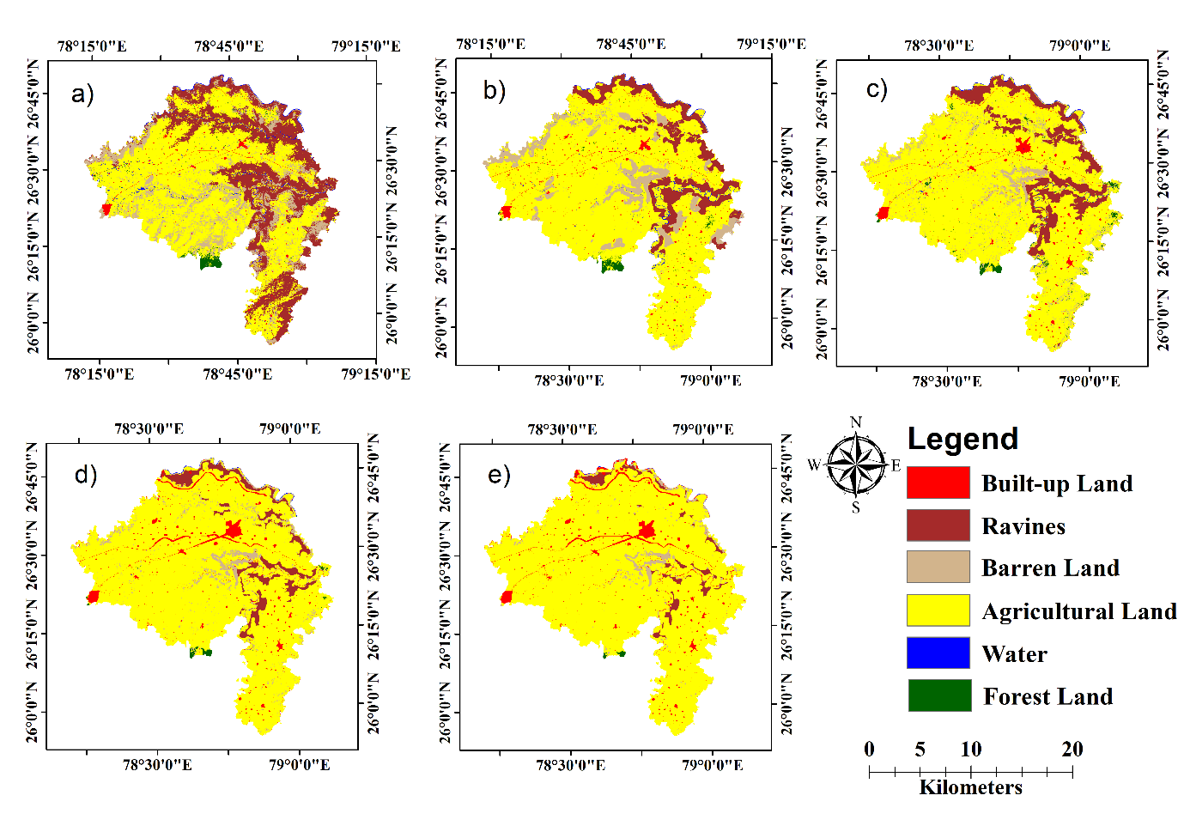
Fig. S1 LULC maps of Bhind District. a) 1992 b) 2008 c) 2024 d) 2040 e) 2056

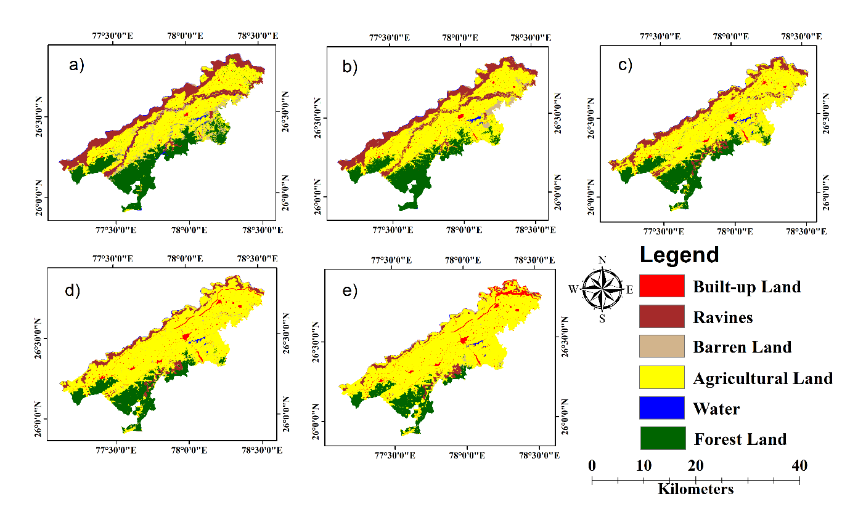
Fig. S2 LULC maps of Morena District. a) 1992 b) 2008 c) 2024 d) 2040 e) 2056
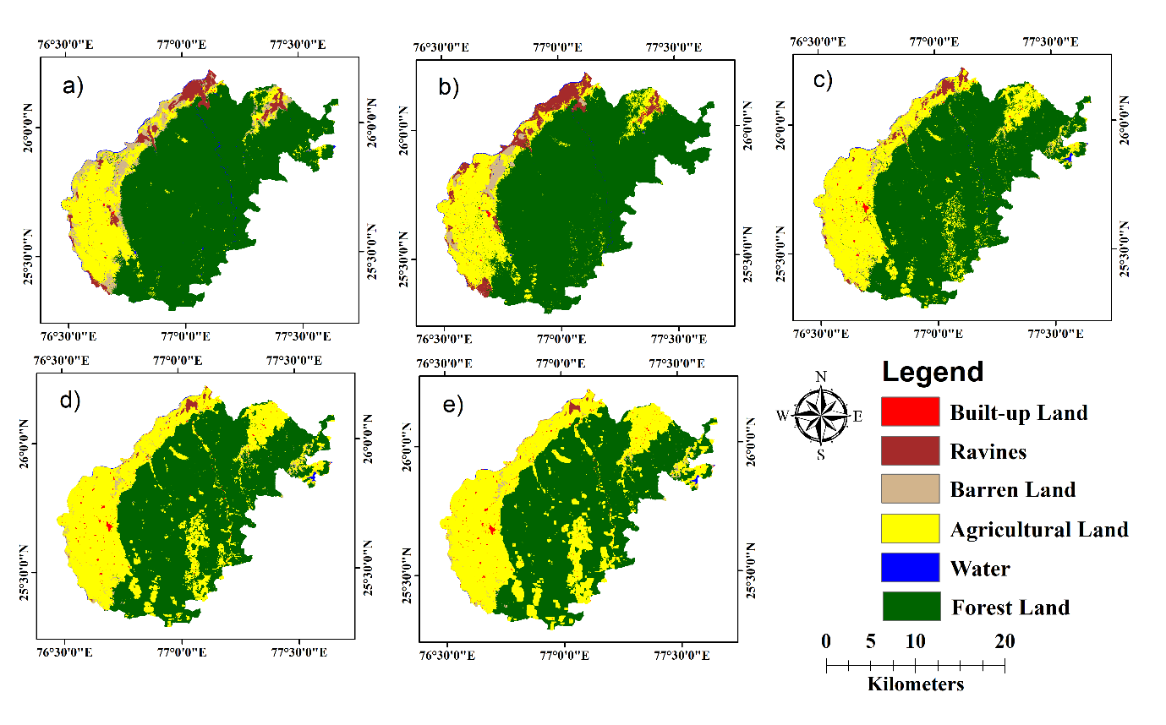
Fig. S3 LULC maps of Sheopur District. a) 1992 b) 2008 c) 2024 d) 2040 e) 2056

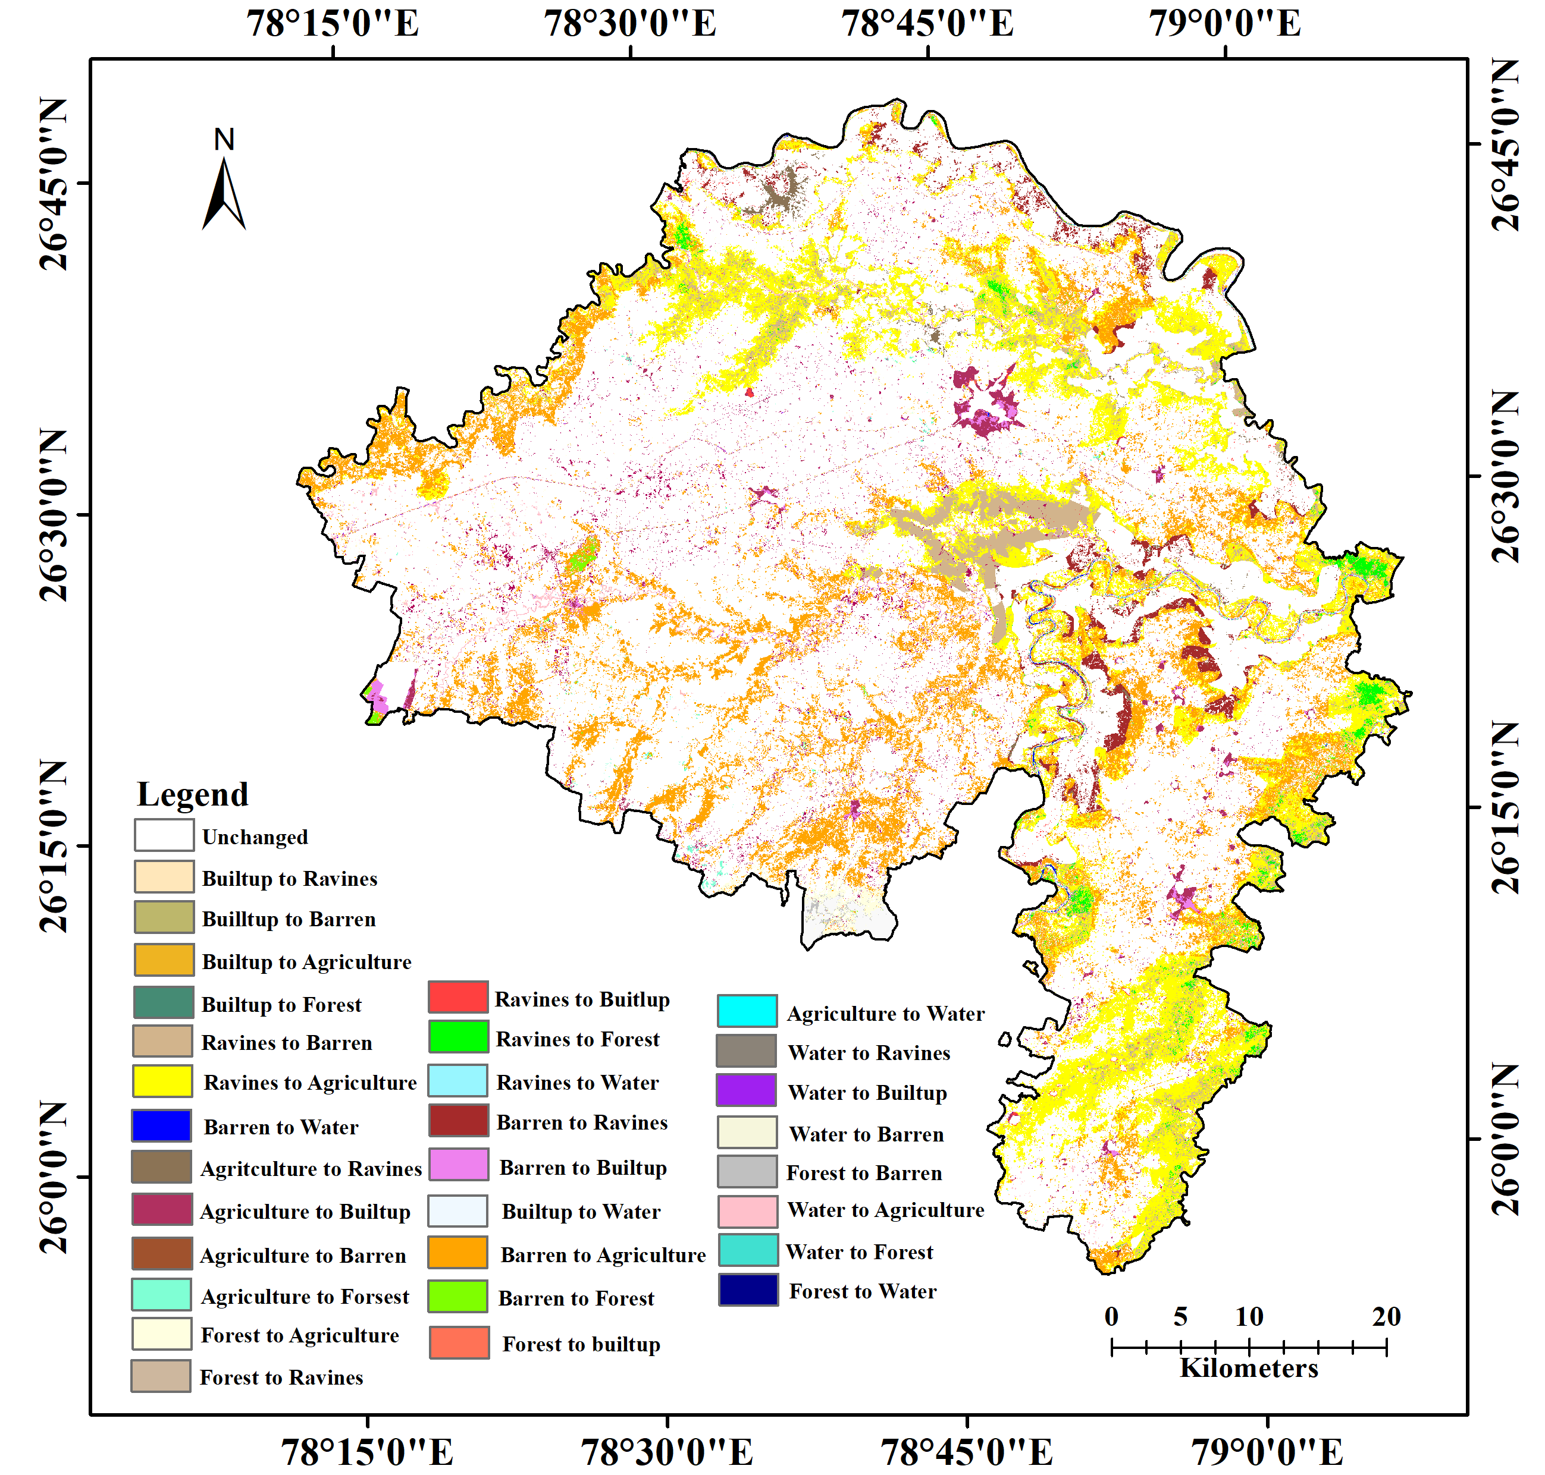

Fig. S4 Change detection of Bhind District (1992-2024)

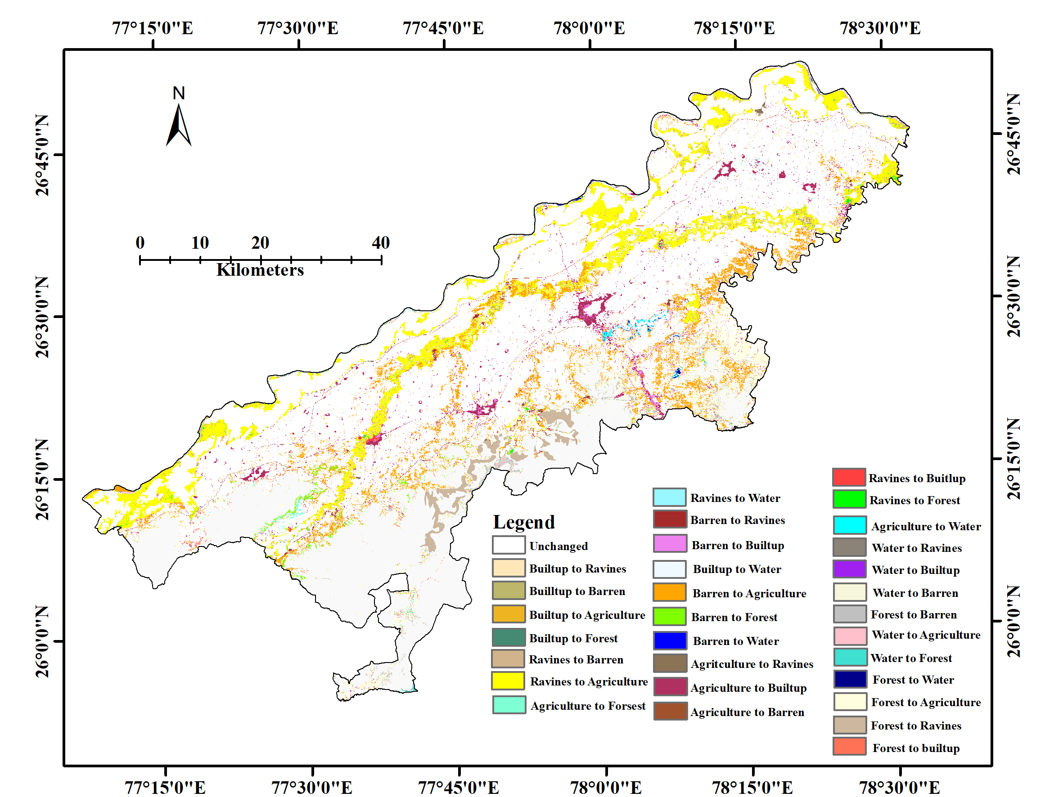

Fig. S5 Change detection of Morena District (1992-2024)

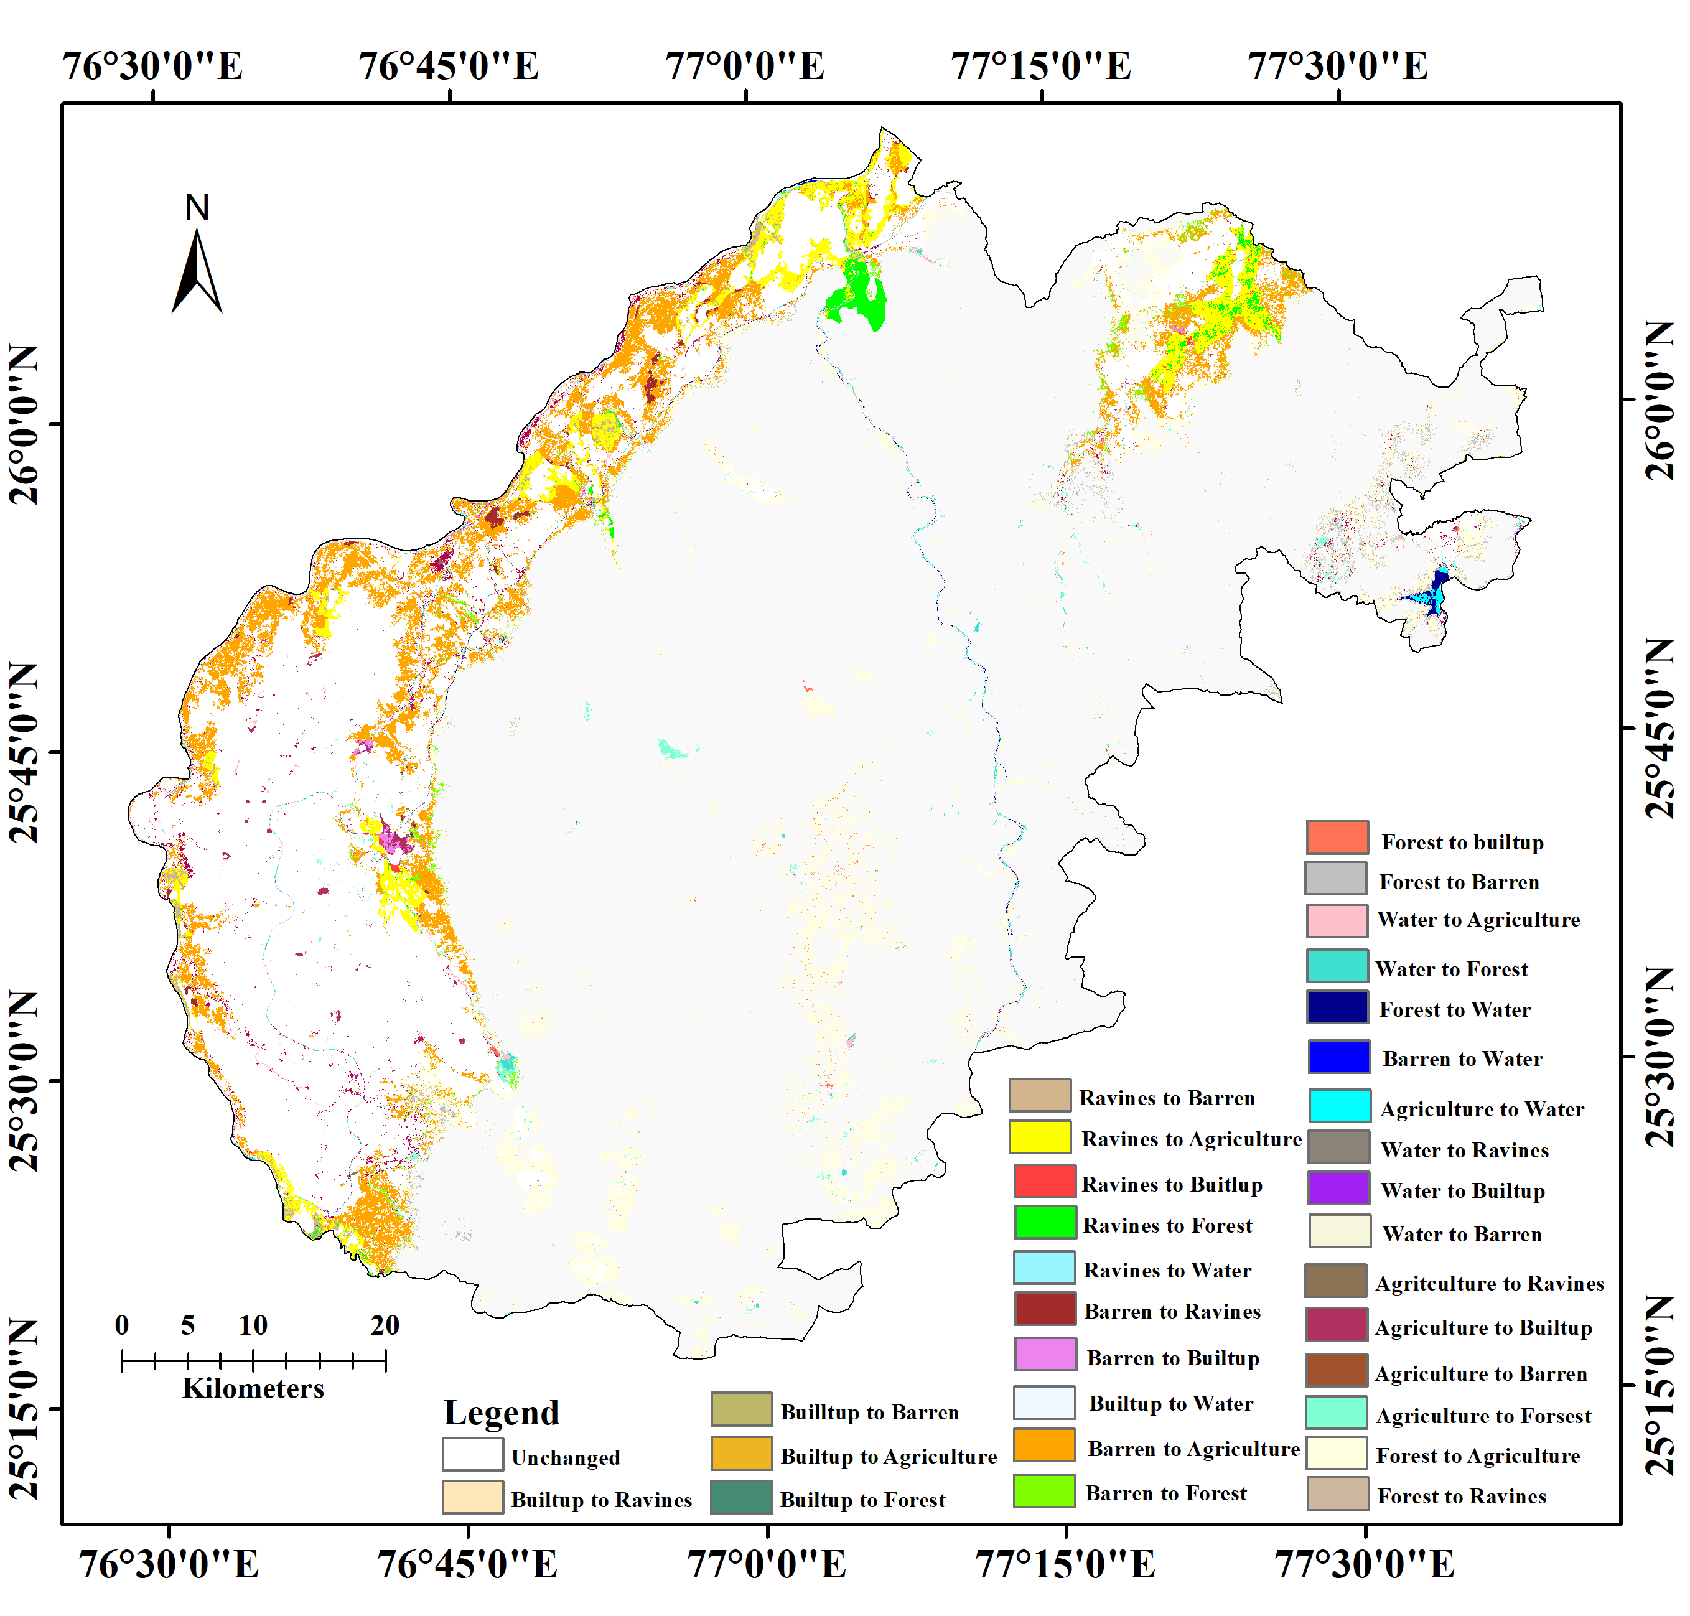

Fig. S6 Change detection of Sheopur District (1992-2024)

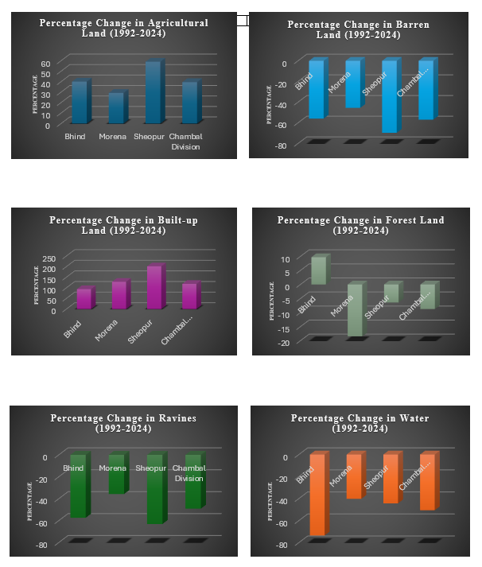

Fig. S7 Percentage Change in various LULC classes in Chambal Division from 1992 to 2024

Fig. S8 R factor a) 1992 b) 2008 c) 2024 d) 2040 e) 2056
Fig. S9 K factor

Fig. S10 LS factor
Fig. S11 C factor a) 1992 b) 2008 c) 2024 d) 2040 e) 2056

Fig. S12 P factor a) 1992 b) 2008 c) 2024 d) 2040 e) 2056

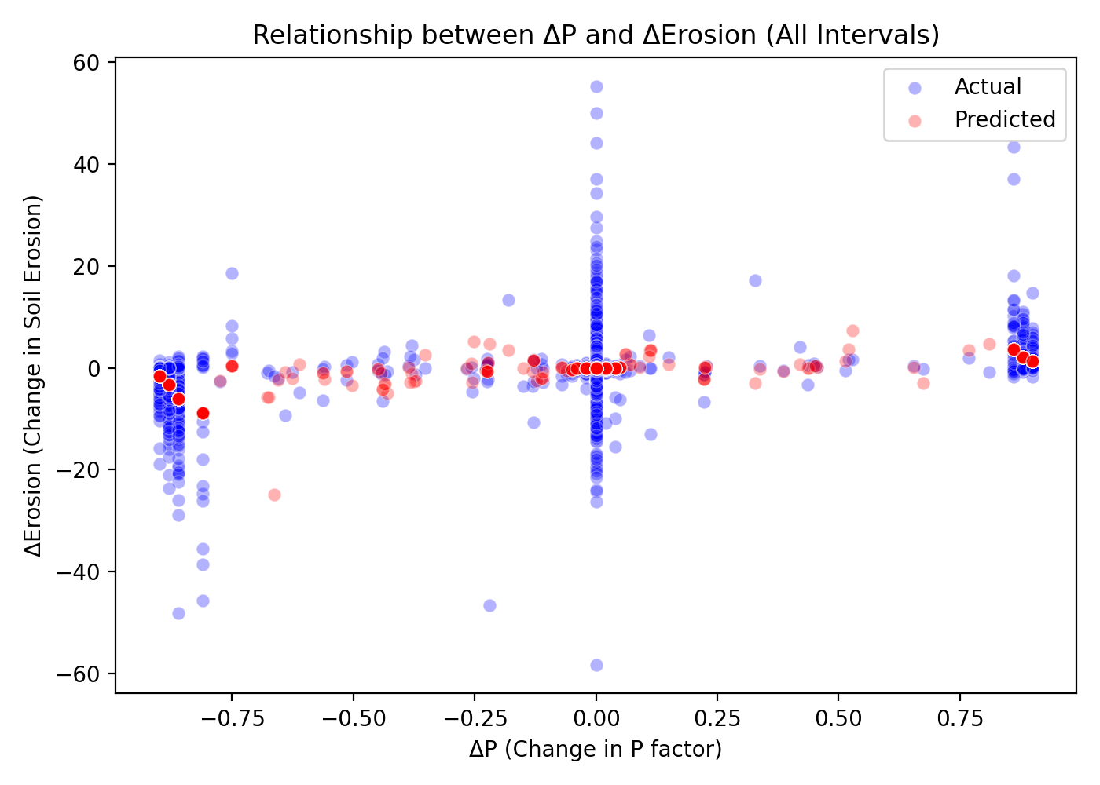
Fig. S13 Scatter Plot: ΔP vs ΔErosion

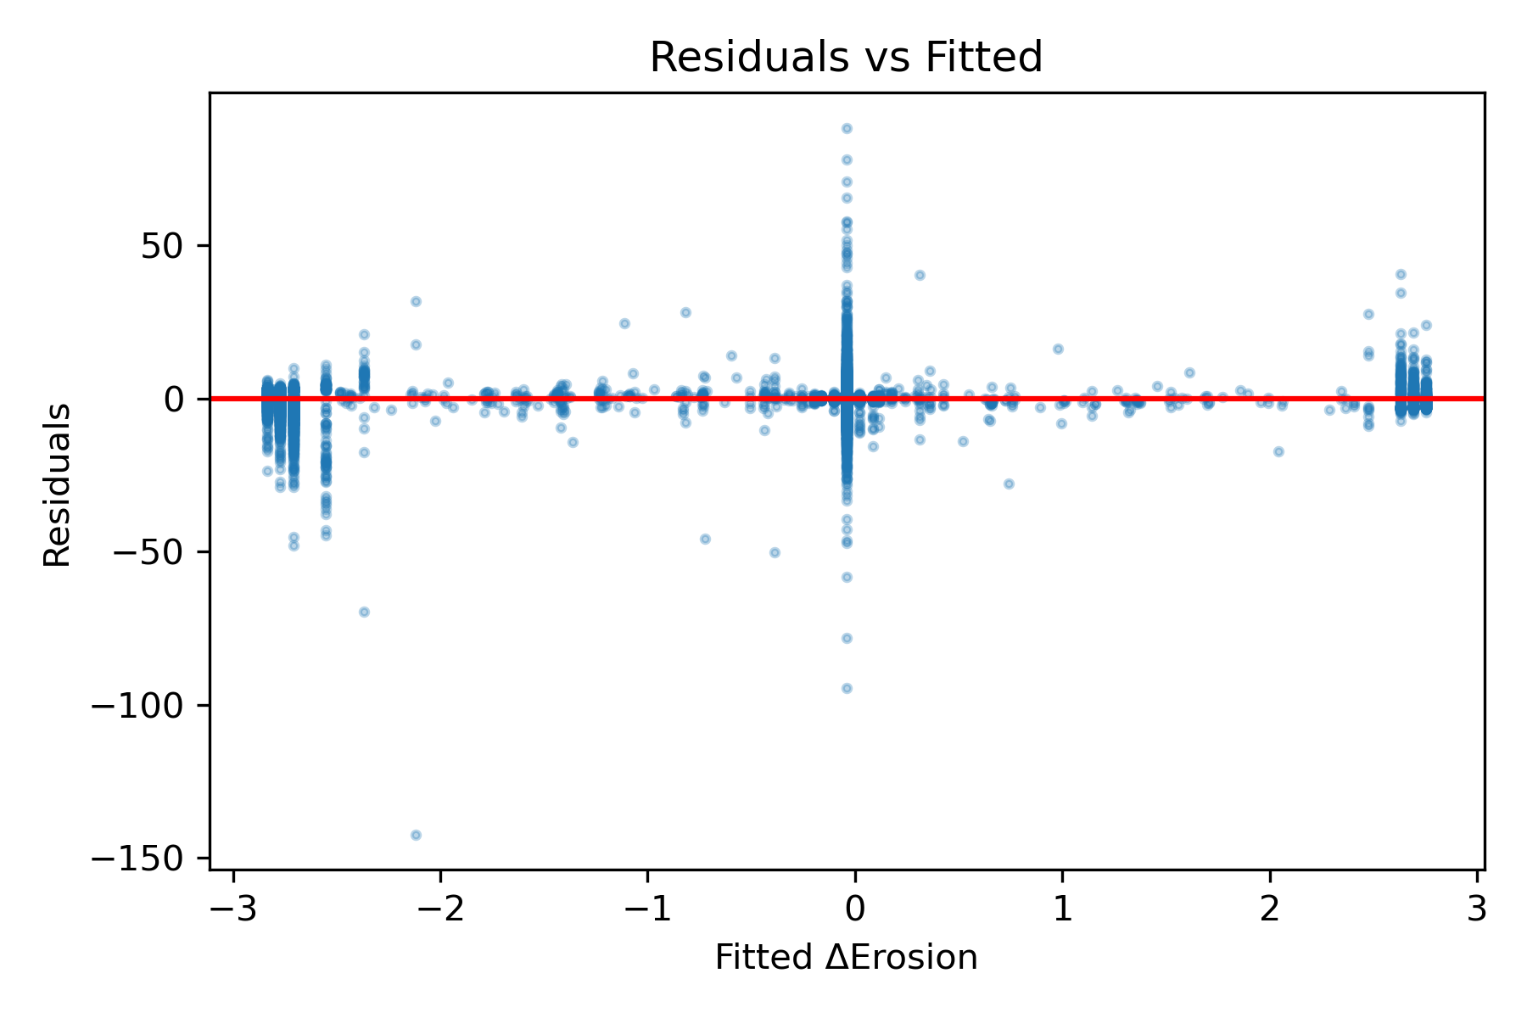
Fig. S14 Residuals versus fitted ΔErosion for the ΔP linear model. The widening spread indicates heteroscedasticity

Section 1: Rainfall Forecasting in the Chambal Basin Using SARIMA

1.1 Station-wise SARIMA Model Orders
Table S10 Station-wise SARIMA Model Orders
Location ID | SARIMA Model Order | AIC | BIC
1 | (1,1,1)(1,1,1,12) | 16732.2 | 16789.4
2 | (1,1,1)(1,1,1,12) | 15892.3 | 15949.5
3 | (2,1,1)(1,1,1,12) | 16234.7 | 16301.2
4 | (1,1,1)(1,1,1,12) | 17123.8 | 17180.9
5 | (1,1,2)(1,1,1,12) | 16456.1 | 16523.4
6 | (2,1,1)(1,1,1,12) | 15987.6 | 16054.1
7 | (1,1,1)(1,1,1,12) | 16789.4 | 16846.6
8 | (1,1,1)(2,1,1,12) | 17234.5 | 17301.8
9 | (2,1,2)(1,1,1,12) | 16123.7 | 16200.3
10 | (1,1,1)(1,1,1,12) | 15678.9 | 15736.1
11 | (1,1,1)(1,1,1,12) | 16345.2 | 16402.4
12 | (2,1,1)(1,1,1,12) | 17012.8 | 17079.3
13 | (1,1,2)(1,1,1,12) | 16567.3 | 16634.6
14 | (1,1,1)(1,1,1,12) | 15834.7 | 15891.9
15 | (1,1,1)(1,1,2,12) | 16723.4 | 16790.7
16 | (2,1,1)(1,1,1,12) | 16198.5 | 16265.0
17 | (1,1,1)(1,1,1,12) | 15923.6 | 15980.8
18 | (1,1,2)(1,1,1,12) | 16445.8 | 16513.1
19 | (1,1,1)(1,1,1,12) | 16789.2 | 16846.4
20 | (2,1,1)(1,1,1,12) | 16034.9 | 16101.4
21 | (1,1,1)(1,1,1,12) | 15712.3 | 15769.5
22 | (1,1,1)(1,1,1,12) | 16456.7 | 16513.9

1.2 ACF/PACF Diagnostic Plots
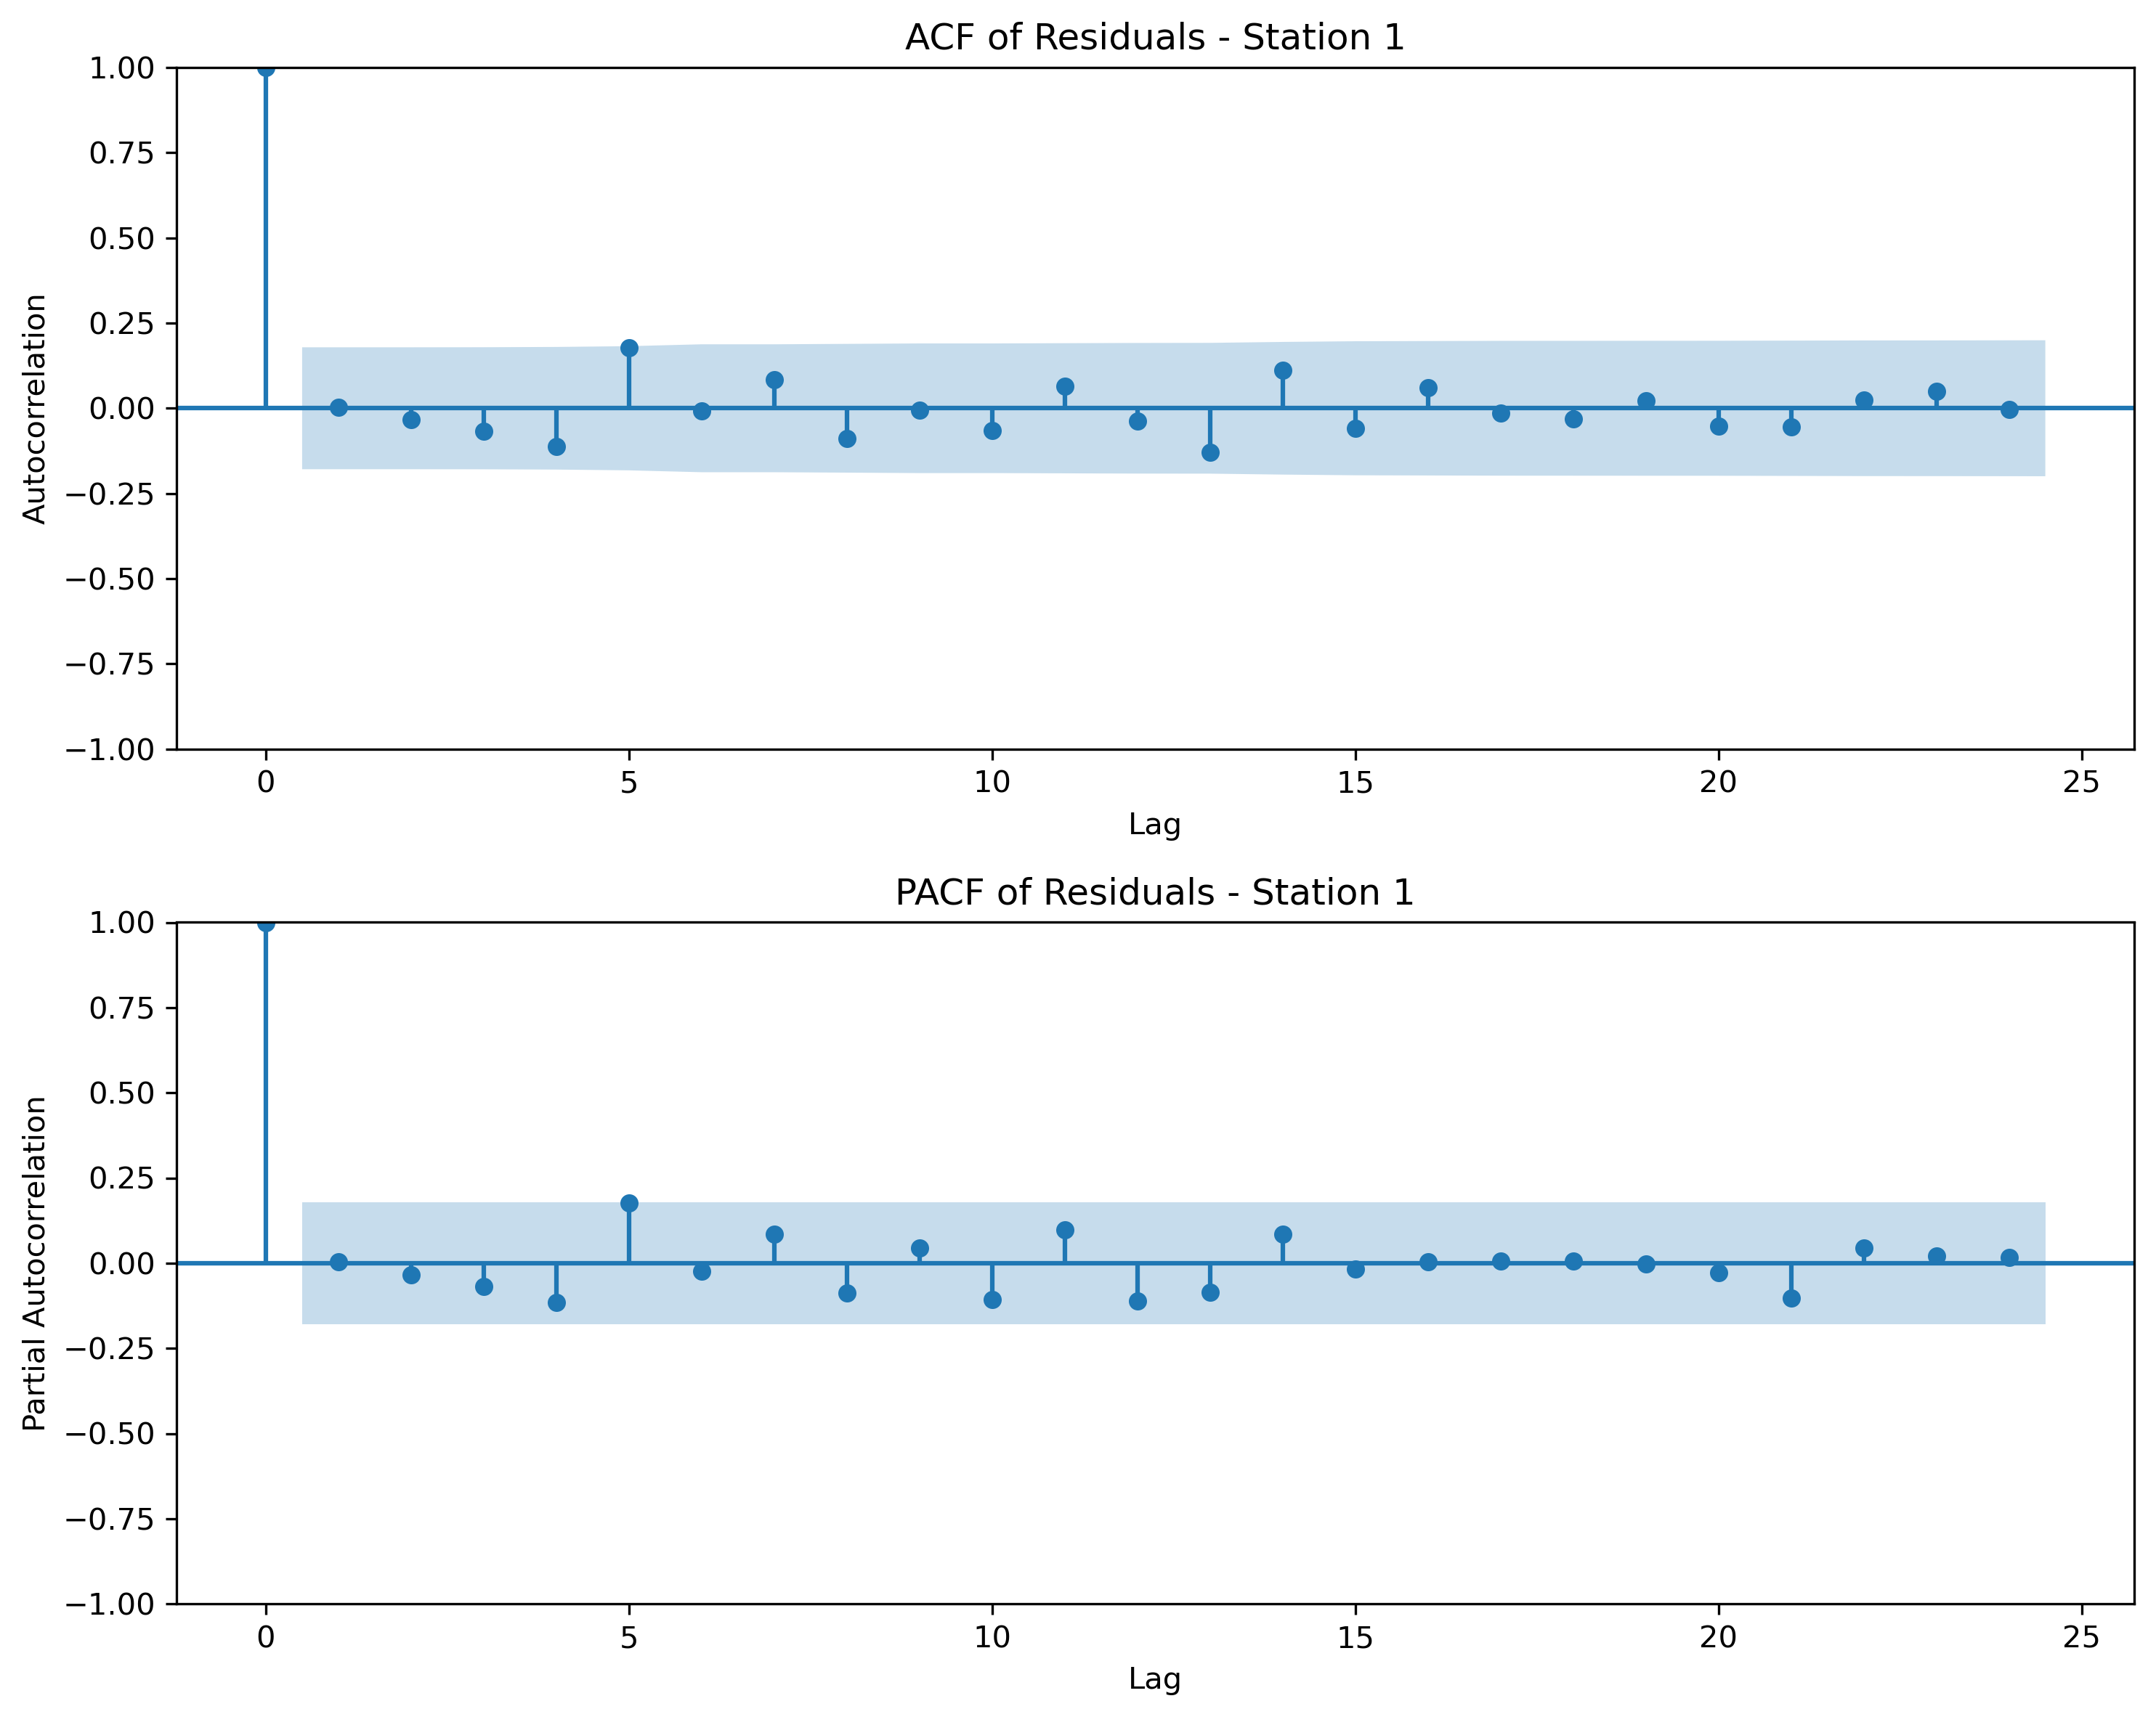
Fig. S15 ACF and PACF plots for residuals of SARIMA model at Station 1
Table S11 The mean forecast and 95% CI width for all 22 locations
Location ID | Mean Forecast (mm) | CI Lower Bound (mm) | CI Upper Bound (mm) | CI Width (mm)
1 | 83.0 | -58.5 | 224.5 | 283.0
2 | 88.3 | -57.3 | 234.0 | 291.2
3 | 82.9 | -56.3 | 222.2 | 278.5
4 | 85.8 | -55.8 | 227.4 | 283.2
5 | 71.5 | -58.2 | 201.2 | 259.4
6 | 65.6 | -59.7 | 190.8 | 250.5
7 | 57.4 | -86.2 | 201.1 | 287.3
8 | 57.7 | -64.3 | 179.6 | 243.9
9 | 58.4 | -80.7 | 197.5 | 278.2
10 | 58.8 | -68.6 | 186.2 | 254.8
11 | 60.6 | -60.2 | 181.4 | 241.6
12 | 44.8 | -68.7 | 158.3 | 227.0
13 | 63.2 | -58.2 | 184.6 | 242.8
14 | 59.6 | -55.2 | 174.5 | 229.8
15 | 61.5 | -58.8 | 181.7 | 240.5
16 | 66.3 | -62.8 | 195.4 | 258.2
17 | 66.3 | -62.8 | 195.4 | 258.2
18 | 58.2 | -62.0 | 178.5 | 240.6
19 | 51.8 | -58.4 | 162.0 | 220.4
20 | 52.5 | -57.4 | 162.3 | 219.7
21 | 56.1 | -63.4 | 175.7 | 239.1
22 | 54.3 | -66.1 | 174.6 | 240.7
The CI width indicates forecast uncertainty, with wider intervals reflecting higher uncertainty in rainfall predictions.
Note: Negative lower bounds in the forecast intervals are a statistical artifact of normally distributed errors; however, actual rainfall is physically bounded at zero.

Table S12 Sensitivity testing using alternate SARIMA configurations was conducted for 6 locations. Results showed minor variation in performance, confirming the robustness of the selected model order
Location ID | RMSE (1,1,0)(1,1,0,12) | RMSE (1,1,1)(1,1,1,12) | RMSE Improvement | AIC (1,1,0)(1,1,0,12) | AIC (1,1,1)(1,1,1,12) | AIC Improvement
1 | 106.28 | 74.28 | 31.99 | 17806.9 | 16732.2 | 1074.7
2 | 109.41 | 77.15 | 32.26 | 17883.9 | 16818.7 | 1065.2
3 | 104.06 | 72.82 | 31.24 | 17746.6 | 16681.4 | 1065.2
4 | 104.17 | 74.02 | 30.16 | 17745.9 | 16718.7 | 1027.2
5 | 100.44 | 68.76 | 31.68 | 17638.2 | 16480.1 | 1158.1
6 | 96.5 | 66.09 | 30.41 | 17525.0 | 16376.9 | 1148.1
Sensitivity testing using alternate SARIMA configurations was conducted. Results showed minor variation in performance, confirming the robustness of the selected model order.
While SARIMA performs well in capturing seasonal and temporal dynamics, it assumes linearity and stationarity after differencing. It does not account for potential non-climatic drivers (e.g., land use change, ENSO). The model also assumes that future patterns will follow historical trends, which may not hold under changing climate conditions. Future studies can integrate exogenous predictors using SARIMAX or machine learning ensembles to address these limitations.

Table S13 ACF/PACF Diagnostic Plots for Representative Stations
Location ID | RMSE (mm) | MAE (mm) | MAPE (%) | Correlation (r) | p-value
1 | 74.28 | 39.36 | N/A* | 0.812 | < 0.001
2 | 77.15 | 40.45 | N/A* | 0.805 | < 0.001
3 | 72.82 | 40.31 | N/A* | 0.804 | < 0.001
4 | 74.02 | 40.41 | N/A* | 0.796 | < 0.001
5 | 68.76 | 35.78 | N/A* | 0.804 | < 0.001
6 | 66.09 | 35.38 | N/A* | 0.793 | < 0.001
7 | 75.56 | 36.45 | N/A* | 0.743 | < 0.001
8 | 64.74 | 33.55 | N/A* | 0.798 | < 0.001
9 | 73.5 | 38.43 | N/A* | 0.769 | < 0.001
10 | 67.45 | 34.84 | N/A* | 0.783 | < 0.001
11 | 64.37 | 34.41 | N/A* | 0.802 | < 0.001
12 | 60.0 | 33.37 | N/A* | 0.809 | < 0.001
13 | 65.07 | 36.11 | N/A* | 0.795 | < 0.001
14 | 61.4 | 34.04 | N/A* | 0.808 | < 0.001
15 | 63.37 | 35.24 | N/A* | 0.782 | < 0.001
16 | 68.06 | 37.75 | N/A* | 0.777 | < 0.001
17 | 68.06 | 37.75 | N/A* | 0.777 | < 0.001
18 | 63.76 | 34.62 | N/A* | 0.789 | < 0.001
19 | 57.23 | 33.07 | N/A* | 0.813 | < 0.001
20 | 57.98 | 33.1 | N/A* | 0.8 | < 0.001
21 | 62.47 | 35.85 | N/A* | 0.789 | < 0.001
22 | 63.21 | 35.97 | N/A* | 0.788 | < 0.001

1.4 Model Limitations and Considerations
While SARIMA models demonstrate strong performance in capturing seasonal and temporal dynamics of rainfall patterns, several limitations should be acknowledged. First, SARIMA assumes linearity and stationarity after differencing, which may not fully capture complex non-linear relationships in rainfall data. Second, the model does not account for potential non-climatic drivers such as land use changes, urbanization effects, or large-scale climate oscillations like ENSO (El Niño-Southern Oscillation) that can significantly influence regional rainfall patterns. Third, SARIMA models assume that future patterns will follow historical trends, which may not hold under changing climate conditions or extreme weather events. Fourth, the model's performance may be affected by data quality issues, missing values, or measurement errors in the historical rainfall records. Finally, while 95% confidence intervals provide uncertainty estimates, they assume normally distributed errors and may not capture all sources of forecast uncertainty, particularly for extreme rainfall events. Future studies can address these limitations by integrating exogenous predictors using SARIMAX models, exploring machine learning ensembles, or incorporating climate indices to improve forecast accuracy and reliability.

Appendix
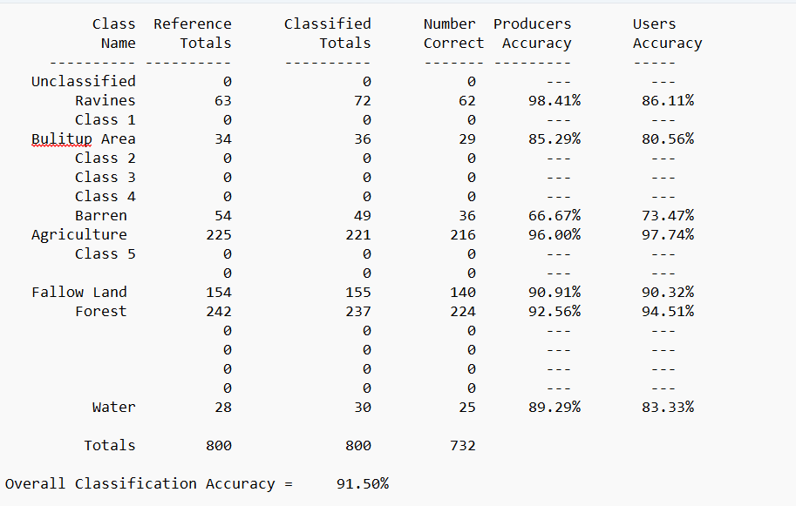
*Accuracy assessment LULC, 2024
(*While 200 field-based observations were collected for ground verification, classification accuracy was evaluated using 800 stratified random reference points interpreted from Google Earth imagery to improve statistical robustness.)
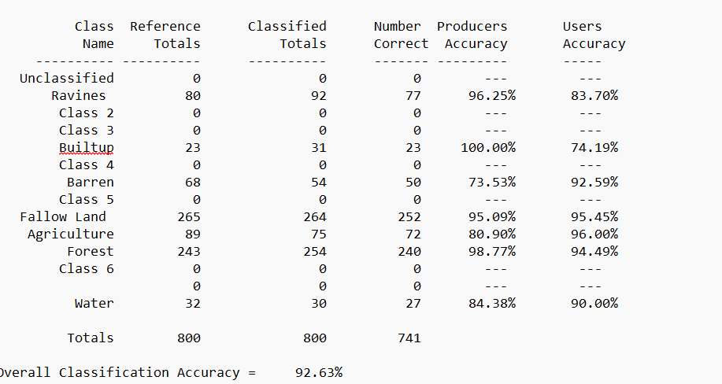
Accuracy assessment LULC, 2008

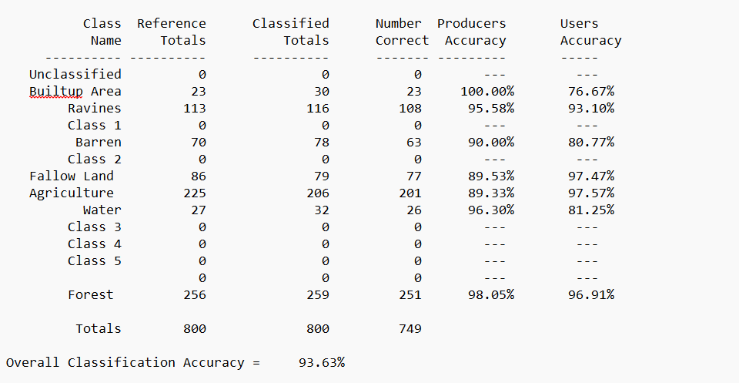
Accuracy assessment LULC, 1992

