Supporting Information for Natural basalt reactivity towards CO₂: implications for geologic storage in mafic rocks

Chelsea W. Neil, ^{1,*} Haylea Nisbet,¹ Darrick J. Williams,² Michael T. Pettes,² Steven G. Young,³ Brian M. Patterson,³ Hari Viswanathan⁴

¹Earth and Environmental Sciences Division, Los Alamos National Laboratory, Los Alamos, NM 87545, USA
²The Center for Integrated Nanotechnologies, Los Alamos National Laboratory, Los Alamos, NM 87545, USA
³Materials Science and Technology Division, Los Alamos National Laboratory, Los Alamos, NM 87545, USA

Address: P.O. Box 1663, Los Alamos, NM 87545
Email: cwneil@lanl.gov
Phone: (505) 695-3485
*Corresponding author

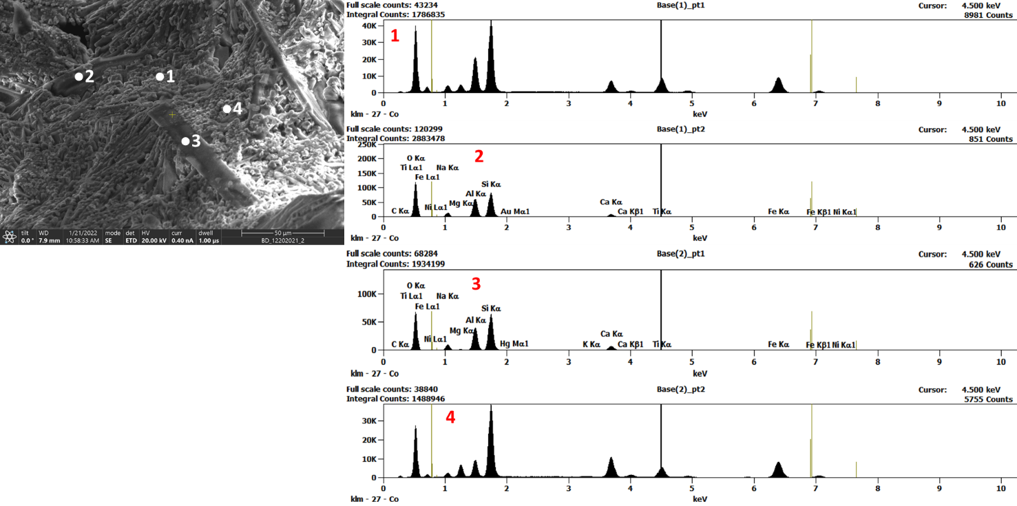
Figure S1. Representative SEM-EDX for unreacted Basalt #1
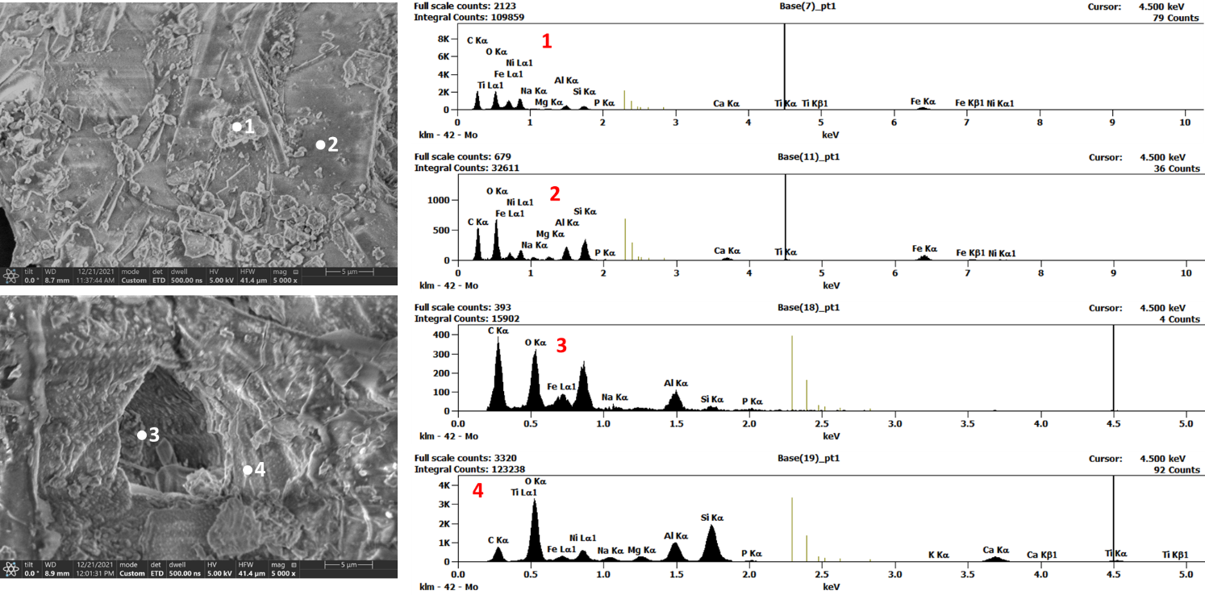
Figure S2. Representative SEM-EDX for reacted Basalt #1

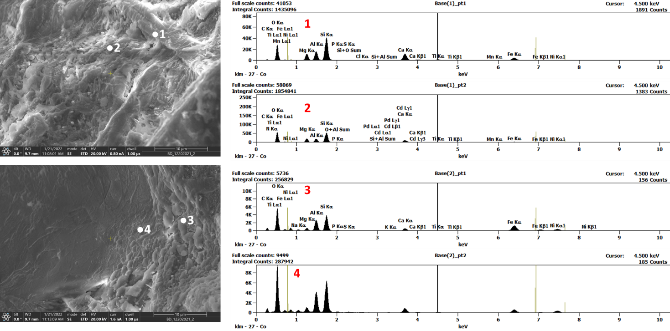
Figure S3. Representative SEM-EDX for unreacted Basalt #2
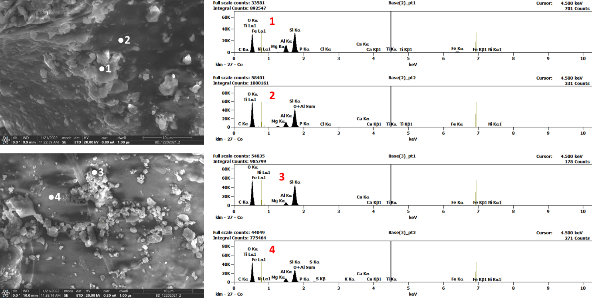
Figure S4. Representative SEM-EDX for reacted Basalt #2

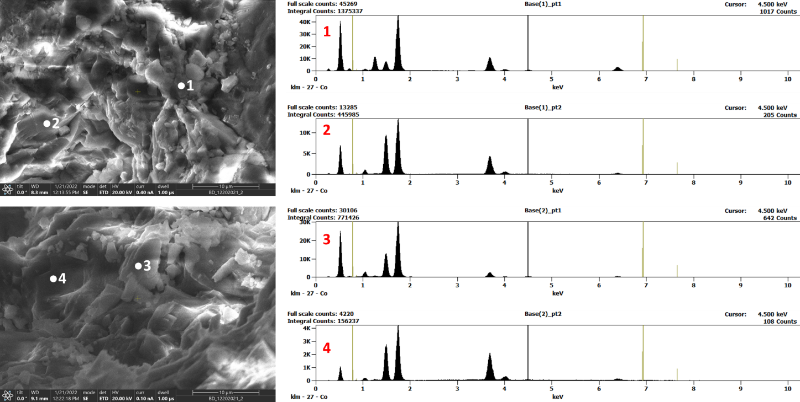
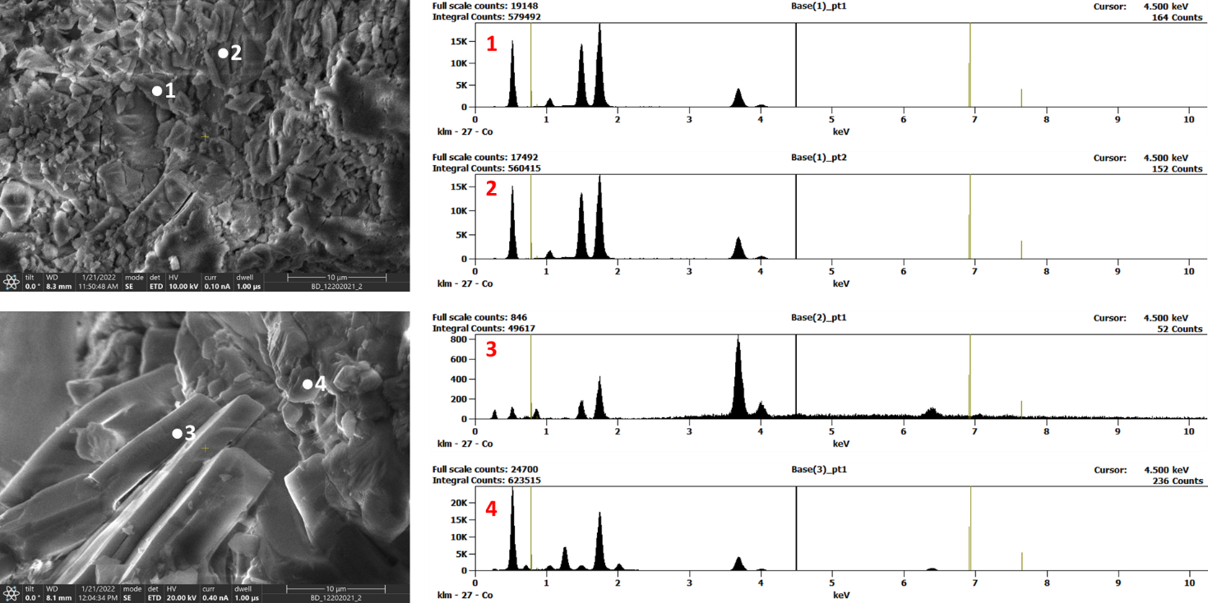
Figure S5. Representative SEM-EDX for reacted Basalt #3
Figure S6. Representative SEM-EDX for unreacted Basalt #3

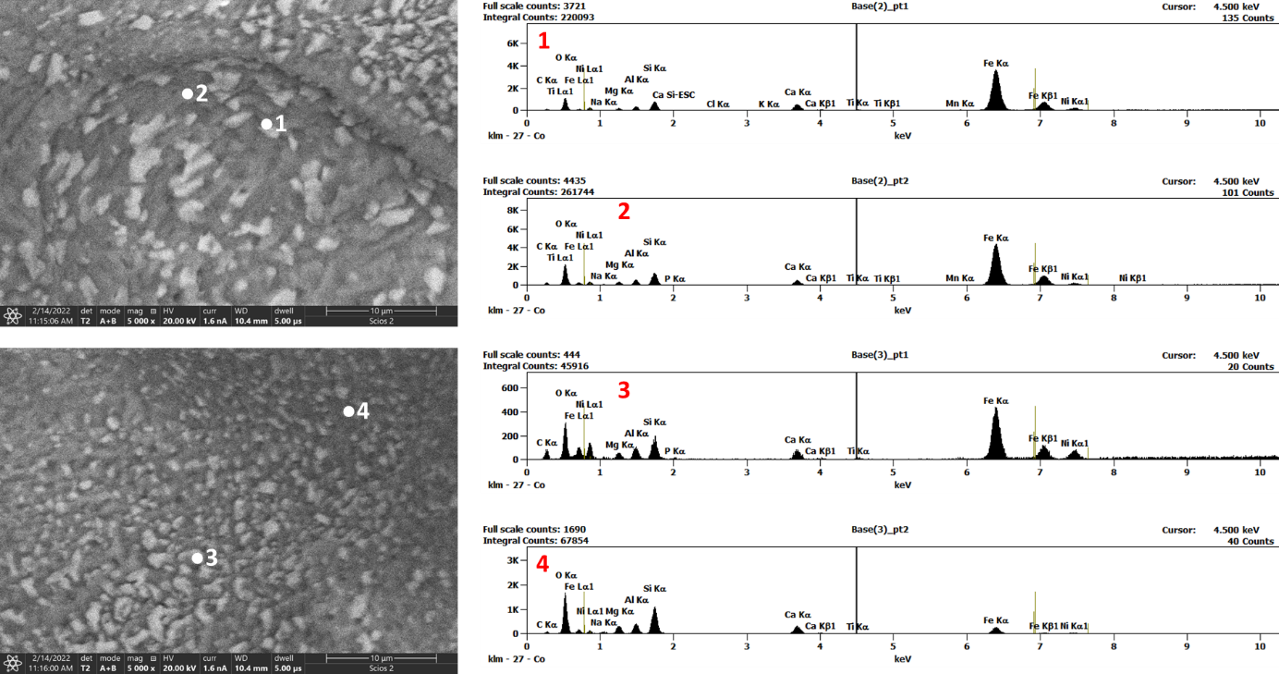
Figure S7. Representative SEM-EDX for unreacted Basalt #4
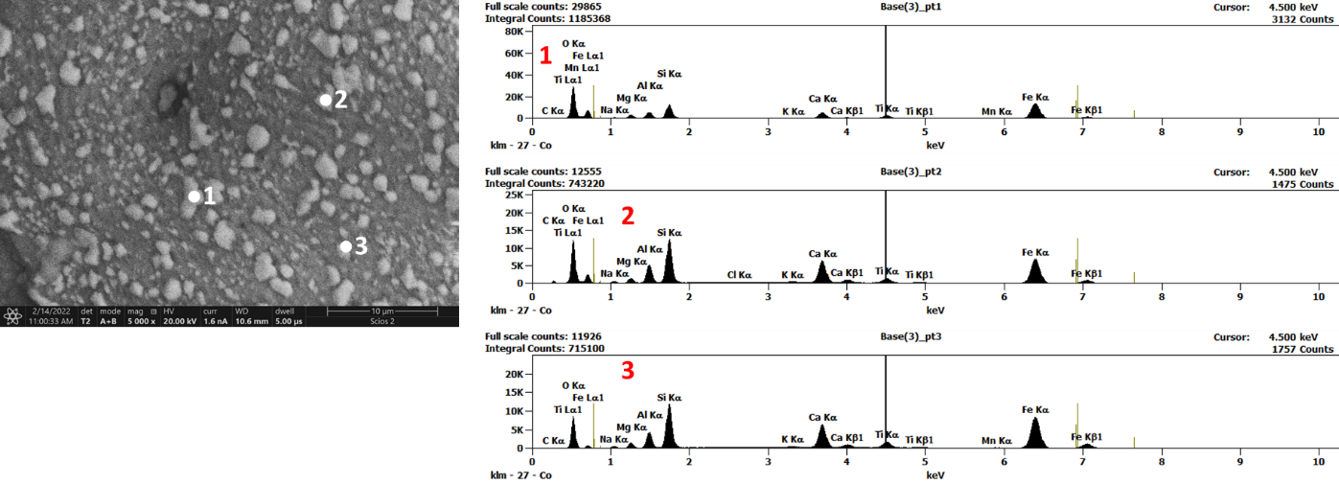
Figure S8. Representative SEM-EDX for reacted Basalt #4

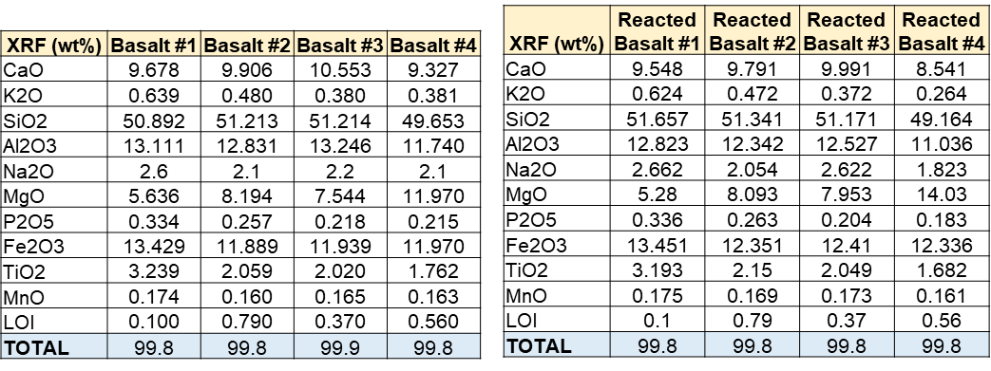
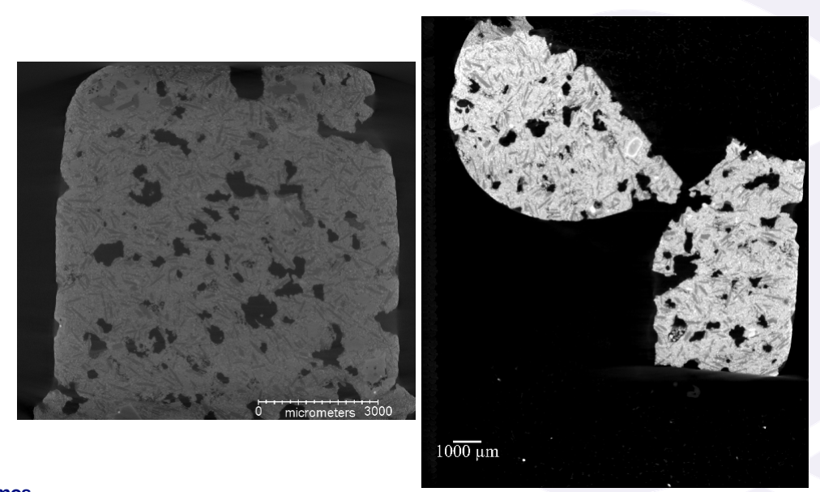
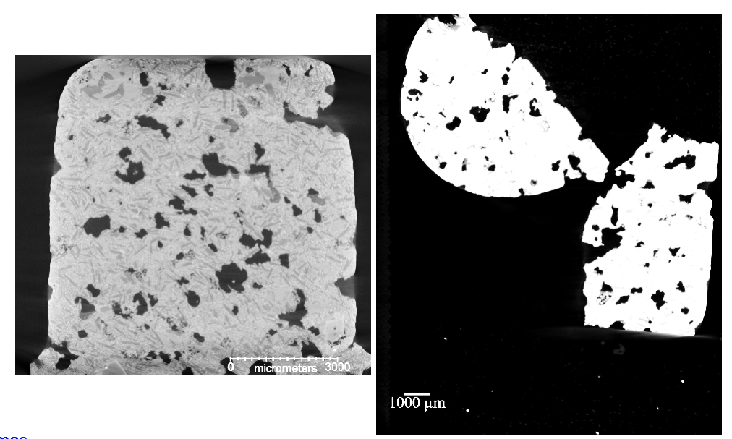
Table S1. Pre- and post-reaction XRF measurement of bulk elemental composition.
Figure S9. micro-XCT images of Basalt #3, which broke during handling. Consequently, it was not possible to get an accurate measurement of porosity and pore size distribution changes for this sample.
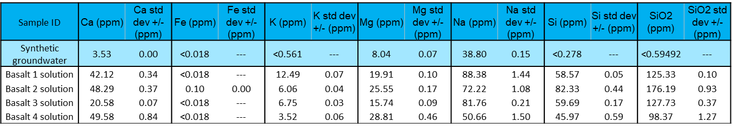
Table S2. ICP-OES measurement of reacted solution and initial synthetic groundwater.

