Geochemistry, sources, human health and ecological risk of trace elements in soil from the Mirsarai export processing zone, southeastern coast of Bangladesh
Md. Shazzadur Rahman ^{a,b,c,*}, Md. Ripaj Uddin ^{d,*}, Mohammad Moniruzzaman ^{e}, Md. Golam Mostafa ^{a,c}, Lutfa Ara Takeya ª, Md. Aminur Rahman ^{c}, Md. Nakib Hossen ^{c}, Md. Ashikuzzaman ^{f}, Ashiqul Amin Abid ^{g}
ª Department of Geology and Mining, University of Rajshahi, Rajshahi-6205, Bangladesh
^{b} Institute of Environmental Sciences, University of Rajshahi, Rajshahi-6205, Bangladesh
^{c}Institute of Mining, Mineralogy and Metallurgy (IMMM), Bangladesh Council of Scientific and Industrial Research (BCSIR), Joypurhat, Bangladesh.
^{d} Institute of National Analytical Research and Service (INARS), Bangladesh Council of Scientific and Industrial Research (BCSIR), Dhanmondi, Dhaka 1205, Bangladesh
^{e} Central Analytical and Research Facilities (CARF), BCSIR, Dhaka-1205
^{f} Department of Environmental Science, Bangladesh Agriculture University, Mymensingh 2202, Bangladesh
^{g} Department of Chemistry, University of Dhaka, Dhaka-1000, Bangladesh
*Corresponding author email address: shazzad_geol@yahoo.com (Md. Shazzadur Rahman); md.ripajuddin@gmail.com (Md. Ripaj Uddin)

Supplementary information
Table S1. Pollution indices, standard formula, and Ranking scale for sediment.
Index | Formula | Ranking scale | References
Enrichment factor (EF) | EF = $\frac{\left(\frac{Metal}{Fe}\right)sample}{\left(\frac{Metal}{Fe}\right)background}$ | EF < 2: Minimal enrichment  2 ≤ EF < 5: Moderate enrichment  5≤EF < 20: Significant enrichment  20≤EF< 40: Very high enrichment  EF≥40: Extremely high enrichment | Hasan et al., 2024  Taylor, 1964
Geoaccumulation index (Igeo) | Igeo = $\frac{{Log}_{2} (C_{n})}{1.5 (B_{n})}$ | Igeo ≤ 0: Unpolluted  0<Igeo≤1: Unpolluted to moderately polluted  1<Igeo≤2: Moderately polluted  2<Igeo≤3: Moderately to heavily polluted  3<Igeo≤4: Heavily polluted  4<Igeo≤5: Heavily to extremely polluted  Igeo>5: Extremely polluted | Muller, 1969  Loska et al., 2004
Contamination factor (CF) | CF = $\frac{C_{n}}{B_{n}}$ | CF < 1: Low contamination  1≤CF<3: Moderate contamination  3≤CF<6: Considerable contamination  CF ≥ 6: Very high contamination | Hakanson, 1980  Siddique et al., 2020
Pollution load index (PLI) | PLI = (CF1 × CF2 × CF3……× CFn)^{1/n} | PLI 1: Baseline level of pollutants  PLI < 1: No pollution (permissible level)  PLI > 1: Deterioration of site quality | Tomlinson et al., 1980
Nemerow integrated pollution index (NIPI) | NIPI = $\sqrt{\frac{{CF}_{Mean}^{2}+ {CF}_{Maximum}^{2}}{2}}$ | NIPI ≤ 0.7: Clean  0.7 < NIPI ≤ 1: Alert level  1 < NIPI ≤ 2: Slight pollution  2 < NIPI ≤ 3: Moderate pollution  NIPI > 3: Heavy pollution | Nemerow, 1985
Toxic unit | TU_{i} = $\frac{C_{i}}{{PEC}_{i}}$ | TU < 1: Low ecological risk  TU ≥ 1: Potential ecological risk | MacDonald et al., 2000
Ecological risk factor (ERF) | ERF=T_{r}× CF_{i} | Eᵣ < 40: Low ecological risk  40 ≤ Eᵣ < 80: Moderate risk  80 ≤ Eᵣ < 160: Considerable risk  160 ≤ Eᵣ < 320: High risk  Eᵣ ≥ 320: Very high risk | Hakanson, 1980
Potential ecological risk index (PERI) | PERI=∑ERF=∑ (T_{r} × CFi) | PERI < 150: Low ecological risk  150 ≤ PERI < 300: Moderate risk  300 ≤ PERI < 600: Considerable risk  PERI ≥ 600: Very high risk | Hakanson, 1980

Table S2. Exposure parameters and their values were adopted from USEPA
Parameter | Unit | Children | Adults | References
Metal concentration (c) | mg/kg |  |  | USEPA, 1989, 1991, 2004, 2020
Body weight (BW) | kg | 15 | 70 | USEPA, 1989, 1991, 2004, 2020
Exposure time (ET) | h/day | 0.71 | 0.54 | USEPA, 1989, 1991, 2004, 2020
Exposure frequency (EF) | days/year | 350 | 350 | USEPA, 1989, 1991, 2004, 2020
Exposure duration (ED) | years | 6 | 30 | USEPA, 1989, 1991, 2004, 2020
Ingestion rate (IngR) | mg/day | 200 | 100 | USEPA, 1989, 1991, 2004, 2020
Inhalation rate (InhR) | m³/day | 10 | 20 | USEPA, 1989, 1991, 2004, 2020
Skin surface area (SA) | cm² | 2100 | 5800 | USEPA, 1989, 1991, 2004, 2020
Soil adherence factor (AF) | mg/ cm² | 0.2 | 0.07 | USEPA, 1989, 1991, 2004, 2020
Dermal absorption factor (ABS) | — | 0.1 | 0.1 | USEPA, 1989, 1991, 2004, 2020
Particulate emission factor (PEF) | m³/kg | 1.3 × 10⁹ | 1.3 × 10⁹ | USEPA, 1989, 1991, 2004, 2020
Conversion factor (CF) | kg/mg | 10⁻⁶ | 10⁻⁶ | USEPA, 1989, 1991, 2004, 2020
Average time (AT) for carcinogens | days | 365 × 70 | 365 × 70 | USEPA, 1989, 1991, 2004, 2020
Average time (AT) for non-carcinogens | days | 365 × 6 | 365 × 30 | USEPA, 1989, 1991, 2004, 2020

Table S3. Reference dose (RfD), Dermal coefficient (Kp) and Carcinogenic slope factor value for health risk calculation
Metals | Reference does value (RfD) |  |  | Carcinogenic slope factor (CSF) |  |  | Dermal coefficient (Kp)
 | Ingestion | Dermal | Inhalation | Ingestion | Dermal | Inhalation
Fe | 0.7 | 0.35 | - | - | - | - | 0.001
Mn | 0.14 | 0.0041 | 0.00005 | - | - | - | 0.001
Ni | 0.02 | 0.0054 | 0.0001 | 1.7 | 0.84 | 0.91 | 0.0002
Cu | 0.04 | 0.0012 | 0.01 | - | - | - | 0.001
Zn | 0.3 | 0.06 | 0.005 | - | - | - | 0.0006
Cr | 0.003 | 0.0006 | 0.0001 | 0.501 | 2.0 | 0.42 | 0.002
Cd | 0.001 | 0.0025 | 0.00001 | 0.38 | 6.3 | 6.3 | 0.001
Pb | 0.0035 | 0.000525 | - | 0.0085 | 0.042 | 0.0000085 | 0.0001
As | 0.0003 | 0.000123 | - | 1.5 | 1.5 | 0.0043 | 0.001
Se | 0.005 | 0.0015 | - | - | - | - | 0.001
Hg | 0.0003 | 0.000021 | - | - | - | - | 0.001
Co | 0.02 | 0.0049 | 0.000143 | - | - | - | 0.0004
[USEPA, 2009, 2010, 2017]
Table S4. Principal component analysis of trace element in soil from Mirsarai EPZ, Chittagong, Bangladesh
Trace elements | Sediment
Principal component | PC1 | PC2 | PC3
As | 0.25064 | -0.38745 | -0.25744
Se | 0.07715 | 0.57783 | -0.09148
Pb | 0.34981 | 0.02394 | 0.16828
Cd | -0.02873 | -0.29778 | 0.8094
Co | 0.35315 | 0.14775 | 0.04293
Cr | 0.33038 | 0.05398 | -0.23562
Cu | 0.34797 | -0.11172 | 9.90E-04
Mn | 0.33707 | -0.132 | 0.0731
Ni | 0.33279 | 0.25212 | 0.0026
Zn | 0.33743 | 0.08392 | 0.18191
Hg | -0.03522 | 0.53298 | 0.3752
Fe | 0.33707 | -0.132 | 0.0731
Eigenvalue | 7.50722 | 2.10569 | 1.14127
Total variance % | 62.56% | 17.55% | 9.51%
Cumulative % of variance | 62.56% | 80.11% | 89.62%

Figure S1. Biplot of principal component (a) and K-means cluster (b) of studied sediment in Mirsarai EPZ, Bangladesh
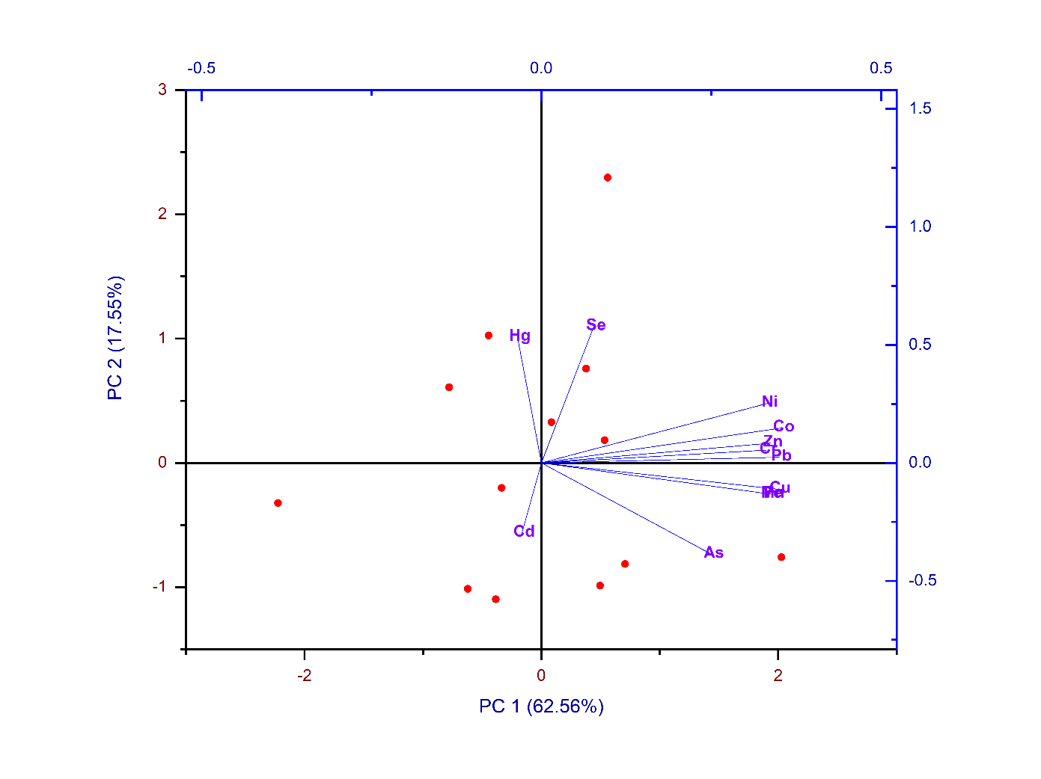
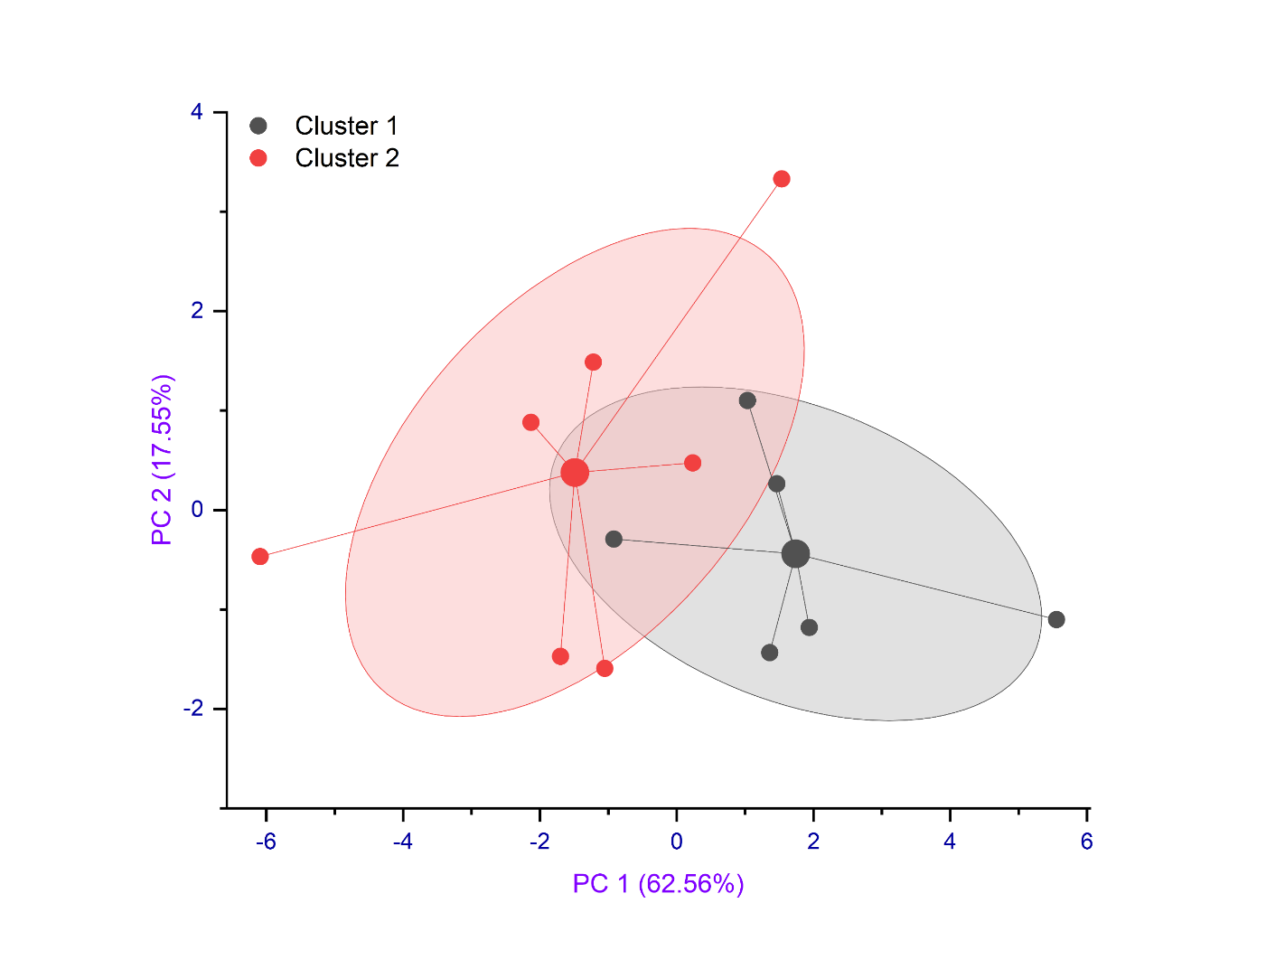
(a)
(b)

Figure S2. The Monte Carlo simulation generates probabilistic distributions for soil in both children and adults, specifically assessing carcinogenic risks. These risks are evaluated separately for: (a) child and (b) adults
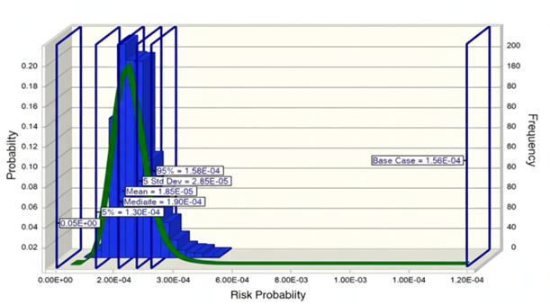
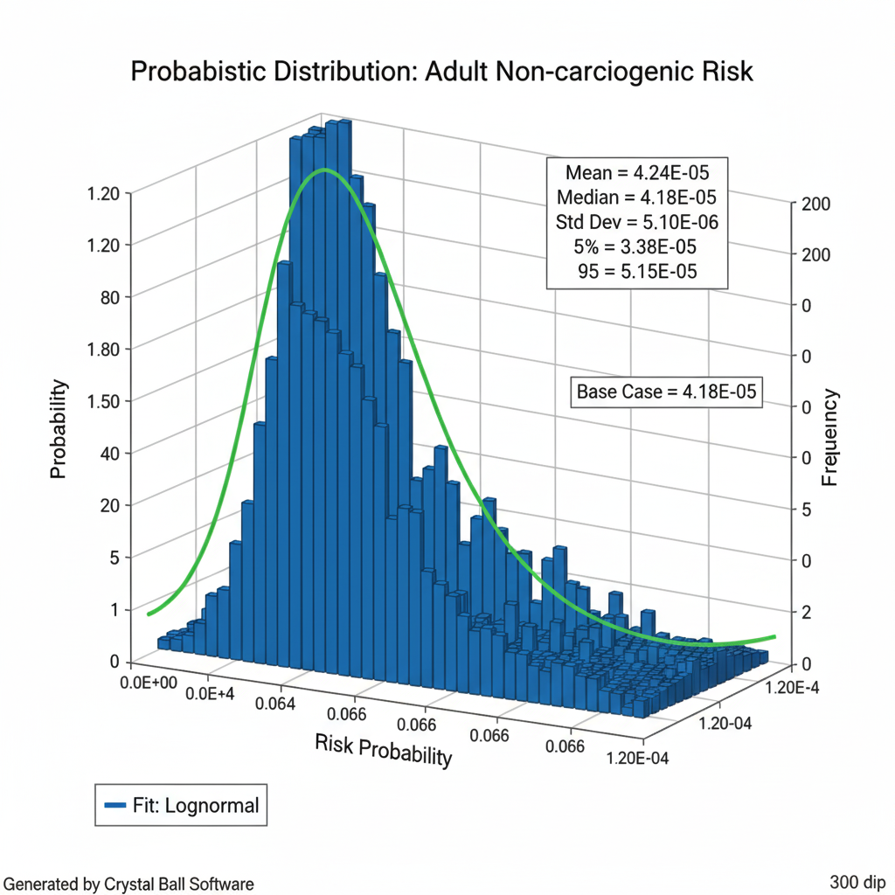
(a)
(b)

References
Hakanson, L., 1980. An ecological risk index for aquatic pollution control.a sedimentological approach. Water Res 14, 975–1001. https://doi.org/10.1016/ 0043-1354(80)90143-8.
Hasan, A.B., Reza, A.S., Siddique, M.A.B., Akbor, M.A., Nahar, A., Hasan, M., Uddin, M.R., Zaman, M.N. and Islam, I., 2024. Origin, spatial distribution, sediment contamination, ecological and health risk evaluation of trace metals in sediments of ship breaking area of Bangladesh. Journal of Hazardous Materials, 465, p.133214.
Horton, R.K., 1965. An index number system for rating water quality. J Water Pollut Control Fed, 37(3), pp.300-306.
Linjin, L., Baohui, M. and Rui, P., 2021. Water quality evaluation of Wenyu River based on single factor evaluation and comprehensive pollution index method. Nature Environment and Pollution Technology, 20(3), pp.1041-1046.
Loska, K., Wiechuła, D., Korus, I., 2004. Metal contamination of farming soils affected by industry. Environ Int 30, 159–165. https://doi.org/10.1016/S0160- 4120(03)00157-0.
MacDonald, D.D., Ingersoll, C.G., Berger, T.A., 2000. Development and evaluation of consensus-based sediment quality guidelines for freshwater ecosystems. Arch Environ Contam Toxicol 39, 20–31.
Mohan, S.V., Nithila, P. and Reddy, S.J., 1996. Estimation of heavy metals in drinking water and development of heavy metal pollution index. Journal of Environmental Science & Health Part A, 31(2), pp.283-289.
Muller, G., 1969. Index of geoaccumulation in sediments of the Rhine River. Geo J 2, 108–118
Nemerow, N.L., 1985. Stream, Lake, Estuary, and Ocean Pollution. Van Nostrand Reinhold Publishing, New York, NY, USA.
Prasanna, M.V., Praveena, S.M., Chidambaram, S., Nagarajan, R. and Elayaraja, A., 2012. Evaluation of water quality pollution indices for heavy metal contamination monitoring: a case study from Curtin Lake, Miri City, East Malaysia. Environmental Earth Sciences, 67(7), pp.1987-2001.
Saha, P. and Paul, B., 2019. Assessment of heavy metal toxicity related with human health risk in the surface water of an industrialized area by a novel technique. Human and ecological risk assessment: an international journal.
Siddique, M.A.B., Alam, M.K., Islam, S., Diganta, M.T.M., Akbor, M.A., Bithi, U. H., et al., 2020. Apportionment of some chemical elements in soils around the coal mining area in northern Bangladesh and associated health risk assessment. Environ Nanotechnol, Monit Manag 14, 100366. https://doi.org/10.1016/j. enmm.2020.100366
Taylor, S.R., 1964. Abundance of chemical elements in the continental crust: a new table. GeochimCosmochimActa 28(8):1273–1285
Tomlinson, D.L., Wilson, J.G., Harris, C.R., Jeffrey, D.W., 1980. Problems in the assessment of heavy-metal levels in estuaries and the formation of a pollution index. Helgol¨ander Meeresunters 33, 566–575.
USEPA, 1989. Risk assessment guidance for Superfund. Volume I: Human health evaluation manual (Part A). Interim Final. Office of Emergency and Remedial Response. EPA/540/1-89/002. 1989.
USEPA, 1991. Human health evaluation manual, supplemental guidance: "Standard default exposure factors ". OSWER Directive 9285.6-03.
USEPA, 2004. Risk Assessment Guidance for Superfund Volume I: Human Health Evaluation Manual (Part E, Supplemental Guidance for Dermal Risk Assessment) Final. OSWER 9285.7-02EP. 2004. July 2004.
USEPA, 2009. Risk-based Concentration Table. United States Environmental Protection Agency, Washington D.C., USA, Philadelphia PA.
USEPA, 2010. Integrated risk information system (IRIS). United States Environmental Protection Agency, Washington D.C., USA.
USEPA, 2017. Integrated Risk Information System National Center for Environmental Assessment Office of Research and Development U.S.; Environmental Protection Agency: Washington, DC, USA.
USEPA, 2020. Exposure Assessment Tools by Media - Water and Sediment. https://www.epa.gov/expobox/exposure-assessment-tools-media-water-andsediment, 2020. Accessed date: 08 January 2020.
USEPA 2022. Basic Information about the Integrated Risk Information System (IRIS). EPA IRIS

