S1. Cyclone Hazard Map Preparation
From the review of Flood Action Plan 19 (FAP 19), it is found that during the storm surge period, the flooding depth decays linearly towards the inland. It is also observed that the inundated area mainly depends on wave height. As height increases, the inundated area will also increase.
Table 1 - Relation between Wave Height and Inundated Area at Coastline of Bangladesh
Wave Height at Coastline  (meters) | The area with Constant Surge  Depth  (distance from the coastline  in meters) | Total Inundated Area  (distance from the coast in  meters)
3.7 | 415 | 2000
4.1 | 520 | 2900
4.7 | 580 | 3900
5.1 | 670 | 4200
5.6 | 760 | 4400
6.0 | 880 | 4700
6.5 | 1000 | 5000
To develop the cyclone hazard map, the Surge Decay Coefficient (SDC) was first calculated. This coefficient represents the reduction of storm surge height as water moves inland. The decrease in surge height mainly occurs because of surface friction created by terrain characteristics and land use patterns. Therefore, SDC was used to quantify the inland decay of surge water.
The SDC for each return period was calculated using the following equation:
$${SDC}_{RP}=\frac{Wave height at coastline-Average elevation of terrian at end of surge}{Width total inundated area-Width area with constant surge}$$ | (1)
where ${SDC}_{RP}$ is the surge decay coefficient for a specific return period, including 10-, 25-, and 50-year events. The calculated SDC values were then incorporated into the surge modelling process to generate the final cyclone hazard maps..
The procedure for cyclone hazard mapping was carried out in two main stages.

Step 1: Preparation of the Surge Extent Area
First, a distance map was created from the coastline up to at least 5000 m inland for the initial surge height of 6.5 m. This distance range was selected to represent the potential inland reach of the storm surge. After preparing the distance surface, the corresponding area was clipped from the raster image, and the sea portion was removed so that only the land area affected by possible inundation remained for further analysis.
Step 2: Surge Decay and Inundation Depth Estimation
In the second stage, the inland surge behavior was modelled in two parts. A constant surge zone was first created from the coastline to 1000 m inland, assuming that no surge decay occurs within this initial section. Then, from 1000 m to 5000 m inland, a second map was generated to represent the linear decrease in surge height according to the calculated SDC value.
Next, the decay surface was subtracted from the constant surge depth surface to obtain the adjusted inland surge height. This adjusted surge surface was then subtracted from the DEM to estimate the flood inundation depth caused by storm surge. The resulting inundation depth raster was used to classify hazard levels and prepare the final cyclone hazard map.
This approach was applied not only for the 6.5 m surge height but can also be used for other surge heights under different return period scenarios.

S2. Flow Chart to Prepare Flood Inundation Depth Map
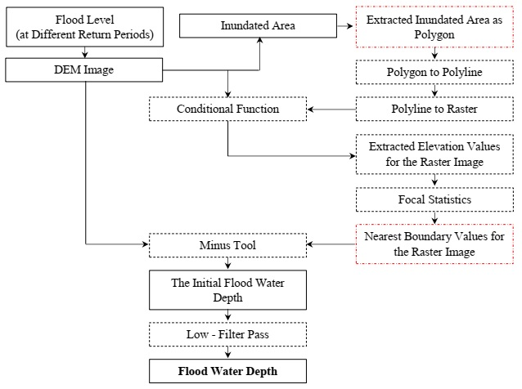

S3: Flowchart for Geomorphological map Preparation
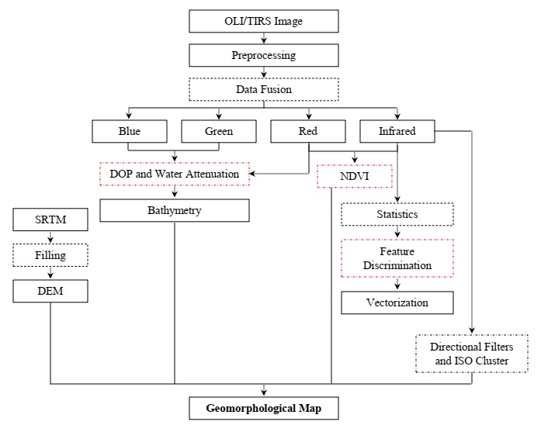

S4. Flowchart to Delineate Shoreline Change
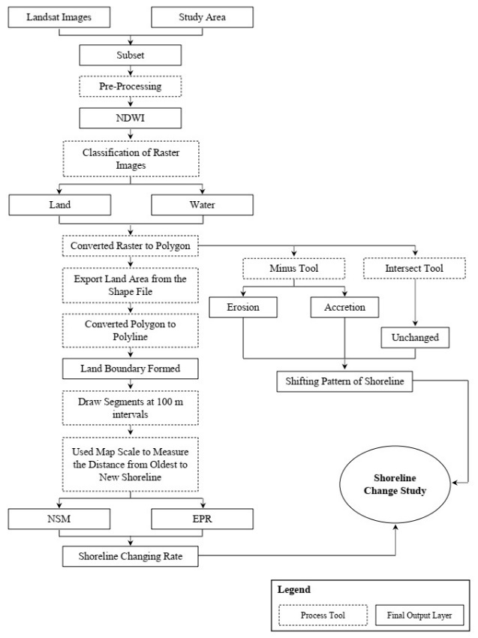

S5. Flowchart to Develop the Map based on Sea Level Change
