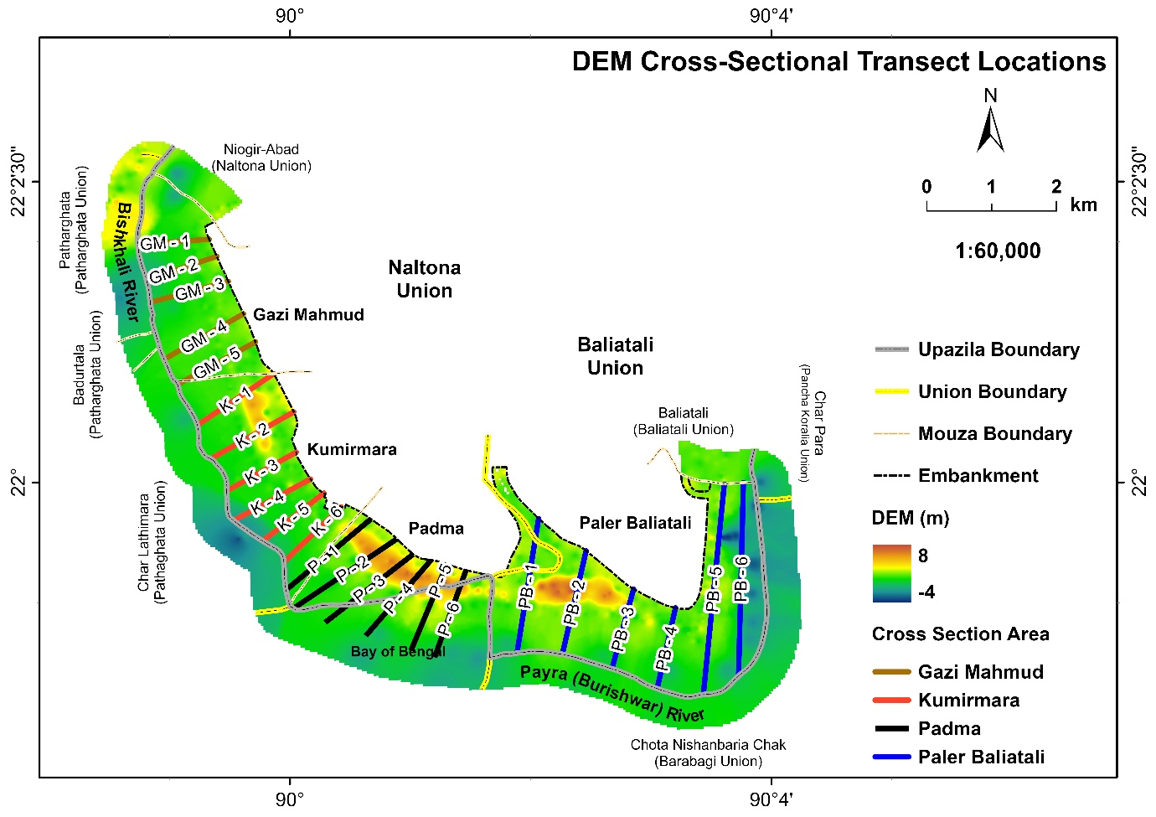
Figure S1: Location of the 23 DEM-derived cross-sectional profiles across the study area, overlaid on the 30 m SRTM digital elevation model. Transects are grouped by location: Gazi Mahmud (GM-1 to GM-5), Kumirmara (K-1 to K-6), Padma (P-1 to P-6), and Paler Baliatali (PB-1 to PB-6), spanning the outside-embankment areas bordered by the Bishkhali River to the west and the Payra (Burishwar) River to the east.
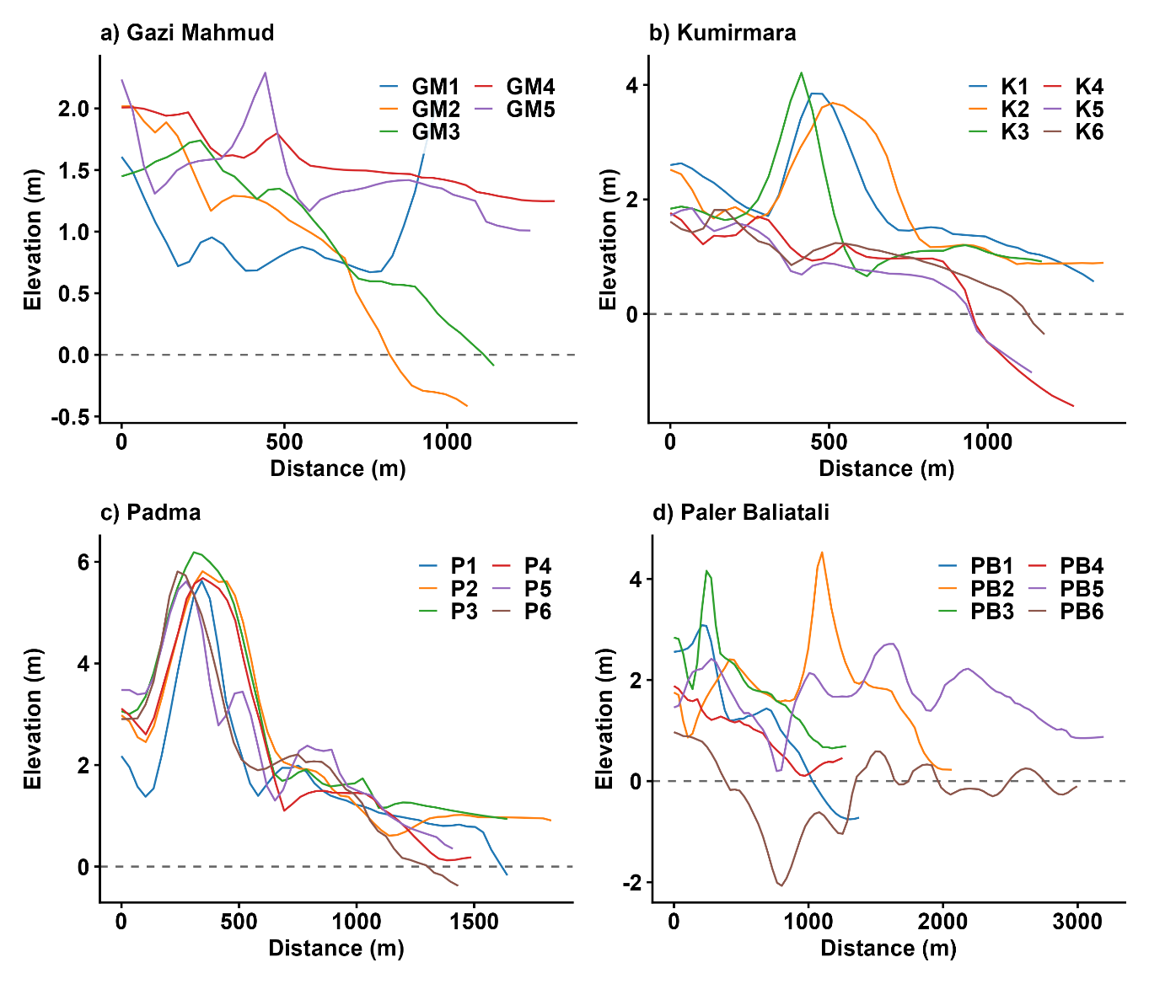
Figure S2: DEM-derived cross-sectional topographic profiles across the four study locations: (a) Gazi Mahmud (GM1–GM5), (b) Kumirmara (K1–K6), (c) Padma (P1–P6), and (d) Paler Baliatali (PB1–PB6). Each line represents elevation (m) plotted against distance (m) along an individual transect, extracted from the 30 m SRTM DEM. The dashed horizontal line marks 0 m elevation (approximate mean sea level).
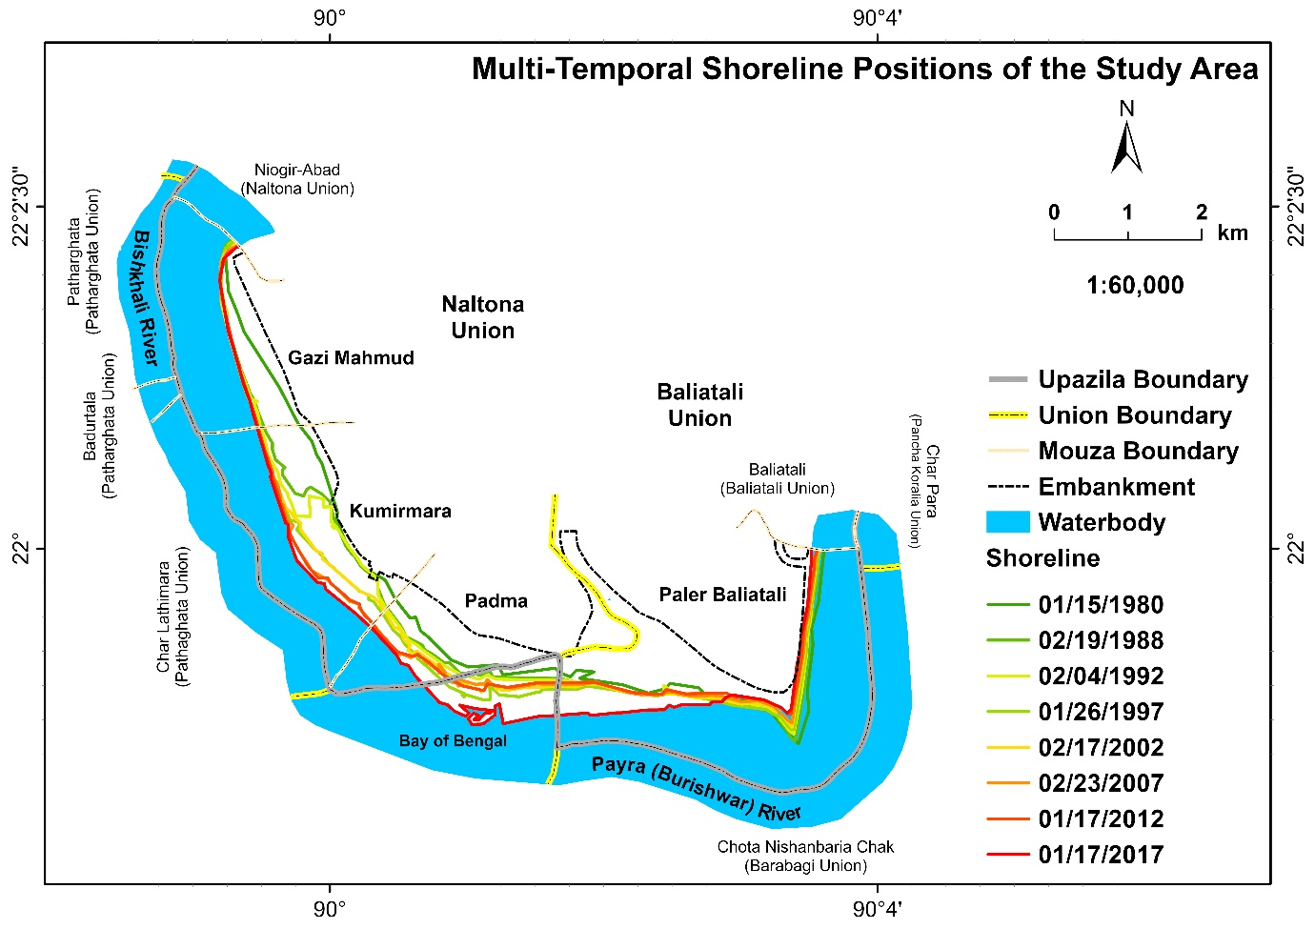
Figure S3: Multi-temporal shoreline positions across the study area digitized from eight Landsat scenes (1980, 1988, 1992, 1997, 2002, 2007, 2012, and 2017.
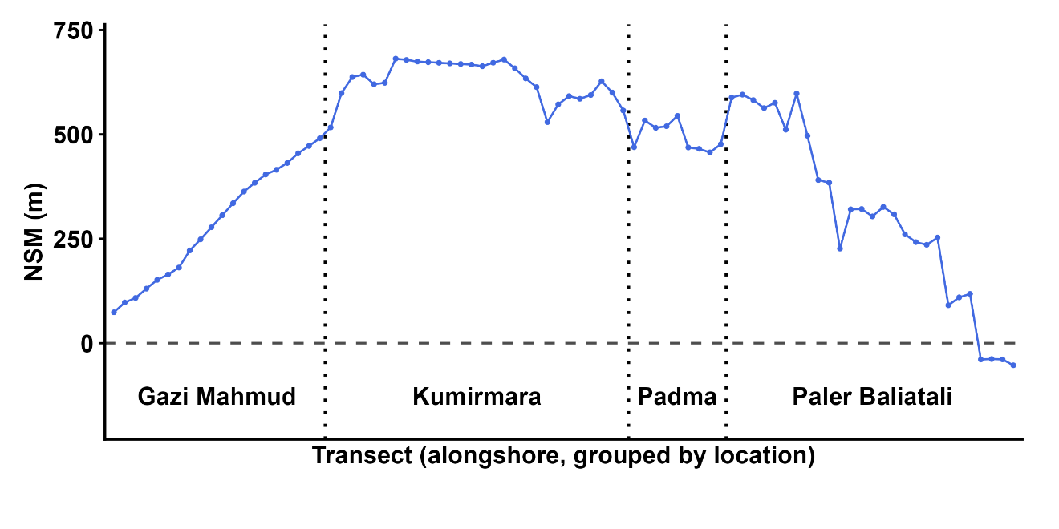
Figure S4: Net Shoreline Movement (NSM, m) along transects grouped by location (Gazi Mahmud, Kumirmara, Padma, and Paler Baliatali

