Supplementary Information

ESM_1. Non-significant trends of ETCCDI indices over the Northwest Himalaya for IMD and HAR v2 for the period 1981-2020, Spatial VIMT plots for ERA 5.
This supplementary material presents the statistically non-significant trends if ETCCDI indices over the NWH sub-regions (JK, HP, UK) for both IMD and HAR v2 datasets. It also contains the spatial plots of ERA5 derived VIMT for the study period, and also the ENSO phases. These figures compliment the main manuscript and maintain completeness of the study.

Supplementary Figures

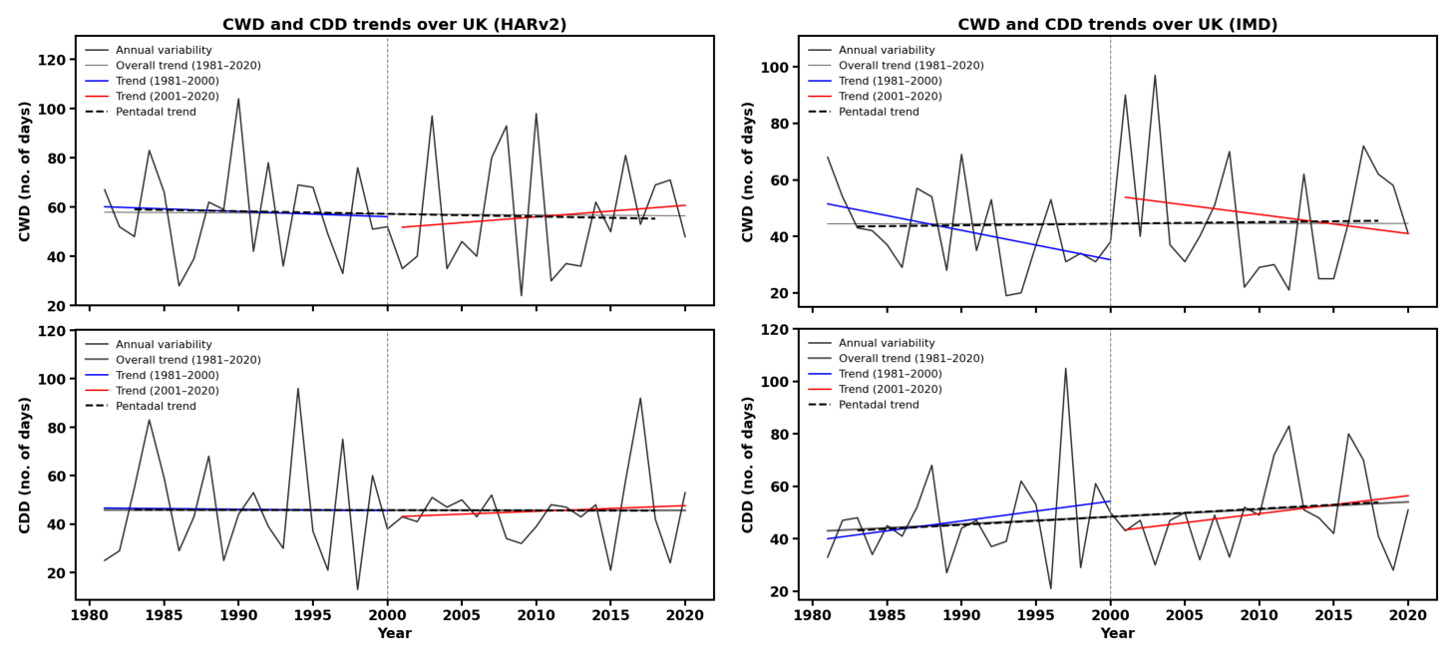
Fig. S1 Temporal variability and trends of CWD (top) and CDD (bottom) over UK from HARv2 (left) and IMD (right) during 1981–2020. Grey lines show annual variability and the overall linear trend; blue and red lines show bifurcated trends for 1981–2000 and 2001–2020, respectively. Black dashed lines represent pentadal mean trends, and the vertical dashed line marks the sub-period division.

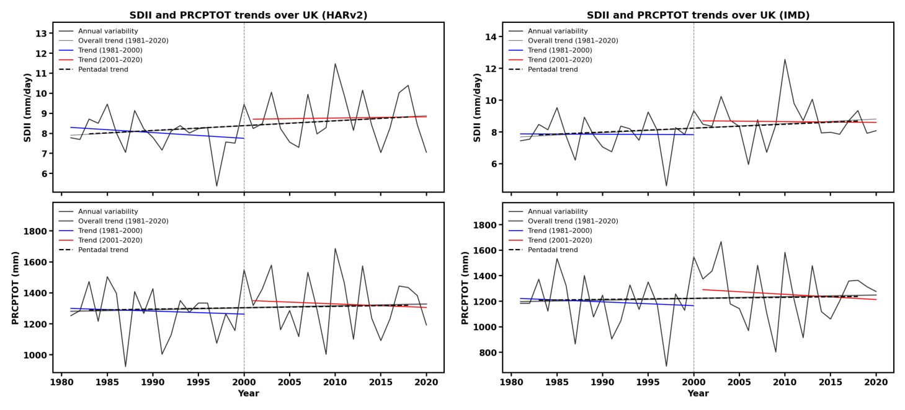
Fig. S2 Temporal variability and trends of SDII (top) and PRCPTOT (bottom) over UK from HARv2 (left) and IMD (right) during 1981–2020. Grey lines show annual variability and the overall linear trend; blue and red lines show bifurcated trends for 1981–2000 and 2001–2020, respectively. Black dashed lines represent pentadal mean trends, and the vertical dashed line marks the sub-period division.

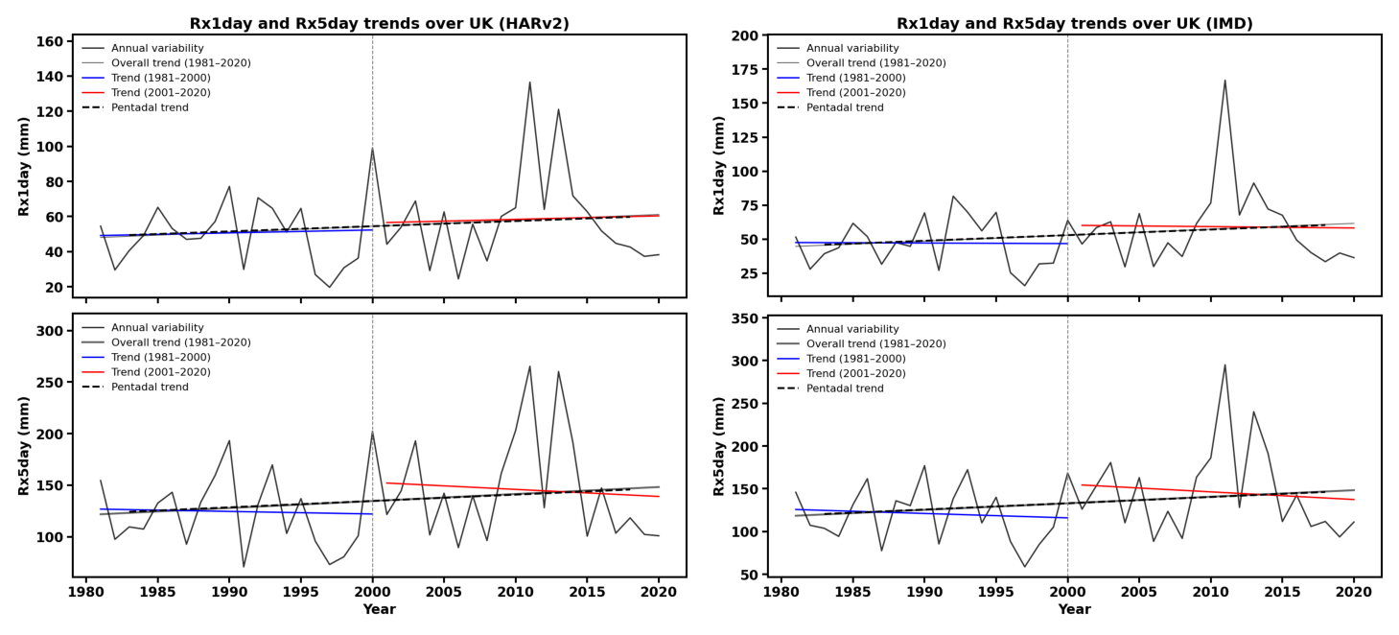
Fig. S3 Temporal variability and trends of Rx1day (top) and Rx5day (bottom) over UK from HARv2 (left) and IMD (right) during 1981–2020. Grey lines show annual variability and the overall linear trend; blue and red lines show bifurcated trends for 1981–2000 and 2001–2020, respectively. Black dashed lines represent pentadal mean trends, and the vertical dashed line marks the sub-period division.

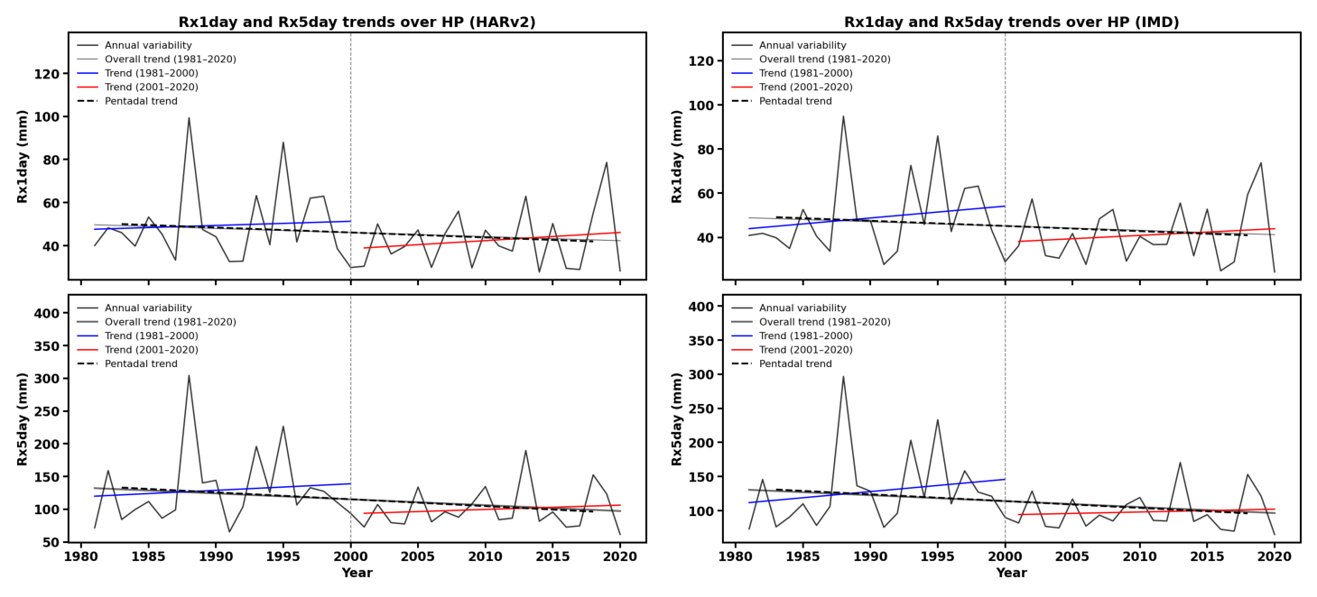
Fig. S4 Temporal variability and trends of Rx1day (top) and Rx5day (bottom) over HP from HARv2 (left) and IMD (right) during 1981–2020. Grey lines show annual variability and the overall linear trend; blue and red lines show bifurcated trends for 1981–2000 and 2001–2020, respectively. Black dashed lines represent pentadal mean trends, and the vertical dashed line marks the sub-period division.
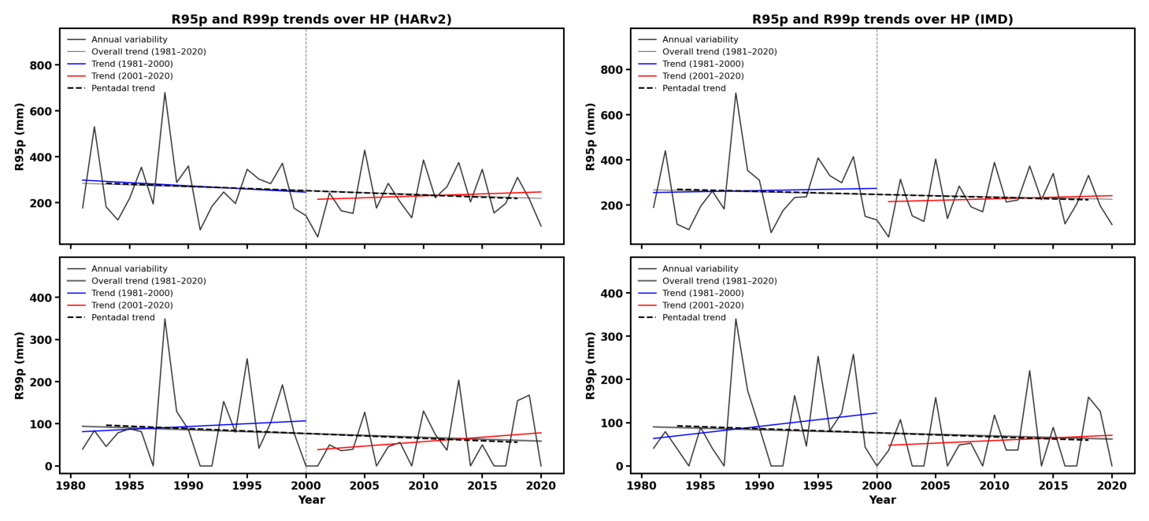
Fig. S5 Temporal variability and trends of R95p (top) and R99p (bottom) over HP from HARv2 (left) and IMD (right) during 1981–2020. Grey lines show annual variability and the overall linear trend; blue and red lines show bifurcated trends for 1981–2000 and 2001–2020, respectively. Black dashed lines represent pentadal mean trends, and the vertical dashed line marks the sub-period division.
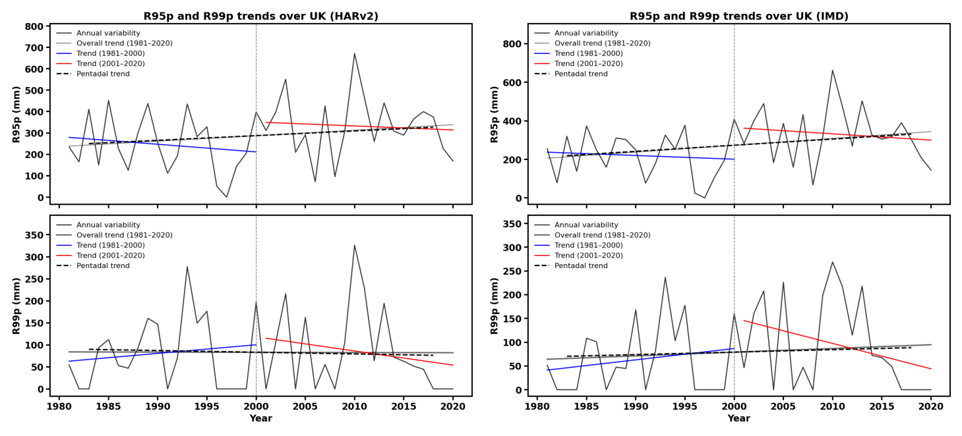
Fig. S6 Temporal variability and trends of R95p (top) and R99p (bottom) over UK from HARv2 (left) and IMD (right) during 1981–2020. Grey lines show annual variability and the overall linear trend; blue and red lines show bifurcated trends for 1981–2000 and 2001–2020, respectively. Black dashed lines represent pentadal mean trends, and the vertical dashed line marks the sub-period division.
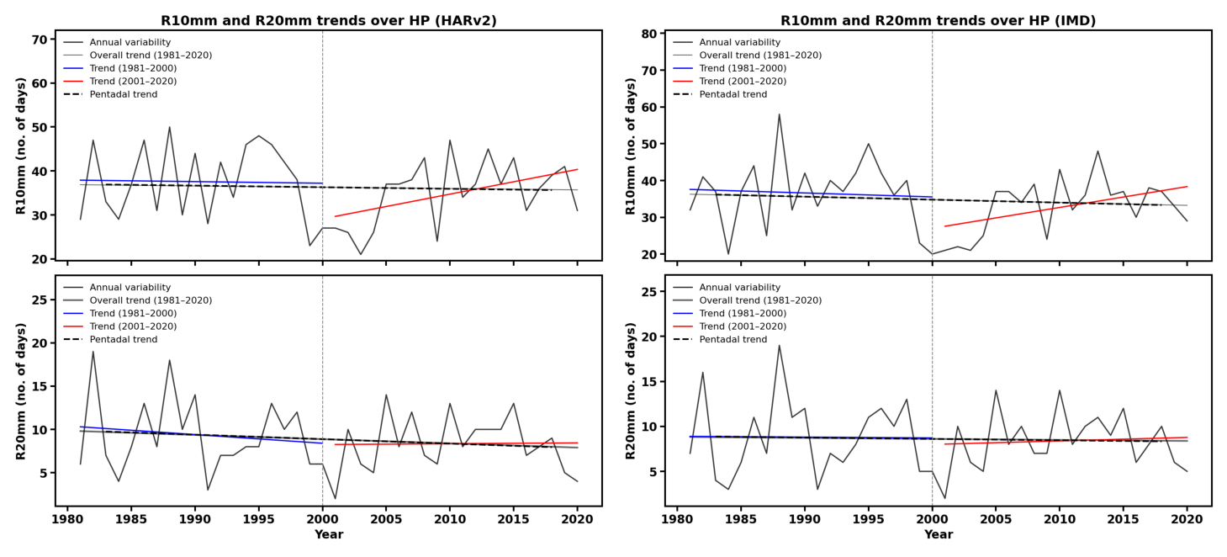
Fig. S7 Temporal variability and trends of R10mm (top) and R20mm (bottom) over HP from HARv2 (left) and IMD (right) during 1981–2020. Grey lines show annual variability and the overall linear trend; blue and red lines show bifurcated trends for 1981–2000 and 2001–2020, respectively. Black dashed lines represent pentadal mean trends, and the vertical dashed line marks the sub-period division.
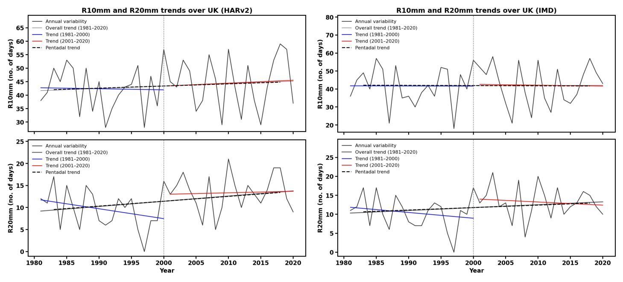
Fig. S8 Temporal variability and trends of R10mm (top) and R20mm (bottom) over HP from HARv2 (left) and IMD (right) during 1981–2020. Grey lines show annual variability and the overall linear trend; blue and red lines show bifurcated trends for 1981–2000 and 2001–2020, respectively. Black dashed lines represent pentadal mean trends, and the vertical dashed line marks the sub-period division.
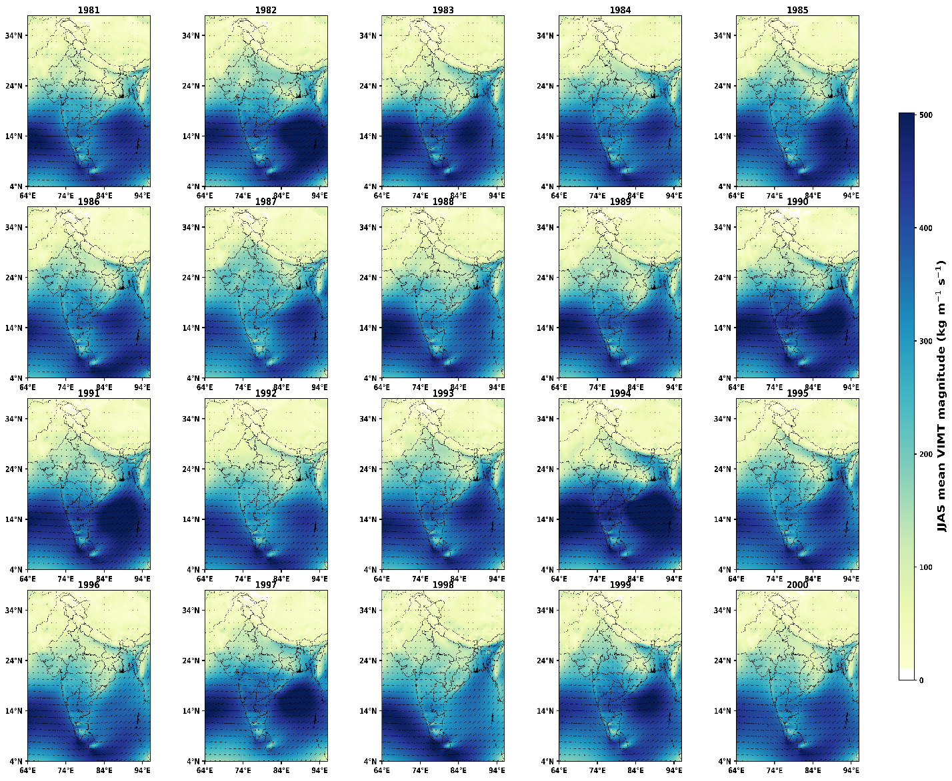
Fig. S9 Mean JJAS Vertically integrated moisture transport (VIMT: kg/ms 300-1000 hPa for 1981-2000.

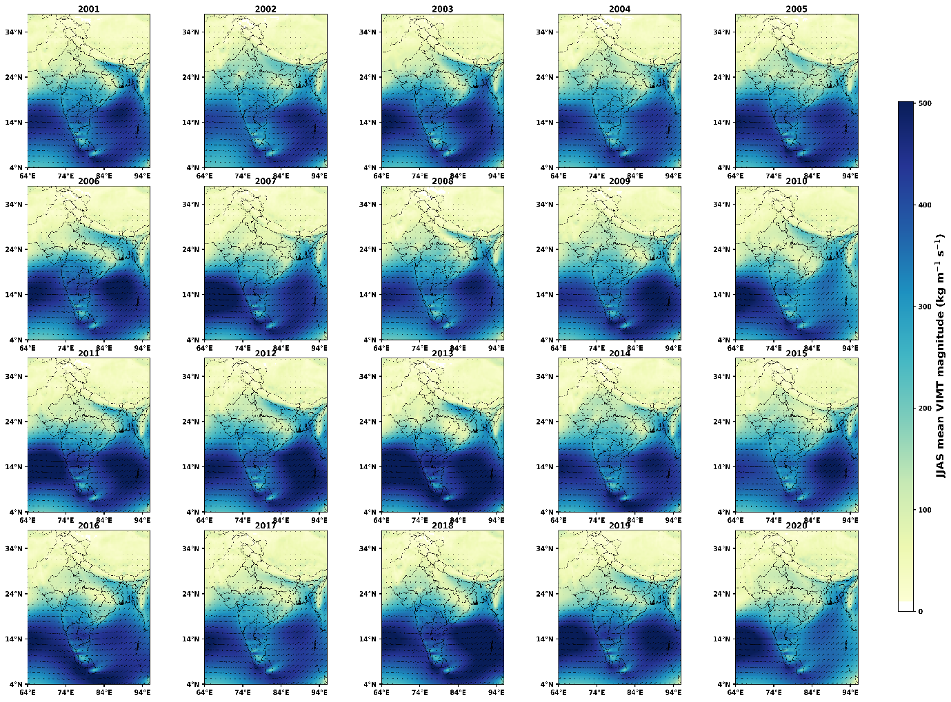

Fig. S10 Mean JJAS Vertically integrated moisture transport (VIMT: kg/ms 300-1000 hPa for 2001-2020
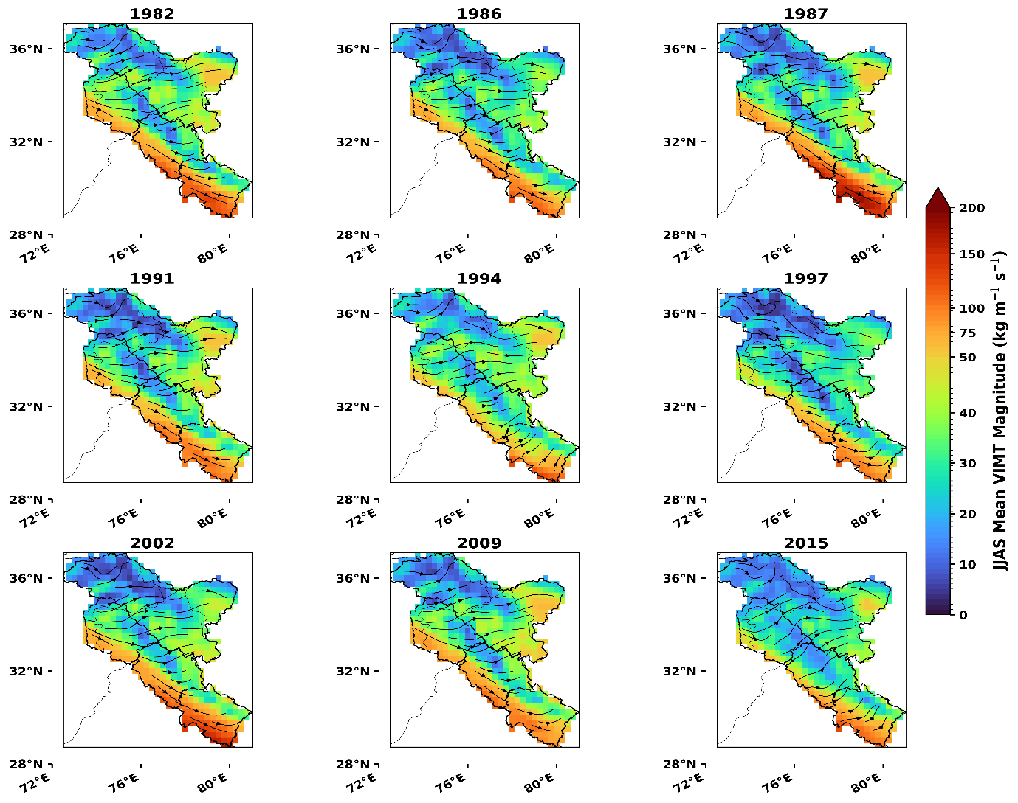
Fig. S11 Mean JJAS Vertically integrated moisture transport (VIMT: kg/ms 300-1000 hPa) for El-Nino years

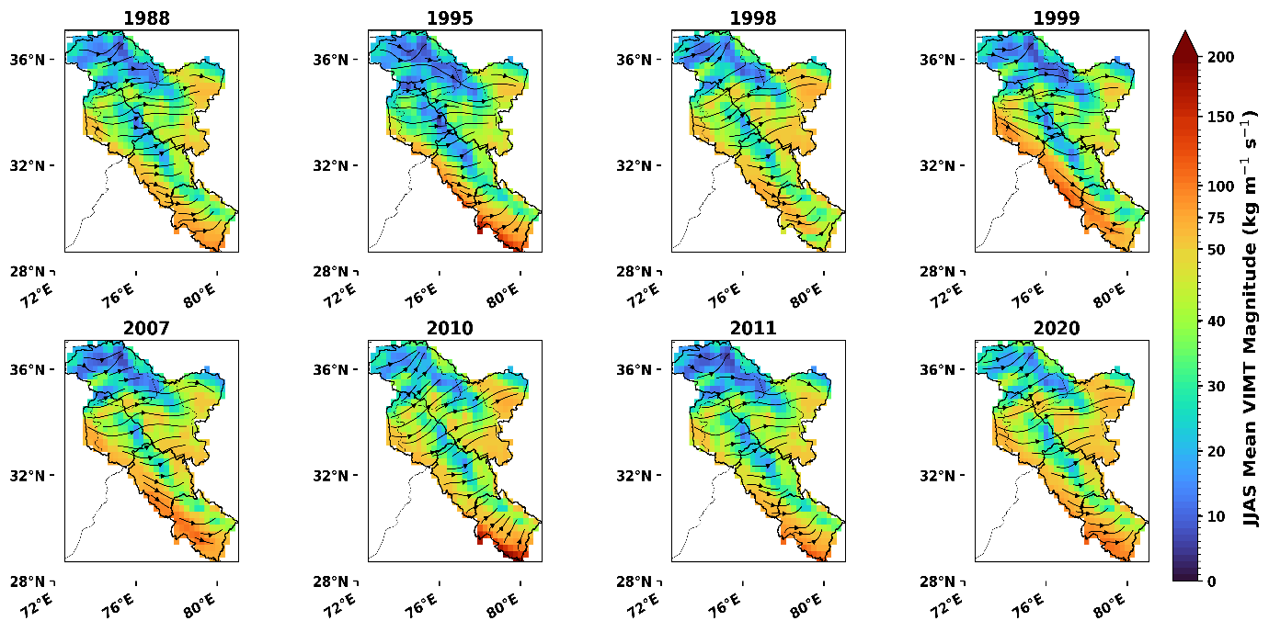
Fig. S12 Mean JJAS Vertically integrated moisture transport (VIMT: kg/ms 300-1000 hPa) for La-Nina years
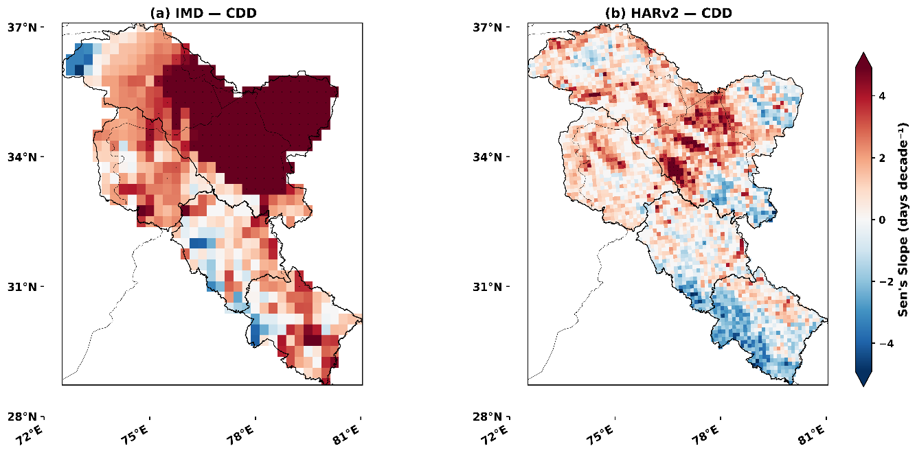
Fig. S13 Spatial distribution of long-term trends in CDD ( days decade⁻¹) over the Northwest Himalayas during 1981–2020, estimated using Sen’s slope for (a) IMD observations and (b) HARv2 data. Positive trends (red shades) indicate increasing dry spell duration, while negative trends (blue shades) indicate decreasing dry spell duration.

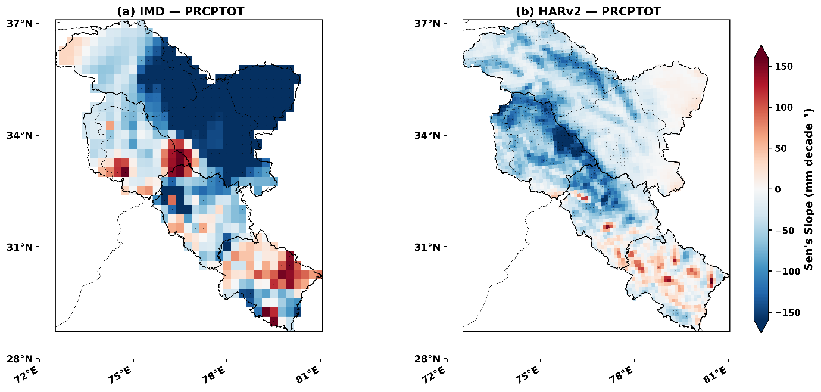

Fig. S14 Spatial distribution of long-term trends in PRCPTOT (days decade⁻¹) over the Northwest Himalayas during 1981–2020, estimated using Sen’s slope for (a) IMD observations and (b) HARv2 data. Positive trends (red shades) indicate increasing annual precipitation totals, while negative trends (blue shades) indicate decreasing totals.

