Supplementary Material

Unfolding the Interaction of Radioactive Cs and Sr with Polyethylene-derived Microplastics in Marine Environment
Sonali Yadav^{#,a,b}, Sabyasachi Rout*^{#,a,b}, Vikram Joshiª Vandana Pulhaniª, A.V. Kumarª
ªEnvironmental Monitoring and Assessment Division, Bhabha Atomic Research Centre, Mumbai, India-400085
^{b}Homi Bhabha National University, Mumbai, India-400094
(*E-mail:srout@barc.gov.in)
# Dual-first authors

Table (S1): Physicochemical characteristics of the host seawater
Parameter | Value
pH | 8.23
Eh | +435mV
Concentration in mg/L (RSD)
Na⁺ | 2.24E+4 (2.0%)
K⁺ | 1.11E+3 (2.5%)
Mg²⁺ | 1.42E+4.2 (0.97%)
Ca²⁺ | 745. 9 (1.88%)
Cl⁻ | 2.15E+4 (2.55%)
SO₄²⁻ | 4.25E+3 (1.45%)
NO₃⁻ | 0.248 (2.53%)
PO₄³⁻ | 0.15 (1.22%)
CO₃²⁻ | 25.2 (1.71%)
HCO₃⁻ | 3.82E+2 (2.5%)

Table (S2): Multi correlation analyis data
 | ⁸⁵Sr_K_{d} (Filtered) |  | ¹³⁷Cs_K_{d} (Filtered) |  | ⁸⁵Sr_K_{d} (Unfiltered) |  | ¹³⁷Cs_K_{d} (Unfiltered) |  | Zeta Potential |  | Biofilm Biomass |  | Hydro  phobicity
⁸⁵Sr_Kd (Filtered) |  | 1
³⁷Cs_Kd (Filtered) |  | 0.96 |  | 1
⁸⁵Sr_Kd (Unfiltered) |  | 1 |  | 0.96 |  | 1
¹³⁷Cs_Kd (Unfiltered) |  | 0.98 |  | 1 |  | 0.98 |  | 1
Zeta Potential |  | -0.71 |  | -0.53 |  | -0.71 |  | -0.53 |  | 1
Biofilm Biomass |  | 0.87 |  | 0.85 |  | 0.90 |  | 0.87 |  | -0.59 |  | 1
Hydrophobicity |  | -0.93 |  | -0.92 |  | -0.93 |  | -0.93 |  | 0.6 |  | -0.88 | 1
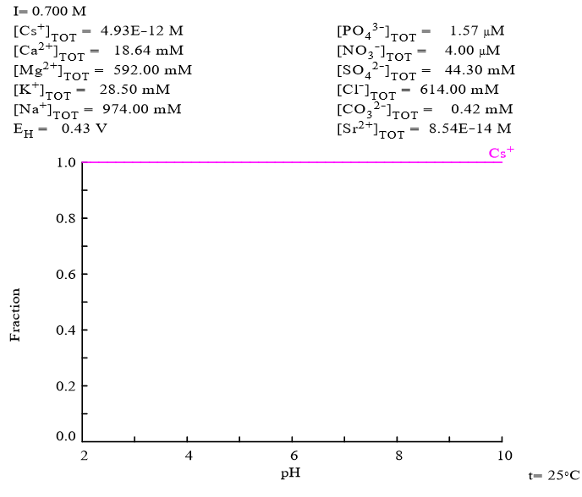

Figure S1: Speciation of Cs in Sea Water

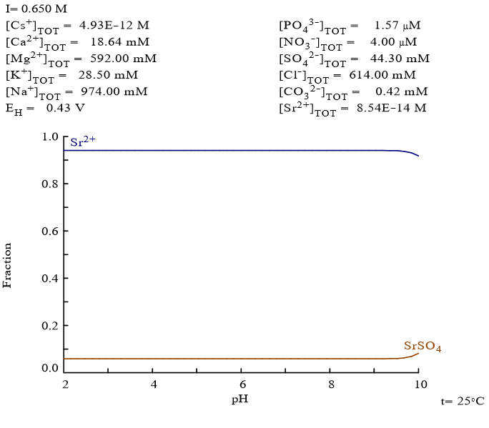

Figure S2: Speciation of Sr in Sea Water

