Supporting Materials.
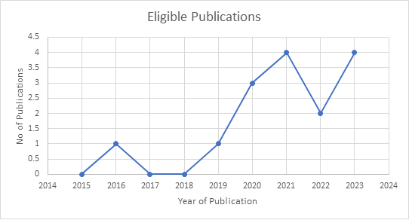
Figure 2: Number of eligible studies per year of publication.

Figure 3. Exploration of gender in eligible studies (n=10)

