Supplementary Figures (S1 and S2):
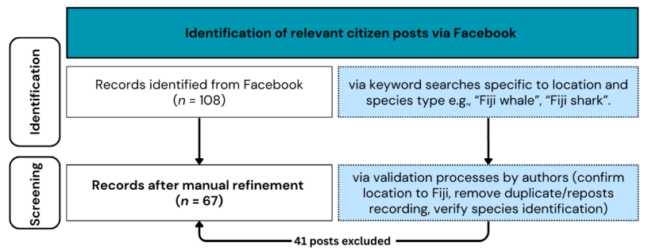
Fig. S1. Data collection flow diagram modified to a two-phase selection procedure for Facebook posts and adapted from the PRISMA approach.

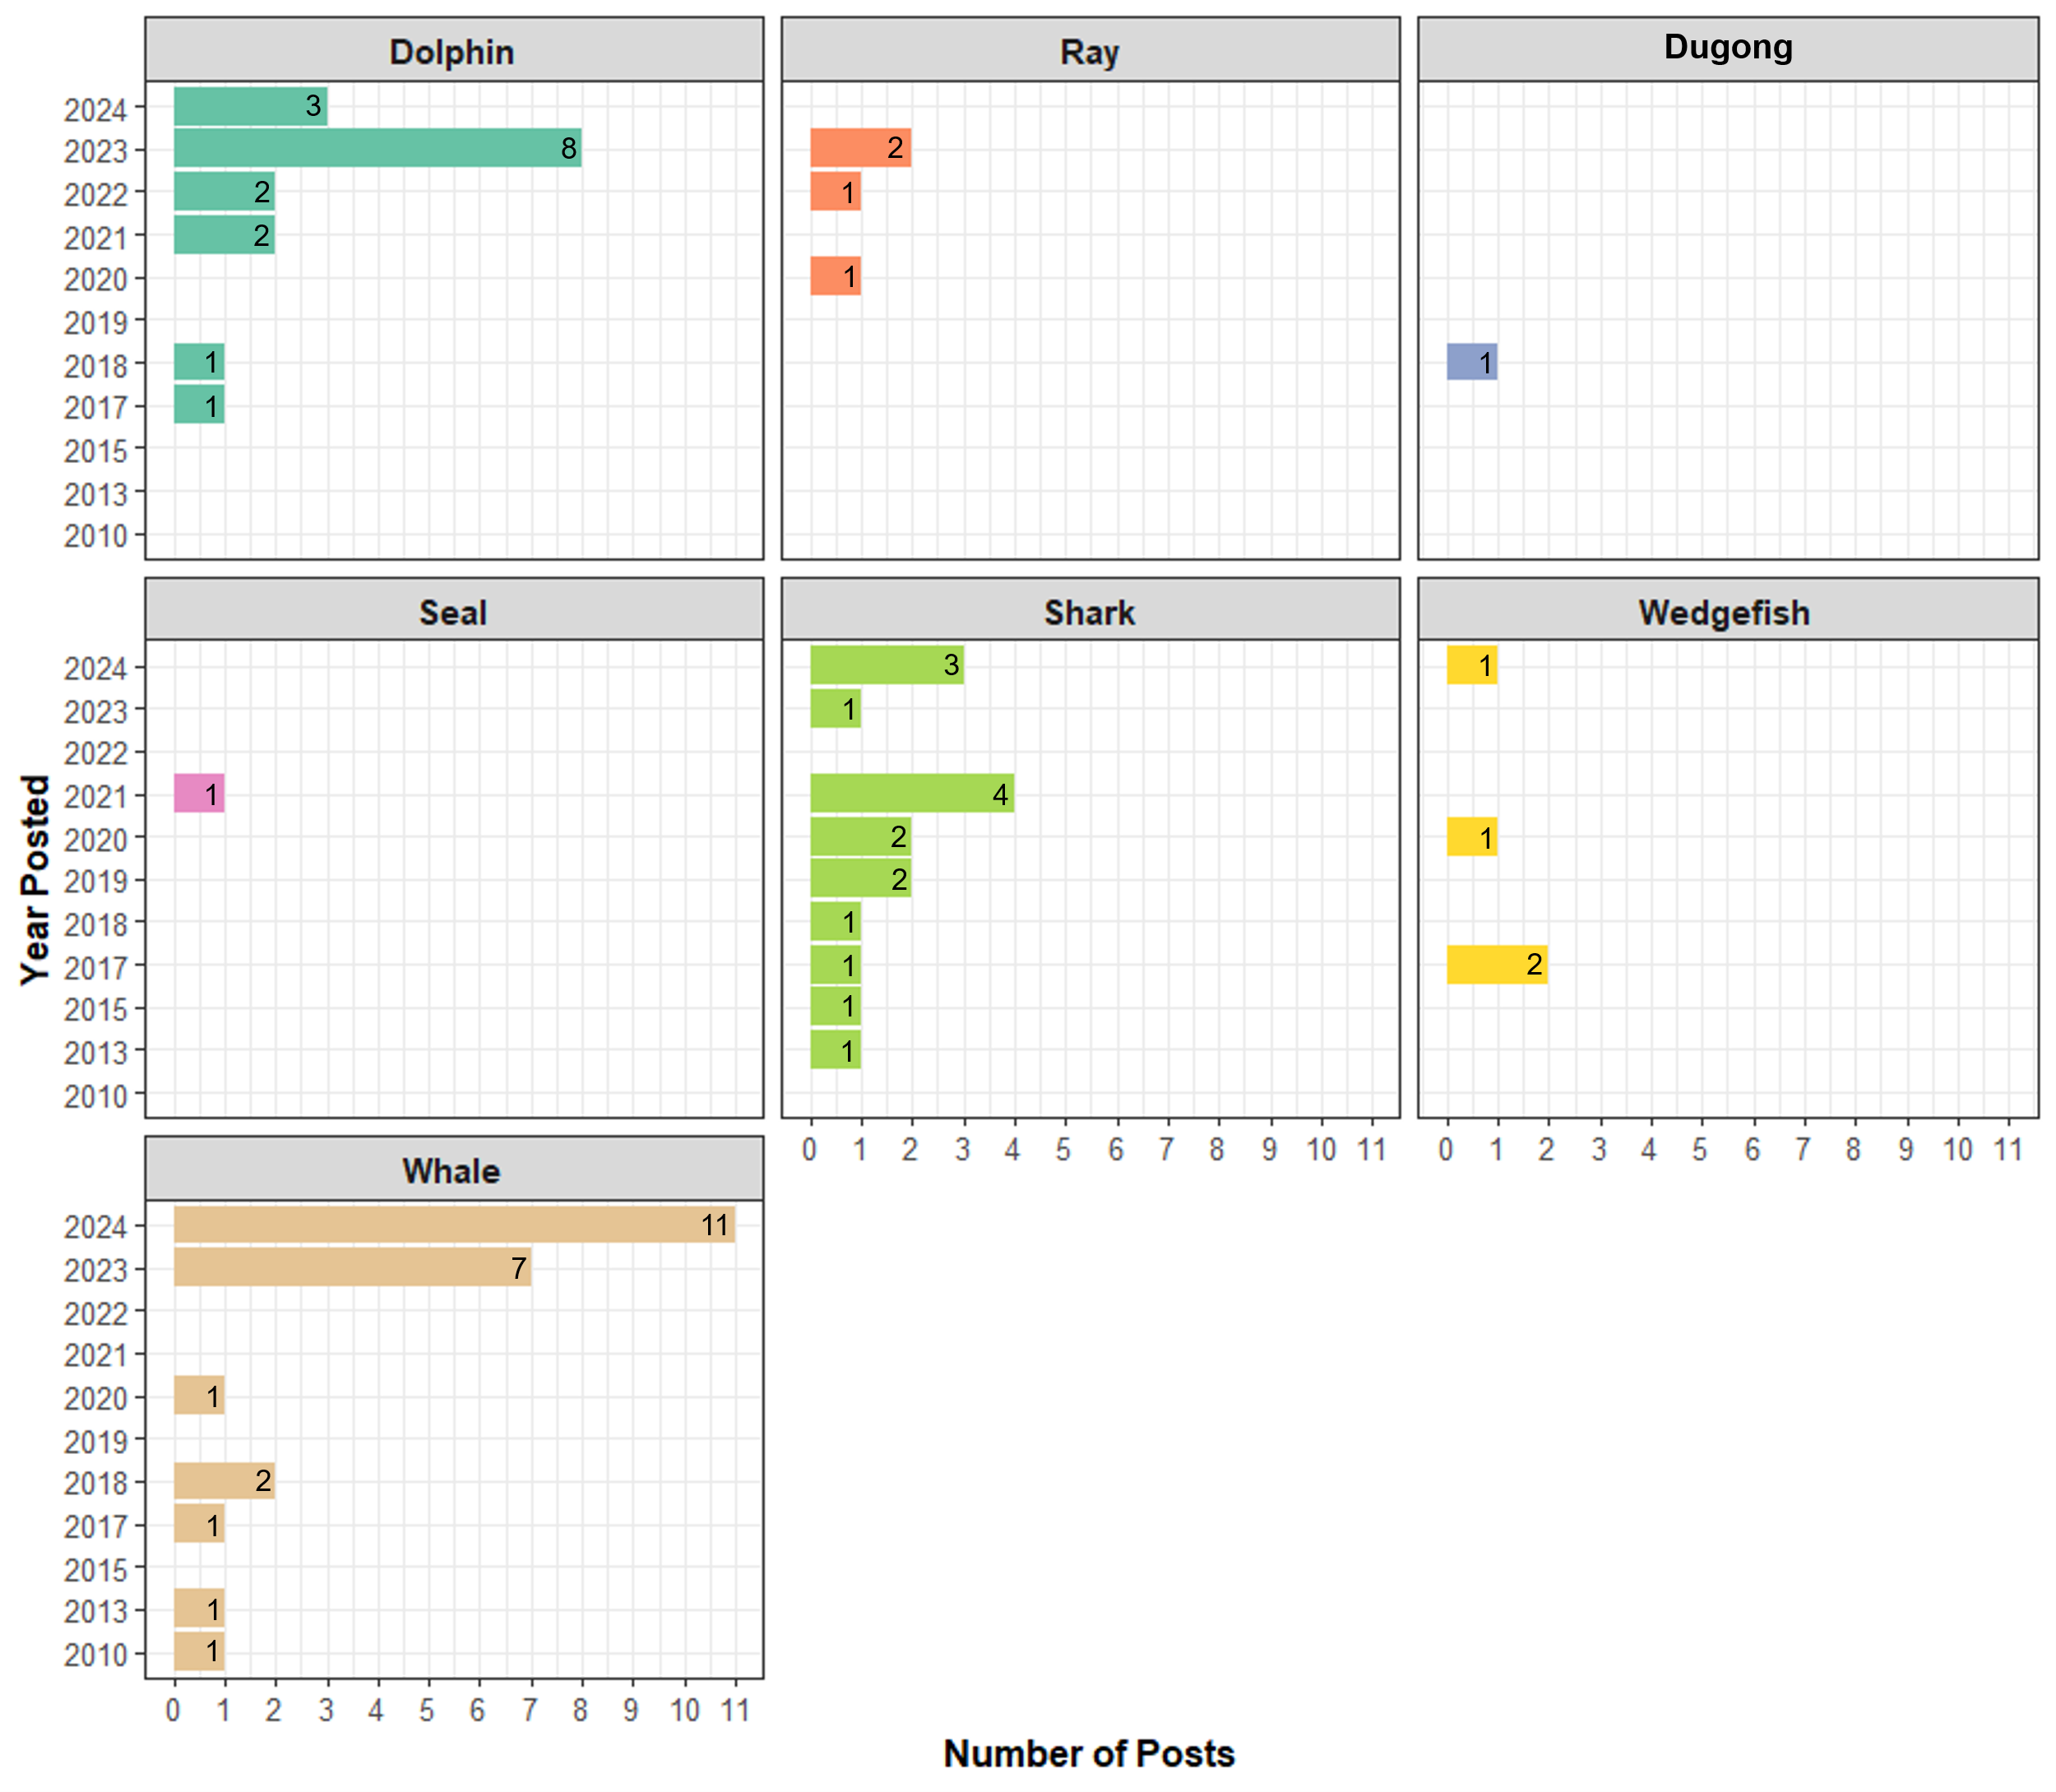
Fig. S2. Total megafauna type posts by year posted.

Supplementary Tables (S1 and S2):
Table S1. Summary of observations in Fiji posted onto Facebook, detailing their encounter types, localities, and conservation statuses under the IUCN Red List (International Union for Conservation of Nature), CMS (Convention on the Conservation of Migratory Species of Wild Animals), and Fiji EPS (Fiji’s Endangered and Protected Species Act). *Species under CITES are protected under the Fiji EPS.
Megafauna Group | Common name | Scientific name | # of posts | Encounter Type | Locality | IUCN Red List Category | Redlist Population | CITES Appendix # | CMS Appendix # | Fiji EPS*
Dolphin | Short-finned pilot whale | Globicephala macrorhynchus | 3 | Stranded, Offshore | Ba, Cakaudrove, Ra | LC | Global | II | - | Yes
 | Long-finned pilot whale | Globicephala melas | 1 | Offshore | Cakaudrove | LC | Global | II | II | Yes
 | Pilot Whale | Globicephala sp. | 4 | Nearshore, Offshore | Bua, Lomaiviti, Serua |  | N/A |  |  | N/A
 | Killer whale | Orcinus orca | 4 | Offshore | Cakaudrove | LC | Global | II | II | Yes
 | False killer whale | Pseudorca crassidens | 4 | Offshore, SCUBA | Cakaudrove, Lomaiviti, Ra | NT | Global | II | - | Yes
 | Spinner dolphin | Stenella longirostris | 1 | Nearshore, SCUBA | Bua | LC | Global | II | II | Yes
Whale | Longman's beaked whale | Indopacetus pacificus | 1 | Stranded | Nadroga-Navosa | LC | Global | II | - | Yes
 | Pygmy/dwarf sperm whale | Kogia sp. | 2 | Stranded, Nearshore | Ba, Ra | N/A | N/A |  |  | N/A
 | Humpback whale | Megaptera novaeangliae | 18 | Nearshore, Offshore, SCUBA | Ba, Kadavu, Lomaiviti, Nadroga-Navosa, Ra, Rewa, Serua, Tailevu | EN | Oceania subpopulation | I | II | Yes
 | Sperm whale | Physeter macrocephalus | 2 | Stranded | Rewa | VU | Global | I | I | Yes
Dugong | Dugong | Dugong dugon | 1 | Stranded | Tailevu | VU | Global | I | II | Yes
Seal | New Zealand fur seal | Arctocephalus forsteri | 1 | Onshroe | Rewa |  |  |  |  | No
Shark | Silvertip shark | Carcharhinus albimarginatus | 1 | Caught | Cakaudrove | VU | Global | II | - | Schedule 1
 | Grey reef shark | Carcharhinus amblyrhynchos | 1 | Caught | Nadroga-Navosa | EN | Global | II | - | Yes
 | Bull shark | Carcharhinus leucas | 5 | Caught, Nearshore, Onshore | Lomaiviti, Nadroga-Navosa, Serua | VU | Global | II | - | Yes
 | Tiger shark | Galeocerdo cuvier | 1 | Stranded | Macuata | NT | Global | - | - | Schedule 1
 | Whale shark | Rhincodon typus | 3 | Offshore | Ra, Rewa | EN | Global | II | II | Yes
 | Hammerhead shark | Sphyrna sp. | 2 | Discarded | Cakaudrove, Rewa | N/A | N/A |  |  | N/A
 | Indo-Pacific leopard shark | Stegostoma tigrinum | 2 | SCUBA | Rewa | EN | Global | - | - | Yes
Wedgefish | Whitespotted wedgefish | Rhynchobatus australiae | 2 | Caught | Macuata, Ra | CR | Global | II | II | Yes
 | Wedgefish | Rhynchobatus sp. | 2 | Stranded, Nearshore | Ba, Nadroga-Navosa | N/A | N/A |  |  | N/A
Ray | Reef manta ray | Mobula alfredi | 1 | Nearshore | Lomaiviti | VU | Global | II | II | Yes
 | Oceanic manta ray | Mobula birostris | 2 | Nearshore | Rewa | EN | Global | II | I | Yes
 | Manta ray | Mobula sp. | 1 | SCUBA | Cakaudrove |  | N/A |  |  | N/A

Table S2. Facebook links to 67 records analysed. Users should note that a Facebook login maybe required to access posts in specific Groups. Persons interested in receiving a complete dataset may request this from the authors.

Megafauna type | Facebook record link | Date of post  dd-mm-yyyy
Dolphin | https://www.facebook.com/share/v/1CqxXiwPks/ | 27-10-2017
Dolphin | https://www.facebook.com/100064794548009/posts/10156639517368678/?rdid=iPPZ9MGCTNKQ8rSE | 21-06-2018
Dolphin | https://www.facebook.com/beth.holland.315/videos/5494396117252802 | 01-01-2021
Dolphin | https://www.facebook.com/photo/?fbid=3513128858700683&set=pcb.3513129942033908&__cft__[0]=AZW2OSVxwBFq5TiVnmXfl6ohwsZ7cQGpPEGFQMUskYLQkZj1_HcwS9EjtI0IzlN8tTgO_sTjbxM1M6uSvCqFrRdyh1GrqKC1UV9WpUd6WmQN3yArBqJBRyYmzOOHhhgOubDdeo8HMC_cRWy8VJED28tTIm5qUXTFuk20wUcf2KliTi7Q0iRvkK4a1vNEWI8alQO4Ofd3cbghg9Youfk4amP0RhBNQJmqYkDpTnQc6CSzVA&__tn__=*bH-y-R | 07-05-2021
Dolphin | https://www.facebook.com/saltdiverfiji/videos/3067521260163466 | 12-02-2022
Dolphin | https://www.facebook.com/watch/?mibextid=WC7FNe&v=1022983525024501&rdid=E0z56tG06PEQbNq1 | 19-04-2022
Dolphin | https://www.facebook.com/share/v/1EWGHSF8k9/ | 04-02-2023
Dolphin | https://www.facebook.com/share/p/14p9jFjb3v/ | 16-03-2023
Dolphin | https://www.facebook.com/reel/201641509229050/?s=single_unit&__cft__[0]=AZXeFXKPVJMbBugmQVaGllyYyWrgteRC_mSazHPJrandJN4T11oYyBGafYR6vv3T_bWQtOncxlxQy4Wkl1aAfFZJt-h1tvH7dSFX9bSHxsu0ZWp-odeAVaZkBCOBzpgK8qz3O8jR0VMEPa6rRxGf-d7J5-VNFqH0eRbbNF2dws1NOdVs226yjLd0JqlDRcotNHZdfqHZ2qKq29sRKMPmBQc8&__tn__=H-R | 23-03-2023
Dolphin | https://www.facebook.com/share/p/15Zh5Mhx6S/ | 20-05-2023
Dolphin | https://www.facebook.com/share/p/15Zh5Mhx6S/ | 20-05-2023
Dolphin | https://www.facebook.com/reel/211375357958622 | 10-06-2023
Dolphin | https://www.facebook.com/reel/1281944179353327 | 26-07-2023
Dolphin | https://www.facebook.com/share/v/1EUVoG5oEo/ | 15-12-2023
Dolphin | https://www.facebook.com/photo/?fbid=974821504648637&set=pcb.974827077981413 | 18-06-2024
Dolphin | https://www.facebook.com/share/p/18UVdGbBEV/ | 31-08-2024
Dolphin | https://www.facebook.com/photo/?fbid=10169163506435315&set=a.10150207322795315 | 04-10-2024
Ray | https://www.facebook.com/share/p/1JqRCEdBK1/ | 29-04-2020
Ray | https://www.facebook.com/share/p/18V4GeKmZs/ | 22-06-2022
Ray | https://www.facebook.com/share/p/1LEcijL4Uv/ | 11-05-2023
Ray | https://www.facebook.com/share/p/1BCyrCRCBQ/ | 23-08-2023
Sea Cow | https://www.facebook.com/search/top/?q=dugongs%20fiji | 21-05-2018
Seal | https://www.facebook.com/100063790502056/posts/378416550358105/?rdid=nCUnUWhOZN1RuUXi | 31-08-2021
Shark | https://www.facebook.com/share/12Dzka55kSe/?mibextid=wwXIfr | 09-04-2013
Shark | https://www.facebook.com/SuvaScubaDiveClub/photos/a.491978757560146/739767696114583/?type=3&mibextid=WC7FNe&rdid=8mIZGrbPX1PVsWxJ&share_url=https%3A%2F%2Fwww.facebook.com%2Fshare%2Ft5oHJsMFBUBkcPVK%2F%3Fmibextid%3DWC7FNe | 05-01-2015
Shark | https://www.facebook.com/share/158n7dtkB5/?mibextid=wwXIfr | 29-09-2017
Shark | https://www.facebook.com/share/v/15mahG2J1V/?mibextid=wwXIfr | 03-10-2018
Shark | https://fb.watch/wKhzK4S0m-/ | 07-02-2019
Shark | https://www.facebook.com/share/v/1HDJmxn4Mq/?mibextid=wwXIfr | 29-10-2019
Shark | https://www.facebook.com/groups/226971231164407/permalink/781013049093553 | 25-03-2020
Shark | https://www.facebook.com/reel/362700121552063 | 14-09-2020
Shark | https://www.facebook.com/share/1AcH5YsSsz/?dftrwfsd=wdXIfr | 08-03-2021
Shark | https://www.facebook.com/civafijipearls/videos/qio-tuki/465690274475387/?mibextid=wwXIfr&rdid=tS8aTZ5c7VRX6jcX | 08-03-2021
Shark | https://www.facebook.com/100052035602369/posts/302247054853146/?mibextid=wwXIfr&rdid=rVqOX6N8uO4kE0Na# | 01-06-2021
Shark | https://www.facebook.com/photo/?fbid=1320092131778276&set=a.208467066274127&__cft__%5b0%5d=AZW1zHL_VKsEsh4V2By7nrusJYPEv6-V6jcaZqvL7OjOaeO9X-IwitptfD3I9EuJwDFtkD1h9ksH3hTTkcZOjuinXu_VcPewlzygnt3ABlMPb9s-HstTDVRhos4rdcnkfr12pz5-jTnoBc4wFBY-j3gVHT9tUs7LVvoASY-ahDLFPw&__tn__=EH-R | 21-10-2021
Shark | https://www.facebook.com/share/19woRZLeab/?mibextid=wwXIfr | 09-02-2023
Shark | https://www.facebook.com/photo/?fbid=122188846790222826&set=pcb.122188849274222826 | 06-10-2024
Shark | https://www.facebook.com/reel/889982006401795 | 11-10-2024
Shark | https://www.facebook.com/reel/1643648326185211 | 18-11-2024
Wedgefish | https://www.facebook.com/share/1AFLHg6kWY/? | 26-06-2017
Wedgefish | https://www.facebook.com/groups/361220933947896/permalink/1614221381981172/?mibextid=K35XfP&rdid=M6lL5HZSEdYiOL4z&share_url=https%3A%2F%2Fwww.facebook.com%2Fshare%2Fp%2FYUS3HYAWthq5Z6ic%2F%3Fmibextid%3DK35XfP | 09-07-2017
Wedgefish | https://www.facebook.com/share/1DbH2YNSsz/?mibextid=wwXIfr | 25-11-2020
Wedgefish | https://www.facebook.com/100004461192480/videos/8398980576861184/ | 07-10-2024
Whale | https://www.facebook.com/share/15vUC7DXsU/ | 10-08-2010
Whale | https://www.facebook.com/photo?fbid=660102014014230&set=a.674556955902069 | 17-09-2013
Whale | https://www.facebook.com/100064515891315/posts/10159014192465524/?rdid=yCBwkuiilkqjjsvC | 18-07-2017
Whale | https://www.facebook.com/share/17sqJXYjQq/?mibextid=wwXIfr | 24-06-2018
Whale | https://www.facebook.com/share/16LZfFmKqC/?mibextid=wwXIfr | 30-10-2018
Whale | https://www.facebook.com/search/top?q=buli%20metui%20dolphin | 08-04-2020
Whale | https://www.facebook.com/share/p/14oF2g99YS/ | 15-06-2023
Whale | https://www.facebook.com/share/p/1ZrajphZWg/ | 05-07-2023
Whale | https://www.facebook.com/share/p/15aQb2WE3T/ | 06-07-2023
Whale | https://www.facebook.com/share/v/14vYr254my/ | 31-07-2023
Whale | https://www.facebook.com/share/r/19y7syEHEM/ | 08-08-2023
Whale | https://www.facebook.com/share/p/14XRsyNc7h/ | 15-08-2023
Whale | https://www.facebook.com/share/p/1AD67X2yae/ | 09-09-2023
Whale | https://www.facebook.com/reel/428152360083387 | 15-06-2024
Whale | https://www.facebook.com/reel/1193352948473386 | 16-06-2024
Whale | https://www.facebook.com/100043595988061/posts/1043223997140790/?mibextid=WC7FNe&rdid=xgDSxc0WcidBRnB5 | 04-08-2024
Whale | https://www.facebook.com/reel/1598444437379628 | 08-08-2024
Whale | https://www.facebook.com/vomofiji/videos/484561647718972 | 16-08-2024
Whale | https://www.facebook.com/100007889227824/videos/pcb.3807978076141796/1050830939927929 | 26-08-2024
Whale | https://www.facebook.com/share/v/15jtBP4Xgt/ | 29-08-2024
Whale | https://www.facebook.com/reel/2100761050319003 | 02-09-2024
Whale | https://www.facebook.com/reel/906754444724208 | 01-10-2024
Whale | https://www.facebook.com/share/r/18ZWnd41Kt/?mibextid=wwXIfr | 10-11-2024
Whale | https://www.facebook.com/share/v/14rv6JYM4Y/ | 17-11-2024

