Discover Oceans
Supplimentary data
Glutaminase free L-asparaginase from seaweed associated Bacillus licheniformis with promising therapeutic potential
Doniya Elze Mathew^{1,3}, Shahrukh A. Siddiqui^{1,3}, Astha Soni¹, Anjana K. Vala⁴, Pramod B. Shinde^{2,3*}, Vaibhav A. Mantri^{1,3*}

¹Applied Phycology & Biotechnology Division,
CSIR- Central Salt and Marine Chemicals Research Institute, Bhavnagar, 364001, India
²Mairne Natural Products and Bio-Polymers Division,
CSIR- Central Salt and Marine Chemicals Research Institute, Bhavnagar, 364001, India
³Academy of Scientific and Innovative Research (AcSIR), Ghaziabad, 201002, India
⁴Department of Life Sciences, Maharaja Krishnakumarsinhji Bhavnagar University, Bhavnagar 364001, India
*Corresponding author at: Vaibhav A. Mantri (vaibhav@csmcri.res.in); Tel: +91-278-2567760 Ext. 6131; fax: +91-278-2566970; Orcid ID: 0000-0002-8587-8634
Pramod B. Shinde (pramodshinde@csmcri.res.in); Orcid ID: 0000-0002-3173-0896

Supplimentary fig. 1: Neighbor joining phylogenetic tree based on 16S rRNA gene sequences of B. licheniformis strain 4T1C26E (3F 4-26 Bacillus licheniformis).

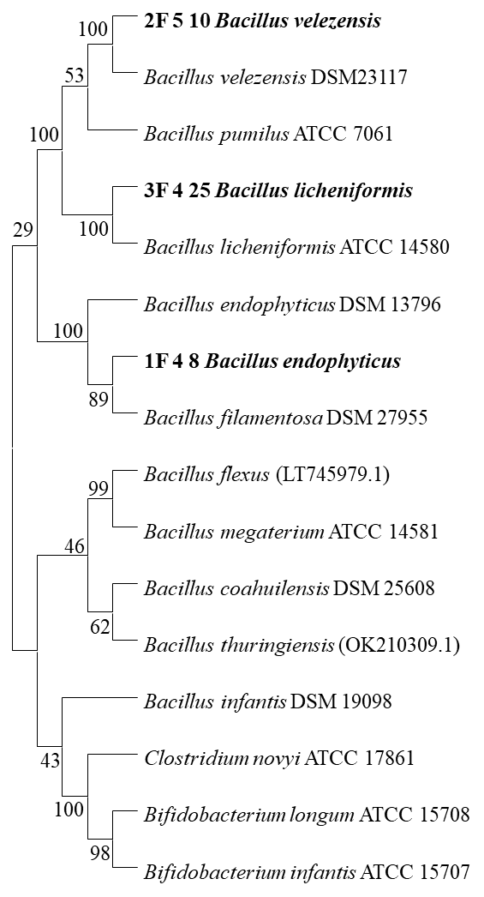
2F 5-10 Bacillus velezensis
3F 4-26 Bacillus licheniformis
1F 4-8 Bacillus endophyticus

Supplementary fig. 2: The SDS-PAGE image of crude and purified enzyme. The enzyme produced single band around 34 KDa

Ladder Pure crude

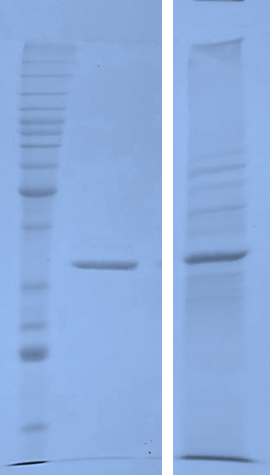
~34 KDa
220 KDa
10 KDa
50 KDa
40 KDa
30 KDa
25 KDa
20 KDa

