Role of mesophotic ecosystems to preserve reef fish biodiversity under a climate change scenario in the eastern tropical Pacific.
Omar Valencia-Méndez, Rosalía Aguilar-Medrano, Rafael A. Cabral-Tena, Luis E. Calderon-Aguilera*
Supplemental Material 2 Light attenuation coefficient K_{d490}

We ﻿estimated the light attenuation coefficient (K_{dPAR}) to determine the location of the mesophotic zone; K_{dPAR} indicates the decomposition rate of photosynthetically active radiation throughout the water column and is a measure of transparency. The values for each site were transformed into K_{dPAR} using the equation proposed by [1] for Case I waters (< 0.2 m−1):
K_{dPAR} = 0.0864 + 0.0884K_{d490} – 0.00137[K_{d490}]⁻¹
And, the 10% of the incident light at the surface was considered the upper limit of the mesophotic zone Z_{10%,} calculated as: Z_{10%} = 2.3/ K_{dPARmax}, where K_{dPARmax} = maximum mean K_{dPAR} value per month.
To determine the mesophotic depth, monthly averages of light attenuation in the sea at 490 nm (Kd490) were compiled from satellite-derived products from NASA’s MODIS-Aqua projects (4 km resolution). Time series (August 2002 - April 2022) were created using the nearest pixel(s) for each study site. Shallow: from surface down to 10% of incident light, mesophotic: depth below 10% of incident light. This depth varies seasonally at each site, so the mean monthly average is used to define the stratum. To create map animations, the data were interpolated using the R raster library and processed using Ocean Data View.

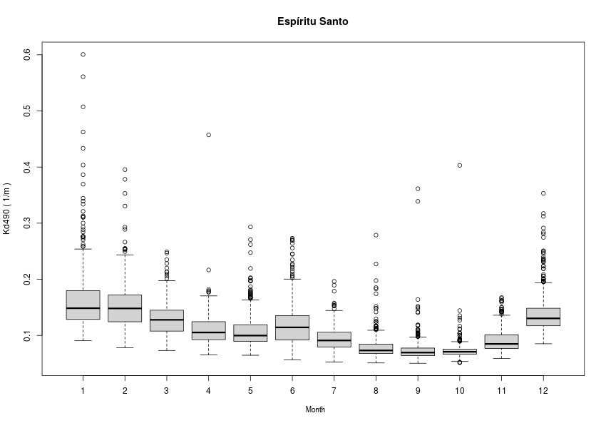
SM2_Fig1 Boxplot of mean light attenuation coefficient K _{d490} (2003 -2022) in Archipelago Espíritu Santo

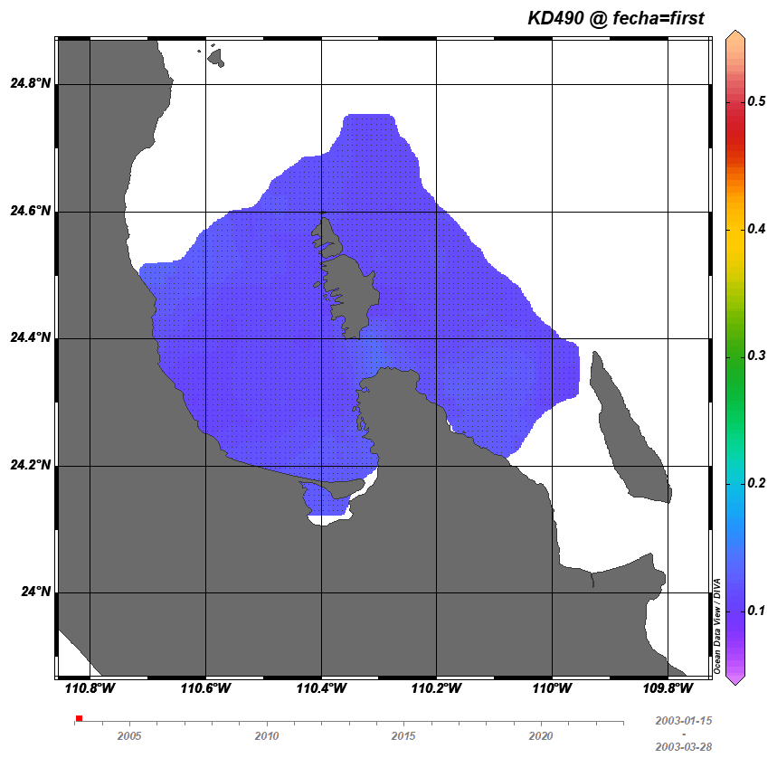
SM2_Fig 2 Animation of the light attenuation coefficient K _{d490} (2003 -2022) in Archipelago Espíritu Santo, generated by the GlobColour-Hermes

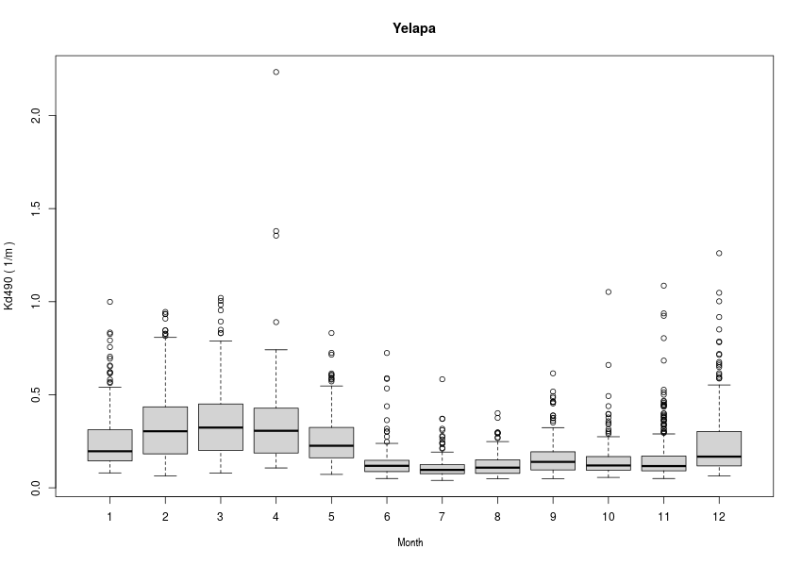
SM2_Fig 3 Boxplot of mean light attenuation coefficient K _{d490} (2003 -2022) in Yelapa

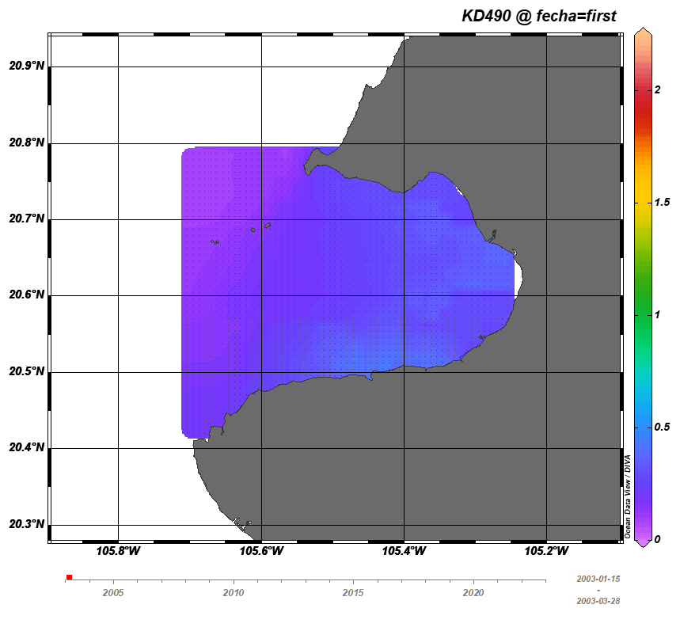
SM2_Fig 4 Animation of the light attenuation coefficient K d490 (2003 -2022) in Yelapa, generated by the GlobColour-Hermes

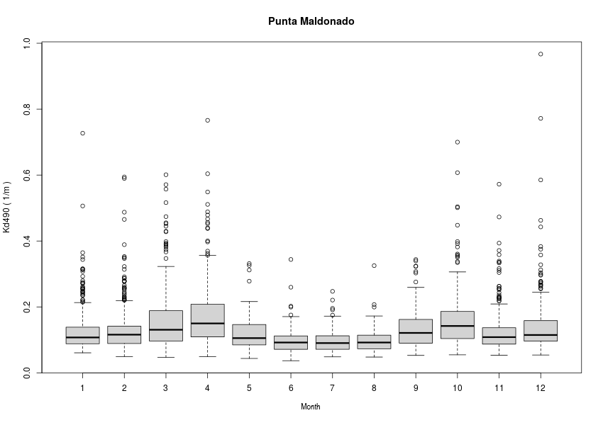
SM2_Fig 5 Boxplot of mean light attenuation coefficient K _{d490} (2003 -2022) in Punta Maldonado

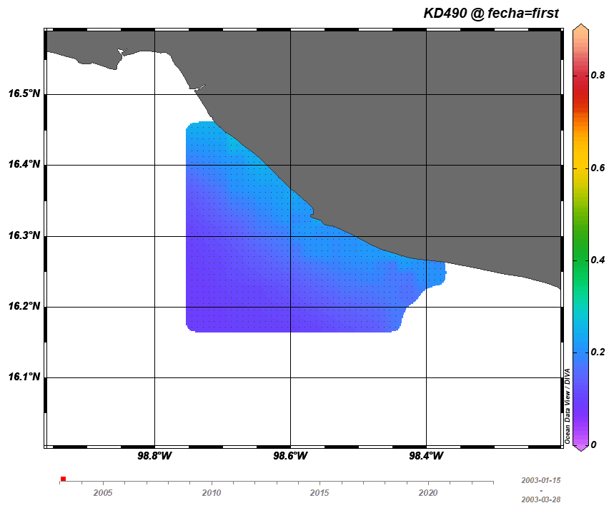
SM2_Fig 6 Animation of the light attenuation coefficient K d490 (2003 -2022) in Punta Maldonado, generated by the GlobColour-Hermes

Reference:
[1] A. Morel, Y. Huot, B. Gentili, P. J. Werdell, S. B. Hooker, and B. A. Franz, “Examining the consistency of products derived from various ocean color sensors in open ocean (Case 1) waters in the perspective of a multi-sensor approach,” Remote Sens Environ, vol. 111, no. 1, pp. 69–88, 2007, doi: 10.1016/j.rse.2007.03.012.

