Supplementary Material
A Comprehensive Theoretical Investigation of Lead-Free Mixed Antimony-Bismuth Halide Double Perovskite (Cs₂AgBi₀.₇₅Sb₀.₂₅Br₆) Solar Cell using SCAPS-1D

Parwaz Asif *, Anupam Chetia, Dibyajyoti Saikia, Satyajit Sahu
Department of Physics, Indian Institute of Technology Jodhpur 342037, India
*Corresponding author E-mail: asif.1@alumni.iitj.ac.in;
Contributing authors: chetia.1@iitj.ac.in; saikia.2@iitj.ac.in; satyajit@iitj.ac.in

Table S1 The numerical parameters used for various electron transport materials (ETMs).
Parameters | ZnO  [1] | ZnSe  [2] | STO  [3] | IGZO  [4] | CdS  [5] | C₆₀  [6],[7] | TiO₂  [8], [9] | Cd_{0.5}Zn_{0.5}S  [10] | PCBM  [11]
Thickness(µm) | 0.07 | 0.07 | 0.07 | 0.07 | 0.07 | 0.07 | 0.07 | 0.07 | 0.07
Bandgap (eV) | 3.30 | 2.81 | 3.20 | 3.05 | 2.40 | 1.70 | 3.20 | 2.80 | 2.00
Electron affinity(eV) | 4.00 | 4.09 | 4.00 | 4.16 | 4.20 | 3.90 | 3.90 | 3.80 | 3.90
Dielectric permittivity | 9.0 | 8.6 | 8.7 | 10.0 | 10.0 | 4.20 | 9.00 | 10.0 | 3.90
Effective density of states of CB (cm⁻³) | 3.7x 10¹⁸ | 2.2x 10¹⁸ | 1.7x 10¹⁹ | 5x  10¹⁸ | 2x  10¹⁸ | 8x 10¹⁹ | 10²¹ | 10¹⁸ | 2.5x 10²¹
effective density of states of VB (cm⁻³) | 1.8x 10¹⁹ | 1.8x 10¹⁸ | 2x  10¹⁸ | 5x 10¹⁸ | 1.8 10¹⁹ | 8x 10¹⁹ | 2x 10²⁰ | 10¹⁸ | 2.5x 10²¹
Thermal velocity of electron(cm/s) | 10⁷ | 10⁷ | 10⁷ | 10⁷ | 10⁷ | 10⁷ | 10⁷ | 10⁷ | 10⁷
Thermal velocity of hole(cm/s) | 10⁷ | 10⁷ | 10⁷ | 10⁷ | 10⁷ | 10⁷ | 10⁷ | 10⁷ | 10⁷
Mobility of electron(cm²/Vs) | 100 | 400 | 5300 | 15 | 20 | 0.08 | 20 | 100 | 0.2
Mobility of hole(cm²/Vs) | 25 | 110 | 660 | 0.1 | 10 | 0.0035 | 10 | 25 | 0.2
Shallow uniform donor density N_{D} (cm⁻³) | 5x  10¹⁷ | 5x 10¹⁷ | 5x  10¹⁷ | 5x  10¹⁷ | 10¹⁷ | 2.6x 10¹⁸ | 10¹⁷ | 10¹⁷ | 2.93x 10¹⁷
Shallow uniform acceptor density N_{A} (cm⁻³) | 0 | 0 | 0 | 0 | 0 | 0 | 0 | 0 | 0

Table S2 Various cell parameter for simulated device with different ETMs.
ETM | V_{oc}(V) | Jsc(mA/cm²) | FF(%) | PCE(%)
ZnO | 1.40011 | 15.278024 | 81.99 | 17.54
ZnSe | 1.3393 | 15.438965 | 80.71 | 16.69
STO | 1.3722 | 15.432828 | 81.14 | 17.18
IGZO | 1.2491 | 15.414279 | 79.71 | 15.35
CdS | 1.2317 | 15.409216 | 79.57 | 15.10
C60 | 1.3787 | 15.797710 | 86.57 | 18.86
TiO2 | 1.1720 | 15.311448 | 78.74 | 14.13
Cd_{0.5}Zn_{0.5}S | 1.4321 | 15.389733 | 88.19 | 19.44
PCBM | 1.3500 | 15.689894 | 81.66 | 17.30

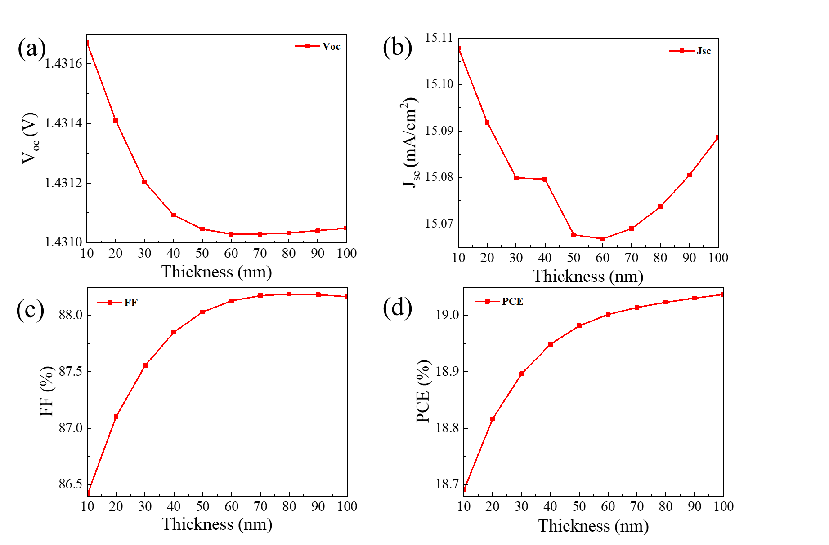 Fig. S1 Variation of ETL Thickness on (a) $V_{oc}$, (b) $J_{sc}$, (c) FF, and (d) PCE

Table S3 The numerical parameters used for various Hole transport materials (HTMs).
Parameters | NiO  [12] | CuI  [13] | CuSCN  [14] | SnS  [15] | CuInSe₂  [16]
Thickness(µm) | 0.07 | 0.07 | 0.07 | 0.07 | 0.07
Bandgap (eV) | 3.80 | 3.10 | 3.60 | 1.60 | 1.00
Electron affinity(eV) | 1.46 | 2.10 | 1.70 | 4.10 | 3.80
Dielectric permittivity | 10.70 | 6.50 | 10 | 13.0 | 9.00
Effective density of states of CB (cm⁻³) | 2.8x 10¹⁹ | 2.8 x 10¹⁹ | 2.2x10¹⁹ | 1.18 x 10¹⁸ | 10¹⁷
effective density of states of VB (cm⁻³) | 1 x 10¹⁹ | 1x 10¹⁹ | 1.8x10¹⁸ | 4.46 x 10¹⁸ | 10¹⁹
Thermal velocity of electron(cm/s) | 10⁷ | 10⁷ | 10⁷ | 10⁷ | 10⁷
Thermal velocity of hole(cm/s) | 10⁷ | 10⁷ | 10⁷ | 10⁷ | 10⁷
Mobility of electron(cm²/Vs) | 12 | 100 | 100 | 15 | 10⁻⁴
Mobility of hole(cm²/Vs) | 2.8 | 43.9 | 25 | 100 | 10⁻⁴
Shallow uniform donor density N_{D} (cm⁻³) | 0 | 0 | 0 | 0 | 0
Shallow uniform acceptor density N_{A} (cm⁻³) | 10¹⁸ | 10¹⁸ | 10¹⁸ | 1.1 x 10¹⁶ | 10¹⁹

Table S4 Various cell parameter for simulated device with different HTMs.
HTM | Voc(V) | Jsc(mA/cm²) | FF(%) | PCE(%)
CuI | 1.4282 | 14.855680 | 87.56 | 18.58
CuInSe2 | 1.2689 | 11.365478 | 80.06 | 11.55
CuSCN | 1.4310 | 15.068992 | 88.17 | 19.01
NiO | 1.4294 | 15.010441 | 88.00 | 18.88
SnS | 1.1747 | 11.992886 | 80.94 | 11.40

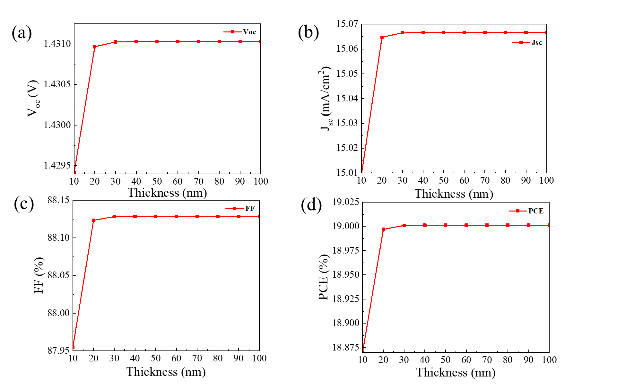
Fig. S2 Variation of HTL Thickness on (a) $V_{oc}$, (b) $J_{sc}$, (c) FF, and (d) PCE

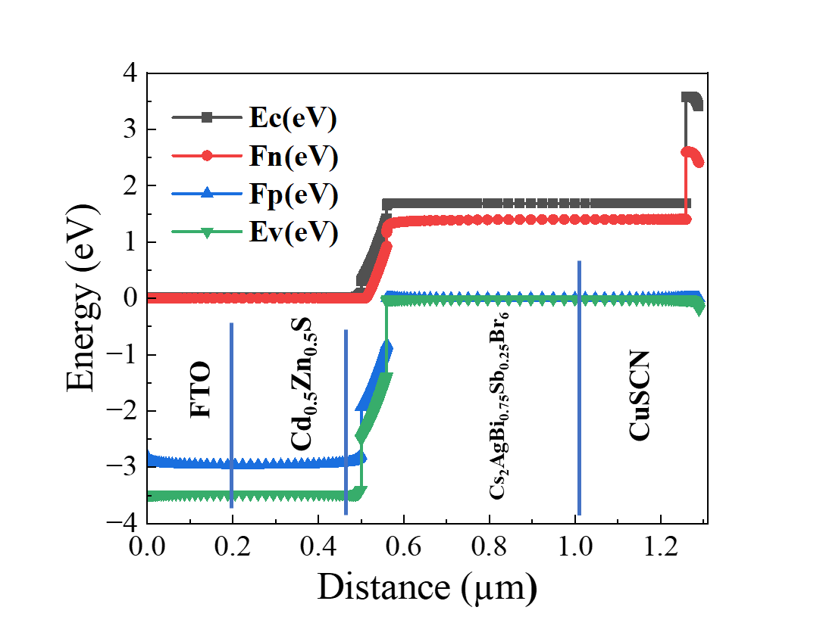
Fig. S3 Energy Level diagram for optimized device.

References
[1] D. Jalalian, A. Ghadimi, and A. Kiani, ‘Modeling of a high performance bandgap graded Pb-free HTM-free perovskite solar cell’, Eur. Phys. J. Appl. Phys., vol. 87, no. 1, p. 10101, 2019.
[2] J. A. Owolabi, M. Y. Onimisi, J. A. Ukwenya, A. B. Bature, and U. R. Ushiekpan, ‘Investigating the effect of ZnSe (ETM) and Cu2O (HTM) on absorber layer on the performance of pervoskite solar cell using SCAPS-1D’, Am. J. Phys. Appl., vol. 8, no. 1, pp. 8–18, 2020.
[3] S. Bishnoi and S. K. Pandey, ‘Device performance analysis for lead‐free perovskite solar cell optimisation’, IET Optoelectron., vol. 12, no. 4, pp. 185–190, 2018.
[4] F. Azri, A. Meftah, N. Sengouga, and A. Meftah, ‘Electron and hole transport layers optimization by numerical simulation of a perovskite solar cell’, Sol. energy, vol. 181, pp. 372–378, 2019.
[5] Y. Guo et al., ‘RF sputtered CdS films as independent or buffered electron transport layer for efficient planar perovskite solar cell’, Sol. Energy Mater. Sol. Cells, vol. 178, pp. 186–192, 2018.
[6] X. Liu, K. Yan, D. Tan, X. Liang, H. Zhang, and W. Huang, ‘Solvent engineering improves efficiency of lead-free tin-based hybrid perovskite solar cells beyond 9%’, ACS Energy Lett., vol. 3, no. 11, pp. 2701–2707, 2018.
[7] Z. Qirong et al., ‘A study on numerical simulation optimization of perovskite solar cell based on CuI and C60’, Mater. Res. Express, vol. 9, no. 3, p. 36401, 2022.
[8] N. Pezhooli, J. Rahimi, F. Hasti, and A. Maleki, ‘Synthesis and evaluation of composite TiO2@ ZnO quantum dots on hybrid nanostructure perovskite solar cell’, Sci. Rep., vol. 12, no. 1, p. 9885, 2022.
[9] Y. Gan et al., ‘Numerical investigation energy conversion performance of tin-based perovskite solar cells using cell capacitance simulator’, Energies, vol. 13, no. 22, p. 5907, 2020.
[10] Y. H. Khattak, E. Vega, F. Baig, and B. M. Soucase, ‘Performance investigation of experimentally fabricated lead iodide perovskite solar cell via numerical analysis’, Mater. Res. Bull., vol. 151, p. 111802, 2022.
[11] A. Raj, A. Anshul, V. Tuli, P. K. Singh, R. C. Singh, and M. Kumar, ‘Effect of appropriate ETL on quantum efficiency of double perovskite La2NiMnO6 based solar cell device via SCAPS simulation’, Mater. Today Proc., vol. 47, pp. 1656–1659, 2021.
[12] R. R. Kumar and S. K. Pandey, ‘Performance evaluation and material parameter perspective of eco-friendly highly efficient CsSnGeI3 perovskite solar cell’, Superlattices Microstruct., vol. 135, p. 106273, 2019.
[13] S. Pitchaiya et al., ‘A review on the classification of organic/inorganic/carbonaceous hole transporting materials for perovskite solar cell application’, Arab. J. Chem., vol. 13, no. 1, pp. 2526–2557, 2020.
[14] M. Alla et al., ‘Optimized CH3NH3PbI3-XClX based perovskite solar cell with theoretical efficiency exceeding 30%’, Opt. Mater. (Amst)., vol. 124, p. 112044, 2022.
[15] A. Mohandes, M. Moradi, and H. Nadgaran, ‘Numerical simulation of inorganic Cs 2 AgBiBr 6 as a lead-free perovskite using device simulation SCAPS-1D’, Opt. Quantum Electron., vol. 53, pp. 1–22, 2021.
[16] R. Saha, K. Chakraborty, M. G. Choudhury, and S. Paul, ‘Simulation study of Formamidinium Lead Halide (FAPbX3; X= I and Br) Based Perovskite Solar Cells Using SCAPS-1D Device Simulator’, 2021.

