SUPPORTING INFORMATIONS

Fundamentals of Electrochemical Impedance Spectroscopy in Energy Storage Devices: Principles and Innovative Curve Fitting Approaches
Yuda Prima Hardianto ^{a,b}, Syed Shaheen Shah ^{c}, Mostafa M. Mohamed ^{a,b}, Subrata Sarker ^{d,*}, Md. Abdul Aziz ^{b,e*}

ª Physics Department, King Fahd University of Petroleum & Minerals, KFUPM Box 5047, Dhahran 31261, Saudi Arabia
^{b} Interdisciplinary Research Center for Hydrogen Technologies and Carbon Management (IRC-HTCM), King Fahd University of Petroleum & Minerals, KFUPM Box 5040, Dhahran 31261, Saudi Arabia
^{c} Socio-Environmental Energy Science Department, Graduate School of Energy Science, Kyoto University, Yoshida-honmachi, Sakyo-ku, Kyoto 606-8501, Japan
^{d} Department of Materials Science and Engineering, Hongik University, Sejong 30016, Republic of Korea
^{e} Department of Civil and Environmental Engineering, King Fahd University of Petroleum & Minerals, Dhahran 31261, Saudi Arabia

* Corresponding Authors email: subrata_sarker@yahoo.com (SS) and maziz@kfupm.edu.sa (MAA)

Derivation of Equations
- Derivation of Equation (6)
To derive those equations, let’s call equation 5 as follows:
$Z_{Cell}=R_{0}-\frac{j}{ωC_{0}}$ (5)
The total impedance can be obtained using the following formula:
$\left|Z\right|=\sqrt{ZZ^{*}}$ (S1)
where Z* is the complex conjugate of Z. Therefore, using equation 5 and S1, the total cell impedance can be determined as the following equation:
$\left|Z_{cell}\right|=\sqrt{\left(R_{0}-\frac{j}{ωC_{0}}\right)\left(R_{0}+\frac{j}{ωC_{0}}\right)}=\sqrt{{R_{0}}^{2}+\frac{1}{ω^{2}{C_{0}}^{2}}}$ (S2)
The last equation is the same equation as presented in equation 6.
- Derivation of Equation (8) and explanation of semicircle behavior in the Nyquist plot of RC parallel cell
Since we already have the impedance of the capacitor from AC circuit analysis, the total impedance of the parallel connection between the resistor R and the capacitor can be represented by the following equation:
$Z_{RC-parallel}=\frac{RX_{C}}{R{+X}_{C}}=\frac{R\left(-\frac{j}{ωC_{0}}\right)}{R-\frac{j}{ωC_{0}}}$ (S3)
By multiplying both nominator and denominator with $R+\frac{j}{ωC_{0}}$, the last equation can be modified as the following equation:
$Z_{RC-parallel}=Z_{RCP}=\frac{R\left(-\frac{j}{ωC_{0}}\right)\left(R+\frac{j}{ωC_{0}}\right)}{R^{2}+\frac{1}{ω^{2}{C_{0}}^{2}}}=\frac{1}{R^{2}+\frac{1}{ω^{2}{C_{0}}^{2}}}\left(\frac{R}{ω^{2}{C_{0}}^{2}}-\frac{jR^{2}}{ωC_{0}}\right)$ (S4)
The last equation is the same expression as equation 8.
Essentially, Equation S4 can be separated into its real and imaginary components as follows:
$Re(Z_{RCP})=\frac{\frac{R}{ω^{2}{C_{0}}^{2}}}{R^{2}+\frac{1}{ω^{2}{C_{0}}^{2}}}$ (S5)
$Im(Z_{RCP})=-\frac{\frac{R^{2}}{ωC_{0}}}{R^{2}+\frac{1}{ω^{2}{C_{0}}^{2}}}$ (S6)
Using equation S5 and S6, a new equation can be obtained as the following:
$Re(Z_{RCP})-ω{RC}_{0}Im(Z_{RCP})=R$ (S7)
The last equation can be mathematically modified to be the following equation:
$ω^{2}R^{2}{C_{0}}^{2}{Im(Z_{RCP})}^{2}={\left(R-Re(Z_{RCP})\right)}^{2}$ (S8)
Additionally, by using Equations S5 and S6, a new equation can be derived and expressed as follows:
${Im(Z_{RCP})}^{2}=ω^{2}R^{2}{C_{0}}^{2}{Re(Z_{RCP})}^{2}$ (S9)
Therefore, by combining equation S8 and S9, the interpretable equation can be found as follows:
$Re(Z_{RCP})\left(R-Re(Z_{RCP})\right)={Im(Z_{RCP})}^{2}$ (S10)
Basically, the last equation above can be modified as the following:
${Im(Z_{RCP})}^{2}+{\left(Re(Z_{RCP})-\frac{R}{2}\right)}^{2}=\frac{R^{2}}{4}$ (S11)
The last equation represents a standard circular equation, where - $Im(Z_{RCP})$ is plotted on the y-axis and $Re(Z_{RCP})$ is plotted on the x-axis, with a radius of R/2. Furthermore, as indicated by equation S11, the center of the circle is located at the point (0, R/2).
- Derivation of Equation (13) and (14)
To derive those equations, let’s call equation 12 as follows:
$Z_{Randle}=R_{s}+\frac{\frac{1}{jωC}\left(R_{ct}+\frac{σ}{\sqrt{ω}}-j\frac{σ}{\sqrt{ω}}\right)}{R_{ct}+\frac{σ}{\sqrt{ω}}-j\frac{σ}{\sqrt{ω}}+\frac{1}{jωC}}$ (12)
In the context of typical complex analysis, Equation (12) can be reformulated as follows:
$Z_{Randle}=R_{s}+\frac{\frac{1}{jωC}\left(R_{ct}+\frac{σ}{\sqrt{ω}}-j\frac{σ}{\sqrt{ω}}\right)\left(R_{ct}+\frac{σ}{\sqrt{ω}}+j\frac{σ}{\sqrt{ω}}+j\frac{1}{ωC}\right)}{{\left(R_{ct}+\frac{σ}{\sqrt{ω}}\right)}^{2}+{\left(\frac{σ}{\sqrt{ω}}+\frac{1}{ωC}\right)}^{2}}$ (S12)
Then, by employing a straightforward algebraic method, the previous equation can be expanded as follows:
$Z_{Randle}=R_{s}+\frac{\frac{1}{ω^{2}C^{2}}\left(R_{ct}+\frac{σ}{\sqrt{ω}}\right)}{{\left(R_{ct}+\frac{σ}{\sqrt{ω}}\right)}^{2}+{\left(\frac{σ}{\sqrt{ω}}+\frac{1}{ωC}\right)}^{2}}-j\frac{\frac{1}{ωC}\left\{{\left(R_{ct}+\frac{σ}{\sqrt{ω}}\right)}^{2}+\frac{σ^{2}}{ω}+\frac{σ}{ω\sqrt{ω}C}\right\}}{{\left(R_{ct}+\frac{σ}{\sqrt{ω}}\right)}^{2}+{\left(\frac{σ}{\sqrt{ω}}+\frac{1}{ωC}\right)}^{2}}$ (S13)
Therefore, the real and imaginary components of the total impedance can be expressed as follows:
$Re(Z_{Randle})=R_{s}+\frac{\frac{1}{ω^{2}C^{2}}\left(R_{ct}+\frac{σ}{\sqrt{ω}}\right)}{{\left(R_{ct}+\frac{σ}{\sqrt{ω}}\right)}^{2}+{\left(\frac{σ}{\sqrt{ω}}+\frac{1}{ωC}\right)}^{2}}$ (13)
$Im\left(Z_{Randle}\right)=-\frac{\frac{1}{ωC}\left\{{\left(R_{ct}+\frac{σ}{\sqrt{ω}}\right)}^{2}+\frac{σ^{2}}{ω}+\frac{σ}{ω\sqrt{ω}C}\right\}}{{\left(R_{ct}+\frac{σ}{\sqrt{ω}}\right)}^{2}+{\left(\frac{σ}{\sqrt{ω}}+\frac{1}{ωC}\right)}^{2}}$ (14)
- Derivation of Equation (24)
To derive Equation 24, the definition of CPE impedance must be recalled as the following:
$Z_{CPE}=\frac{1}{Q{\left(jω\right)}^{n}}$ (23)
In complex number analysis, complex number can be represented as exponential as the following equation:
$e^{jx}=\cos{x}+j\sin{x}$ (S14)
If we set x = π/2, then
$e^{jπ/2}=\cos{π/2}+j\sin{π/2}=j$ (S15)
Therefore, using equation S15, formulation of CPE impedance can be modified as follows:
$Z_{CPE}=\frac{j^{-n}}{Q{\left(ω\right)}^{n}}=\frac{e^{-jnπ/2}}{Q{\left(ω\right)}^{n}}=\frac{1}{Q{\left(ω\right)}^{n}}\left(\cos{nπ/2}+j\sin{nπ/2}\right)$ (S16)
The last equation has the same expression as equation 24 in the main manuscript.
- Derivation of Equation for Supercapacitor Model
To derive these equations, it is necessary to refer to the electrical circuit model for the supercapacitor electrode system, as illustrated in Figure S2.
Figure S2. Electrical circuit model for supercapacitor electrode system.
Through basic electrical circuit analysis, the total impedance of the circuit model shown in Figure S2 can be represented by the following equation:
$Z_{SC}=R_{S}+\frac{X_{{CPE}_{EDLC}}\left(R_{ct}+X_{{CPE}_{ct}}\right)}{X_{{CPE}_{EDLC}}+R_{ct}+X_{{CPE}_{ct}}}$ (S17)
To shorten the formula expression, label “EDLC” was replaced by “E”. Therefore,
$Z_{SC}=R_{S}+\frac{X_{{CPE}_{E}}\left(R_{ct}+X_{{CPE}_{ct}}\right)}{X_{{CPE}_{E}}+R_{ct}+X_{{CPE}_{ct}}}$ (S18)
By using equation S18 and 23, X_{CPE} can be replaced by complex number representation as the following:
$Z_{SC}=R_{s}+\left(\frac{\frac{1}{Q_{E}ω^{n_{E}}}\left(\cos{\frac{n_{E}π}{2}}-j\sin{\frac{n_{E}π}{2}}\right)\left(R_{ct}+\frac{1}{Q_{ct}ω^{n_{ct}}}\left(\cos{\frac{n_{ct}π}{2}}-j\sin{\frac{n_{ct}π}{2}}\right)\right)}{R_{ct}+\frac{1}{Q_{ct}ω^{n_{ct}}}\left(\cos{\frac{n_{ct}π}{2}}-j\sin{\frac{n_{ct}π}{2}}\right)+\frac{1}{Q_{E}ω^{n_{E}}}\left(\cos{\frac{n_{E}π}{2}}-j\sin{\frac{n_{E}π}{2}}\right)}\right)$ (S19)
Moreover, the extraction of Equation S19 will be conducted step by step as follows:
- Multiply both the numerator and denominator of Equation S19 by the complex conjugate of the denominator. Thus,
$Z_{SC}=R_{s}+\left(\frac{\left(\cos{\frac{n_{E}π}{2}}-j\sin{\frac{n_{E}π}{2}}\right)\left(R_{ct}+\frac{1}{Q_{ct}ω^{n_{ct}}}\left(\cos{\frac{n_{ct}π}{2}}-j\sin{\frac{n_{ct}π}{2}}\right)\right)\left(R_{ct}+\frac{1}{Q_{ct}ω^{n_{ct}}}\left(\cos{\frac{n_{ct}π}{2}}+j\sin{\frac{n_{ct}π}{2}}\right)+\frac{1}{Q_{E}ω^{n_{E}}}\left(\cos{\frac{n_{E}π}{2}}+j\sin{\frac{n_{E}π}{2}}\right)\right)}{Q_{E}ω^{n_{E}}\left({\left(R_{ct}+\frac{1}{Q_{E}ω^{n_{E}}}\cos{\frac{n_{E}π}{2}}+\frac{1}{Q_{ct}ω^{n_{ct}}}\cos{\frac{n_{ct}π}{2}}\right)}^{2}+{\left(\frac{1}{Q_{E}ω^{n_{E}}}\sin{\frac{n_{E}π}{2}}+\frac{1}{Q_{ct}ω^{n_{ct}}}\sin{\frac{n_{ct}π}{2}}\right)}^{2}\right)}\right)$ (S20)
- Using the simple algebra for complex numbers, equation S20 can be breakdown into the following equation:

$Z_{SC}=Z_{Re}+jZ_{Im}$

where the real and imaginary part can be written as the following equation:

$Z_{Re}=R_{s}+\frac{\left\{\begin{aligned}\left(\frac{1}{Q_{E}ω^{n_{E}}}\cos{\frac{n_{E}π}{2}}\left(R_{ct}+\frac{1}{Q_{ct}ω^{n_{ct}}}\cos{\frac{n_{ct}π}{2}}\right) - \frac{1}{Q_{E}Q_{ct}ω^{n_{E}+n_{ct}}}\sin{\frac{n_{ct}π}{2}}\sin{\frac{n_{E}π}{2}}\right)\left(R_{ct}+\frac{1}{Q_{E}ω^{n_{E}}}\cos{\frac{n_{E}π}{2}}+\frac{1}{Q_{ct}ω^{n_{ct}}}\cos{\frac{n_{ct}π}{2}}\right)+ \\ \left(\frac{1}{Q_{E}ω^{n_{E}}}\sin{\frac{n_{E}π}{2}}\left(R_{ct}+\frac{1}{Q_{ct}ω^{n_{ct}}}\cos{\frac{n_{ct}π}{2}}\right)+ \frac{1}{Q_{E}Q_{ct}ω^{n_{E}+n_{ct}}}\sin{\frac{n_{ct}π}{2}}\cos{\frac{n_{E}π}{2}}\right)\left(\frac{1}{Q_{E}ω^{n_{E}}}\sin{\frac{n_{E}π}{2}}+\frac{1}{Q_{ct}ω^{n_{ct}}}\sin{\frac{n_{ct}π}{2}}\right)\end{aligned}\right\}}{{\left(R_{ct}+\frac{1}{Q_{E}ω^{n_{E}}}\cos{\frac{n_{E}π}{2}}+\frac{1}{Q_{ct}ω^{n_{ct}}}\cos{\frac{n_{ct}π}{2}}\right)}^{2}+{\left(\frac{1}{Q_{E}ω^{n_{E}}}\sin{\frac{n_{E}π}{2}}+\frac{1}{Q_{ct}ω^{n_{ct}}}\sin{\frac{n_{ct}π}{2}}\right)}^{2}}$ (S21)
$Z_{Im}=-\frac{\left\{\begin{aligned}\left(\frac{1}{Q_{E}ω^{n_{E}}}\sin{\frac{n_{E}π}{2}}\left(R_{ct}+\frac{1}{Q_{ct}ω^{n_{ct}}}\cos{\frac{n_{ct}π}{2}}\right)+ \frac{1}{Q_{E}Q_{ct}ω^{n_{E}+n_{ct}}}\sin{\frac{n_{ct}π}{2}}\cos{\frac{n_{E}π}{2}}\right)\left(R_{ct}+\frac{1}{Q_{E}ω^{n_{E}}}\cos{\frac{n_{E}π}{2}}+\frac{1}{Q_{ct}ω^{n_{ct}}}\cos{\frac{n_{ct}π}{2}}\right)+ \\ \left(\frac{1}{Q_{E}ω^{n_{E}}}\cos{\frac{n_{E}π}{2}}\left(R_{ct}+\frac{1}{Q_{ct}ω^{n_{ct}}}\cos{\frac{n_{ct}π}{2}}\right)- \frac{1}{Q_{E}Q_{ct}ω^{n_{E}+n_{ct}}}\sin{\frac{n_{ct}π}{2}}\sin{\frac{n_{E}π}{2}}\right)\left(\frac{1}{Q_{E}ω^{n_{E}}}\sin{\frac{n_{E}π}{2}}+\frac{1}{Q_{ct}ω^{n_{ct}}}\sin{\frac{n_{ct}π}{2}}\right)\end{aligned}\right\}}{{\left(R_{ct}+\frac{1}{Q_{E}ω^{n_{E}}}\cos{\frac{n_{E}π}{2}}+\frac{1}{Q_{ct}ω^{n_{ct}}}\cos{\frac{n_{ct}π}{2}}\right)}^{2}+{\left(\frac{1}{Q_{E}ω^{n_{E}}}\sin{\frac{n_{E}π}{2}}+\frac{1}{Q_{ct}ω^{n_{ct}}}\sin{\frac{n_{ct}π}{2}}\right)}^{2}}$
(S22)
- Derivation of Equation for Metal Ion Battery System
Likewise, to derive these equations, it is important to refer to the electrical circuit model for the metal-ion battery electrode system, as shown in Figure S3.
Figure S3. Electrical circuit model for metal-ion battery electrode system.
Using simple electrical circuit analysis, the total impedance of the electrical circuit model depicted in Figure S3 can be expressed as the following equation:
$Z_{MB}=R_{S}+\frac{X_{{CPE}_{E}}\left(R_{ct}+X_{{CPE}_{ct}}\right)}{X_{{CPE}_{E}}+R_{ct}+X_{{CPE}_{ct}}}+\frac{X_{{CPE}_{SEI}}\left(R_{SEI}\right)}{X_{{CPE}_{SEI}}+R_{SEI}}$ (S23)
Essentially, the first two terms are identical to those derived in the supercapacitor electrode system, while the last term is an additional component specifically associated with the metal-ion battery electrode. By applying the same equation used for the supercapacitor electrode system, namely Equation S18, the total impedance in Equation S23 can be expressed as follows:
$Z_{SC}=R_{s}+\left(\frac{\frac{1}{Q_{E}ω^{n_{E}}}\left(\cos{\frac{n_{E}π}{2}}-j\sin{\frac{n_{E}π}{2}}\right)\left(R_{ct}+\frac{1}{Q_{ct}ω^{n_{ct}}}\left(\cos{\frac{n_{ct}π}{2}}-j\sin{\frac{n_{ct}π}{2}}\right)\right)}{R_{ct}+\frac{1}{Q_{ct}ω^{n_{ct}}}\left(\cos{\frac{n_{ct}π}{2}}-i\sin{\frac{n_{ct}π}{2}}\right)+\frac{1}{Q_{E}ω^{n_{E}}}\left(\cos{\frac{n_{E}π}{2}}-i\sin{\frac{n_{E}π}{2}}\right)}\right)+\left(\frac{\frac{1}{Q_{SEI}ω^{n_{SEI}}}\left(\cos{\frac{n_{SEI}π}{2}}-j\sin{\frac{n_{SEI}π}{2}}\right)R_{SEI}}{R_{SEI}+\frac{1}{Q_{SEI}ω^{n_{SEI}}}\left(\cos{\frac{n_{SEI}π}{2}}-i\sin{\frac{n_{SEI}π}{2}}\right)}\right)$ (S24)
Furthermore, the extraction of equation S24 will be conducted step by step as follows:
- Multiply both nominator and denominator of the second and the third terms from equation S24 with complex conjugate of their denominator. As a result,
$Z_{SC}=R_{s}+\begin{matrix}\left(\frac{\left(\cos{\frac{n_{E}π}{2}}-j\sin{\frac{n_{E}π}{2}}\right)\left(R_{ct}+\frac{1}{Q_{ct}ω^{n_{ct}}}\left(\cos{\frac{n_{ct}π}{2}}-j\sin{\frac{n_{ct}π}{2}}\right)\right)\left(R_{ct}+\frac{1}{Q_{ct}ω^{n_{ct}}}\left(\cos{\frac{n_{ct}π}{2}}+i\sin{\frac{n_{ct}π}{2}}\right)+\frac{1}{Q_{E}ω^{n_{E}}}\left(\cos{\frac{n_{E}π}{2}}+j\sin{\frac{n_{E}π}{2}}\right)\right)}{Q_{E}ω^{n_{E}}\left({\left(R_{ct}+\frac{1}{Q_{E}ω^{n_{E}}}\cos{\frac{n_{E}π}{2}}+\frac{1}{Q_{ct}ω^{n_{ct}}}\cos{\frac{n_{ct}π}{2}}\right)}^{2}+{\left(\frac{1}{Q_{E}ω^{n_{E}}}\sin{\frac{n_{E}π}{2}}+\frac{1}{Q_{ct}ω^{n_{ct}}}\sin{\frac{n_{ct}π}{2}}\right)}^{2}\right)}\right) \\ \begin{matrix}+ \\ \left(\frac{\frac{1}{Q_{SEI}ω^{n_{SEI}}}\left(\cos{\frac{n_{SEI}π}{2}}-j\sin{\frac{n_{SEI}π}{2}}\right)R_{SEI}\left(R_{SEI}+\frac{1}{Q_{SEI}ω^{n_{SEI}}}\left(\cos{\frac{n_{SEI}π}{2}}-j\sin{\frac{n_{SEI}π}{2}}\right)\right)}{{\left(R_{SEI}+\frac{1}{Q_{SEI}ω^{n_{SEI}}}\cos{\frac{n_{SEI}π}{2}}\right)}^{2}+{\left(\frac{1}{Q_{SEI}ω^{n_{SEI}}}\sin{\frac{n_{SEI}π}{2}}\right)}^{2}}\right)\end{matrix}\end{matrix}$ (S25)
- Using the simple algebra for complex numbers, equation S25 can be breakdown into the following equation:

$Z_{SC}=Z_{Re}+jZ_{Im}$

where the real and imaginary part can be written as the following equation:
$Z_{Re}=R_{s}+\begin{matrix}\frac{\left\{\begin{aligned}\left(\frac{1}{Q_{E}ω^{n_{E}}}\cos{\frac{n_{E}π}{2}}\left(R_{ct}+\frac{1}{Q_{ct}ω^{n_{ct}}}\cos{\frac{n_{ct}π}{2}}\right) - \frac{1}{Q_{E}Q_{ct}ω^{n_{E}+n_{ct}}}\sin{\frac{n_{ct}π}{2}}\sin{\frac{n_{E}π}{2}}\right)\left(R_{ct}+\frac{1}{Q_{E}ω^{n_{E}}}\cos{\frac{n_{E}π}{2}}+\frac{1}{Q_{ct}ω^{n_{ct}}}\cos{\frac{n_{ct}π}{2}}\right)+ \\ \left(\frac{1}{Q_{E}ω^{n_{E}}}\sin{\frac{n_{E}π}{2}}\left(R_{ct}+\frac{1}{Q_{ct}ω^{n_{ct}}}\cos{\frac{n_{ct}π}{2}}\right)+ \frac{1}{Q_{E}Q_{ct}ω^{n_{E}+n_{ct}}}\sin{\frac{n_{ct}π}{2}}\cos{\frac{n_{E}π}{2}}\right)\left(\frac{1}{Q_{E}ω^{n_{E}}}\sin{\frac{n_{E}π}{2}}+\frac{1}{Q_{ct}ω^{n_{ct}}}\sin{\frac{n_{ct}π}{2}}\right)\end{aligned}\right\}}{{\left(R_{ct}+\frac{1}{Q_{E}ω^{n_{E}}}\cos{\frac{n_{E}π}{2}}+\frac{1}{Q_{ct}ω^{n_{ct}}}\cos{\frac{n_{ct}π}{2}}\right)}^{2}+{\left(\frac{1}{Q_{E}ω^{n_{E}}}\sin{\frac{n_{E}π}{2}}+\frac{1}{Q_{ct}ω^{n_{ct}}}\sin{\frac{n_{ct}π}{2}}\right)}^{2}} \\ \begin{matrix}+ \\ \frac{\left\{R_{SEI}\left(\frac{1}{Q_{SEI}ω^{n_{SEI}}}\cos{\frac{n_{SEI}π}{2}}\left(R_{SEI}+\frac{1}{Q_{SEI}ω^{n_{SEI}}}\cos{\frac{n_{SEI}π}{2}}\right) +{\left(\frac{1}{Q_{SEI}ω^{n_{SEI}}}\sin{\frac{n_{SEI}π}{2}}\right)}^{2}\right)\right\}}{{\left(R_{SEI}+\frac{1}{Q_{SEI}ω^{n_{SEI}}}\cos{\frac{n_{SEI}π}{2}}\right)}^{2}+{\left(\frac{1}{Q_{SEI}ω^{n_{SEI}}}\sin{\frac{n_{SEI}π}{2}}\right)}^{2}}\end{matrix}\end{matrix}$ (S26)
$Z_{Im}=\begin{matrix}-\frac{\left\{\begin{aligned}\left(\frac{1}{Q_{E}ω^{n_{E}}}\sin{\frac{n_{E}π}{2}}\left(R_{ct}+\frac{1}{Q_{ct}ω^{n_{ct}}}\cos{\frac{n_{ct}π}{2}}\right)+ \frac{1}{Q_{E}Q_{ct}ω^{n_{E}+n_{ct}}}\sin{\frac{n_{ct}π}{2}}\cos{\frac{n_{E}π}{2}}\right)\left(R_{ct}+\frac{1}{Q_{E}ω^{n_{E}}}\cos{\frac{n_{E}π}{2}}+\frac{1}{Q_{ct}ω^{n_{ct}}}\cos{\frac{n_{ct}π}{2}}\right)+ \\ \left(\frac{1}{Q_{E}ω^{n_{E}}}\cos{\frac{n_{E}π}{2}}\left(R_{ct}+\frac{1}{Q_{ct}ω^{n_{ct}}}\cos{\frac{n_{ct}π}{2}}\right)- \frac{1}{Q_{E}Q_{ct}ω^{n_{E}+n_{ct}}}\sin{\frac{n_{ct}π}{2}}\sin{\frac{n_{E}π}{2}}\right)\left(\frac{1}{Q_{E}ω^{n_{E}}}\sin{\frac{n_{E}π}{2}}+\frac{1}{Q_{ct}ω^{n_{ct}}}\sin{\frac{n_{ct}π}{2}}\right)\end{aligned}\right\}}{{\left(R_{ct}+\frac{1}{Q_{E}ω^{n_{E}}}\cos{\frac{n_{E}π}{2}}+\frac{1}{Q_{ct}ω^{n_{ct}}}\cos{\frac{n_{ct}π}{2}}\right)}^{2}+{\left(\frac{1}{Q_{E}ω^{n_{E}}}\sin{\frac{n_{E}π}{2}}+\frac{1}{Q_{ct}ω^{n_{ct}}}\sin{\frac{n_{ct}π}{2}}\right)}^{2}} \\ \begin{matrix}+ \\ \frac{\left\{R_{SEI}\left(-\frac{1}{Q_{SEI}ω^{n_{SEI}}}\sin{\frac{n_{SEI}π}{2}}\left(R_{SEI}+\frac{1}{Q_{SEI}ω^{n_{SEI}}}\cos{\frac{n_{SEI}π}{2}}\right) +\frac{1}{{Q_{SEI}}^{2}ω^{2n_{SEI}}}\sin{\frac{n_{SEI}π}{2}}\cos{\frac{n_{SEI}π}{2}}\right)\right\}}{{\left(R_{SEI}+\frac{1}{Q_{SEI}ω^{n_{SEI}}}\cos{\frac{n_{SEI}π}{2}}\right)}^{2}+{\left(\frac{1}{Q_{SEI}ω^{n_{SEI}}}\sin{\frac{n_{SEI}π}{2}}\right)}^{2}}\end{matrix}\end{matrix}$
(S27)

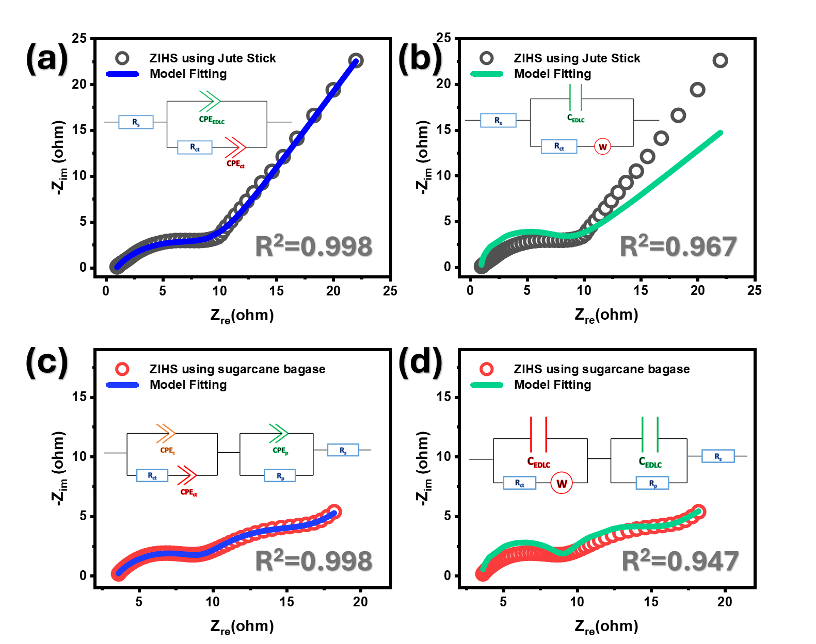
Figure S4. (a) Nyquist plot and corresponding fitting results using the proposed model for ZIHS fabricated from jute sticks; (b) Nyquist plot and corresponding fitting results using the Randle circuit model for ZIHS fabricated from jute sticks; (c) Nyquist plot and corresponding fitting results using the proposed model for ZIHS fabricated from sugarcane bagasse; (d) Nyquist plot and corresponding fitting results using the double Randle circuit model for ZIHS fabricated from sugarcane bagasse.
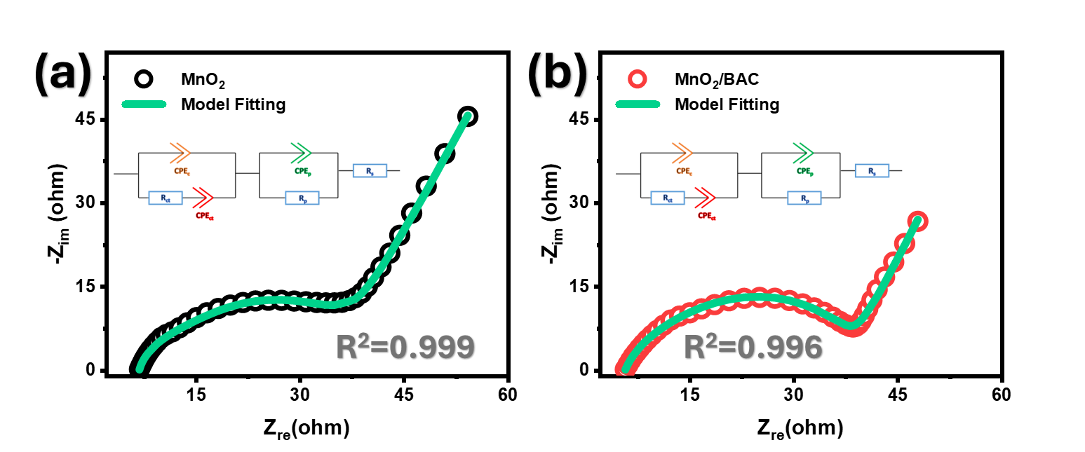
Figure S5. Nyquist plot and corresponding fitting results using the proposed model for ZIB employing (a) MnO₂ and (b) MnO₂/BAC.

