Table S1. Structures and antifungal activities against F. graminearum of 101 phenamacril derivates (2-cyanoacrylate compounds) tested in this study.

Number | Compound structure |  | Activity rating* | EC₅₀ (μg/ml)
ZJS-089 | 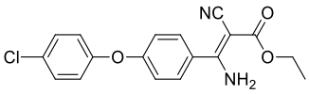 | – |  | /
ZJS-090 | 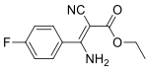 | – |  | /
ZJS-091 | 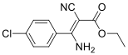 | – |  | /
ZJS-098 | 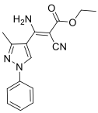 | – |  | /
ZJS-106 | 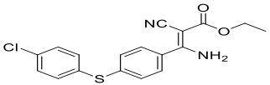 | – |  | /
ZJS-107 | 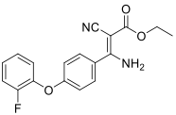 | – |  | /
ZJS-108 | 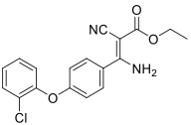 | – |  | /
ZJS-109 | 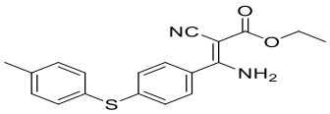 | – |  | /
ZJS-110 | 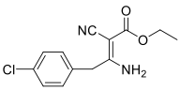 | – |  | /
ZJS-111 | 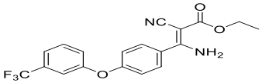 | – |  | /
ZJS-114 | 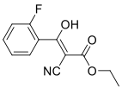 | – |  | /
ZJS-115 | 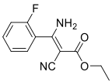 | – |  | /
ZJS-116 | 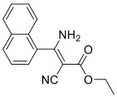 | – |  | /
ZJS-117 | 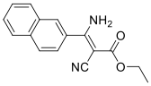 | + |  | /
ZJS-118 | 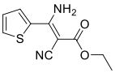 | + |  | /
ZJS-119 | 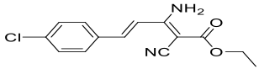 | – |  | /
ZJS-120 | 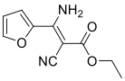 | – |  | /
ZJS-121 | 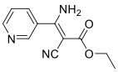 | – |  | /
ZJS-122 | 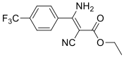 | – |  | /
ZJS-123 | 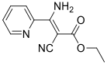 | – |  | /
ZJS-124 | 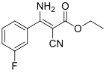 | + |  | /
ZJS-125 | 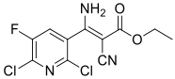 | – |  | /
ZJS-126 | 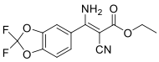 | – |  | /
ZJS-127 | 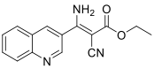 | – |  | /
ZJS-128 | 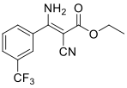 | – |  | /
ZJS-129 | 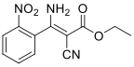 | – |  | /
ZJS-130 | 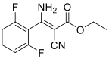 | – |  | /
ZJS-131 | 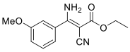 | – |  | /
ZJS-132 | 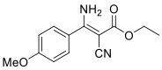 | ++ |  | 0.181
ZJS-133 | 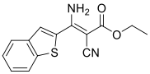 | + |  | /
ZJS-134 | 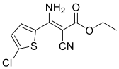 | – |  | /
ZJS-141 | 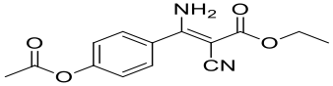 | – |  | /
ZJS-142 | 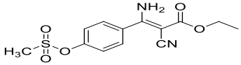 | – |  | /
ZJS-143 | 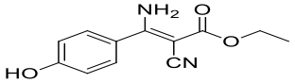 | – |  | /
ZJS-144 | 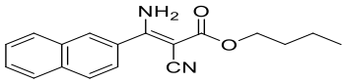 | – |  | /
ZJS-145 | 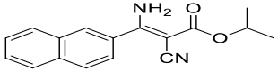 | – |  | /
ZJS-146 | 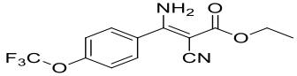 | – |  | /
ZJS-147 | 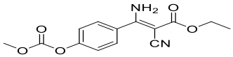 | – |  | /
ZJS-148 | 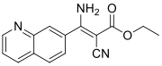 | – |  | /
ZJS-150 | 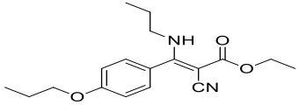 | – |  | /
ZJS-151 | 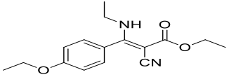 | – |  | /
ZJS-152 | 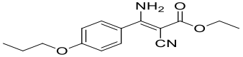 | – |  | /
ZJS-153 | 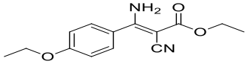 | + |  | /
ZJS-154 | 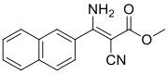 | – |  | /
ZJS-155 | 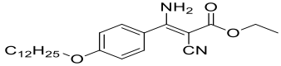 | – |  | /
ZJS-156 | 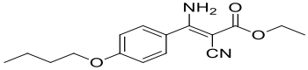 | – |  | /
ZJS-157 | 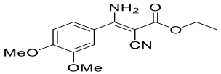 | – |  | /
ZJS-158 | 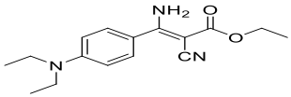 | ++ |  | 0.093
ZJS-159 | 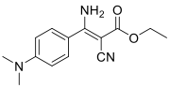 | ++ |  | 0.124
ZJS-160 | 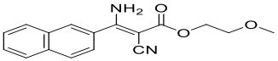 | – |  | /
ZJS-161 | 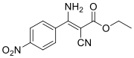 | – |  | /
ZJS-162 | 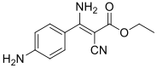 | – |  | /
ZJS-163 | 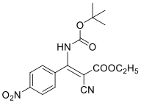 | – |  | /
ZJS-164 | 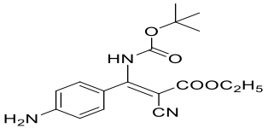 | – |  | /
ZJS-165 | 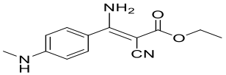 | ++ |  | 0.358
ZJS-166 | 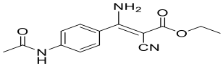 | – |  | /
ZJS-167 | 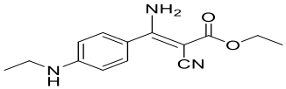 | ++ |  | 0.320
ZJS-168 | 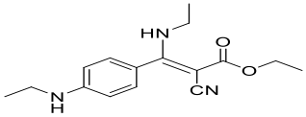 | – |  | /
ZJS-169 | 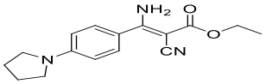 | + |  | /
ZJS-170 | 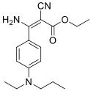 | ++ |  | 0.318
ZJS-171 | 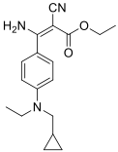 | + |  | /
ZJS-172 | 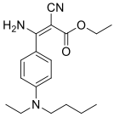 | – |  | /
ZJS-173 | 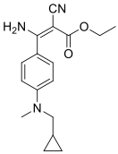 | + |  | /
ZJS-174 | 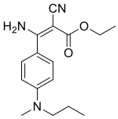 | ++ |  | 0.231
ZJS-175 | 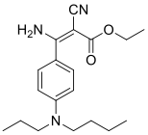 | – |  | /
ZJS-176 | 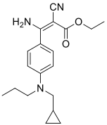 | – |  | /
ZJS-177 | 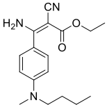 | – |  | /
ZJS-178 | 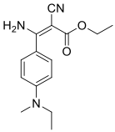 | ++ |  | 0.086
ZJS-179 | 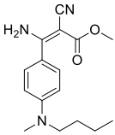 | – |  | /
ZJS-180 | 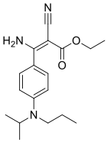 | – |  | /
ZJS-181 | 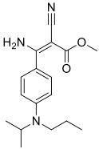 | – |  | /
ZJS-182 | 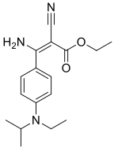 | – |  | /
ZJS-183 | 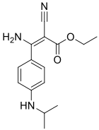 | ++ |  | 0.233
ZJS-184 | 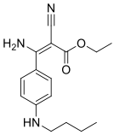 | + |  | /
ZJS-185 | 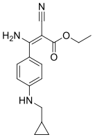 | + |  | /
ZJS-186 | 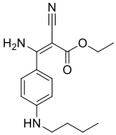 | – |  | /
ZJS-187 | 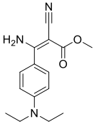 | – |  | /
ZJS-188 | 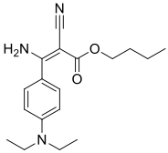 | – |  | /
ZJS-189 | 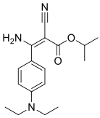 | – |  | /
ZJS-190 | 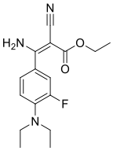 | ++ |  | 0.240
ZJS-191 | 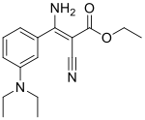 | – |  | /
ZJS-192 | 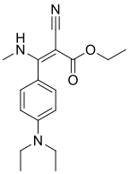 | – |  | /
ZJS-193 | 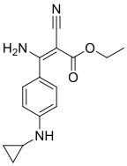 | + |  | /
ZJS-194 | 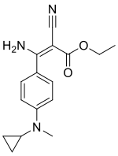 | ++ |  | 0.258
ZJS-195 | 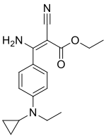 | + |  | /
ZJS-196 | 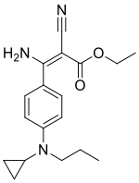 | – |  | /
ZJS-197 | 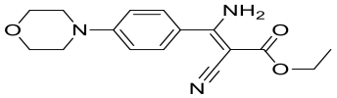 | – |  | /
ZJS-198 | 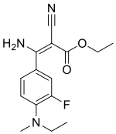 | ++ |  | 0.131
ZJS-199 | 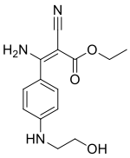 | – |  | /
ZJS-200 | 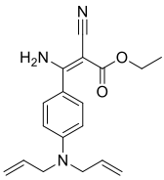 | – |  | /
ZJS-201 | 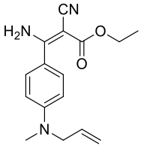 | + |  | /
ZJS-202 | 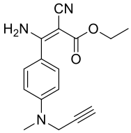 | ++ |  | 0.180
ZJS-203 | 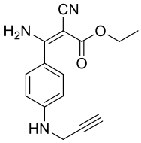 | + |  | /
ZJS-204 | 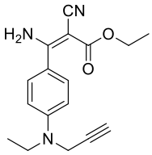 | ++ |  | 0.164
ZJS-205 | 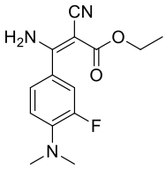 | + |  | /
ZJS-206 | 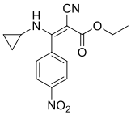 | – |  | /
ZJS-207 | 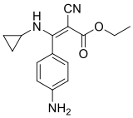 | – |  | /
ZJS-208 | 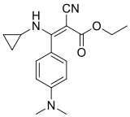 | – |  | /
ZJS-209 | 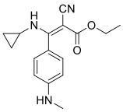 | – |  | /
ZJS-210 | 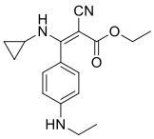 | – |  | /
ZJS-211 | 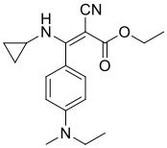 | – |  | /

* The activity of the compound is lower than phenamacril (–); + and ++ indicate that the activity of the compound is similar and higher than phenamacril, respectively.

